Enrollment Management Committee (EMC) Committee
March 3, 2022
1:00 pm Zoom

Agenda
Attendance: Jessica Wojtysiak, Krista Moreland, Kylie Campbell, Tom Greenwood, Gamaliel Ocampo, William Chapman, Sharon Bush, Pamela Rivers, Isabel Castaneda, Steven Watkin

note-taker: Isabel Castaneda  Approval of Minutes: 2/17/22- not reviewed | 5 minutes
Chairs Report: Krista and Jessica  Spring Enrollment Data- Jessica  - Data Dashboard review looks good from section count, anticipates late start classes will impact; enrollment efforts have increased (Dan Hall) taking the lead.  - Reviewed data dashboard, late start coursed have increased significantly over the years. Current efforts to fill courses are underway with a possible campaign led by Dan Hall and his team.  - Late start courses currently aid students in program completion; 6 programs are mapping 8+8 completion strategies.  - some courses are not suitable for 8+8, especially those with high activities and labs  - 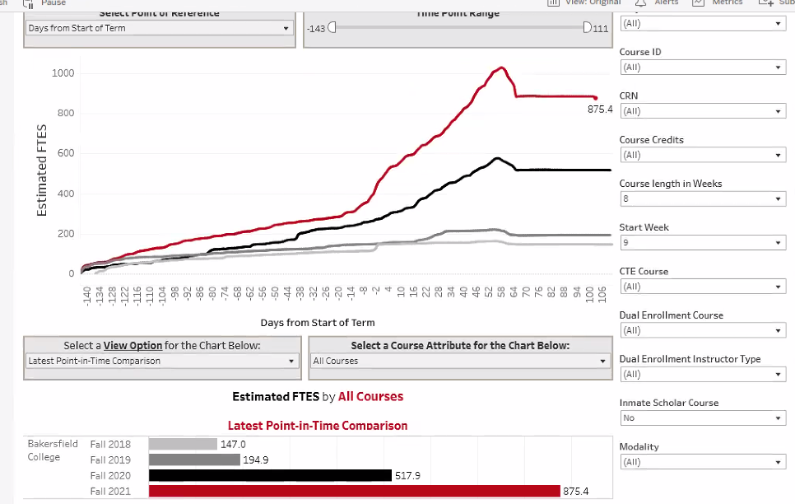  Late start classes and Bots: need to send out a reminder of "How to Identify" fraudulent students for those teaching late start courses.  a request was made for DO, A&R, and Financial Aid to provide an update on what is being done to prevent BOT's from registering  AB 705 Update to CC  - the team would like a further discussion and possibly invite speakers  - there is a significant concern among faculty feeling their voice is not being heard  - team requested data to be revisited as it is believed throughput is not being represented accurately | 10 minutes
Winter Intercession Update: Krista and Kylie  the committee reviewed program concerns and revised survey for multiple groups; the committee will meet again to finalize | 10 minutes
Guided Pathways Scale of Adoption Draft

https://committees.kccd.edu/sites/committees.kccd.edu/files/Bakersfield_CCRC_AACCPathways_SOAA_Fall%202021_v2.pdf
briefly reviewed document, encouraged the committee to take a deeper dive and make suggestions- Report Due in March.

Student Services Updates  Graduation fest planning happening now | 10 minutes

