Enrollment Management Committee (EMC) Committee
March 31, 2022
1:00 pm Zoom

Meeting Minutes
Attendance: Jessica Wojtysiak, Tom Greenwood, Leo Ocampo, Bill Chapman, Chelsi Womack, Marissa Marquez, Michelle Pena, Emily Wilson, Dan Hall, Kylie Campbell
Set note-taker: Chelsi Womack  Approval of Minutes: 3/3/22  Tom Greenwood: 1st approval.  Bill Chapman: 2nd approval.  Committee approved. | 5 minutes
Chairs Report  Committee Composition: Faculty Chair and New appointees:  New EMC Faculty Chair needed.  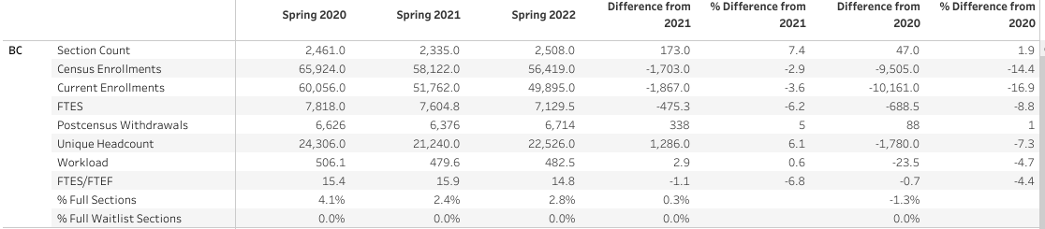  Spring Enrollment Data:  Dan Hall data report:  From March 9 - March 29, 2022 went down by approx. 200 FTES.  When filtered by modality, data shows F2F FTES did not decrease; suggests that the FTE decrease was a result of bot elimination.  Confirmed that faculty can register students as fraudulent in Starfish.  AB 705 Update:  Per Tom Greenwood, Math 26 approved.  Persistence Survey:  https://docs.google.com/forms/d/e/1FAIpQLScx3MVz-kbvUxhjiGIRaUoAklJ6GTxY1WoFZVVRYW43_g3kpg/viewform  Committee encouraged to share Persistence survey | 10 minutes
Winter Intercession Update: Krista and Kylie:
Tabled

Summer/Fall Registration: Student Interface

Registration database overview.
Instruct students to remove unnecessary tools to increase size of columns.
Advanced search feature is most useful.

Graduation Project Update: Marisa

Degree Completion Strategy overview.
Students color-coded to determine their completion status.
Outreach via Ocelot, email, postcards and more.

Student Services Updates

Just a reminder that students needing support to register for classes should be encouraged to contact the Student Information Desk for live assistance through our virtual platform.

