Enrollment Management Committee (EMC) Committee
April 28, 2022
1:00 pm Zoom

Agenda
Set note-taker  Approval of Minutes: 3/31/22 | 5 minutes
Chairs Report  College Council Update  Committee Composition: Faculty Chair and New appointees  Spring 2022, Summer 2022, Fall 2022 Enrollment Data | 15 minutes
Winter Intercession Update: Tom and Kylie | 5 minutes
Graduation Project Update: Angelica | 15 mins
Student Services Updates

Just a reminder that students needing support to register for classes should be encouraged to contact the Student Information Desk for live assistance through our virtual platform.

Spring 2022 Enrollments
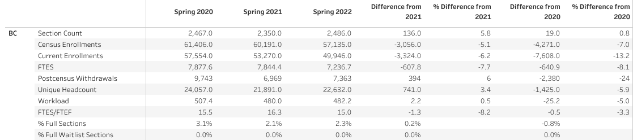

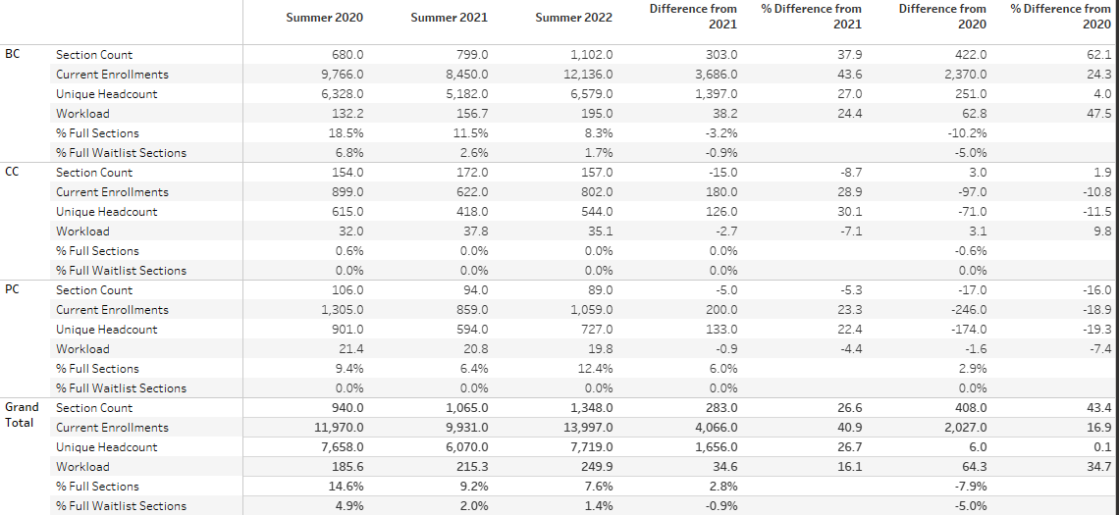
Summer 2022 Enrollments

Fall 2022
