Enrollment Management Committee (EMC) Committee
March 31, 2022
1:00 pm Zoom

Agenda
Set note-taker  Approval of Minutes: 3/3/22 | 5 minutes
Chairs Report  Committee Composition: Faculty Chair and New appointees  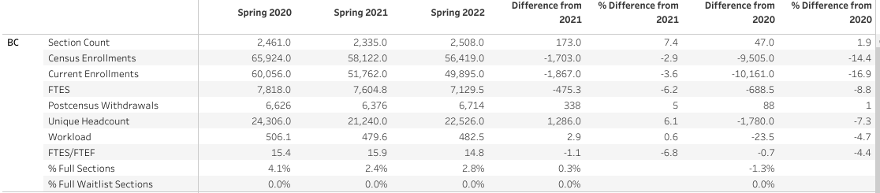  Spring Enrollment Data  AB 705 Update  Persistence Survey:  https://docs.google.com/forms/d/e/1FAIpQLScx3MVz-kbvUxhjiGIRaUoAklJ6GTxY1WoFZVVRYW43_g3kpg/viewform | 10 minutes
Winter Intercession Update: Krista and Kylie

Summer/Fall Registration: Student Interface

Graduation Project Update: Marisa

Student Services Updates

Just a reminder that students needing support to register for classes should be encouraged to contact the Student Information Desk for live assistance through our virtual platform.

