JOHN CHARLES REID MEMORIAL SYMPOSIUM PROPOSAL FOR FUNDING OF
DR. ALEX SARAGOZA LECTURE
ON “THE HISTORY OF LATINOS IN THE CENTRAL VALLEY”
I am asking, on behalf of the Cultural & Historical Awareness Program (CHAP) for John Reid Memorial Symposium Funds to pay for the honorarium of the speaker Dr. Alex Saragoza who will lecture, (as a CHAP event) on May 3, 2023, on “The History Of Latinos In The Central Valley”
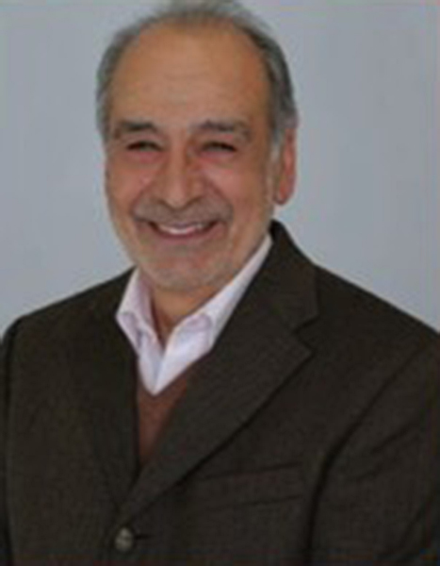
Alex M. Saragoza is Professor emeritus at the University of California, Berkeley, where he has taught for the Department of Ethnic Studies and for the American Studies program. He was born in Madera, California; he is the son of Mexican immigrant farm laborers, and he worked in the fields along with his parents. He is a graduate of Fresno State, Harvard, and University of California, San Diego, and he has published widely on Mexico, immigration, and Latino history.

In 2012, he was visiting professor at the Sorbonne, Paris, France, and he has lectured at several universities, such as the University of Aix-en-Provence, University of Texas, Austin, Universidad Nacional Autonoma de Mexico, Universidad de Salamanca, Spain, among several other institutions of higher education.

Professor Saragoza was the recipient of the 2017 Excellence in Teaching and Learning Award from the Osher Life-Learning Institute at UC Berkeley; and he has been selected to the Distinguished Lecturer Program of the Organization of American Historians. He is the historical consultant to the recent exhibit entitled, “Caminos: A History of Latinos of the Central Valley”, recently at the Tulare County Museum at Mooney Grove in Visalia (the exhibit closed December 23, 2022).

I am asking for $1,000 from the John Reid fund to pay for the honorarium to have Dr. Saragoza come speak at Porterville College.

Criteria for using of the John Reid fund (as defined by the National Endowment for the Humanities):
“In the act that established the National Endowment for the Humanities, the term humanities includes, but is not limited to, the study of the following disciplines: history, theory and criticism of the arts; ethics; comparative religion; and those aspects of the social sciences that employ historical or philosophical approaches…”

This lecture by Dr. Saragoza on “The History Of Latinos In The Central Valley” is of “the study of the following disciplines: history…” Therefore, this lecture should qualify for the use of John Reid fund money.

Jim Entz, Coordinator of CHAP

Leslie Pelon, as Secretary of CHAP, will speak on this proposal at the Academic Senate Meeting on 4/28/23, because I will be out of town.

