Division Chairs Handbook
The Role of the Division Chair

When you become a division chair your role on the campus changes in numerous ways. A division chair is charged with looking at the big picture: looking at the division as a whole and at the division's relationship to the college. But the chair is also charged with guiding many of the daily operations of the division, and it is easy to drown in the minutiae of paper-pushing, to lose sight of the larger issues that should be of concern. There is much to balance as chair: the small tasks with the large vision, and also the job of chair with your own teaching assignment. Meeting deadlines such as scheduling classes for future semester, finding substitute instructors, marketing our programs to the students, approving course substitutions and all the other small tasks of the chair are part of this new role. However, being able to reach and have a positive influence on more student lives than just the ones in your own classes are part of the reward to being a division chair.
The “Big Picture” Person
It's important for the chair to keep in mind the big picture—the division’s place in the college and the needs of the students it serves. Of course it's good for all faculty to have such a perspective, but while in the role of division chair you are tasked with setting the tone for the culture and expectation of your respective divisions. Some of the issues for which the big picture may need to be invoked include:
- Culture: This is perhaps the most fundamental of all: establishing a collegial environment, one in which much of the above will take care of itself because all members feel valued, that they have a stake in the endeavor, that they are part of a team, that they have ownership in the program
- Program Review: Besides completing the paperwork report to meet the deadlines, it is important to take a step back and look at what your division is doing, how it is doing it and whether those efforts genuinely meet the needs of students. Often times we think of this process defensively and feel we have to prove ourselves and our worth to the campus. However, when we take this position, we deny ourselves the opportunity for authentic self-reflection. The program review invites recognition of our accomplishments but it also invites identification and analysis of program shortcomings. This is essential so we can make adjustments to better serve future students.
- Conflict Resolution: Conflict is unavoidable and can be healthy and as the division chair you almost certainly will be involved in trying to resolve conflicts at some point. Common areas of conflict may include competition for scarce resources and fundamental personality differences.
- Sharing the Load: We have a lot of work to do and we need to spread the tasks within the division. Failure to do this can really hurt the “Culture” as mentioned earlier
- Balanced Scheduling: Finding ways to balance the wide variety of factors that go into what courses are taught when and by whom is key:
  - course offerings for majors with general education courses for non-majors
  - faculty's ability to teach from their strengths with the needs of the program
  - faculty ability to teach in the blocks they prefer while also sharing the burden of teaching in unpopular blocks
In other words, the chair has an important role in helping faculty in the division be realistic about how much of what they do can be chosen entirely individually, how much should be done in consultation with others, and with attention to the needs of others. How much latitude is available can also depend on the nature of one's division, particularly with regard to curriculum. Some divisions have standard introductory courses, but almost everything above that is flexible. A new person coming into such a division will have a wider choice of courses to develop than someone coming into a division where the curricula is highly sequential, and one person's course depends heavily on another's. But even in this latter sort of division, it will help the morale of everyone if the obligations of the required courses can be balanced with the occasional fruit, the chance for a faculty member to have input in what, when and where they teach whenever possible. (Much of the structure and verbiage above came from the Cornell College Faculty Handbook 2018-19)
Specific Roles of Division Chair
- Leadership: Serves in a faculty leadership capacity for the division. The chair is the primary communicator/spokesperson for the division. In this role, it is expected that the chair will attend both the Enrollment Management and College Council committee meetings.
- Curriculum: Encourages & supports curriculum development, revision, and innovation. Division chair also reviews all curriculum proposed for revision or creation in the division.
- Scheduling: Works with faculty on the development of semester class schedule, long-term course program scheduling plans.
- Program Review: Coordinates division faculty to create annual program review updates and 3 year full program review documents.
- Fiscal: Works with division to develop division budget. This includes making annual budget requests and updates as a part of the program review and planning process.
- Personnel: Participates in the recruitment process for the division for full-time/part-time faculty and classified staff. Participates in the evaluation process for full-time/adjunct faculty.

Important Dates/Deadlines:

- Program Review Annual Update | September
- Budget Worksheet | September
- 5 Year Instructional Funds Request | September
- Fall Schedule Due in Schedule Plus: | Dec 1st 2018 (for Summer 19)
- Spring Schedule Due in Schedule Plus: | Dec 1st 2018 (for Fall 19)
- Summer Schedule Due in Schedule Plus: | Dec 1st 2018 (for Spring 20)
- Program Review (Full 3 Year Report) | By the end of Fall Semester every 3rd year

Meeting Schedules:

- Division Chairs Retreat | Wed before Fall FLEX day
- College Council | 1st / 3rd Monday (3 – 5pm)
- Enrollment Management | 2nd / 4th Monday (3 – 4pm)
- Curriculum Committee | 2nd / 4th Tuesdays (230 – 5pm)

Faculty Evaluations:

Full-Time Tenure-Track Faculty | Typically done during Fall Semester
Full-Time Tenured Faculty | Done once every 3 years based on previous evaluation date.
Adjunct Faculty: | Done in 1st semester the adjunct teaches for our school. If they receive a satisfactory evaluation , then they will be evaluated again during their 3rd year and every 3 years thereafter

- NOTE: Because there are numerous steps and calendars in each evaluation, it is strongly suggested to begin the process as early in the semester as feasible.
The division chair is responsible for coordinating the evaluation of all faculty and staff assigned to their division. These processes are explained in the KCCD/CCA faculty contract 2017-2020 starting with Article Six. See the link below for more detail.
https://www.kccd.edu/sites/kccd.edu/files/page/KCCD%20CCA%202017-2020%2009-20-17%20a_0.pdf
The division chair role and responsibilities are further described in Article Five of the KCCD/CCA faculty contract. In addition, the division chair must also go through a regular evaluation as part of their assignment. These details may be found at the link below.
https://www.kccd.edu/sites/kccd.edu/files/page/KCCD%20CCA%202017-2020%2009-20-17%20a_0.pdf

Student Conduct:

- Student Complaints:
If a student wishes to submit a formal complaint about an instructor, college staff, etc. then they should be forwarded to the “Student Complaint Intake Form” located on the college website at https://www.portervillecollege.edu/student-services/complaint-procedures
- Student Behavioral Issues:
The Behavioral Intervention Team, or BIT, at Porterville College serves as the centralized coordinated body for discussion and action regarding students exhibiting behaviors that indicate distress, cause of disturbance in the community, and/or present a danger to oneself or others. Committed to proactive, early intervention, the BIT supports students directly through consultation with campus partners. If you or one of your instructors becomes aware of a related issue, the behavior should be reported by completing a BIT Report Form located on the college website at https://www.portervillecollege.edu/behavioral-intervention-team-bit

Curriculum:

As stated before, the division chair encourages and supports curriculum development, revision, and innovation. The division chair is also responsible for reviewing all curriculum proposed for revision or creation from the division. The Curriculum Committee webpage has numerous resources for all faculty with two of the most important being the Porterville College Curriculum Handbook as well as the over-arching resource document put out by the State Chancellors Office known as the Program & Course Approval Handbook (PCAH). The committee website is accessible at https://committees.kccd.edu/committee/curriculum-committee
NEW! One point of focus for division chairs to be aware of is a relatively new procedure for requesting articulation agreements after a course receives approval from our local college Curriculum committee. Once our committee approves a course or program, it is the division’s responsibility to request any and all articulation agreements be sent out by sending an email to the Articulation Officer directly via email itemizing the courses and each specific request. There are two forms that have been made to simplify this process and are stored on the local “J: Drive”
that should be accessible from any school computer. The two files are titled “How to Articulate a Course” and “Articulation Request” and can be found using this breadcrumb trail seen in the screenshot below:
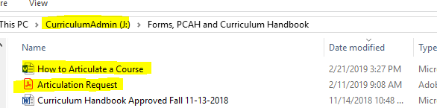

Managing Budgets / Purchase Orders:

Each Division Chair is responsible for managing the various budgets within that division. This includes tasks such as approving purchase orders, monitoring fiscal year cut-off deadlines, transferring money between division accounts, etc. Some of the most important and frequent items are discussed below but there are far more detailed descriptions and resources are available at https://committees.kccd.edu/committee/budget-committee

- “What’s a FOAPAL”?
The chart of account elements that are utilized by Kern Community College District are:
Fund – Organization – Account – Program – Activity – Location
(aka FOAPAL)
Fund: Indicate the source of money and uniquely identify all sources of funding. Funds may be unrestricted (GU001) or restricted; and may be specific to one department or shared by many.
The General Fund is the primary operating fund of the district. It is used to account for those transactions that, in general, cover the full scope of operations of the district, and are considered unrestricted (instruction, administration, student services, maintenance and operations, etc).
Restricted Funds are used to account for resources available for the operation and support of the educational programs that are specifically restricted by laws, regulations, donors, or other outside agencies as to their expenditure.
Organization: Hierarchical field that identifies a unit of budgetary responsibility. Typically designates specific departments or operating entities. Organization codes identify where approvals and budget control occur.
Account: To track assets, liabilities, fund equity items, expense and/or income individually. The account provides the district with a uniform method of recognizing and classifying expenditures, capturing information that must be reported on financial statements, serves as a guide for planning by providing historical information on costs.
1000-1999 Academic Salaries
2000-2999 Classified Salaries
3000-3999 Employee Benefits
4000-4999 Supplies & Materials
5000-5999 Services/Utilities/Operating Expenses
6000-6999 Capital Outlay/Equipment

Program: Category of activities with common outputs, functions and objectives. Program codes are, for the most part, dictated by the State TOPS Codes and other State reporting forms and manuals. A program may cross departments.
Activity: Reflects the purpose of expenditures. Used to capture activities that could span one or more funds, organizations, or accounts, so they can be “lumped together” for reporting purposes. Activity codes are non-hierarchical. The use of the activity code is optional.
Location: Broad classification that reflects the location of the campus or department. The use of the location code is optional

- Budget Request & Monitoring
There are several reports the division chair is responsible for completing and submitting each year that are related to budget. The following are brief descriptions of those reports.
- Budget Worksheet: This form is required of all Division Chairs and requested and submitted in the fall semester. The form is an Excel spreadsheet, where the primary purpose is to request and justify your budgets for the following academic year.

- Program Review Annual Update: This should to be completed by every division/area each year. In terms of budgeting, these updates serve as the appropriate place to document new purchase requests that may not have appeared in the last full program review.

- 5 Year Instructional Request: This request may be updated each year for larger purchases and “wish list” items. If you don’t get an item in a given year identified, each year it is suggested to have the division re-rank items on this list and re-submit a revised draft.

- One Time Funding Requests: These are similar in purpose and function to the 5 Year Instructional Request, but these are for items the division would like to purchase that are one-time purchase requests that relate directly to instruction. These funds come from a very specific source that is allocated to the school with strict “instructional purchase” guidelines the amount of which fluctuates wildly from year to year.

- Training Materials
These PowerPoint presentations includes detailed explanations of what the common division chair responsibilities are along with detailed walk-thru instructions on how to look up budgets, complete the annual program review and budget updates and complete budget requests.
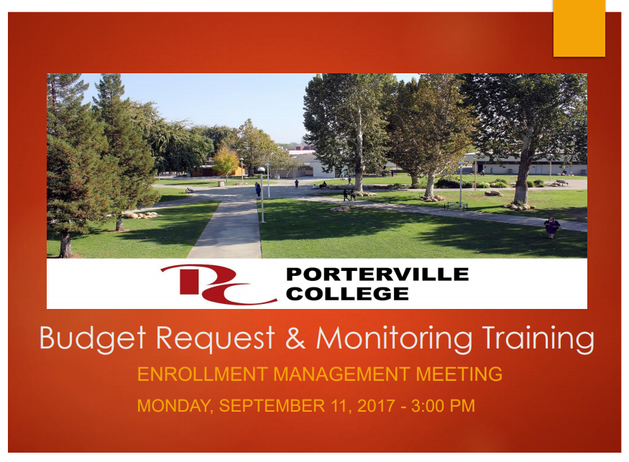
https://committees.kccd.edu/sites/committees.kccd.edu/files/Budget%20DevelopmentTraining_17.pdf
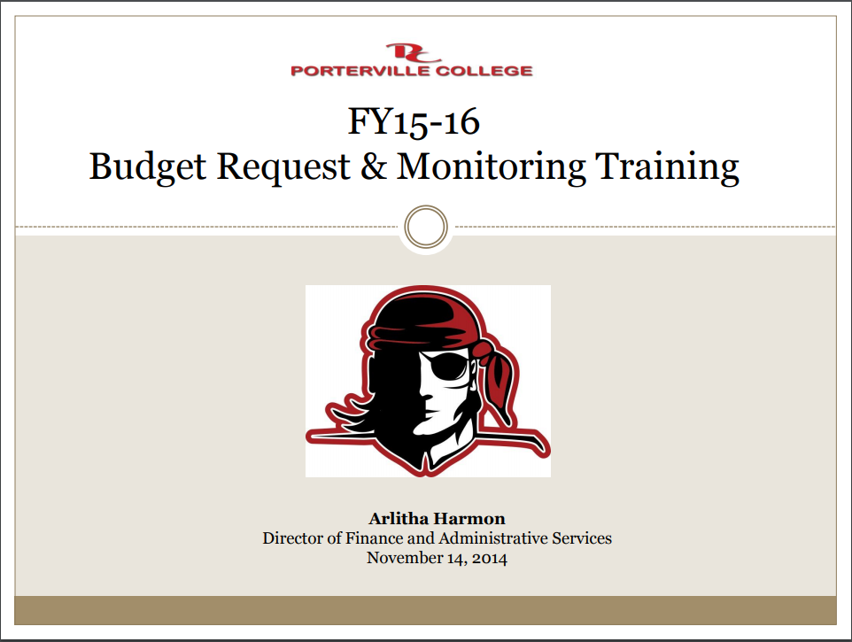 https://committees.kccd.edu/sites/committees.kccd.edu/files/Budget%20MonitoringTraining%20_15_16-1.pdf

Disability Resource Center (DRC):

- Role & Function
The DRC assists students with verified temporary, chronic, or permanent disabilities in requesting and receiving academic accommodations. We also assist PC faculty in providing accommodations. Some students prefer to communicate directly with their instructors regarding accommodations, and some prefer to have the DRC communicate with instructors on the student’s behalf.

- DRC Faculty Handbook
An electronic copy of the DRC Faculty Handbook is available on the Porterville College website: https://www.portervillecollege.edu/drc-faculty-corner. New hires may contact the DRC by email or phone to request a hard copy.

- Mental Wellness & Suicide Prevention
Mental Wellness - Please refer at-risk students to Errin-Sullivan Arcos in AC-115 or call (559) 791-2366.
Suicide Prevention - Conversations can change lives! Have you ever been worried about a student on campus? Porterville College offers an online-simulation training for talking to at-risk students and connecting them with campus services. Trainings are also available for creating a supportive campus culture for LGBTQ and military-connected students. To complete the simulation, follow the instructions below:

- Go to Kognito (ccc.kognito.com)
- Create a New Account
- Follow the on-screen instructions
- Choose your simulation and click "LAUNCH"
- For more info on this Call Counseling (559) 791-2329 or Student Services (559) 791-2218 for more information.

- Contact Info:
Location: AC-115
Phone: (559) 791-2215
Email: drc@portervillecollege.edu
DRC Coordinator/Counselor: Stephanie Olmedo-Hinde

Safety & Security:

Coming Soon!

