Curriculum Handbook
PORTERVILLE COLLEGE
Draft 21-22

Table of Contents

I. The Curriculum Committee page 2
- The Role of the Curriculum Committee
- Membership of the Curriculum Committee
- Technical Review Subcommittee
- The Curriculum Committee Chair
- Governance Issues
- Duties and Responsibilities of the Curriculum Committee
- Other Duties Typically Assigned to the CC

II. Curriculum Development Process (Reference KCCD Local Board Policy) page 7
- Guide to Course Development
- Developing the Course Outline

III. Curriculum Approval Process page 13
- Origination of Proposals
- Review Process
- Approval Workflow Process
- Faculty Guide to eLumen
- Reviewers Guide to eLumen

IV. Curriculum Resources page 28
- Content Review form
- Course Unit Justification Form
- Articulation Form

V. Guidelines for Approval Evaluation page 33
- New and Revised Courses
- Credit Hours
- Prerequisites, Corequisites, and Advisories on Recommended Preparation
- Distance Education Courses and Sections
- Associate Degree Requirements
- Course Repetition
- CSU-GE and IGETC Courses
- New Degree and Certificate Programs
- Discontinuation of Existing Programs

VI. Glossary and Sources page 42
A. Glossary of Terms
B. Curriculum Reference Sources

SECTION I: The Curriculum Committee

The Curriculum Committee plays a central role in the California Community Colleges. This role has expanded tremendously with the expanding role of faculty in community college governance and with the increasing demand for a curriculum which is flexible and responsive to the needs of our increasingly diverse student body. These demands have necessitated, now more than ever, that faculty understand the role of the curriculum committee, remain committed to high curriculum standards, and implement the college curriculum in an organized, efficient manner, in order to effectively facilitate the development of curricula.

Part A. The Role of the Curriculum Committee

The Education Code and Title 5 specify the following:

- The academic senate has primary responsibility for making recommendations in the area of curriculum and academic standards [Ed. Code §70902(b)(7)]. This right is protected as a minimum standard set by the Board of Governors [Ed. Code §70901(b)(1)(E)].

- The local governing board has the responsibility to establish policies for and approve courses of instruction and educational programs [Ed. Code §70902(b)(2)].

- The Board of Governors has the responsibility to develop policies and guidelines for strengthening the role of the academic senate with regard to determination and administration of course approval and curricula [AB 1725 Section 61] and has done so in Title 5 §53203 and §55002.

- The academic senate has the authority and responsibility delegated to it by the KCCD Board to develop recommendations on policies and procedures in academic and professional matters, which include curriculum [Title 5 §53203].

- The curriculum committee has the responsibility to recommend to the KCCD Board those courses and programs which meet stated standards Title 5 §55002].

The Curriculum Committee reviews and recommends courses and programs functioning under policies and procedures set by the academic senate (either through primary advice to or mutual agreement with the board). The board approves courses and programs recommended directly by the curriculum committee and with the assurance of the academic senate that established policies and procedures have been reviewed and followed. The Board of Governors has final approval for educational programs passed by the KCCD Board.

The role of the Curriculum Committee is specified in Title 5 in the area of recommending courses and programs in the curriculum. However, other duties may be assigned to the committee as part of the shared governance structure of the college.

Part B. Membership of the Curriculum Committee

Because curriculum is the primary responsibility of the faculty, the voting membership of the Committee should be predominantly faculty. Students must be provided an opportunity to participate in formulation and development of district and college policies and procedures on curriculum (Title 5 §51023.7). Classified staff do not generally participate as voting members of the curriculum committee because the decisions made do not generally have a significant effect on classified positions as detailed in Title 5 §51023.5.

The Porterville College Curriculum Committee membership structure will include:

Voting Members:

- Faculty representatives from each division appointed by the individual divisions
- A student representative appointed by the Associated Student Body

Non-Voting Members:

- Curriculum Specialist and/or Curriculum Technician
- Administrators and other advisory members
- Advisory Members as necessary
- Vice President of Instruction
- Deans of Instruction
- Director of Enrollment Services
- Financial Aid Director
- Articulation Officer
- Disability Resources Coordinator
- Librarian Cur

Part C. The Technical Review Subcommittee

The Role of the Technical Review Subcommittee:

To provide technical input to the Curriculum Committee and faculty related to course/program development, proposal, and review process to review and make recommendations on courses and programs from a technical review perspective related to curriculum.
Technical areas may include and are not limited to the following subjects/areas: Financial Aid, Admissions & Records, California Education Code, Title 5 Regulations, California Community Colleges Chancellor’s Office guidelines and requirements, state/federal requirements, Accrediting Commission for Community and Junior Colleges (ACCJC) standards & policies, and Kern Community College District (KCCD) Board policies and processes.

SPECIFIC TASKS
- Assist the faculty and Curriculum Committee on items to be considered as it relates to financial aid, admissions & records, regulatory, and other applicable legal, accreditation, KCCD Board requirements and policies.
- Review and make recommendations to the faculty and Curriculum Committee to support curriculum development, review, and approval process at Porterville College.
- Advise and provide recommendations through the Curriculum Chair & Curriculum Specialist on items on Curriculum Committee Agenda.
- Serve as technical subject-matter resource for the Curriculum Committee and the faculty.

MEMBERSHIP

Curriculum Committee Faculty Member 2
Curriculum Chair 1
Curriculum Specialist 1
Director of Financial Aid or Designee 1
Director of Admissions & Records or Designee 1
Articulation Officer/Counselor or Designee 1
Academic Administrators 2

Total Membership 9
*Executive Secretary 1

Part D. The Curriculum Committee Chair, Chair-Elect, and Past Chair

Curriculum Committee Chair Responsibilities:

The Curriculum Chair is selected by the membership and serves a two (2)-year term. In the fall semester of the second year, the Curriculum Committee will select a Chair Elect to serve one year in this position and two years as the Curriculum Chair. The duties of the Curriculum Committee Chair, in conjunction with the Curriculum Specialist serving as the assistant to the Chair, are:
- Prepare agendas
- Conduct the committee meetings
- Edit minutes (typically taken by the curriculum specialist)
- Set the calendar of committee meetings
- Keep informed of curriculum standards including Title 5, the curriculum standards handbook, intersegmental, and accreditation
- Supervise the orientation of new members and on-going training of continuing members
- Assist discipline faculty in the curriculum development process (usually with faculty curriculum committee member from that division)
- Assure that committee functions take place smoothly: technical review, prerequisite review, distance education review, general education review, articulation, and program review reports to the committee
- Report regularly to the Academic Senate and College Council (CC)
- Sign off on final version of curriculum recommendations to the board
- Only votes on proposals in the case of a tie

Curriculum Committee Chair Elect Responsibilities:

In an effort to ease the transition to the Curriculum Chair position, the following are good practice for the Curriculum Chair Elect to participate in during the semester prior to becoming the Curriculum Chair:
- Assist in running the curriculum committee meetings (perhaps alternate running the computer at one meeting and then moving through the agenda, facilitating the discussions and voting at the next).
- Assist in putting together meeting agendas
- Shadowing the current chair while they review courses
- Shadow the Curriculum Specialist while they review courses
- Shadow the Chair while the input changes and/or approvals following a meeting
- Note: The Chair-Elect does not vote on proposals unless they are the current representative for their division

Curriculum Committee Past Chair Responsibilities:

In an effort to ease the transition to the Curriculum Chair position, the following are good practice for the Curriculum Committee Past Chair to participate in following the completion of their term as Curriculum Chair:
- Meet with Chair-Elect over the summer to answer questions and help prepare for upcoming semester
- Help facilitate discussions and running of meetings (as needed)
- Run meetings in absence of the current chair
- Offer historical context of issues, conversations, and/or other factual information that may be useful to the current chair and the committee as a whole
- Note: The Curriculum Committee Past Chair Chair-Elect does not vote on proposals unless they are the current representative for their division

Part E. Governance Issues

Accountability for effective curricula which meet applicable standards is a shared responsibility. A rigorous curriculum review process is demanding and adherence to time lines is crucial to assure that deadlines are met for catalog publication, CSU General Education Breadth (CSU-GE) and Intersegmental General Education Transfer Curriculum (IGETC) submissions, etc. Moreover, the structures of Title 5 regulations, accreditation standards, CSU Executive Orders, Chancellor’s Office standards and so on are detailed and voluminous. This is clearly an area in which faculty and administrative cooperation will greatly facilitate the decision making process. Following the principle of shared governance, all members of the committee share the responsibility of assuring courses and programs meet the highest academic standards and that the review and approval process runs smoothly so that deadlines can be met. Faculty takes the responsibility for their primacy on curriculum matters seriously.

Part F. Duties and Responsibilities of the Curriculum Committee

The following duties and responsibilities are described in Part II of this Curriculum Handbook:

- Approval of New and Revised Courses
- Approval of Credit Hours
- Approval of Prerequisites, Corequisites, and Advisories on Recommended Preparation
- Approval of Distance Education Courses and Sections
- Approval of Associate Degree Requirements
- Approval of Course Repetition
- Approval of CSU-GE and IGETC Courses
- Approval of New Degree and Certificate Programs
- Approval of Discontinuation of Existing Programs

Part G. Other Duties Typically Assigned to Curriculum Committees

Catalog and Schedule of Classes

Colleges are required to publish complete information about each course (Title 5 §55005):
- status as credit, noncredit, or community service
- transferability
- fulfillment of major and general education requirements
- availability of credit/non-credit option (§55752)

As stated in the Handbook of Accreditation and Policy Manual (1996) produced by the Accrediting Commission for Community and Junior Colleges, Western Association of Schools and Colleges,
2.1 The institution represents itself clearly, accurately, and consistently to its constituencies, the public and prospective students through its catalogues, publications, and statements, including those presented in electronic formats. Precise, accurate, and current information is provided in the catalog concerning (a) educational purposes; (b) degrees, curricular offerings, educational resources, and course offerings; (c) student fees and other financial obligations, student financial aid, and fee refund policies; (d) requirements for admission and for achievement of degrees, including the academic calendar and information regarding program length; and (e) the names of administrators, faculty, and governing board.

Curriculum Committee involvement in the review of the accuracy of course catalog descriptions, particularly those recently added or revised, benefits tremendously from perusal by those who approved that material. Such benefits apply equally to the catalog listings of program major course requirements, general education requirements, transferability to UC and CSU, prerequisite policies, and CSU GE-Breadth and IGETC course listings.

Program and Course Review

As part of maintaining accreditation, colleges are required to regularly review their curriculum. As stated in the Handbook of Accreditation and Policy Manual (1996) produced by the Accrediting Commission for Community and Junior Colleges, Western Association of Schools and Colleges,

4D.1 The institution has clearly defined processes for establishing and evaluating all of its educational programs. These processes recognize the central role of faculty in developing, implementing, and evaluating the educational programs. Program evaluations are integrated into overall institutional evaluation and planning and are conducted on a regular basis.

The most direct implication of the accreditation standards is the need to review each course outline of record on a regular basis, at least within the six-year accreditation cycle. Occupational programs are to review the program to the standards required by Ed. Code §78016 (see above) every two years and then do a course-by-course review for curriculum standards every six years (While the State Chancellor’s Office mandates a six-year review cycle, Porterville College’s Curriculum Committee uses a four-year cycle.) This specific review of the course outlines is much more effective if conducted within the scope of a review of the entire program of which the course is a part. Program-by-program reviews are to be communicated to the curriculum committee. In exceptionally rare cases the Curriculum Committee may conditionally approve course revisions that would not otherwise meet these deadlines with an early “sunset date”. This would mandate that the course revision be completed in a shorter time than the usual 2, 4 and 6 year standards described above. It is to be stressed that this will not be done unless strong documentation and reason exist. For example, if a course or program was currently undergoing a major overhaul of the entire curriculum, has evidence to that plan and progress in a Program Review on file, and in an area where the discipline expert full time faculty may have retired but not been replaced, and the other division faculty are not major-specific discipline experts, then this “sunset” approval may be granted. In most cases, if a course has not been reviewed for longer than four years, there will be a one-year grace period, after which the Curriculum Committee will recommend to the President that the course not be offered until it has been reviewed and approved by the Committee.

Articulation

The Curriculum Committee plays an important role in articulation. An essential communication link is that between the Committee and the Articulation Officer, who is a member of the Committee. The role of the Articulation Officer is to be the contact person and mediator between campuses, to be the liaison to the system level offices, to serve on the Curriculum Committee and other committees as appropriate, to maintain and communicate accurate articulation information, and to stay well informed and inform others on articulation issues.

In reviewing and approving courses, the Curriculum Committee should evaluate the appropriateness of the course to meet articulation standards. Articulation agreements fall into four distinct categories, each of which has its own standards:
- baccalaureate credit courses
- general education-breadth
- course-to-course articulation
- major preparation agreements

Baccalaureate credit courses transfer for elective credit only.

The Curriculum Committee will request from course originators an explanation of whether or not the course meets baccalaureate standards and to identify comparable courses at UC and CSU campuses.
General Education-Breadth courses can be certified at the system level following the CSU-GE Breadth and IGETC process discussed in the previous section of this paper. Individual course-to-course agreements between specific CCC and UC or CSU campuses are the responsibility of the individual campuses, whether in general education areas or other courses. NOTE: It is the responsibility of the proposal originator to notify the Articulation Officer directly following the approval of the course by the KCCD Board of Trustees if they would like the course to be submitted for any new CSU GE Breadth and/or IGETC areas.
Major Preparations Agreements specify comparable courses at the individual community college which, upon transfer, meet the lower-division major preparation requirements for a specific UC, CSU, or private four-year institution. Such courses are accepted in lieu of the specified major preparation courses at the receiving school. Those agreements are negotiated on a campus-to-campus basis through the services provided by the articulation officers at both institutions. Submission for major preparation agreements often require additional information beyond the course outline of record, such as syllabi, texts, and sample course materials. Such agreements are often of limited duration. NOTE: It is the responsibility of the proposal originator to notify the Articulation Officer directly following the approval of the course by the KCCD Board of Trustees if they would like the course to be submitted for any new Major Preparation Agreements.

Lower division major preparation agreements serve as the basis for identifying the courses which are part of each “transfer program” at the college. In reviewing such courses, the Curriculum Committee has the responsibility to assure that the standards expected within the agreements are maintained.

C-ID (Course Identification Numbering) numbers are available in many disciplines that give a form of articulation between community colleges and CSU schools. These have played a much bigger role since the passing of California Senate Bills 1440 and 440 as part of the new “Transfer” degree programs. NOTE: It is the responsibility of the proposal originator to notify the Articulation Officer directly following the approval of any new course by the KCCD Board of Trustees if they would like the course to be submitted for any new C-ID. This request can be made at any time for any course that has a course revision on file that is less than five years old.

How to Articulate a Course

- Before developing a new course it is recommended that you discuss the proposal with the Articulation Officer (AO). This is not a requirement, but a suggestion.
- Once the course is approved by the Curriculum Committee (CC), complete the Articulation Request Form (see J drive or Curriculum Canvas Shell) and email it to the AO.
- The AO will confirm your request. If you do not receive confirmation within fourteen days, please email the AO.
- The AO will share all articulation decisions (i.e., approval, denial) with the originator, division chair and Instruction Office Specialist.

Articulation Deadlines –
UCTCA – May 5th
CSUGE – December 1st
IGETC – December 1st
C-ID – Open
Course to Course – Open

Articulation Abbreviations –
UCTCA – University of California Transfer Course Agreement
CSUGE – California State University General Education
IGETC – Intersegmental General Education Transfer Curriculum
C-ID – Course Identification Numbering System
COR – Course Outline of Record

Articulation Request Form:
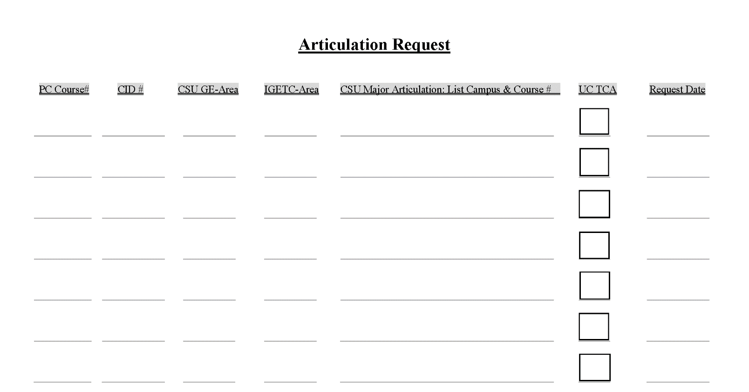
SECTION II: CURRICULUM DEVELOPMENT PROCESS

The curriculum development process can involve the initiation of a new course or courses; revision of existing curriculum; periodic renewal or updating; or relatively minor changes (updates).

Any new, revised or updated curriculum is initiated and is the responsibility of faculty. Initial discussion takes place with colleagues within the division, with the division chair and with the division representative on the Curriculum Committee. After tentative agreement has been reached on the proposal, the next step is discussion with the instructional dean, and, on approval, preparation of paperwork.

If new staff or other substantial resources are required by the new course(s), the proposal should be submitted to the Divisions Chairs Committee.

All courses must be reviewed by the Curriculum Committee on a regular basis, at least every four years, (two years for CTE courses).

Following agreement and approvals at the division level, the responsible faculty member (Originator) will submit the proposal using eLumen.

It is important to provide the Curriculum Committee with adequate information in order to avoid delay of course approval. Courses may not be offered to students without Curriculum Committee approval. See Curriculum Calendar for deadlines.

After the Originator has submitted the proposal in eLumen, it is then reviewed by the Curriculum Committee, making suggestions for changes and asking pertinent questions.

Any faculty member who is working on a proposal must complete all the elements of the proposal and have them uploaded to eLumen before requesting that the proposal be added to the agenda for a curriculum meeting. The Originator should request (from either the Curriculum Specialist or Chair) to have the proposal added to the agenda for a meeting of the Curriculum Committee (which meets every 2nd and 4th Tuesday, 2:30 pm). The originator should formally request to add items to the agenda by notifying the Curriculum Specialist no later than 4pm on the Thursday that falls 12 19 days before each scheduled Curriculum meeting. Do not assume that submitting a proposal in eLumen constitutes adding it to the next meeting’s agenda.

The Technical Review Subcommittee will meet to review and discuss the course. The subcommittee will either approve the course for the Curriculum meeting agenda, conditionally approve the course for the agenda ending corrections, or table the course.

At the meeting, either the Originator or a faculty member who is knowledgeable to address the Committee’s concerns about the proposal should be present. The Committee will either approve the proposal, table the proposal for a second reading, table the proposal so that corrections can be made, or deny the proposal.

After approval by the Committee, the course is reviewed by the Vice President of Instruction, then by the College President, approved at the district, and included in the next edition of the catalog. It is unwise to promise staff or students that a course will be offered before securing all approvals.

PART A. GUIDE TO COURSE DEVELOPMENT

The following information is provided to assist with the paperwork associated with curriculum requests. Specifically, this information identifies the form(s) needed to request a particular action in the curriculum process. Sample forms follow. These forms are also available on line, https://committees.kccd.edu/committee/curriculum-committee. Please contact the Division Chair for assistance needed during the preparation process.

Revised courses with changes of a substantive nature and new courses require Curriculum Committee approval. Changes of a "substantive nature" include changes in units, hours per week, prerequisites, general education status, graduation requirements and the addition of field trips. In some cases a “new course” may be required if substantive changes are made to a course.

PART B. DEVELOPING THE COURSE OUTLINE

The course outline is the key document in developing and maintaining the college curriculum. It provides a brief but complete official record of the information essential to understanding the nature and scope of a specific course offering. As such, it serves as a means for ensuring a reasonable degree of consistency and continuity regardless of when, where or by whom a course is being taught.

Although the outline is not intended to dictate instructional methods and materials, it should delineate an agreed upon set of learning objectives which are central to the course in that they (1) determine the desired outcomes of the course and (2) establish a basis for evaluating student performance.

This information is offered to assist the preparer in the process of developing the course outline for a new course or revising the outline for an existing course. Before developing the course outline, it is suggested that the preparer read the overview of the course/curriculum approval process, paying particular attention to the section on standards of approval. Refer to examples provided in this section. You may obtain forms online or if assistance is needed during the preparation of this form, the initiator may contact the division committee representative, division chairperson or the Office of Academic Affairs.

The following information describes in more detail the elements contained on the official Course Outline of Record (COR) for your reference in understanding how to complete these areas in your proposals.

The mission of the college should drive all curriculum development as well as potential revision when the mission of the college is changed or expanded. Accreditation standards for many agencies also involve the role of the college mission in institutional planning and may therefore need to be considered in terms of curriculum development and revision.

General Information

During a course revision, much of the information will not change. If a new course is being created, the required information will need to be created. If there is uncertainty about what to do at any point in the development process, contact the division curriculum representative.

Cover Information

Course Code:
Subject: (Example: ENGL)

Number: Remember that numbers P148, P058 and P078 are reserved for experimental classes. An example would be P101A.

Course Title: Enter a title which accurately characterizes the nature and content of the course. The title is a more descriptive name used in the catalog description and master schedule, such as Expository Composition. Do not use abbreviations.

TOP Code, CIP Code, Department, SAM Code, and Course Control Number: In revisions you will not change these. If developing a new course, select from drop down menus. If you are not sure, contact your Curriculum Representative.

Catalog Course Description: List any prerequisites / corequisites. Enter a brief, direct statement of course purpose and content, preferably no more than 50 words, from one to three sentences. It should be written in language that is intelligible to the student and should describe the course in terms of its primary objectives, without repeating the course title. The final part (in parentheses) should list any applicability to the AA/AS degree, CSU transferability or UC transferability. It is important to note that you may insert the local and/or the CSU designation letter before actually receiving this designation from the appropriate body but you may not do this for UC IGETC applicability. Once the UC report comes back from the state, the curriculum specialist will add it to the catalog description if it is approved.

Example (taken from Astronomy 101):

Prerequisite: Eligible for level 2 English placement. Recommended: MATH 55. Total lecture 54 hours, laboratory 54 hours. An introduction to the origin, characteristics, and evolution of the solar system, the stars, the galaxies, and the universe, and historical milestones in the science of astronomy from ancient astronomers to space probes of today. Approved for pass/no pass grading option. (A/CSU/UC)

Faculty Requirements: Leave Blank at this time.

Start Term: Unless a significant justification exists otherwise, please select the summer semester as the start term for course revisions to take place. Please select summer semester as this aligns with the college catalog effective dates and is less confusing for student advising purposes. The deadline for course submission is usually in October for the following summer. Please consult with your Curriculum Representative for exact dates.

Rationale: Give a summary of why this new course/revision/update is being submitted. Some examples include (but are not limited to):

- “Curriculum review cycle”
- “Textbook update”
- “SLO update”
- “Catalog description needs revision.”
- Delivery Methods & Distance Education: This takes the place of the Distance Education Addendum form. Enter the appropriate information for Distance Education. Include all possible delivery methods. Fill out all sections as completely as possible.

Attachments: Upload the appropriate attachments.

Authors: Add co-authors if necessary.

Course Development Options

More Options:

Course Basic Skill Status, Course Special Status: In most instances courses will not be Basic Skills or Special status. Choose the NOT option from the drop down menus.

Grading Method: Usually, you will choose “Letter Grade Options” from the drop down menu and check the “Allow Students To Audit Course”. In Fall 2012, the Curriculum Committee determined that all CORs would have “Audit” as an option; each professor still retains the right to allow (or disallow) students to audit in individual sections of the course.

Associated Programs

“Course is part of a program”, may not be accessible. If this is a new course and the program is also in creation or revision, choose the box. If not, skip.
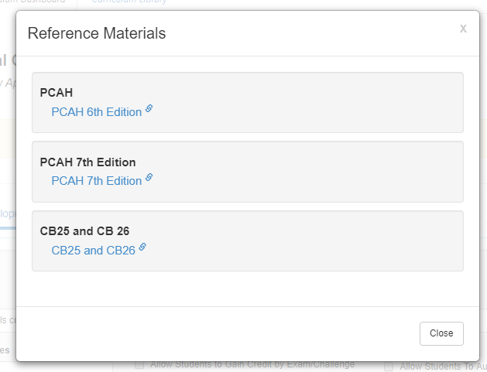
Transferability & Gen. Ed. Options

CB 25 and CB 26
These codes are new requirements to address AB 705. CB 25 deals with General Education transferability and CB 26 is for support courses The information on how to complete CB 25 and CB 26 can be found by using the information link in the upper right of the COR workflow.

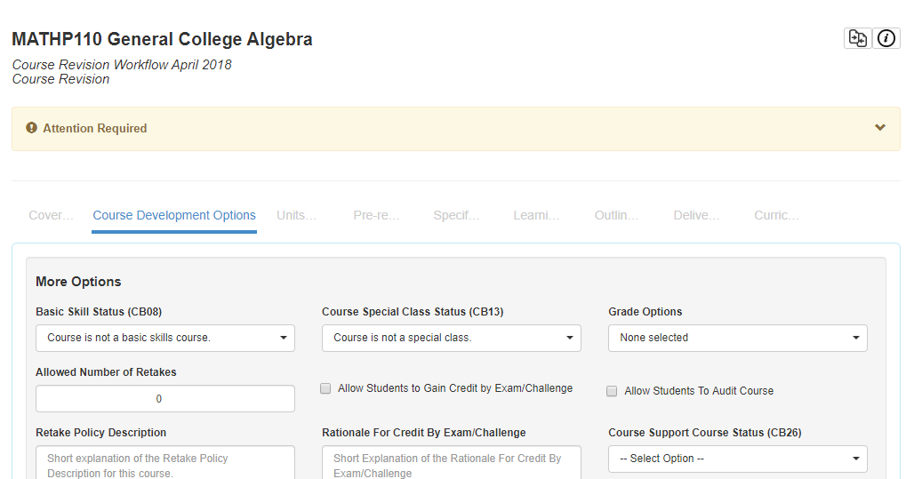

Click the link for the document

Course General Education Status (CB25)
You will indicate here whether the course meets certain GE Breadth or IGETC GE requirements.
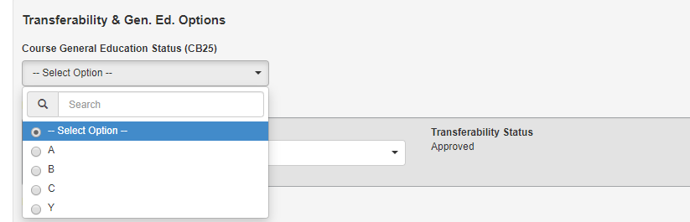

Course Support Course Status (CB26)

Here you will indicate whether the course is a support course.
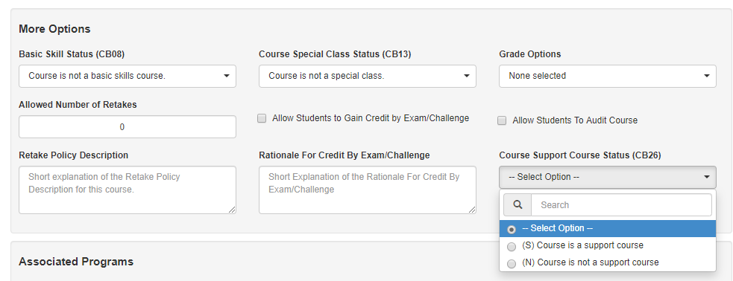

Transferability of Courses

Enter the appropriate information. If checking CSU or UC transferability, the Committee asks the originator to identify at least three universities for which the course transfers. If the course checks both UC and CSU transferability, please indicate at least one school from each system in the makeup of three samples. When entering these courses make sure The words “articulated” or “similar” should be placed in parentheses following the title of the courses to differentiate if we have a direct articulation agreement with the sample campus or if it is the determination of the discipline expert that this course is “similar” to ours but there is no direct articulation agreement. To further clarify; every course listed in this area should have the school discipline acronym, a course number, a course title, units and hours, and a notation in parentheses about being either “articulated” or “similar”. There is a link to the website assist.org on the left-hand side of the page which may help in identifying such courses. This information will no longer be included on the Unit Form. Please provide CSU, UC, and CC courses where appropriate. NOTE: If the course has already been granted a C-ID designation, then listing this number would be sufficient in cases where only CSU transferability are being indicated.

Units and Hours

Credit/Non-Credit Options:
You will choose from the drop down menu the appropriate designation:

Weekly Student Hours:

Enter the in class hours for Lecture, Lab, and activity if applicable. eLumen will calculate the rest.

Weekly Specialty Hours: Leave Blank

NOTE: Effective 3/11/15, all new course proposals, course updates, and course revisions are required to complete and attach a “Couse Unit Value / Contact Hours Justification Form”. This procedure was adopted in an effort to more formally document and defend why we are doing what we are doing in each of our courses. Another reason for this change is to make the process more equitable for those courses for which something other than three units is the norm. For many of our courses, this will be a relatively short and simple process and only require a couple of fields be completed (see directions in the form itself). This form is located on the J drive folder labeled “Forms, PCAH and Curriculum Handbook” and in Section V: Curriculum Resources of this handbook.

On the 16-week semester, one unit of credit represents 18 hours of in-class lecture and 36 hours of homework, or 54 hours of in-class laboratory work or physical education activity.

Lecture hours are those in which the primary method of instruction is a formal or informal presentation by an instructor to an entire class or substantial portion of this class. While discussion and/or laboratory work may be included, it is not the primary method of instruction.

Laboratory hours are those in which students perform in class either individually or collectively under the supervision of an instructor. Lecture and discussions may be included in a laboratory class, but will not be the primary method of instruction. Out-of-class study and preparation by students are relatively limited.

Activity (such as clinical activity) hours should be appropriately identified even though they are often a variation of the laboratory situation.

Prerequisites and Entrance Skills

Note any previous knowledge and/or skills that are essential to successful participation in this course. As far as possible, prerequisites should be identified as prior courses, related academic skills or equivalent knowledge. Instructor's permission is not a permissible entry.

From the State Chancellor’s Office:
Prerequisites or corequisites must be established for a course if the curriculum committee, with input from the discipline faculty, believes that students are “highly unlikely” to succeed without the skills and knowledge learned in the prerequisite course(s). The process used to establish the prerequisites must be based on content review (definition follows) which may be augmented by statistical validation according to local board policy. Once prerequisites have been determined, then regular review of the prerequisite is required (every two years for vocational courses; every six years1 for all other courses) to ensure that the prerequisite is still necessary and appropriate and to monitor disproportionate impact.

If your course has a course prerequisite, co-requisite, or advisory then you must also complete a content review and attach it to the COR or indicate other justification for that condition of enrollment.

With the implementation of AB705, please use the following language both in the Prerequisite area as well as in the catalog description.
Prerequisite: None
Prerequisite: Intermediate Algebra, (MATH P051) or the equivalent.
Prerequisite: Beginning Algebra, (Math P055) or appropriate math placement as determined
by the PC multiple measures process.
Please list the Course Name as well as the PC course number.

Specifications

Methods of instruction: Enter all the possible appropriate methods of instruction.

Assignments: List typical assignments.

Methods of Evaluation: List appropriate methods of evaluation.

Textbooks:
[The course outline shall... specify types or provide examples of required reading and writing assignments, other outside-of-class assignments, instructional methodology, and methods of evaluation for determining whether the stated objectives have been met by students. Title 5, §55002(a)3]

Unless there is a compelling reason, textbooks should be no more than four years old. This is because listing only a textbook sample that is more than 5 years old on a course outline results in the frequent rejection by outside institutions when we request articulation. Remember that listing a given textbook on the course outline does not mandate that it must be used as the primary textbook for the course, but rather reflects that the subject area experts on our campus have reviewed recent publications relevant to the course and included at least one that may be used in these instances. It is also acceptable for a course outline to list more than one textbook and perhaps even a note indicating when an older text may be the department’s preference. This would allow a department to help in advising new faculty on textbook recommendations and at the same time reduce the probability of facing articulation rejections. If a listed textbook is more than four years old, please provide a reason to the Committee.

Other Instructional Materials: List other necessary materials for the course.

Learning Outcomes

Course Objectives:

- Enter the course objectives individually here in the box and click “Add New Course Objective” for each objective.

CSLOs:
- Enter the Course Student Level Outcomes individually here in the box and click “Add New CSLOs” for each CSLO.

Outline
Course Outline: Enter the course content in the box. You can copy and paste from word. Add the Lab content if appropriate.

SECTION III: Curriculum Approval Process

The Curriculum Committee approves courses and programs for recommendation to the Board of Trustees. What follows is a general description of that process. As of this writing (October 2017) Porterville College uses eLumen for all curriculum approval processes; therefore, the specific suggestions below are specific to the eLumen template currently being used.

NOTE: In order to keep the review process reasonable for committee members and originators, the curriculum agenda will be limited to 25 courses.

PART A. Origination of Proposals

Proposals for new and revised courses and programs should come from the discipline faculty. Each division’s Curriculum Committee representative should be able to advise the faculty member (Originator) proposing the course revision on how to use eLumen The College’s Curriculum Specialist and Curriculum Chair are also available to assist with eLumen issues.

PART B. Review Process

The review process occurs when a new course is proposed and reviewed every four years thereafter as a part of the College’s continuing program review/renewal process. Faculty in each discipline must ensure that their courses are reviewed on a regular basis to comply with California state law. The Curriculum Committee requires that courses be reviewed every four years (two years for CTE courses). If a course has not been reviewed for longer than four years, there will be a one-year grace period, after which the Curriculum Committee will recommend to the President that the course not be offered until it has been reviewed and approved by the Committee. The Committee also reviews and approves new or substantially revised programs and courses of study--both degree and certificate level. This review, based on the mission of the College and applicable regulatory criteria, occurs at two stages in the program development process.

Proposals for new courses/programs are done by completing the “New Course/Program Form,” submitting the form as a discussion point, and once the course has been discussed, the new course/program can be initiated in eLumen are brought to the Committee in the form of course outlines for a first reading. This allows the Committee to determine whether the proposed item is consistent with the College mission, meets standard requirements such as units versus hours, Title V regulations, etc. Much discussion and suggestions for change or improvement take place during this first reading.

The proposal is then brought back to the Committee by the originator and/or division representative at a subsequent meeting for a second reading. Usually changes have been made based upon the first reading discussion and suggestions. If acceptable, the item is then approved by the Committee.

Timeline & Due Dates

Originator Responsibility:
All proposals must be completed, launched in eLumen, and the Curriculum Specialist be notified directly 12 19 days in advance of any scheduled Curriculum meeting by 4 pm. At the time of this draft, meetings are held on the 2nd and 4th Tuesdays of each month. This deadline is important in order to give the Technical Review Subcommittee and Curriculum Committee members adequate time to review submissions before each meeting.

Technical review Subcommittee Responsibility:
The members of the Technical review Subcommittee will review and request changes of all agenda items within 3 working days of the course submission. The originator will have until Thursday at 4:00 pm to make requested changes before the course is forwarded to the Curriculum Committee. Substantial errors or failure to make correction in a timely manner may result in the course being removed from the agenda.

Curriculum Committee Responsibility:
The members of the Committee will review and request changes of all agenda items no later than 12:00 pm on Sunday before the Curriculum Committee meeting. Any suggested/requested changes can be viewed in eLumen This would allow the originator time to make the requested changes before the actual Curriculum meeting on Tuesday. This should reduce the number of courses and/or programs that we send back to the originator to fix for the next meeting.

PART C. Approval Workflow

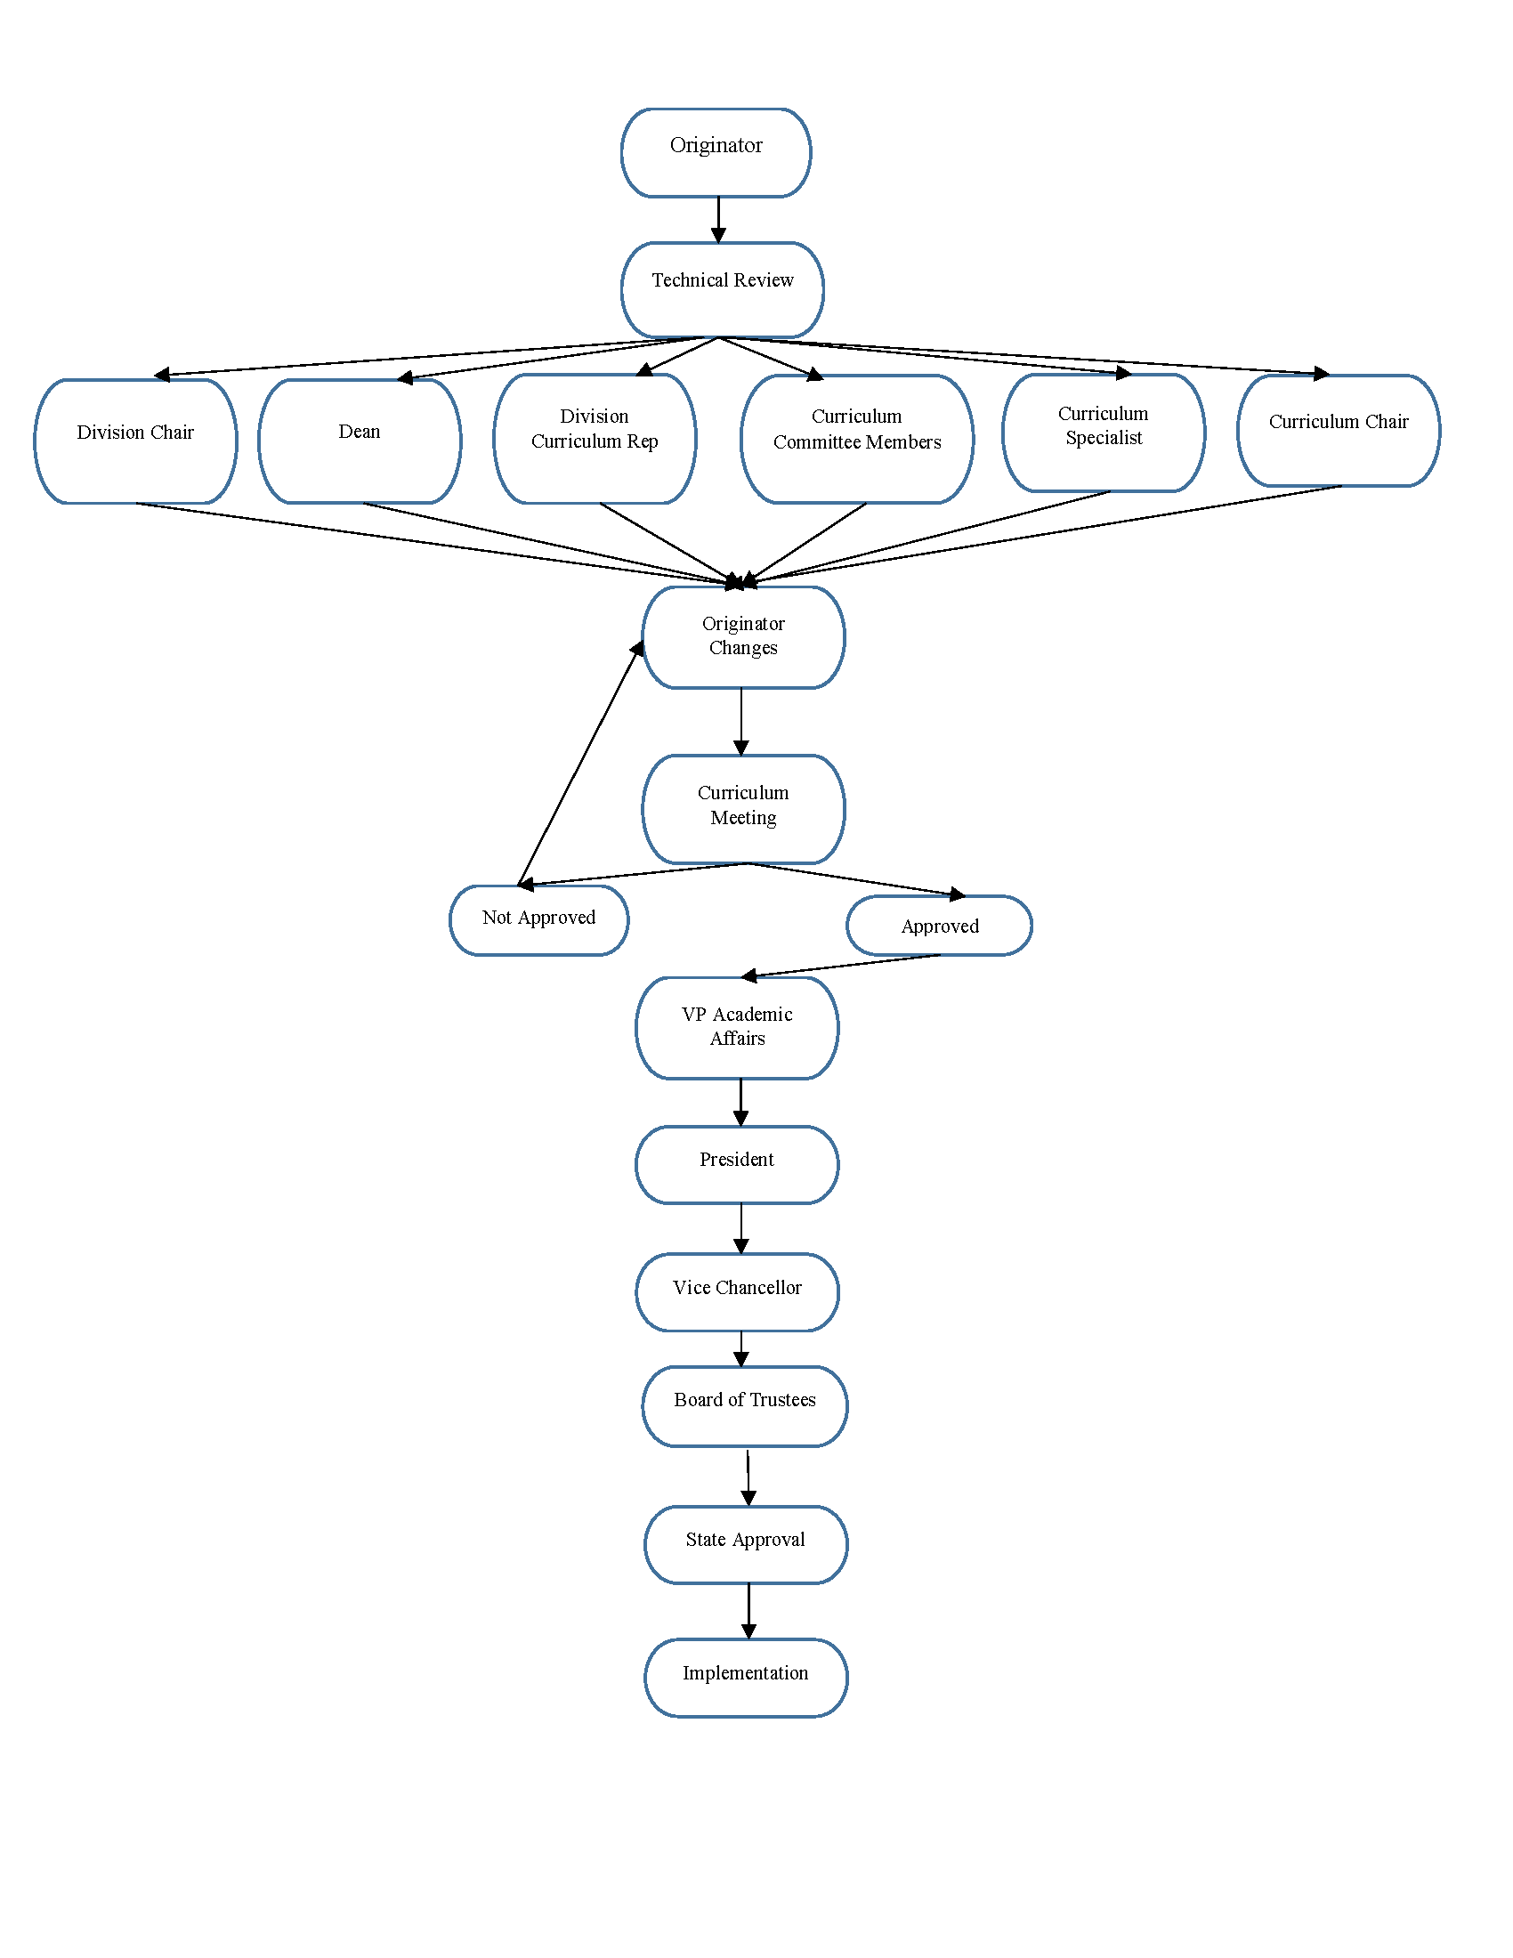

Faculty Guide to eLumen.

This guide is designed to help faculty navigate the eLumen system to create a new course/program or to revise courses on the regular curriculum cycle.

- Log into eLumen with your regular campus login.
https://porterville.elumenapp.com
(you can also log into the test site to practice https://portervilletest.elumenapp.com)

The Default Home Screen.
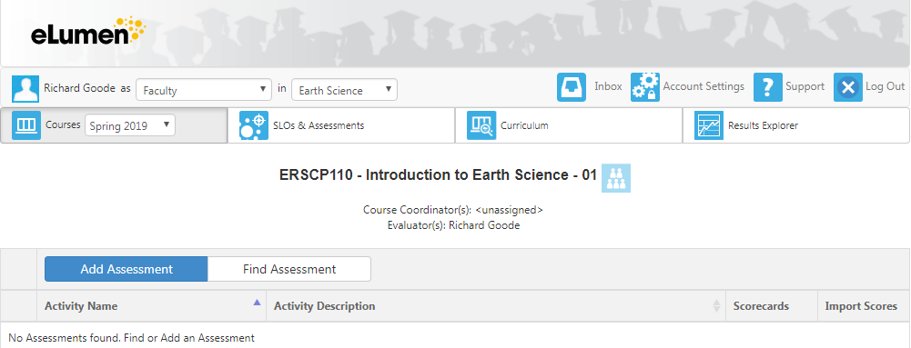
This is the screen you should see when you log into the eLumen default screen.

ROLE DISCIPLINE CURRICULUM INBOX

Role: This is the role you are assigned in eLumen. Faculty is the default but you may be assigned different roles as needed.

Discipline: These are assigned by BANNER based on the courses you have taught. You do have to be assigned to a discipline to revise a course. If you need access, contact your Curriculum Rep who will request access for you. You will then be assigned a “Curriculum Faculty Role” in that discipline. You do not need to have access to a discipline to create a new course. If you are experiencing difficulties, check to see that the correct discipline is selected.

Curriculum: This is the area where you will access the courses to revise.

Inbox: This is where you will access items that are in a workflow that needs your attention or is in progress.

The Curriculum Screen

Once you have selected Curriculum tab, you will notice that there are four tabs to choose from: Curriculum Dashboard, Curriculum Library, Course and Program.

Curriculum Library:
This is where you can create a new course or revise a course within your discipline.

Curriculum Dashboard Curriculum Library
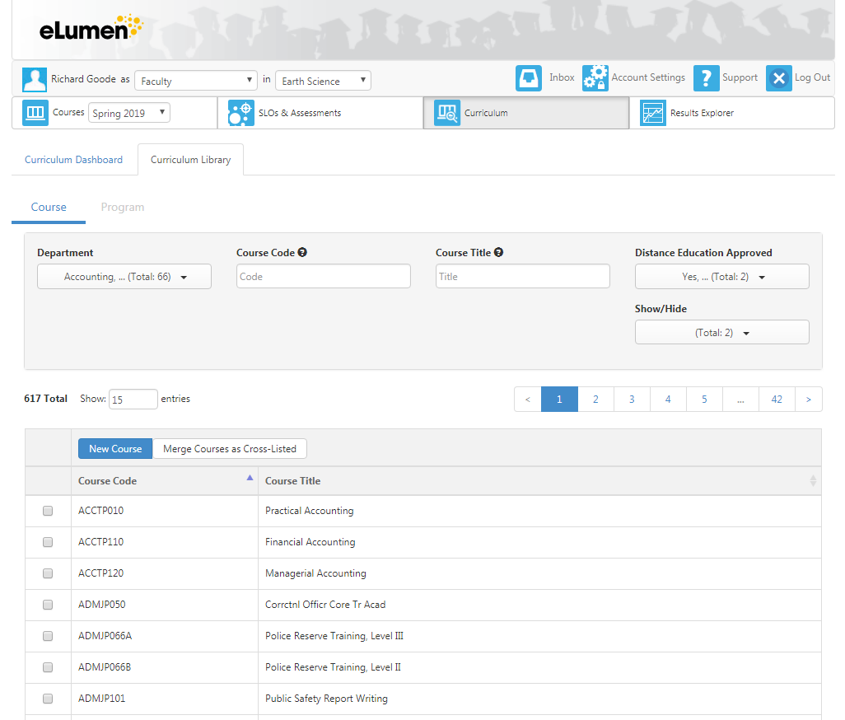
Course Program

Curriculum Library - Course: This is where all courses in the system are listed and where you can view a COR for any course.
Curriculum Library – Program: This is where all programs in the system are listed.

Curriculum Dashboard

Curriculum Dashboard Curriculum Library

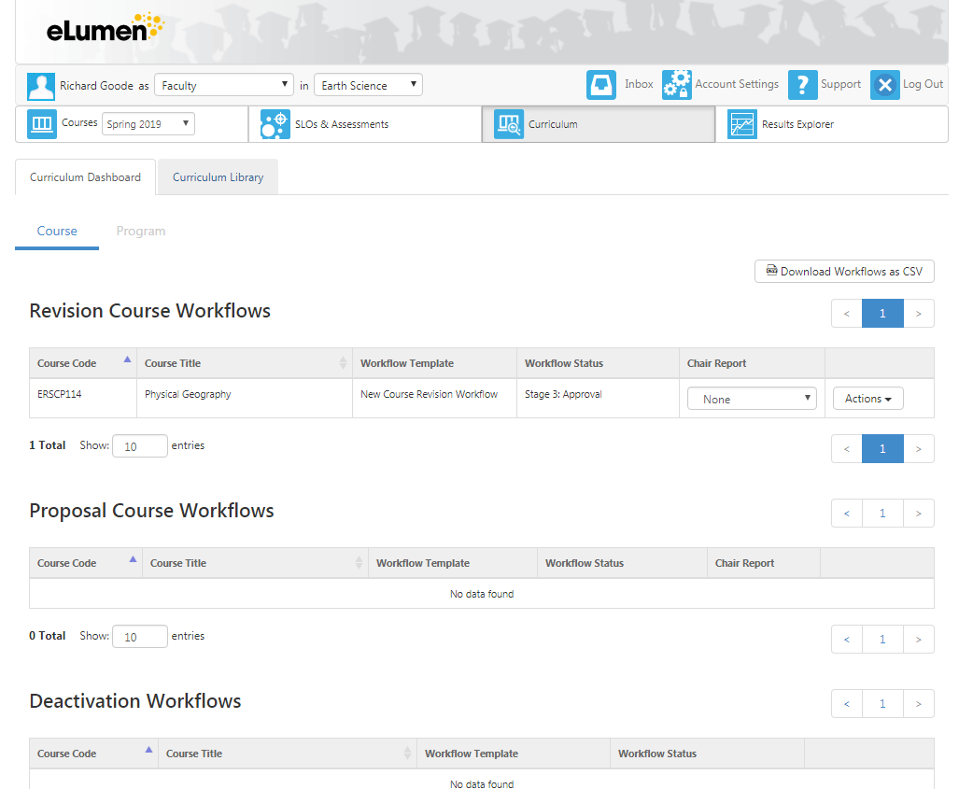

Curriculum Dashboard - Course: This is where you have access to all the course workflows you currently have in process.
Curriculum Dashboard – Program: This is where all program workflows are that you currently have in process.

CREATE NEW COURSE
- Complete the “New Course/Program Form” and submit to curriculum as a discussion point PRIOR to the course being developed on eLumen. The New Course/Program Form can be found on the Curriculum Canvas shell under files.
- Log into eLumen with your regular campus login.
https://porterville.elumenapp.com
- Choose the appropriate role from the drop-down menu next to your name.
- Choose the right discipline
- Click on the Curriculum tab
- Select Curriculum Library
NOTE: The Curriculum Dashboard is where you will find your current workflows in the approval process.

- Select “New Course”.

- Select the appropriate Workflow.

The popup screen will ask you to select a workflow. If there is a choice, ALWAYS choose the latest date. We are still working out the bugs in the workflow process and the latest workflow will ensure a more fluid approval process

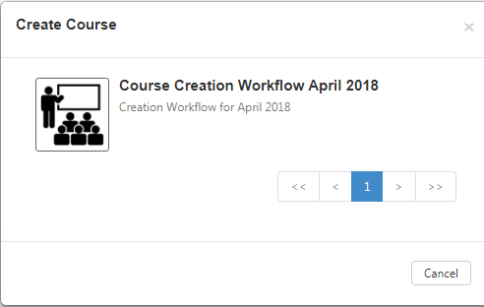
Click on the icon.

- Click on tabs across the top to see different areas of course information.

Different Tabs are: Cover Info (you can add co-authors here and upload files), Course Development Options, Units, Pre-requisites and Entrance Skills, Specifications (methods of instruction, assignments, methods of evaluation, materials), Learning Outcomes, Outline, Curriculum Technician.
WARNING: Do NOT click on blue “Submit” button until you are completely done.

- Click on blue “Submit” button when done to move the course to the next stage.
- Notify the Curriculum Specialist and the Curriculum Chair to place the course on the next Curriculum Agenda.

MODIFY EXISITING COURSE
- Log into eLumen with your regular campus login.
https://porterville.elumenapp.com
- Choose the appropriate role from the drop-down menu next to your name.
- Choose the right discipline
- Click on the Curriculum tab
- Select Curriculum Library
NOTE: The Curriculum Dashboard is where you will find your current workflows in the approval process.
- In the Course Code box, type the 4 letter code for the course you wish to revise, GEOL for Geology, MATH for Math, ACCT for Accounting………
- Click on the course you want to revise
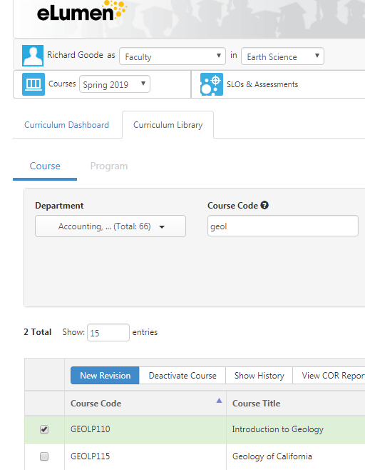
- Select “New Revision”.

- Select the appropriate Revision Workflow.
- Click on tabs across top to see different areas of course information.
  - Change only what needs changing.

WARNING: Do NOT click on blue “Submit” button until you are completely done.

- Different Tabs are: Cover Info (you can add co-authors here and upload files), Course Development Options, Units, Pre-requisites and Entrance Skills, Specifications (methods of instruction, assignments, methods of evaluation, materials), Learning Outcomes, Outline, Curriculum Technician.

- Click on blue “Submit” button when done to move the course to the next stage.
- Notify the Curriculum Specialist and the Curriculum Chair to place the course on the next Curriculum Agenda.

Deactivate (Delete) EXISITING COURSE
- Log into eLumen with your regular campus login.
https://porterville.elumenapp.com
- Choose the appropriate role from the drop-down menu next to your name.
- Choose the right discipline
- Click on the Curriculum tab
- Select Curriculum Library
NOTE: The Curriculum Dashboard is where you will find your current workflows in the approval process.
- In the Course Code box, type the 4 letter code for the course you wish to deactivate, GEOL for Geology, MATH for Math, ACCT for Accounting………
- Click on the course you want to revise
- Select “Deactivate Course”.

- Select the appropriate Workflow.
- Provide the rationale for the deactivation.

WARNING: Do NOT click on blue “Submit” button until you are completely done.

- Different Tabs are: Cover Info (you can add co-authors here and upload files), Course Development Options, Units, Pre-requisites and Entrance Skills, Specifications (methods of instruction, assignments, methods of evaluation, materials), Learning Outcomes, Outline, Curriculum Technician.

- Click on blue “Submit” button when done to move the course to the next stage.
- Notify the Curriculum Specialist and the Curriculum Chair to place the course on the next Curriculum Agenda.

Inactivate EXISITING COURSE
- Log into eLumen with your regular campus login.
https://porterville.elumenapp.com
- Choose the appropriate role from the drop-down menu next to your name.
- Choose the right discipline
- Click on the Curriculum tab
- Select Curriculum Library
NOTE: The Curriculum Dashboard is where you will find your current workflows in the approval process.
- In the Course Code box, type the 4 letter code for the course you wish to deactivate, GEOL for Geology, MATH for Math, ACCT for Accounting………
- Click on the course you want to revise

- Select “New Revision”.

- Select the COURSE REVISION FOR THE PURPOSE OF INACTIVATING A COURSE FOR A PERIOD OF NO LONGER THAN 4 YEARS Workflow.

- Provide the rationale for the deactivation.

WARNING: Do NOT click on blue “Submit” button until you are completely done.

- Different Tabs are: Cover Info, Course Development Options, Units, Pre-requisites and Entrance Skills, Specifications (methods of instruction, assignments, methods of evaluation, materials), Learning Outcomes, Outline, Curriculum Technician.
- You will only need to enter information in the Cover Info, Proposal Details section. Enter the rationale for the inactivation. Provide an explanation in the Notes section.

- Click on blue “Submit” button when done to move the course to the next stage.
- Notify the Curriculum Specialist and the Curriculum Chair to place the course on the next Curriculum Agenda.

MODIFY EXISITING PROGRAM

- Log into eLumen with your regular campus login.
https://porterville.elumenapp.com
- Choose the Faculty role from the drop-down menu next to your name.
- Click on the Curriculum tab
- Select Curriculum Library
- Select Program
- Type the name of the program in the Program Title Box
Note: A partial name should be enough to search for the program. Or you can scroll through until you find the correct program.
- Select “New Revision” (the blue button).

WARNING: Do NOT click on blue “Submit” button until you are completely done.

- Different Tabs are: Program Basics (you can add co-authors here and upload files), Program Details, Course Blocks, Program Outcomes, Program Narrative
NOTE: Short version of Program Narrative will appear. You may have to fill in information from scratch the first time you modify a program.
- Click on blue “Submit” button when done to move the Program to the next stage.
- Notify the Curriculum Specialist and the Curriculum Chair to place the course on the next Curriculum Agenda.

CREATE NEW PROGRAM

- Complete the “New Course/Program Form” and submit to curriculum as a discussion point PRIOR to the course being developed on eLumen. The New Course/Program Form can be found on the Curriculum Canvas shell under files.
- Log on to eLumen with your regular campus log-on https://porterville.elumenapp.com
- Choose the Faculty role from the drop-down menu next to your name.
- Click on the Curriculum tab
- Select Curriculum Library
- Select Program
- Select “Add Program” (the blue button)
- Select the appropriate workflow.
WARNING: Do NOT click on blue “Submit” button until you are completely done.

- Different Tabs are: Program Basics (you can add co-authors here and upload files), Program Details, Course Blocks, Program Outcomes, Program Narrative

NOTE: You must fill in fields with an asterisk and then select “Save As Draft and Continue” blue button.

- Different Tabs are: Program Basics (you can add co-authors here and upload files), Program Details, Course Blocks, Program Outcomes, Program Narrative.
- Click on blue “Submit” button when done to move the Program to the next stage.
- Notify the Curriculum Specialist and the Curriculum Chair to place the course on the next Curriculum Agenda.

Workflow Review Process

The approval process is the same for courses and programs.
- Log into eLumen with your regular campus login.
https://porterville.elumenapp.com
- Choose the appropriate role from the drop-down menu next to your name.
- Select the “Inbox” icon
- Find the course to review, hover over “Start Review” to display the review view options:
  - Step View: This option will display the areas of the outline of the course as tabs across the top of the page. Each area will display on the screen one at a time. Navigate between tabs by selecting any tab.
  - Outline View: This option will display the outline all on one page. Use the carrot at the end of the blue bars to expand or collapse an area.
- Review each section of the course/program. Make appropriate comments in the comments section at the bottom of each section. If you have no comments, please indicate this in the comment box. You should email the originator of the course that there suggested edits to be made.
- If you need to come back later, select “Save as Draft”. The system will save your work to that point, and the course will remain in your inbox to come back to later. If you would like to exit the workflow without saving your changes, select “Cancel”.

WARNING: Do NOT click on blue “Submit” button until you are completely done.

- When all sections have been reviewed select “Submit” to move the course to the next stage of the workflow. A warning message will indicate what will happen to the course next, select “Close” to stop the course from moving forward. Select “Submit” to confirm moving the course forward.
- The final stage of the workflow will approve the course. The Curriculum Specialist or the Curriculum Chair will approve the course in eLumen after the Committee has approved the course.

8/2018

Curriculum Committee Reviewers Guide to eLumen.

This guide is designed to help faculty navigate the eLumen system to create a new course/program or to revise courses on the regular curriculum cycle.

- Any new courses, programs, or certificates must have the “New Course/Program Form” submitted to curriculum as a discussion point PRIOR to the course being developed on eLumen. The New Course/Program Form can be found on the Curriculum Canvas shell under files.
- Log into eLumen with your regular campus login.
https://porterville.elumenapp.com
(you can also log into the test site to practice https://portervilletest.elumenapp.com)

The Default Home Screen.
This is the screen you should see when you log into the eLumen default screen.

ROLE DISCIPLINE CURRICULUM INBOX

Role: This is the role you are assigned in eLumen. You will log into eLumen as the reviewer role you are assigned: Division Rep, Division Coordinator……

Discipline: These are assigned by BANNER based on the courses you have taught. You do have to be assigned to a discipline to revise a course. If you need access, contact you Curriculum Rep who will request access for you. You will then be assigned a “Curriculum Faculty Role” in that discipline. You do not need to have access to a discipline to create a new course. If you are experiencing difficulties, check to see that the correct discipline is selected.

Curriculum: This is the area where you will access the courses to review.

Inbox: This is where you will access items that are in a workflow that needs your attention or is in progress.

The INBOX Screen

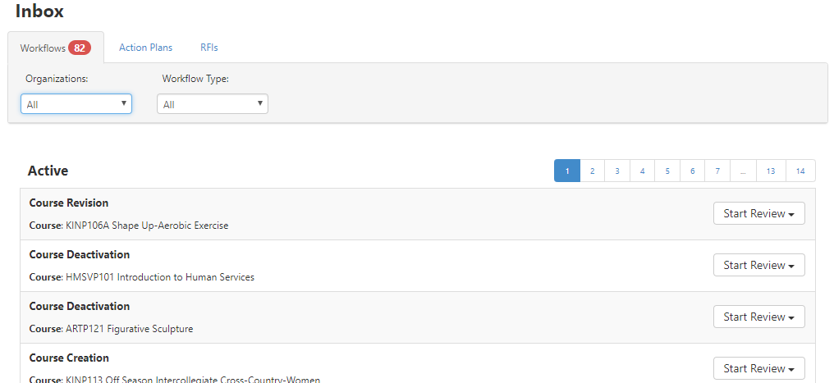

This lists the pages of courses and programs to review. You can narrow the list either by Discipline or by workflow type.

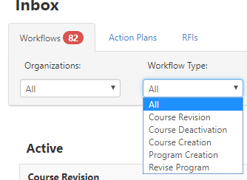

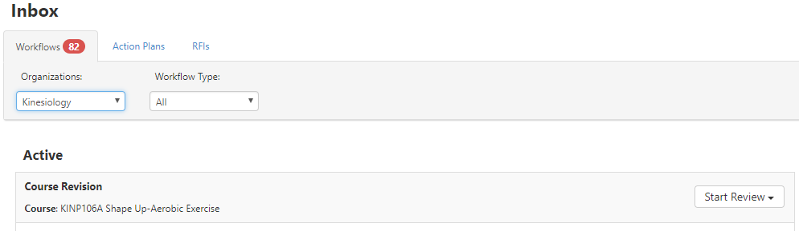

You will now have the list of courses assigned to you to review in that discipline area.
Select “Start Review” for the appropriate course.

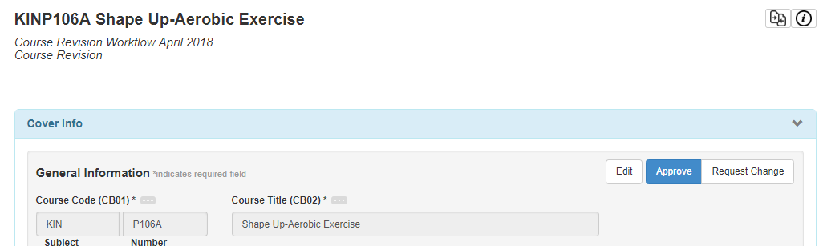

The course outline will appear. Outline view is the default but you can choose Step View.

Once you have reviewed this section, Select “Request Change”. At the bottom of the section, you will be able to enter a comment. This is where you can request the originator to make necessary changes or leave a comment such as, ”Reviewed, No Change Requested”. Please leave a comment so we know the course was reviewed.
Once this is done you can move on to the next section. Once all sections are completed, you will select the Request Change button at the bottom of the page.

At any time, you can “Save as Draft” to return to the review at a later time.

Please email the originator, the Curriculum Specialist and the Curriculum Chair that you have requested changes so they are reminded to edit the course.

You are now ready to review another course.

The Curriculum Screen
Once you have selected Curriculum tab, you will notice that there are four tabs to choose from: Curriculum Dashboard, Curriculum Library, Course and Program.

Curriculum Dashboard

You can also access courses to review here. The process should work the same as above. The courses are listed in alphabetical order. Find the correct course and under the Action menu select view COR. This should take you to the request change screen.

Curriculum Dashboard

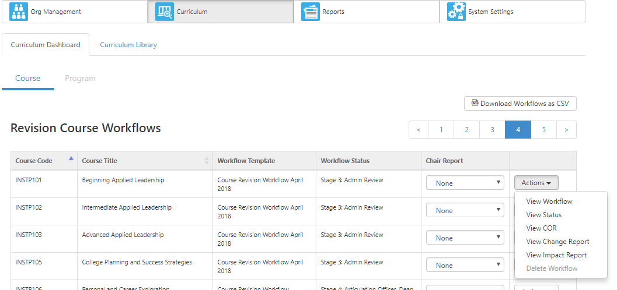

SECTION IV: Curriculum Resources

The following section includes samples of Content Review forms (including a blank form, and directions and templates for use for English level 1 & 2 prerequisites or advisories), Course Unit Value / Contact Hour Justification Form, Distance Learning Addendum, glossary of terms, and references. The Content Review and Course Unit Value – Contact Hour Justification Form files below are also available separate from the handbook by accessing them on the schools “J Drive” that should be accessible from any on-campus computer. The specific file pathway at the time of this published revision can be found at: CurriculumAdmin (J:) Forms, PCAH and Curriculum Handbook.

PORTERVILLE COLLEGE
CONTENT REVIEW WORKSHEET

Course:
Prerequisite:
Corequisite:
Recommendation:
Date:

LIST OF SKILLS OR KNOWLEDGE NEEDED
RATING OF RELEVANCE

1
2
3
4
5
6
7
8

Rating Scale: 5=critically relevant 4=very relevant 3=moderately relevant
2=slightly relevant 1=not relevant

Skill # Rater #1 Rater #2 Rater #3 Rater #4 Mean

1
2
3
4
5
6
7
8

Number of ratings with a mean rating of 3 or greater is _______

Percent of items with a mean rating of 3 or greater is _______

Department Recommendation: |  | Prerequisite |  | Corequisite |  | Recommendation

Completed by:

Course Unit Value / Contact Hour Justification Form

COURSE ID: |  | COURSE TITLE:

Overview
This form is designed to guide faculty when submitting any course proposals for determining course unit values and contact hours. ASCCC(Academic Senate for California Community Colleges, the state Chancellors offices at both the CC and CSU levels, and C-ID have established that “normal” unit values are generally defined by C-ID descriptor minimums, local transfer institution equivalents (for us that would be CSU, Fresno and CSU, Bakersfield), other mandated model curricula or starting with a 3 Carnegie Lecture unit course. It is for these reasons that our campus has agreed to look at courses more closely and evaluate what positive and negative impact they are having on students. It has been discussed and agreed that when possible we will use the suggested “minimum units” (and related contact hours) suggested by a C-ID descriptor as a baseline for our courses. The Curriculum Committee has created this form to be completed and attached to your CORs in eLumen using the “Attached Files” tab. Please enter your responses in the provided blue shaded boxes like the sample to the right.

Units/Hours Review
Please review and supply the following information, taking into account the following definitions*.
- LECTURE HOURS/UNITS (Ratio of in-class to homework hours is 1:2) An instructional method that primarily uses full-class or group content delivery. May include some small group work, presentations, and discussion.
- LAB HOURS/UNITS (Ratio of in-class to homework hours is 3:0) An instructional method where students primarily work independently or in groups to develop or practice skills in a laboratory, workshop, studio, court, field, or other specialized instructional space. Instructor supervised and directs activity at the student or small group level for most of the class period.
- INTEGRATED LAB HOURS/UNITS (Ratio of in-class to Homework Hours is 2:1) An instructional method where the instructor switches between lecture and lab instruction in the same class period and classroom.
*Definitions derived from multiple sources, including Title 5, and the Program & Course Approval Handbook.

SECTION 1: Course Unit Overview
Please show how the unit values and modalities/hours are changing or unchanging with this proposal.
 | PROPOSED COURSE VALUES |  |  | CURRENT COURSE VALUES
 |  | UNITS |  |  | UNITS
 |  | LECTURE hours (per term) |  |  | LECTURE hours (per term)
 |  | LAB hours (per term) |  |  | LAB hours (per term)

 | Yes/No | C-ID Number Assigned
Is this course C-ID approved and the course content and units align with the C-ID Descriptor?
 | Yes/No | Last Revision Date
Has this course been previously approved with a Contact Hour Justification Form submitted and the rationale and data submitted previously is still valid?
STOP - *If you answered yes to either of the previous questions, you are done. No further justification is required.
If no, you must complete the justification sections on the following pages.

SECTION 2: Justification Units/Hours

State Norms:
How does the course, as proposed, compare to courses across the State in terms of breadth and depth? Use CID-approved courses, other CIDs, ASSIST, CurricUSEARCH, state mandates, other model curricula as resources to help complete this section. NOTE: Limit comparisons between colleges to those that have been reviewed in the last 5 years and have been C-ID approved if applicable. The reason for this is that old courses have not been reviewed under new standards and are out of compliance.

Mandates:
Are there any mandates or regulations that require the number of units and/or contact as proposed for this course? (i.e. if there was a state regulation that required an EMT course to meet for no less than 75 hours)

Does a mandate exist for this course?
If yes, please identify, describe and document them here:

STOP - *If you answered that you are complying with a state mandate or regulation and have documented this in your response above, then you are done. No further justification is required.

*If you answered no, please continue completing the form.

C-ID Unit Value:
C-ID descriptor unit “minimums” reflect the minimum number of units that CCC/CSU (DIG) discipline faculty have collegially agreed reflect the instructional time necessary to cover the content in the descriptor. The CID descriptor is assumed to be the essential or “minimum” content covered in a course to be eligible for C-ID. To use the C-ID Descriptor as a unit justification, the course should align with the descriptor and will be submitted to C-ID for approval.

C-ID Eligibility:
Is there a C-ID descriptor available for this course?
Are you submitting the course for C-ID approval?
Are you aligning with the course content and the “Minimum Units” indicated on the C-ID descriptor?
Please list C-ID#, Course Title, and attach the C-ID Descriptor:

STOP - *If you answered yes to all of these questions, you are done. No further justification is required.

*If you answered no, please continue completing the form.

CID Content Review
If you are not aligning with the “Minimum Units” indicated on the C-ID descriptor, please explain.

*If your course does not match units, contact hours, and content please complete the rest of the form.

Outside Institution Equivalent Course Unit Values & Contact Hours
The following section contains information that is frequently requested and/or discussed by the Curriculum Committee. In an effort to save time, please identify similar courses offered at outside institutions. For transfer-level courses CSU and UC sections must be completed. Empty fields for a university will imply that no equivalent course is offered at that institution. If you would like to include information beyond what is prompted below, please attach additional data and address in “Narrative Justification” section below. NOTE: Please convert all quarter units to semester units when completing the section below.
“Highest Rate of Transfer” Schools: CSU/UC System

 | CSU FRESNO offers: |  |  |  |  |  |  | CSU Bakersfield offers:
Course ID: |  |  |  |  |  |  | Course ID:
Course Title: |  |  |  |  |  |  | Course Title:
Applicable for Major? Y/N |  |  |  |  |  |  | Applicable for Major? Y/N
 |  | UNITS |  |  |  |  |  |  | UNITS
 |  | LECTURE hours (per term) |  |  |  |  |  |  | LECTURE (per term)
 |  | LAB hours (per term) |  |  |  |  |  |  | LAB hours (per term)
 | (Other Institution) offers:
Course ID:
Course Title:
Applicable for Major? Y/N
 |  | UNITS
 |  | LECTURE hours (per term)
 |  | LAB hours (per term)

Local Community College Equivalents

These colleges are within the region or from a region with similar demographics.
 | COLLEGE of the SEQUOIAS offers: |  |  |  |  |  |  | REEDLEY COLLEGE offers:
Course ID: |  |  |  |  |  |  | Course ID:
Course Title: |  |  |  |  |  |  | Course Title:
 |  | UNITS |  |  |  |  |  |  | UNITS
 |  | LECTURE hours (per term) |  |  |  |  |  |  | LECTURE (per term)
 |  | LAB hours (per term) |  |  |  |  |  |  | LAB hours (per term)
 | BAKERSFIELD COLLEGE offers:
Course ID:
Course Title:
 |  | UNITS
 |  | LECTURE hours (per term)
 |  | LAB hours (per term)
SECTION 3: Narrative Justification
In addition to “Faculty Considerations”, the following are typical considerations of the Curriculum Committee. Please respond to the questions listed following the lists of considerations in narrative form.
STUDENT CONSIDERATIONS  - Financial Aid  - Scheduling Flexibility  - Available Course Offerings  - Student Demographics and Preparedness  - Ability to Persist Toward Identified Goals  - Required Instructor/Student Contact Hours?  - Cost for Enrollment/Materials  - Total Contact Time Plus Outside-of-Class Time  - Units Available for Degree/Transfer  - Eligibility for Priority Registration  - Ability to Pursue More Than One Major  - Contact Time as it Relates to Student Success  - Maintaining Full-Time status (12 units) | INSTITUTIONAL CONSIDERATIONS  - Articulation Considerations  - Scheduling Resources  - Budgetary Considerations  EXTERNAL CONSIDERATIONS  - California Community College Chancellor’s Office (CCCCO)  - Ed Code  - Title 5  - Academic Senate of California Community Colleges  - The Community

What is the need for and/or benefit of allocating additional / fewer unit(s) / contact hours?
Your Claim:
(describe the need and/or benefit here):
Evidence of Claim Above:
(This could include, but are not limited to, academic research, success rates, etc. Please note that a list of one or two randomly selected schools that also have high units is not independently justification to warrant high units / contact hours):
Source of Backing:
(Please be specific. For example, if you tell us it is required by Title 5, then include the section numbers and text used or if referencing a data set or research report, please provide a complete reference and/or attach the actual report.) This will greatly expedite the review process.
NOTE: If you have more than one unique claim, please repeat the format above and number them.

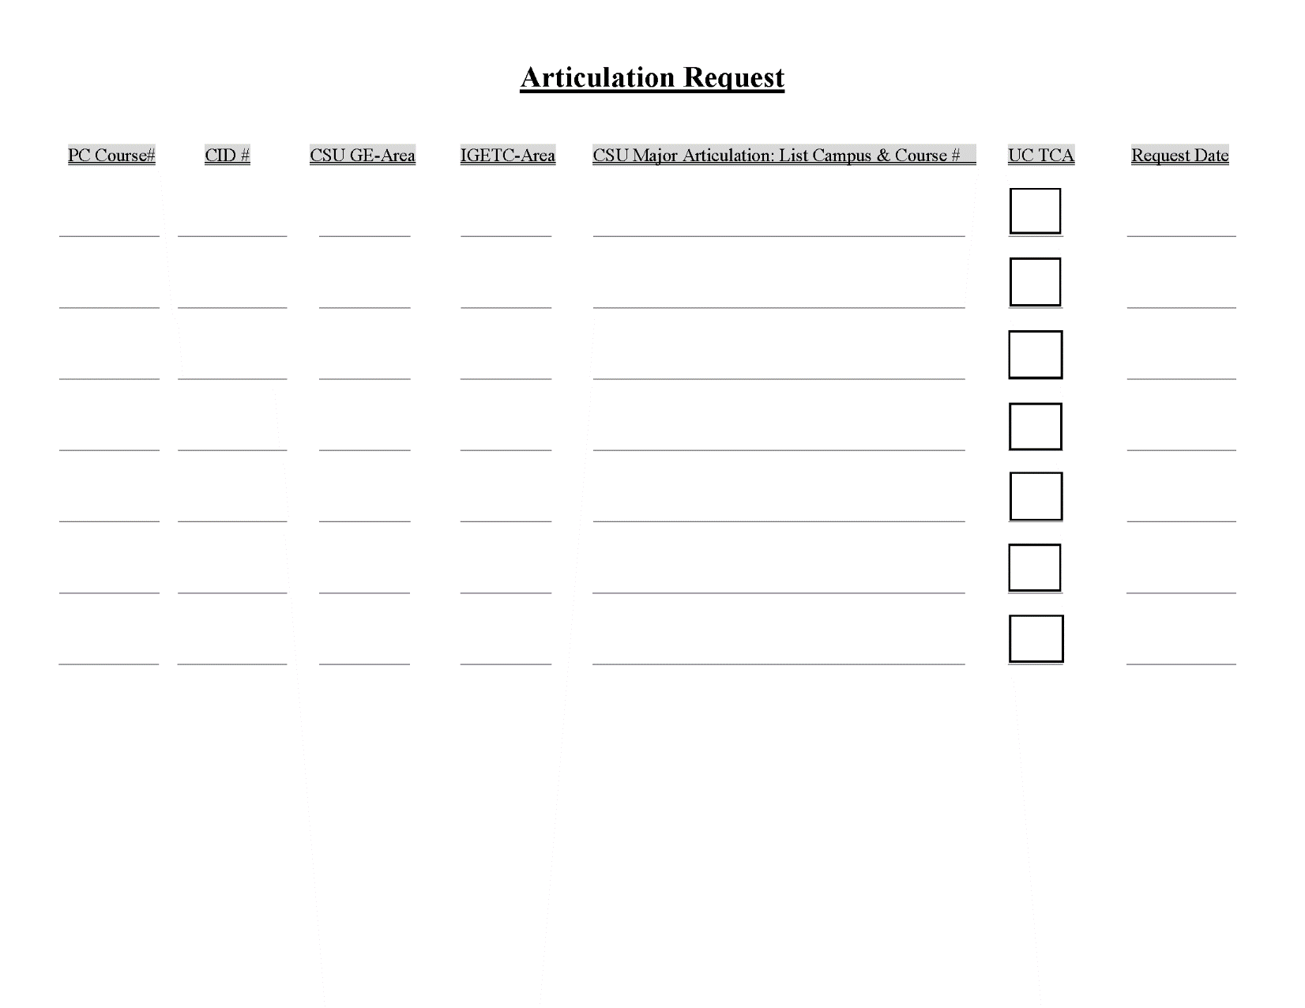

SECTION V: Guidelines for Approval Evaluation

PART A. Course Outline

The outline must contain all the elements specified in Title 5 §§55002.(a), (b), or (c): unit value, contact hours, requisites, catalog description, objectives, and content. The outline must also include types or examples of assignments, instructional methodology, and methods of evaluation. The course outline must be rigorous and effective in integrating the required components of critical thinking, essay writing and problem solving, college-level skills, and vocabulary if such skills are appropriate for the type of course being developed. In addition, the course must comply with any other applicable laws, such as those related to access for students with disabilities. A COR also must address any requirements based on accreditation.

PART B . Placing Courses in Disciplines

AB 1725 replaced the credential system with minimum qualifications for each discipline. (The Disciplines List is updated every three years) All the courses taught at a community college fall within one or more of the established disciplines. Only those faculty with minimum qualifications (or credentials, if hired prior to July 1, 1990), can teach courses within a given discipline. Essential to this process is the placing of all new and existing courses into one or more disciplines. In meeting the requirements of AB 1725, each local academic senate has established a process whereby all existing courses are placed in disciplines. As new and substantially revised courses are brought before the curriculum committee, the originator(s) will propose the discipline listing for the curriculum committee to review and approve.

It may be that a given course is best listed in more than one discipline. This is referred to as multiple listing. For example, Business Management 101 might be listed in both the Business and Management disciplines. This would enable instructors with minimum qualifications in either Business or Management to teach the course. Another option is to list Business Management 101 as interdisciplinary. This would require the instructor to meet minimum qualifications in Business or Management plus upper division or graduate work in the other. (The exact nature of the training in the other discipline would be specified locally.) The decision as to a multiple or interdisciplinary listing of the course should be made on the basis of the course content. If either discipline prepares the instructor to teach the course, multiple listing is appropriate. If the instructor needs the knowledge base of both disciplines, the curriculum committee should list the course as interdisciplinary.

A separate issue is the existence of two courses, Business 101 and Management 101, each of which is taught to an identical course outline of record. This is called double listing and is most often done to meet the major preparation needs of students. For example, a student majoring in business might sign up for the course as Business 101, and a management major might be in the same classroom but registered for Management 101. Double listing does not address the question of placement in a discipline. The content of the double listed Business 101/Management 101 course would still need to be examined to see if it could be taught with preparation in either discipline (multiple listing) or if it needs preparation in both (interdisciplinary).

The Taxonomy of Programs and Services (TOPS) is a common taxonomy by which the districts and colleges identify programs. This taxonomy is to be used for all program and course reports required by the Chancellor’s Office. “Link to Taxonomy of PC Courses”

PART C. Prerequisites, Corequisites, and Advisories on Recommended Preparation

Curriculum committees must approve prerequisites, corequisites and advisories and must do so by separate action from that used in approving the course. (Title 5 §55200-202)

Title 5, §55201(b) (3), requires that prerequisites be reviewed on a regular six-year cycle.

The California Community Colleges Chancellor’s Office states:
Curriculum committees must have documented processes outlining how content review will be conducted, including who is involved, the criteria used to determine the correct prerequisite(s), how the prerequisite will be evaluated, and the role of the curriculum committee.

The Curriculum Committee should review the prerequisites and corequisites for each course that it reviews (whether as a New Course or as a Course Revision). The faculty member (Originator) who submits the course to the Committee should demonstrate to the Committee that the prerequisites/corequisites are necessary for the success of students in the course. The originator should complete a Porterville College Content Review for each pre-/corequisite.

Title 5, §55002(a)
Prerequisites and Corequisites. When the college curriculum committee determines, based on a review of the course outline of record, that a student would be highly unlikely to receive a satisfactory grade unless the student has knowledge or skills not taught in the course, then the course shall require prerequisites or corequisites that are established, reviewed, and applied in accordance with the requirements of Article 2.5 (commencing with Section 55200) of this Subchapter.

PART D. Distance Education Courses and Sections

Courses and sections delivered by distance education must be separately reviewed and approved by the Curriculum Committee. Curriculum committees must approve prerequisites, corequisites and advisories and must do so by separate action from that used in approving the course. Title 5 regulations for distance education appear in sections 55352 to 55380.

PART E. Associate Degree Requirements

Criteria established by the KCCD Board to implement Associate Degree requirements must follow the standards in Title 5 §55002(a) including recommendation by the curriculum committee. In establishing the Associate Degree requirements, districts must adopt a board policy on its philosophy on general education (§55805), include only courses of appropriate level (§55805.5), and adhere to the minimum requirements set by the Board of Governors (§55806).

Title 5,§55805. Philosophy and Criteria for Associate Degree and General Education

(a) The governing board of a community college district shall adopt a policy which states its specific philosophy on General Education. In developing this policy governing boards shall consider the following policy of the Board of Governors:
The awarding of an Associate Degree is intended to represent more than an accumulation of units. It is to symbolize a successful attempt on the part of the college to lead students through patterns of learning experiences designed to develop certain capabilities and insights.

Among these are the ability to think and to communicate clearly and effectively both orally and in writing; to use mathematics; to understand the modes of inquiry of the major disciplines; be aware of other cultures and times; to achieve insights gained through experience in thinking about ethical problems; and to develop the capacity for self-understanding. In addition to these accomplishments, the student shall possess sufficient depth in some field of knowledge to contribute to lifetime interest.

Central to an Associate Degree, General Education is designed to introduce students to the variety of means through which people comprehend the modern world. It reflects the conviction of colleges that those who receive their degrees must possess in common certain basic principles, concepts and methodologies both unique to and shared by the various disciplines. College educated persons must be able to use this knowledge when evaluating and appreciating the physical environment, the culture and the society in which they live. Most importantly, General Education should lead to better self-understanding.

In establishing or modifying a general education program, ways shall be sought to create coherence and integration among the separate requirements. It is also desirable that general education programs involve students actively in examining values inherent in proposed solutions to major social problems.

(b) The governing board of a community college district shall also establish criteria to determine which courses may be used in implementing its philosophy on the associate degree and general education.

(c) The governing board of a community college district shall, on a regular basis, review the policy and criteria established pursuant to subsections (a) and (b) of this section.

Title 5, §55805.5 Types of Courses Appropriate to the Associate Degree
The criteria established by the governing board of a community college district to implement its philosophy on the associate degree shall permit only courses that conform to the standards specified in Section 55002 (a) and that fall into the following categories to be offered for associate degree credit:

(a) All lower division courses accepted toward the baccalaureate degree by the California State University or University of California or designed to be offered for transfer.

(b) Courses that apply to the major in non-baccalaureate occupational fields.

(c) English courses not more than one level below the first transfer level composition course, typically known as English 1A. Each student may count only one such course as credit toward the associate degree.

(d) All mathematical courses above and including Intermediate Algebra.

(e) Credit courses in English and mathematics taught in or on behalf of other departments and which, as determined by the local governing board, require entrance skills at a level equivalent to those necessary for the courses specified in sections (c) and (d) above.

Minimum Requirements for the Associate Degree (Title V Revised, Section 55063)

The governing board of a community college district shall confer the associate degree upon a student who has demonstrated competence in reading, in written expression, and in mathematics, and who has satisfactorily completed at least 60 semester units or 90 quarter units of degree-applicable credit course work (as defined in section 55002(a)) which falls into the categories described in section 55062. A college may also accept toward satisfaction of this requirement courses that were not completed at a California community college that would reasonably be expected to meet or exceed the standards of section 55002(a).

Effective for all students admitted to a community college for the Fall 2009 term or any term thereafter, competence in written expression shall be demonstrated by obtaining a satisfactory grade in an English course at the level of the course typically known as Freshman Composition (either Freshman Composition or another English course at the same level and with the same rigor, approved locally) or by completing an assessment conducted pursuant to subchapter 6 of this chapter (commencing with section 55500) and achieving a score determined to be comparable to satisfactory completion of the specified English course. Satisfactory completion of an English course at the level of Freshman Composition shall satisfy both this competency requirement and the coursework requirement set forth in subdivision (b)(1)(D)(i) of this section.

Effective for all students admitted to a community college for the Fall 2009 term or any term thereafter, competence in mathematics shall be demonstrated by obtaining a satisfactory grade in a mathematics course at the level of the course typically known as Intermediate Algebra (either Intermediate Algebra or another mathematics course at the same level, with the same rigor and with Elementary Algebra as a prerequisite, approved locally) or by completing an assessment conducted pursuant to subchapter 6 of this chapter (commencing with section 55500) and achieving a score determined to be comparable to satisfactory completion of the specified mathematics course. Satisfactory completion of a mathematics course at the level of Intermediate Algebra shall satisfy both this competency requirement and the coursework requirement set forth in subdivision (b)(1)(D)(ii) of this section.

The competency requirements for written expression and mathematics may also be met by obtaining a satisfactory grade in courses in English and mathematics taught in or on behalf of other departments and which, as determined by the local governing board, require entrance skills at a level equivalent to those necessary for Freshman Composition and Intermediate Algebra respectively. Requirements for demonstrating competency in reading shall be locally determined.

The required 60 semester or 90 quarter units of course work must be fulfilled in a curriculum accepted toward the degree by a college within the district (as shown in its catalog). It must include at least 18 semester or 27 quarter units in general education and at least 18 semester or 27 quarter units in a major or area of emphasis as prescribed in this section. Of the total required units, at least 12 semester or 18 quarter units must be completed in residence at the college granting the degree. Exceptions to residence requirements for the associate degree may be made by the governing board when it determines that an injustice or undue hardship would be placed on the student.

- Requirements for a major or area of emphasis.

(1) At least 18 semester or 27 quarter units of study must be taken in a single discipline or related disciplines, as listed in the community colleges “Taxonomy of Programs,” or in an area of emphasis involving lower division coursework which prepares students for a field of study or for a specific major at the University of California or the California State University.
(2) Effective for all students admitted to a community college for the Fall 2009 term or any term thereafter, each course counted toward the unit requirement of this subdivision must be completed with a grade of C or better or a “P” if the course is taken on a “pass-no pass” basis.

- General Education Requirements.

(1) Students receiving an associate degree shall complete a minimum of 18 semester or 27 quarter units of general education coursework which includes a minimum of three semester or four quarter units in each of the areas specified in paragraphs (A), (B) and (C) and the same minimum in each part of paragraph (D). The remainder of the unit requirement is also to be selected from among these four divisions of learning or as determined by local option:

(A) Natural Sciences. Courses in the natural sciences are those which examine the physical universe, its life forms, and its natural phenomena. To satisfy the general education requirement in natural sciences, a course shall be designed to help the student develop an appreciation and understanding of the scientific method, and encourage an understanding of the relationships between science and other human activities. This category would include introductory or integrative courses in astronomy, biology, chemistry, general physical science, geology, meteorology, oceanography, physical geography, physical anthropology, physics and other scientific disciplines.

(B) Social and Behavioral Sciences. Courses in the social and behavioral sciences are those which focus on people as members of society. To satisfy the general education requirement in social and behavioral sciences, a course shall be designed to develop an awareness of the method of inquiry used by the social and behavioral sciences. It shall be designed to stimulate critical thinking about the ways people act and have acted in response to their societies and should promote appreciation of how societies and social subgroups operate. This category would include introductory or integrative survey courses in cultural anthropology, cultural geography, economics, history, political science, psychology, sociology and related disciplines.

(C) Humanities. Courses in the humanities are those which study the cultural activities and artistic expressions of human beings. To satisfy the general education requirement in the humanities, a course shall be designed to help the student develop an awareness of the ways in which people throughout the ages and in different cultures have responded to themselves and the world around them in artistic and cultural creation and help the student develop aesthetic understanding and an ability to make value judgments. Such courses could include introductory or integrative courses in the arts, foreign languages, literature, philosophy, and religion.

(D) Language and Rationality. Courses in language and rationality are those which develop for the student the principles and applications of language toward logical thought, clear and precise expression and critical evaluation of communication in whatever symbol system the student uses. Such courses include:
(i) English Composition. Courses fulfilling the written composition requirement shall be designed to include both expository and argumentative writing.
(ii) Communication and Analytical Thinking. Courses fulfilling the communication and analytical thinking requirement include oral communication, mathematics, logic, statistics, computer languages and programming, and related disciplines.
(3) Ethnic Studies will be offered in at least one of the areas required by subdivision (2).

(c) While a course might satisfy more than one general education requirement, it may not be counted more than once for these purposes. A course may be used to satisfy both a general education requirement and a major or area of emphasis requirement. Whether it may be counted again for a different degree requirement is a matter for each college to determine. Students may use the same course to meet a general education requirement for the associate degree and to partially satisfy a general education requirement at the California State University, if such course is accepted by that system to satisfy a general education requirement.

(d) For the purpose of this section, “satisfactorily completed” means either credit earned on a “pass-no pass” basis or a grade point average of 2.0 or better in community college credit courses in the curriculum upon which the degree is based.

NOTE: Authority cited: Sections 66700 and 70901, Education Code. Reference: Sections 70901 and 70902, Education Code.

Guidelines for Section 55063
This section of the regulation describes the criteria and minimum requirements for the associate degree, which must require coursework in a major or area of emphasis.
A major may be defined by the lower-division requirements of a specific major at the University of California or California State University or 18 units in a field or related fields selected by the community college.
An area of emphasis is considered to be a broader group of courses and may be defined as 18 units in related fields intended to prepare the student for a particular major at the four-year institution or to prepare a student for a particular field as defined by the community college. For example, the 18 units would provide the student with an understanding of a discipline, such as psychology. Within the 18 units there might be just two psychology courses while the remaining courses would be foundational courses in philosophy, biology, and statistics.
An area of emphasis is similar to patterns of learning that a student in the first two years of attendance at a 4-year institution might follow in order to explore an area of interest as a possible major. It is not expected that all associate degrees with an area of emphasis will consist of courses that are aligned with the requirements for transfer in a major, but associate degrees can be designed so that all of the 18 units in the area of emphasis are transferable and prepare the student well for an intended major area at the four-year institution.
General education transfer patterns do not, by themselves, satisfy the requirement for a major or an area of emphasis. In other words, an Associate Degree cannot consist of CSU breadth, IGETC, or the local GE pattern with the remaining units (to reach 60) in electives, selected at the student's discretion. For students intending to transfer, the Associate degree would ideally include the CSU breadth/IGETC pattern to fulfill the GE requirement, the requirements for a major or area of emphasis (18 units), and the balance of units (to reach 60) in electives selected by the student.
Proposed majors or areas of emphasis may also meet community needs and reflect the educational philosophy of the faculty in a discipline or disciplines. These degrees can represent a cohesive packaging of courses that are not accepted for transfer at 4-year institutions. The intent of such degrees must be clearly expressed in the narrative portion of the application for approval of a new degree program. Documentation of need can be letters of support, survey results, or anything that provides evidence that the degree fulfills a need of the community.
As specified in earlier guidelines, effective in the Fall 2009 term, minimum requirements for competency in written expression must be demonstrated by obtaining a satisfactory grade in an English course at the level of the course typically known as Freshman Composition. Competency in mathematics is now specified as satisfactory completion of a course at the level of Intermediate Algebra. Competency in written expression and mathematics may be met by completing an assessment with a score comparable to satisfactory completion of the specified course. Courses in English and mathematics taught in or on behalf of other departments may be approved by the local governing board to fulfill the requirements for Freshman Composition and Intermediate Algebra.
Also effective for all students admitted to a community college in Fall 2009 and thereafter, all courses that count toward the associate degree major or area of emphasis must be “satisfactorily completed” with grades of A, B, C or P (pass). All degree requirements, including general education, must be completed with an overall grade point average of 2.0 or better.

PART F. Course Repetition

(a) The governing board of each community college district is required to adopt and publish policies and procedures pertaining to the repetition of credit courses. (§ 55040(a)55024, 55040 et seq., 58161.) The following definitions and descriptions do not restate all the provisions of Title 5, and for a full understanding of the legal requirements these guidelines must be read in conjunction with the regulations themselves as well as local district policies. The information found in this document labeled “Part F. Course Repetition” was retrieved from the “Credit Course Repetition Guidelines” published in November of 2013 by the California Community Colleges Chancellor’s Office.
(b) For purposes of course repetition, academic renewal, and all other related provisions in this division, the following terms shall have the meanings specified below:
(1) "Course repetition" occurs when a student who has previously received a grade as defined in section 55023, in a particular course re-enrolls in that course.

(2) "Substandard academic work" means course work for which the grading symbols "D," "F," "FW," "NP" or "NC" (as defined in section 55023 and 55030) have been recorded.

(c) The general rule is that district policy may not permit a student to enroll again in a credit course (also referred to as repeating or re-enrolling in a credit course) if the student received a satisfactory grade on the previous enrollment. An enrollment occurs when a student receives an evaluative or non-evaluative symbol pursuant to section 55023 in a credit course. (§ 55000(n).) Evaluative symbols include A, B, C, D, F, P, NP55023(a) & (c).) Nonevaluative symbols include I, IP, RD, W and MW. (§ 55023(e).) A satisfactory grade is an A, B, C or P. (§ 55000(w).) Substandard work is course work for which the grading symbols D, F, FW, NP or NC (as defined in section 55023) have been recorded. (§ 55000(y).) A student receiving an A, B, C or P typically cannot enroll in that course again 2 and for those districts who provide for the use of it, FW. (§unless an exception to the general rule applies that allows an additional enrollment or enrollments in that course.

(d) There are a few exceptions to the general rule that permit districts to adopt policies which allow a student receiving a satisfactory grade to enroll in the same credit course again. (See § 55040(b):
• courses properly designated by a district as repeatable (Beginning January 2013, district policy may designate only three types of courses as repeatable),
• a subsequent enrollment due to significant lapse of time,
• variable unit courses offered on an open-entry/open-exit basis,
• extenuating circumstances,
• occupational work experience courses,
• students with disabilities repeating a special class for one of the reasons specified in section 56029,
• legally mandated courses, and
• courses necessary as a result of significant change in industry or licensure standards.

(e) The Three Types of Courses that a District Policy may Designate as Repeatable:
1) Courses for which repetition is necessary to meet the major requirements of CSU or UC for completion of a bachelor’s degree (§ 55041(a)(1)):
Certain CSU or UC campuses may require students to repeat a specified course as part of the requirements for a specific major. Students who do not repeat these courses are not permitted to receive a bachelor’s degree in that major. For example, CSU Sacramento requires the following: “All [Bachelor’s of Music] music majors, regardless of their unit load, shall be enrolled each semester in Applied Music for 2 units (until they have reached the maximum of 16 units), and in a Large Performance Ensemble until the Senior Recital is completed.” A district can thus designate its corollary Applied Music course and its corollary Large Performance Ensemble course as repeatable until the student meets the lower division component of these major requirements.
2) Intercollegiate Athletics (§ 55041(a)(2)):
District policy may designate courses in intercollegiate athletics as repeatable. Intercollegiate athletic courses are limited to the following:
• those courses in which student athletes are enrolled to participate in an organized competitive sport sponsored by the district, or
• a conditioning course which supports the organized competitive sport.

These types of courses are intended to be narrowly construed, meaning the course is either the one that the athlete must be enrolled in to participate in the sport that is sponsored by the district or the course that is devoted to conditioning the athlete to safely participate in the competitive sport. Typical sports theory courses, e.g., courses in which students watch a game film and discuss the film with coaches, are not conditioning courses that support the organized competitive sport and thus, are not courses that a district may properly designate as repeatable.

3) Intercollegiate academic or vocational competition (§ 55041(a)(3)):
Districts may designate intercollegiate academic or vocational competition courses as repeatable. Intercollegiate academic or vocational competition courses are very narrowly defined as courses that meet the following criteria:
• the course must be designed specifically for participation in non-athletic competitive events,
• the competition must be between students from different colleges,
• the competition must be sanctioned by a formal collegiate or industry governing body, AND
• the participation in the sanctioned competitive event between students from different colleges must be a course requirement and that requirement must be specified in the course content and objectives pursuant to subdivisions (a) or (b) of section 55002.

PART G. CSU-GE and IGETC Courses

Approval of the Curriculum Committee and sign-off by the Curriculum Committee Chair are required for the annual submission of courses for the California State University General Education-Breadth (CSU GE-Breadth) and the Intersegmental General Education Transfer Curriculum (IGETC) requirements.

PART H. New Degree and Certificate Programs

An educational program is “an organized sequence of courses leading to a defined objective, a degree, a certificate, a diploma, a license, or transfer to another institution of higher education” (Title 5 §55000). Programs may thus be considered to have one of two general goals: degree, certificate and licensing programs which prepare students to directly enter an occupation and programs which prepare students for transfer. Occupational and transfer program follow different approval procedures.

All programs must be 1) published in the college catalog with a specific title, 2) result in a degree or certificate, 3) consist of a specific set of required courses, and 4) have stated goals and objectives. Courses are a required part of a program if they are 1) required for a degree or certificate in the program major, 2) part of the general education requirements for that degree, or 3) part of a set of restricted electives, that is, a set of courses of which the student must complete at least one to meet the degree or certificate requirements. (The Curriculum Standards Handbook, Section 5.1)

Occupational programs must be approved by the Chancellor before being offered [Title 5 §55230(a)]. No such state approval is required for “new transfer programs that are the subject of an articulation agreement that specifies that all courses required in the new community college program will be counted by a four year college towards the fulfillment of either its own general education or the major requirements in a specified discipline” (The Curriculum Standards Handbook, Section 5.2).

Any new courses, programs, or certificates must have the “New Course/Program Form” submitted to curriculum as a discussion point PRIOR to the course being developed on eLumen. The New Course/Program Form can be found on the Curriculum Canvas shell under files. Submission of a New Program Application requires the signature of both the curriculum committee chair and the academic senate president. The approval process for new occupational programs is described in Title 5 §55130 and in Chapter 5 of The Curriculum Standards Handbook.

PART I. Discontinuation of Existing Programs

Districts should have an agreed-upon process for discontinuing programs on the basis of criteria established in the Education Code, §78016. In addition, the Chancellor’s Office, as authorized in Title 5 §55130(d), may evaluate programs and determine that an educational program should no longer be offered.

Title 5, §55130(d)
An approval is effective until the program or implementation of the program is discontinued or modified in any substantial way. From time to time the Chancellor may evaluate an educational program, after its approval, on the basis of factors listed in this section. If on the basis of such an evaluation the Chancellor determines that an educational program should no longer be offered, the Chancellor may terminate the approval and determine the effective date of termination.

Ed. Code, §78016 Review of program; termination

(a) Every vocational or occupational training program offered by a community college district shall be reviewed every two years by the governing board of the district to assure that each program, as demonstrated by the California Occupational Labor Market Information Program established in Section 10533 of the Unemployment Insurance Code, or if this program is not available in the labor market area, other available sources of labor market information, does all of the following:
(1) Meets a documented labor market demand
(2) Does not represent unnecessary duplication of other manpower training programs in the area.
(3) Is of demonstrated effectiveness as measured by the employment and completion success of its students.

(b) Any program that does not meet the requirements of subdivision (a) and the standards promulgated by the governing board shall be terminated within one year.

(c) The review process required by this section shall include the review and comments by the County Private Industry Council established pursuant to Division 8 (commencing with Section 15000) of the Unemployment Insurance Code, which review and comments shall occur prior to any decision by the appropriate governing body.

- The provisions of this section shall apply to each program commenced subsequent to July 28, 1983.

SECTION V: Glossary And Sources

APPORTIONMENT

The method of allocating state or federal aid, district taxes or other monies to community college districts or other governmental units.

ARTICULATION

Process by which the status of a course in an educational program and the course equivalency with similar courses at other institutions of higher learning is determined for the purposes of acceptance at transfer institutions.

ASSIGNMENTS

Reading and writing which must be regularly assigned unless problem solving or skill demonstrations are more appropriate to the objectives of the course.

CALIFORNIA STATE UNIVERSITY (CSU)

One of the three systems of public higher education in California. It typically confers bachelor’s and master’s degrees.

COLLEGE LEVEL

Course materials which will reflect a complexity and/or breadth of ideas. In most cases the language used in such material will reflect care, reason, evidence, and counter-arguments. Such materials may present alternatives and pose questions or problems for discussions.

COMMUNICATION SKILLS

The ability or competence to read, write, speak and listen. The ability to convey information, attitudes, emotions, etc.; and also, the ability to receive and interpret communication. These skills also encompass nonverbal expression and perception.

CONJOINT

A program approved at one campus within a district but available conjointly at other campuses. Colleges within the Kern Community College District may offer courses or programs under the approved program of student listing. However, a memorandum of agreement should be obtained prior to offering courses or programs under a TOPS approved for one of the sister colleges.

CORE INDICATORS

Statistical measures that use college-wide data to determine progress toward institutional goals. Examples include retention rates, persistence rates and degree/certificate awards.

COURSE

A topic of specific content offered for instruction. A course is usually connected to a program of study. However, single-subject courses may be offered. A course has specific goals and objectives.

COURSE ACTIVITY MEASURES (CAM)

A survey of instructional activity in community college courses. Colleges submit CAM reports twice a year (usually March and August).

COURSE CLASSIFICATION SYSTEM (CCS)

A system that serves to describe the total educational program of the community college. Districts are required to annually report on the classification of all courses and classes in accordance with Title 5, section 55001.

COURSE IDENTIFICATION NUMBERING SYSTEM (C-ID)

C-ID is a supranumbering system being developed to ease the transfer and articulation burdens in California’s higher educational institutions. Most C-ID numbers identify lower-division transferable courses commonly articulated between the California Community Colleges (CCC) and universities (including Universities of California, the California State Universities, as well as with many of California's independent colleges and universities). While C-ID’s focus is on courses that transfer, some disciplines may opt to develop descriptors for courses that may not transfer to UC or CSU.

COURSE OUTLINE

An outline that lists the major topics to be covered in a course. It describes course information including course goals and objectives. This form is submitted with the Application for New Course Approval or with the Course Modification form.

COURSE/CURRICULUM REVIEW

This is a process that looks at each of the courses that are offered to see if they are current, rigorous, and include such things as critical thinking, reading, writing and oral components. Those courses found lacking in any of the above areas are to be revised so that they meet those requirements. A typical cycle for this type of formal review is every three years.

COURSE MODIFICATION

This is a formal process in which changes are made to a previously approved course. The three types of modifications are labeled as course update, course revision, and course deletion.

- COURSE UPDATE

This is a formal process in which small changes are made to a previously approved course. This type of modification will only allow changes to SLO wording and textbook listings.

- COURSE REVISION

This is a formal process in which small to large changes are made to a previously approved course. This type of modification will allow and involve reviewing all areas of the course outline of record.

- COURSE DELETION

This is a formal process in which courses are deleted from the college catalog. This was referred to as “deactivating” a course in the past. Note: Even when a course is deactivated, eLumen will maintain a historical archive of the course outline details.

CREATIVE SKILLS

The ability to design, produce, or otherwise bring into existence original perspectives, explanations, and implementations (e.g., the productions of unique communication, the development of an effective plan or solution to problems, or the creation of works of art).

CREDIT COURSE

An organized pattern of instruction of a specified subject offered by a community college.

CRITICAL THINKING AND REASONING SKILLS

The ability to formulate and use objective, active, organized thought to analyze, evaluate, or respond logically to ideas, data, projects or situations. It also recognizes the need for certain actions and the ability to take such actions on one’s own, without requiring specific directions.

DAILY STUDENT CONTACT HOURS (DSCH)

Attendance accounting method for credit courses scheduled to meet five or more days and scheduled regularly with respect to the number of hours during each scheduled day, but not scheduled conterminously with the primary term.
DATA ELEMENT DICTIONARY

Formal definitions of all data elements contained in the California Community College statewide information system files. Individuals responsible for submitting data to the Chancellor’s Office through the uniform statewide reporting system should prepare submitted data according to definitions contained in this publication.

DISCIPLINE

A distinct branch of knowledge the division of which may be specific to each institution (e.g., humanities, social sciences, fine arts, etc.).

EDUCATIONAL PROGRAM

An organized sequence of courses leading to a defined objective, a degree, a certificate, a diploma, a license, or transfer to another institution of higher learning normally consisting of at least 18 semester or 27 quarter units of related subjects.

FULL-TIME EQUIVALENT STUDENT (FTES)

The student workload used as the basis for computation of state support for California Community Colleges. An FTES represents one full-time student, carrying 12 - 15 units for the semester.

GENERAL EDUCATION REQUIREMENTS

Courses required for the A.A. degree that come from each of the discipline areas. These requirements ensure a breadth of experiences that aim toward a well-rounded student.

GENERAL EDUCATION BREADTH CURRICULUM (GE BREADTH)

Permits a student to transfer from a community college to a campus in the CSU system without the need, after transfer, to take additional lower division, general education courses to satisfy campus G.E. requirements.

INACTIVE

Refers to a course or program that has inactive status for a period of two years.

INDEPENDENT STUDY AND WORK EXPERIENCE (IS/WE)

Attendance accounting method for credit courses scheduled as independent study or work experience.

INSTITUTIONAL EFFECTIVENESS AND STUDENT SUCCESS

This process looks at the college as a whole. It attempts to identify how well we are serving our students and the surrounding community. Identification is based upon core indicators that are common to most colleges. Linked to each indicator is a threshold of success/effectiveness that is designed and established by each college. A typical cycle for this type of formal review is every two to three years.

INTERDISCIPLINARY

A course that cannot be listed as conforming to only one discipline and which contains elements that are found in more than one discipline category.

INTERSEGMENTAL GENERAL EDUCATION TRANSFER CURRICULUM (IGETC)

The IGETC is a general education program which community college transfer students can use to fulfill lower-division general education requirements in either the CSU or UC system without the need, after transfer, to take additional lower-division general education courses.

KNOWLEDGE SKILLS

The ability to relate general or specialized knowledge relevant to a problem and to implement a solution; also, the ability to locate, retain and apply relevant knowledge.

MAJOR PREP AGREEMENT

Course-to-course agreements between four-year and two-year schools. These agreements identity lower-division courses that are acceptable at the four-year institution for a specific major only.

MASTER CATALOG

An inventory of all courses at Porterville College including courses in inactive status. Not the same as the published catalog.

METHOD OF EVALUATION

Student performance must be evaluated against a common standard which must include essay exams unless problem solving or skill demonstration is more appropriate. When essay exams are used, questions should require analysis and/or the relating of parts of the course to each other or to practical application.

METHOD OF INSTRUCTION:

Computer-assisted Instruction
A specialized form of mediated instruction relying primarily on student access to information and prepared lessons or teaching materials through a computer terminal--not under immediate supervision of a credentialed instructor.

Directed Study
Consists of a student or a group of students working with an instructor on a special topic or project. Hours of instructor contact, components of the course, student responsibilities, number of units and evaluation method are specified in a contract.

Field Experience
Course comprised entirely of a field trip, field excursion or field observation.

Independent Study
All independent study courses in which the student is not under the direct supervision of a credentialed instructor. Must be transfer level.

Laboratory
Class conducted in a laboratory setting with students or teams of students, under the direct supervision of a credentialed instructor. Students are engaged in various and/or separate learning activities, samples of which may include skills, scientific, technical, or vocational projects or investigations.

Lecture (Lecture/Discussion) (Lecture/Participation)
Primarily lecture but could include approximately equal division between lecture and discussion and/or participation.

Lecture/Laboratory
Combination of lecture and laboratory instruction.

Mediated Instruction
Instruction is by audio visual means in various combinations. Usually conducted in a learning resources center not under immediate supervision of a credentialed instructor.

Telecourse
Course is taught by television lessons not under the direct supervision of an instructor. Some on-campus lecture/discussion sessions are required.

Work Experience
Employment of students in part-time or full-time jobs selected or approved as having educational value for the student.

MINIMUM QUALIFICATIONS

Refers to the qualifications necessary to serve as a faculty member in a community college in California (AB 1725). They are (1) master's degree in the discipline, (2) master's degree in a reasonably related discipline and a bachelor’s degree in the discipline. To teach in a field in which the master’s is not usual or available: (1) a bachelor’s degree and two years of professional experience, or (2) an associate degree plus six years of professional experience.

NONCREDIT COURSE

Courses designed to meet the special needs and capabilities of those students who do not desire, or need, to obtain unit credit. These courses provide remedial, developmental, occupational and other general education opportunities.

OBJECTIVE (EDUCATIONAL)

A statement that indicates a specific behavior that a student is expected to achieve from a learning experience.

OPEN-ENTRY/OPEN-EXIT

Enrollment and attendance accounting method (results in positive attendance), approved by the Curriculum Committee, for individual courses which allows students to enroll or withdraw from the class any time within the semester. Grade and credit are only earned if the student completes the total number of hours required for the course.

POSITIVE ATTENDANCE

Attendance accounting method for courses scheduled to meet fewer than five days, all credit courses scheduled irregularly with respect to the number of days of the week and the number of hours that the course meets on the scheduled days, all open-entry/open-exit courses and all noncredit courses eligible for state funding. The actual hours of attendance for enrolled students present at each class meeting must be kept and reported.

PREDOMINANT METHOD OF INSTRUCTION

Methods by which organized instruction is predominantly conducted, reflecting educational technology and use of the facilities, materials, equipment and aides.

PRE/COREQUISITE VALIDATION

This process affirms the validity of prerequisites or corequisites. Student success rates in courses based upon their previous academic preparation are a cornerstone of this evaluation process.

PROGRAM

A series of courses which comprise a core of an instructional discipline, e.g., math, English, history, etc. A program usually consists of a minimum of 18 course credits. A program of study may also be interdisciplinary.

PROGRAM ADMINISTRATIVE REVIEW (PAR)

A document used to determine whether districts and colleges are in compliance with federal and state laws and regulations.

PROGRAM REVIEW

This process is one that looks at the quality, cost effectiveness, accessibility, currency, needs, and future directions of each program/department. Program reviews are a major source of information when developing master plans and doing accreditation reports. A typical cycle for this type of formal review is every three years.

RENEWAL

A review of specific programs of study that falls within the institution’s three year curricular review cycle, e.g., English program review, math program review. All programs of study must be reviewed once every three years.

REPEATABILITY

Refers to the number of times a course may be repeated for additional credit and for which state apportionment is granted. It is applicable to courses that enhance skill ability or courses in which the course content frequently changes. NOTE: Any course may be repeated once if any of the following conditions exist: (1) a substandard grade of D or F has been earned,
(2) extenuating circumstances may have adversely affected achievement or (3) a significant lapse of time has occurred since the student previously enrolled in the course. (See course repetition policy in current catalog.)

REPORTING CALENDAR

A document which provides districts and colleges with a listing and time table for submitting required reports to the Chancellor’s Office.

STUDENT ACCOUNTABILITY MODEL (SAM)

A letter symbol assigned by the college in accordance with the SAM Operations Manual to denote the primary reason for each course as transfer, remedial, vocational or ESL.

STUDENT LEARNING OUTCOMES (SLO)

SLOs are the specific measurable goals and results that are expected subsequent to a learning experience. These outcomes may involve knowledge (cognitive), skills (behavioral), or attitudes (affective) that provide evidence that learning has occurred as a result of a specified course, program activity, or process.

TAXONOMY OF PROGRAMS AND SERVICES (TOPS)

A common taxonomy by which the districts and colleges identify programs. This taxonomy is to be used for all program and course reports required by the Chancellor’s Office.

TRANSFERABILITY

Courses reasonably expected to be accepted for lower division elective and/or major credit.

UNIFORM STATEWIDE REPORTING SYSTEM

Clarifies the relationship and timing of reporting for all automated procedures and assists for better understanding of reporting requirements.

UNIVERSITY OF CALIFORNIA (UC)

One of the three systems of public higher education in California. It typically confers bachelor’s, master’s and doctoral degrees and includes the professional schools.

WEEKLY STUDENT CONTACT HOURS (WSCH)

Attendance accounting method for credit courses scheduled conterminously with the primary term. Weekly student contact hours (WSCH) shall mean the number of class hours each course is regularly scheduled to meet during a week inclusive of holidays, multiplied by the number of students actively enrolled in the course.
CURRICULUM RESOURCE MATERIALS
1. The Curriculum Standards Handbook, Volume I, 1995.
Ed Code, Title 5, and Chancellor’s Office legal requirements in the area of curriculum. Source: Each CIO and curriculum chair has one hard copy.

2. The Curriculum Committee: Role, Structure, Duties, and Good Practices, 1996
Summary of requirements and good practices for operation of the college curriculum committee. Source: The Academic Senate.

3. Joint Review for Library/Learning Resources by Classroom and Library Faculty for New Courses and Programs, 1995.
Developed jointly by the Academic Senate and the Chancellor’s Office Curriculum Advisory Committee this summary of mutual instructor/librarian review of needed instructional materials includes suggested forms for the review of both new courses and programs and is recommended as good practice for curriculum committees. Source: The Academic Senate.

4. Curriculum Orientation Package I: Degree Credit Standards, 1993.
Designed for information and training of local curriculum committees, this packet is hands-on information on the curriculum standards for degree credit courses and was prepared jointly by the Academic Senate and the Chancellor’s Office. Source: Curriculum Services & Instructional Resources Unit, Chancellor’s Office.

5. The Course Outline of Record: Revisited, 2017.
Prepared by the Academic Senate to review all requirements for course outlines for degree credit courses including a suggested format and content for the course outline to meet those standards. Source: The Academic Senate.

6. Handbook of California Articulation Policies and Procedures, 1995.
This handbook, prepared by the California Intersegmental Articulation Council, contains an overview of the articulation process used by UC, CSU, and Independent Colleges and Universities and gives contact persons at each of these institutions. Source: California Intersegmental Articulation Council (Helena Bennett, CSU Sacramento).

8. CSU Executive Order 595, 1993.
General education-breadth requirements for students transferring from CCC’s to CSU. Replaces EOs 338 and 342 which allowed self-certification. Source: CSU Chancellor’s Office.

9. Curriculum Orientation Package II: Transfer General Education, 1994.
This package contains intersegmental expectations for credit course outlines of record; CSU Executive Order 595 on GE-Breadth and related forms; IGETC standards, notes, and other relevant documents; local college procedures to comply with CSU GE and IGETC requirements, and sample Course Outlines of Record for CSU GE areas C & E. Source: The Academic Senate.

10. Title 5, Sections 55300-55380. Regulations and Guidelines on Distance Learning.
Requirements for courses and sections taught in distance learning mode are covered, including the role of the curriculum committee. Source: Curriculum Services & Instructional Resources Unit, Chancellor’s Office.

11. Curriculum Committee Review of Distance Learning Courses & Sections, 1995.
A review of the 1994 changes to Title 5 and their impact on curriculum committees, including suggested good practices to implement the regulations and guidelines. Source: The Academic Senate.

12. Distance Learning in California’s Community Colleges, 1993.
This paper reviews the social, fiscal, and educational issues surrounding distance learning. Source: The Academic Senate.

13. California Community Colleges Taxonomy of Programs, 1995.
TOPs codes are the numeric coding system by which districts categorize degree and certificate programs and courses for both authorization by and reporting to the Chancellor’s Office. As such, curriculum committees should recognize that each course and program approved must fall into an assigned TOP code area. (The Chancellor’s Office plans to soon replace the TOP code system with a discipline/subject matter based system.) Source: Chancellor’s Office.

14. Minimum Qualifications for Faculty and Administrators in California Community Colleges, 1996.
As of 1990, minimum qualifications replaced credentials for the hiring of new community college faculty. This document quotes relevant Ed Code and Title 5 sections and gives the Disciplines List and accompanying minimum qualifications. Source: The Academic Senate.

15. Placement of Courses Within Disciplines, 1994.
Faculty hired to teach in a discipline, either under the credential or minimum qualifications systems, are allowed to teach any course in that discipline. As such, it becomes important for each college to assign courses to the subject matter areas identified in the Disciplines List. This document, prepared by the Academic Senate, gives a suggested procedure for local academic senates to use in this process, including multiple listing and interdisciplinary listing. As new courses are approved by curriculum committees, recommendations to the senate for discipline assignment are needed. Source: The Academic Senate.

16. Program Review: Developing a Faculty Driven Process, 1996.

17. Credit Course Repetition Guidelines, 2013
A comprehensive explanation of the title 5 regulations governing when a student may repeat a credit course and when a district may claim apportionment for that repetition. These guidelines were created by the California Community Colleges Chancellor’s Office.

18. Program and Course Approval Handbook, 2017
This document assists California Community College (CCC) administrators, faculty, and staff in the development of programs and courses and the submission of these proposals for review by the Chancellor’s Office.

19. Guidelines for Title 5 Regulations Section 55003: Policies for Prerequisites, Corequisite and Advisories on Recommended Preparation, 2011
This document was created in response to the substantive changes made to Title 5, section 55003 regulations made in March 2011. It serves as a guideline to inform local curriculum committees in defining, discussing and determining the appropriateness and/or need of various conditions of enrollment.

