Curriculum – Assessment Mapping Report Instructions

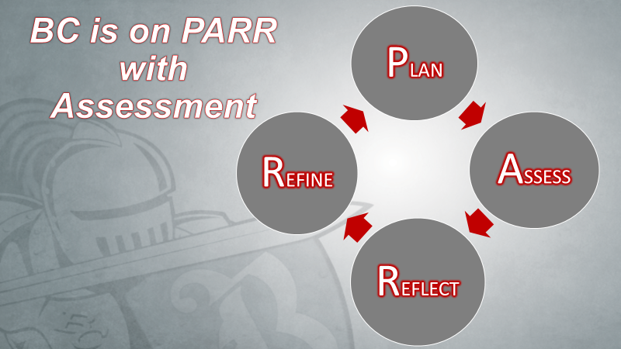

When a course revision is done in eLumen, and changes to the Student Learning Outcomes (SLOs) are made, the mappings of these SLOs are reset with the other learning outcomes (PLOs, ILOs, and GELOs). The purpose of this document is to align learning outcomes across all levels and maintain an updated set of mappings during the curricular process.

Instructions:
- Enter the course number and name (e.g., PHYS B4A – Mechanics and Heat) that will be mapped.
- Mapping Table – Column 1: List each SLO for the course listed in step 1.
- Below the Mapping Table, list each PLO for the course that belongs to the program.
- Mapping Table – Column 2: List all PLOs that match to each SLO listed in Column 1. At least one PLO must be aligned to each SLO. (More than one PLO can match to a single SLO.)
- Mapping Table – Column 3: List all ILOs that match to each SLO listed in Column 1. At least one ILO must be aligned to each SLO. (More than one ILO can match to a single SLO.)
- Mapping Table – Column 4: If the course belongs to any area of the AA/AS General Education Pattern (see pages 5-6), list all GELOs (pages 3-4) that match to each SLO listed in Column 1. At least one GELO must be aligned to each SLO. Ensure that the specific GELO is listed (e.g., C.1.2 and not C.1 or C).
- Complete the Assessment Mapping Report by uploading the attachment to the curriculum workflow in eLumen.

Assessment Mapping Report
Course Number and Name:

Student Learning Outcomes (SLOs)  Upon successful completion of the course, the student will be able to: | PLO | ILO | GELO

Program Learning Outcomes (PLOs):
Upon successful completion of the program, the student will be able to:

Bakersfield College Institutional Learning Outcomes (ILOs):
Upon successful completion of a degree or certificate, the student will be able to:
- THINK: Think critically and evaluate sources and information for validity and usefulness.
- COMMUNICATE: Communicate effectively in both written and oral forms.
- DEMONSTRATE: Demonstrate competency in a field of knowledge or with job-related skills.
- ENGAGE: Engage productively in all levels of society – interpersonal, community, the state and nation, and the world.

Bakersfield College General Education Learning Outcomes (GELOs)
Area A: Communication in the English Language and Critical Thinking
A.1 – Oral Communication
A.1.1: Form and present informative persuasive messages.
A.1.2: Demonstrate competence in both active and empathic listening.
A.1.3: Present oral messages to appropriate audiences and adhere to conventions of message delivery.
A.1.4: Manage personal communication apprehension and anxiety.

A.2 – Written Communication
A.2.1: Identify the controlling idea and the main points of college-level expository & argumentative essays.
A.2.2: Evaluate expository & argumentative essays through the application of critical thinking techniques.
A.2.3: Write logical & coherent expository & argumentative essays, summaries & paraphrases using correctly the standard conventions of written English.

Area B: Physical Universe and Life Forms
B.1 Natural Sciences
B.1.1: Demonstrate a knowledge of natural phenomena and recognize the processes that explain them.
B.1.2: Demonstrate a knowledge of scientific methodologies when solving a problem.

B.2 Mathematics and Logic (Analytical Thinking)
B.2.1: Apply formal systems of reasoning in solving problems or analyzing arguments.

Area C: Arts, Literature, Philosophy and Foreign Language
C.1 Introduction to the Arts
C.1.1: Demonstrate an understanding of and an ability to describe the ways in which arts, literature, philosophy or foreign languages reflect historical, intellectual, and cultural contexts, as well as aesthetic tastes.
C.1.2: Demonstrate the ability to recognize, describe and/or produce various components of an art form or language either visually and/or auditorily.

C.2 Introductions to the Humanities
C.2.1: Demonstrate an understanding of and an ability to describe the ways in which arts, literature, philosophy or foreign languages reflect historical, intellectual, and cultural contexts, as well as aesthetic tastes.

Area D: Social, Political, Legal, and Economic Institution and Behavior; Historical Background
D.1 Foundations in the Behavioral Sciences
D.1.1: Demonstrate an understanding of the perspectives, theories, methods and core concepts of the behavioral sciences.
D.1.2: Explain the major problems and issues in the disciplines in their contemporary, historical and geographical contexts.
D.1.3: Demonstrate an understanding of and an ability to describe the contributions and perspectives of women, ethnic and other minorities, and Western and non-Western peoples.

D.2 Foundations in the Social Sciences
D.2.1: Demonstrate an understanding of the perspectives, theories, methods and core concepts of the social sciences.
D.2.2: Explain the major problems and issues in the disciplines in their contemporary, historical and geographical contexts.
D.2.3: Demonstrate an understanding of and an ability to describe the contributions and perspectives of women, ethnic and other minorities, and Western and non-Western peoples.

D.3 American (U.S.) Institutions
D.3.1: Demonstrate an understanding of the perspectives, theories, methods and core concepts of the social sciences.
D.3.2: Explain the major problems and issues in the disciplines in their contemporary, historical and geographical contexts.
D.3.3: Demonstrate an understanding of and an ability to describe the contributions and perspectives of women, ethnic and other minorities, and Western and non-Western peoples.

Area E: Lifelong Understanding and Self-Development
E.1 Lifelong Understanding and Self-Development
E.1.1: Critically examine the development of the individual as an integrated physiological, psychological, spiritual, and social being.
E.1.2: Identify, describe and explain the interactions of the internal and external influences and effects in human development and behavior over the course of the human life span.

