Step 1 - Log in to curricUNET

- Go to: http://www.curricunet.com/kccd
- Log in with the same user name and password that you use to log into your office computer.
- Select your college.
- Click on “log-in” (It is in small print at the bottom of the same brown box)

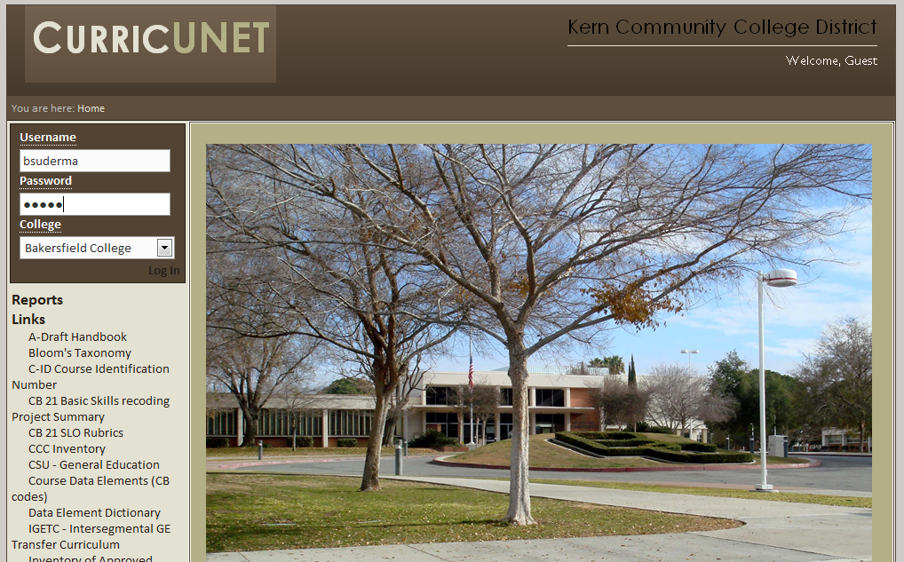

Step 2 - Assessment Module
Click on the level you want to work on: Course or Program
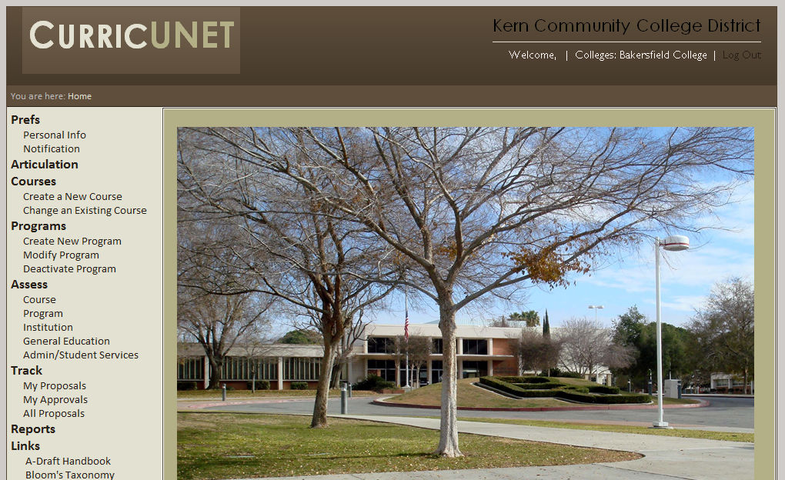

Step 3 - College and Department (Both course and Program)
- Choose your college and BC-department
  - If you are doing a course level assessment plan, this will bring up all of the courses in that department. You may drill down farther to one particular course here if you wish
- You do not need to put in a date unless you have assessed this before and it is in curricUNET)
- Click “Next”
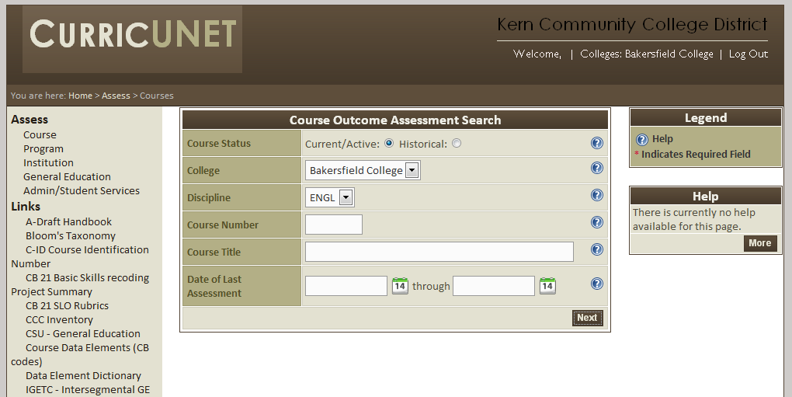

Course Level Assessment
Step 4: Choose Your Course
- Scroll down to your course and click on the white dot.
- Click on “Next” at the bottom of the page
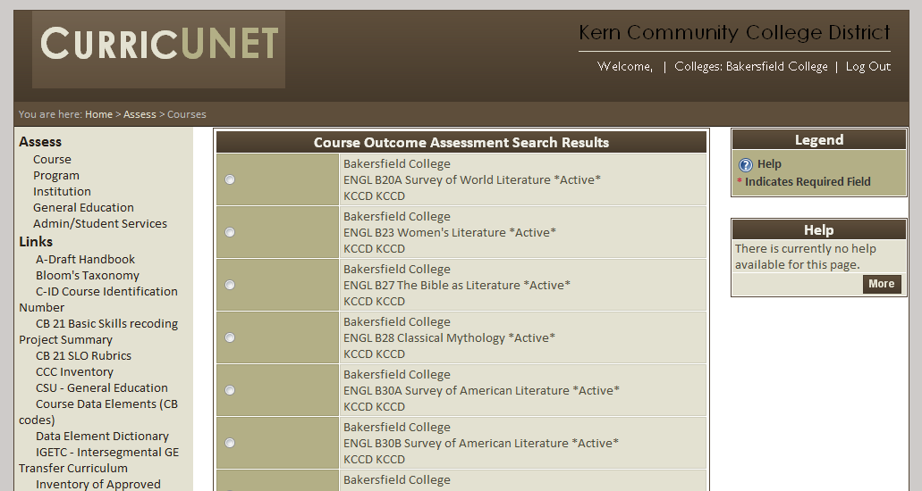
On the next page, click on the SLO on which you are reporting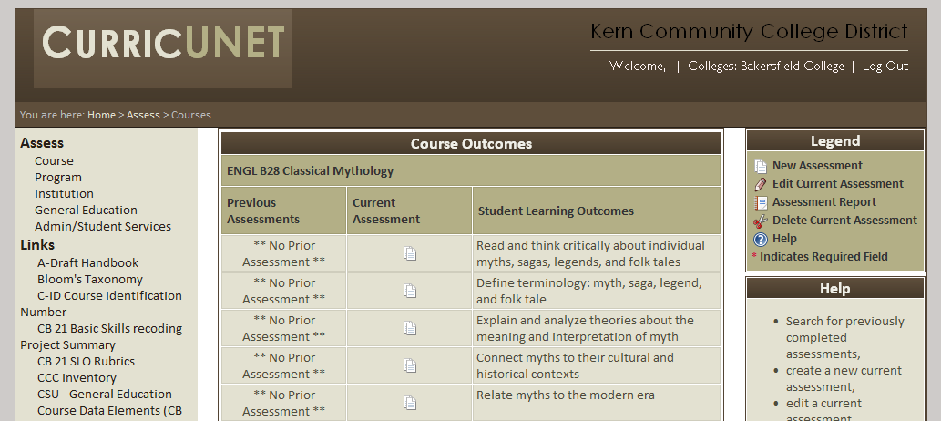
Skip to step 5 to continue Course Level Assessment
Program Level Assessment
Step 4: Choose your Program
- Click on the white dot next to your program
- Click on “next” at the bottom of the page

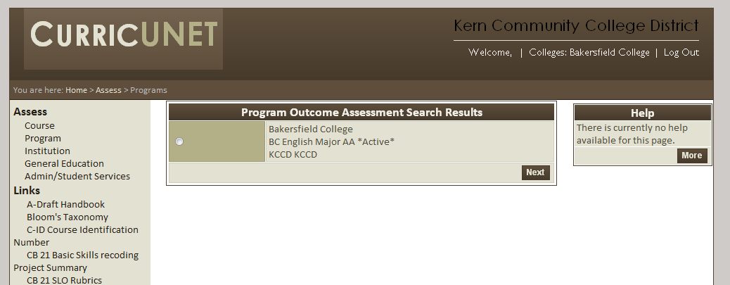

NOTE: If your program is not approved through the Curriculum Committee yet, your program level SLOs will not appear at this time. Contact Bernadette to discuss if you want to have them manually put in for you, or do the paper form from last year.

If your program level outcomes are in curricUNET, proceed to step 5

Step 5: Your Assessment Plan
- Choose the Assessment term (This time it is 30-Spring 2012)
- Tell us the target you were shooting for in your results (You can adjust this next time if you need to)
- Choose the closest option for your Assessment/scoring method, or choose “Other” and describe the assessment
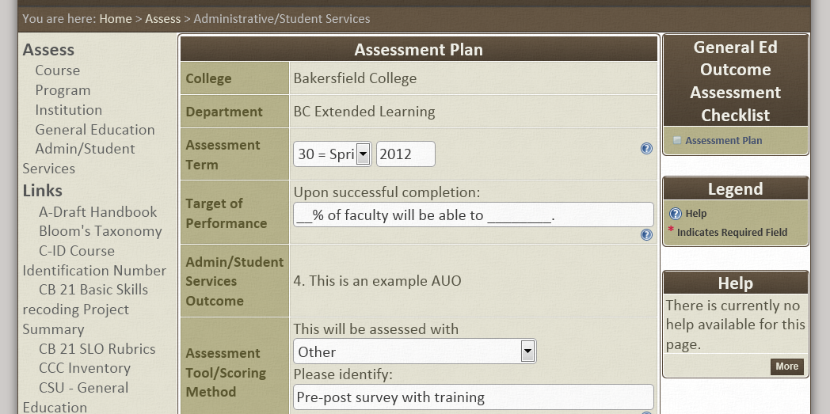

Step 5, Continued

- Describe your assessment method
- Click on “Save” if you want to come back and edit/ or “Finish” if you are done with this section.
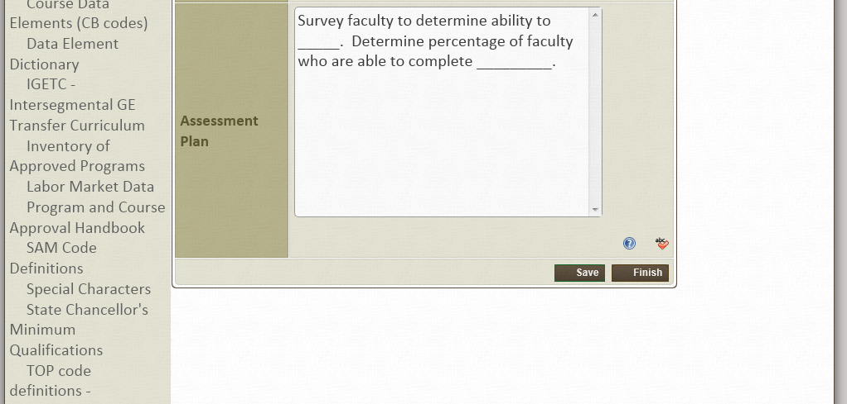

Step 6- Your Assessment Results
- Choose Assessment Results on the right side bar
- Describe what the results were of your assessment

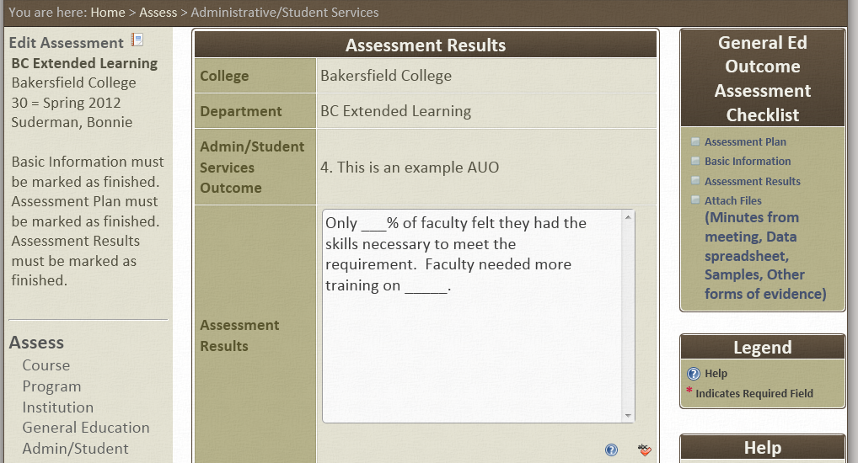

Step 6, Continued
- Describe the decisions you have made based upon those results
- Describe how these new decisions may impact your budget (Make sure this goes in your APR next time!)
- List the participants in your assessment and decision
- Click on “Save” if you want to come back and edit/”Finish” if you are done with this section.

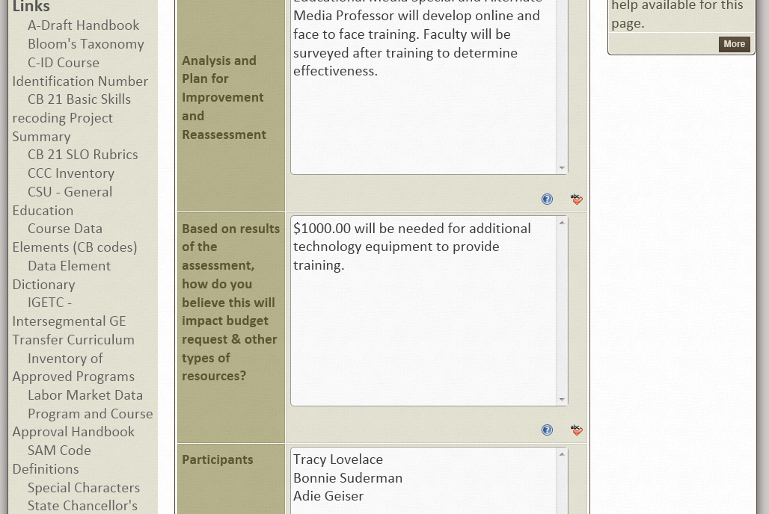

Step 7 —Attach any Documentation
- Click on Attach Files
- Name the Information you will be attaching
- Attach the file
- Click on “Finish” when you have attached all your documentation

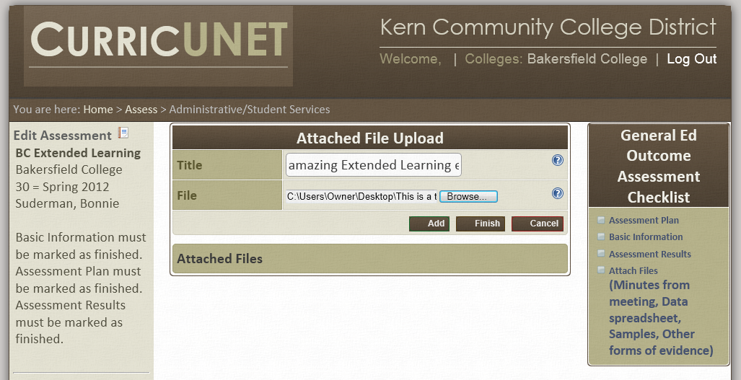

**In this section include any copies of your survey and the results, results of the focus group, results of the essay and rubric scoring, etc.

Step 8- Basic Information
- Tell us when you plan to assess this AUO again
- Add any Co-contributors (these are people you want to have access to this curricUNET report to edit and input information, not just those who have been involved in the assessment process)
- If you had assessed this AUO before and made changes based on those results the last time, describe those changes and what happened.

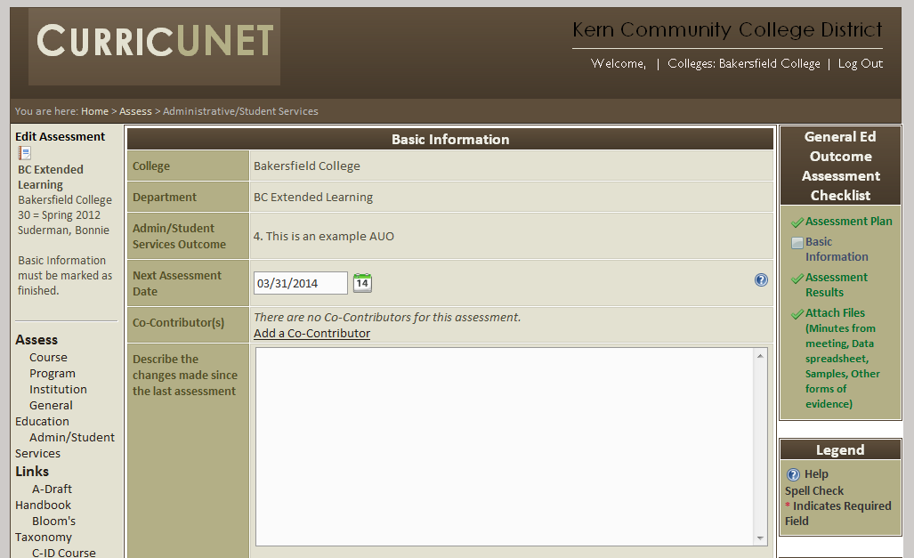

Step 9 - Complete Your Report
- When you have chosen “Finish” on each of the sections, they will turn green on the right side bar. If they are not green, go back to that section and click on “Finish”
- When they are all finished, the complete option will appear on the right side bar. Click on it

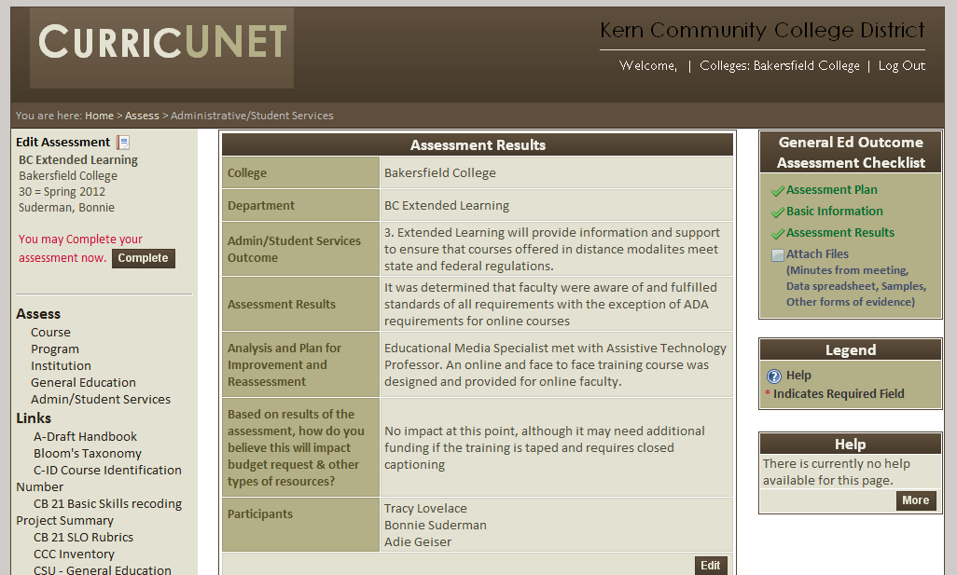

Your report will not be sent to your Assessment Coordinator
Congratulations! You have completed your assessment report and there were no earth-shattering calamities!

