Co-chairs agenda
September 20, 2013
10:30 to 11:50
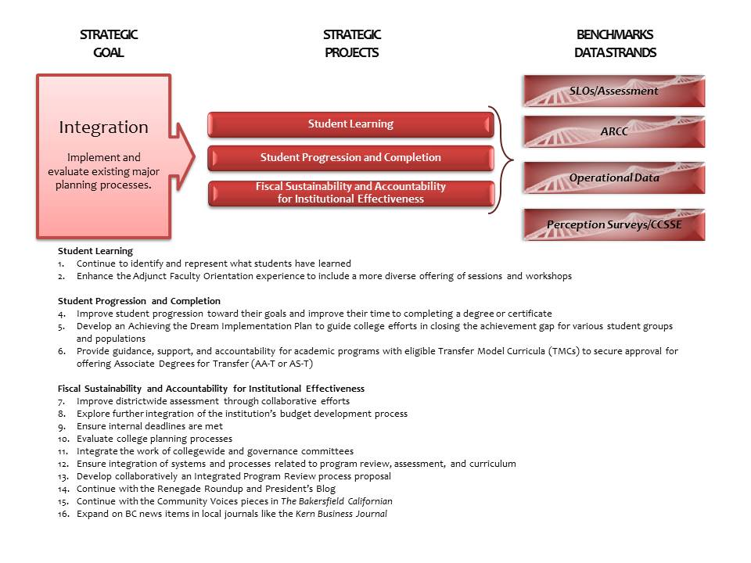

- President’s Report 10 minutes
  - Strategic Focus 2013-2014
  - Accreditation
  - Data
  - Learning Outcomes
- Academic Senate Report: 10 minutes
  - KCCD Staff Diversity Plan
  - Policies (Distance Learning, Wellness, …..)
  - Other
- Campus-wide committee reports: 60 minutes
12 campus-wide committees will report out on their work plan and other issues

