To: College Council

From Sonya Christian, President

RE: Closing the Loop: A Year-End Report

Memo prepared by: Budget—Dr. Anthony Culpepper, Laura Lorigo; Human Resources—Nan Gomez-Heitzeberg, Dena Rhoades; Technology—Todd Coston, Richard Marquez, Kristin Rabe; Facilities—Don Birdwell; Professional Development—Todd Coston; SSSP and Equity—Zav Dadabhoy; Grants: Title V, BSI, STEM—Nan Gomez-Heitzeberg; Distance Learning—Bill Moseley

Introduction
In the spring of 2013, the first Closing the Loop Document was presented to College Council. The idea behind this document was to connect how resource allocation is connected to the strategic goals of the college. Since then, this document serves as a tool to reflect on the progress of the strategic goals and to calibrate the activities on Bakersfield’s Campus. This document is the result of the work of several governance and campus-wide committees along with the responsible lead administrator.

Budget and Finance

Adopted Budget Longitudinal Analysis
Fiscal Period | 2010-11 | 2011-12 | Growth% | 2012-13 | Growth% | 2013-14 | Growth% | 2014-15 | Growth% | 2015-16 | Growth%
Total Budget | 68,750,003 | 70,859,028 | 0.03 | 62,470,997 | -0.12 | 68,122,615 | 0.09 | 74,983,088 | 0.10 | 83,600,477 | 0.11
Projected Reserves | 2,647,045 | 3,775,641 | 0.43 | 0 | -1.00 | 1,957,271 | 0.00 | 4,108,342 | 1,10 | 5,849,905 | 0.42
Adopted Budget | 66,102,958 | 67,083,387 | 0.01 | 62,470,997 | -0.07 | 66,165,344 | 0.06 | 70,874,746 | 0.07 | 77,750,572 | 0.10

The adopted budget table shows a positive growth trend over the past three years. The reserves indicate a continual compliance to board policy.

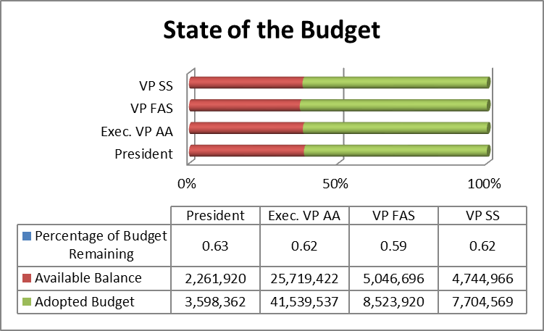
For the 2015-16 fiscal year, Bakersfield College is operating with a general fund adopted budget of approximately $86 million (this amount includes the DO chargeback and college reserves); this equates to approximately 11% growth when compared to the 2014-15 fiscal year. The salaries and benefits account for approximately 64% (2014-15) and 63% (2015-16) of the adopted budget revenue. In addition, Bakersfield College received approximately $11.9 million in state and federal grant dollars; this is a 29% increase when compared to the 2014-15 fiscal year. Bakersfield College has continued its focus on college priorities by strategically repurposing existing resources and using grant dollars. In addition, the college discussions continue to evaluate strategies for long term fiscal sustainability by augmenting its revenue streams through its auxiliary enterprises like facilities rentals. The college reserves are projected to be $6.5M (2015-16); this is an approximate 38% increase when compared to the 2014-15 fiscal year adopted budget.

At the time of this report Bakersfield College’s 2016 academic year is at midpoint (41.2% of the fiscal year). The fiscal year ends on June 30, 2016. The chart indicates the percentage of the budget remaining to be expended for each major department over the next seven months. As indicated in the chart, each departments remaining available budget is below the 41.2% of its respective allocation of the Adopted Budget. This is an indicator that the various departments are efficiently managing and controlling their budgets. Overall, the remaining balance in the college budget represents approximately 62% of the adopted budget. Bakersfield College’s current projected reserve is approximately $6.5M. This represents approximately 7% of its operating budget for 2015-16. In order to be in compliance with the District, a 3% college reserve is required. Further, a portion of approximately $9M is being held by the DO for future allocation to relieve debt obligations and to support new full time faculty hires.

FTES 5 Years Projection Using an Annual 5.83% Growth Rate Based on District Stability Intervention for Two Years
 | 2015-16 DGO | 2016-17 DGO | 2017-18 DGO | 2018-19 DGO | 2019-20 DGO | Additional FTES
 | 14,475 | 15,319 | 16,212 | 17,157 | 18,157
Additional FTES | 798 | 844 | 893 | 945 | 1,000 | 4,480

The District has notified Bakersfield College that additional funded Full Time Equivalent Student (FTES) will be available to the college. Bakersfield College has used a 5.83% growth factor to project the funded FTES growth over the next five years. As a part of its strategic plan, Bakersfield College anticipates the new Baccalaureate program to contribute significant FTES to meet this future growth.

The department of FAS has been focusing on increasing the budget literacy on Bakersfield College’s Campus. Several budget workshops have been held in the past several months. The participants in the workshops have consisted of all Budget Managers, Department Heads, Deans, Administrators, Faculty, and support staff. A survey of the first workshop provided data that indicated the constituency at Bakersfield College believed these types of workshops to be necessary and important. Further, the survey indicated that the frequency of the workshops should be at least quarterly. Also, Dr. Culpepper is leading the Executive Leadership of Bakersfield College through a cultural change of fiscal responsibility and accountability.

The tactic of leveraging its newly constructed infrastructure to enhance its fiscal sustainability has yielded over $500,000 is gross rental revenue to support the college mission. The Manager of Community Relations and Events Development is a new position that has been directed towards branding the Bakersfield Campus with community. The position will focus on developing major event opportunities to use the excess capacity of the campus infrastructure. The Memorial Stadium has been refurbished to support the soccer sports.

This memo is organized in these sections: Section A (Personnel), Section B (Technology), Section C (Facilities), Section D (Professional Development), Section E (SSSP and Equity), Section F (Distance Learning), with correlating appendices.

Section A: Personnel
Table 1 Management Positions FTE and Expenditure
Since the last report, a dean has been hired for the STEM areas of math and the sciences. Two existing deans were reassigned to cover the areas of Career and Technical Education (CTE) and Engineer, Industrial Technology & new bachelor’s degree program. Director positions filled include, Director Equity and Inclusion, Director Health and Wellness, Director, Fire Technology, Associate Director Athletics, and Assistant Director Financial Aid. Program Manager positions filled include CTE, Pathways/Dual Enrollment, Instructional Support Services, Outreach and School relations, Interim Equity and Inclusion, and Managers for Maintenance & Operations and Food Services. Seven administrative positions are funded by SSSP, Equity or other categorical funding. See organizational chart in Appendix A1
 | 2010-2011 | 2011-2012 | 2012-2013 | 2013-2014 | 2014-2015
GUI FTE | 22.08 | 21.38 | 23.60 | 20.81 | 26.06
GUI Expenditure (actuals) | 2,293,490 | 2,561,543 | 2,618,542 | 2,656,386 | 3,094,335
Categorical and RP FTE | 5.62 | 6.42 | 6.4 | 7.22 | 9.02
Categorical and RP Expenditure (actuals) | 256,224 | 309,360 | 332,571 | 416,844 | 670,183

The areas of identified need are in response to promoting student success and completion, innovation, wellness, and fiscal sustainability. The president will determine the priority of need for the coming year and work through the established campus process with College Council and President’s Cabinet. The positions of Dean of Academic Technologies, Dean of Institutional Effectiveness and Director, Food Services/Culinary Arts have been budgeted but not yet filled.

Listed below are management positions hired in 2015-16.

 | Position | Status | Funding
1 | Program Manager, CTE | Rozanne Hernandez | GU001
2 | Associate Dean, Nursing | Reposted **Interim - Carla Gard | GU001
3 | Director, Health & Wellness | Raymond Purcell | GU001
4 | Director, Fire Technology | Tim Capehart - January 2016 | GU001
5 | Program Manager, Pathways/Dual Enrollment | Catherine Francis | SSSP
6 | Program Manager, Instructional Support Services | Eileen Pierce | SSSP
7 | Dean, Institutional Effectiveness | Budgeted - Not Yet Posted | GU001
8 | Institutional Researcher | Posted | SSSP
9 | Dean, Academic Technology | Budgeted - Not Yet Posted | GU001
10 | Director, Culinary Arts & Food Services | Budgeted - Not Yet Posted | GU001
11 | Food Services Manager | Eric Sabella | GU001
12 | Program Manger, Outreach & School Relations | Ashlea Ward | SSSP & Equity
13 | Associate Director, Athletics | Keith Ford | GU001
14 | Director, Student Equity & Inclusion | Odella Johnson | Equity
15 | Program Manager, Equity & Inclusion | Reposted **Interim - Henry Covarrubias | Equity
16 | Assistant Director, Financial Aid | Jennifer Achan | Categorical
17 | Dean of Instruction (Math & Science) | Stephen Waller | GU001
18 | Dean of Instruction, Interim (COMM, ENGL, ESL, LIBR, PHIL) | Vacant - 12/31/15 | GU001
19 | Dean of Instruction, Interim (AG, BEH. SCI, BMIT, FACE) | Corny Rodriguez - 7/1/15 - 12/31/15 | GU001
20 | Dean of Instruction, Interim (ACDV & Pre Collegiate) | Janet Fulks - 7/1/15 - 12/31/15 | GU001
21 | Dean of Student Development & Success, Interim | Paul Beckworth - 7/1/15 - 12/31/15 | GU001
22 | Dean of Instruction (COMM, ENGL, ESL, Library, PHIL) | Interviews (11/24/15) | GU001
23 | Dean of Instruction (AG, BEH. SCI, BMIT, FACE) | Interviews (12/9/15) | GU001
24 | Dean of Instruction (ACDV & Pre Collegiate) | Eliminated | GU001
25 | Dean of Student Development & Success | Interviews (12/3/15) | GU001
26 | Maintenance & Operations Manager | Don Birdwell | GU001
27 | Director of Outreach | Steve Watkin | SSSP
28 | Program Manager, MIH | Lesley Bond | SSSP
29 | Program Manager, Rural Initiatives | Gustavo Enrique | SSSP
30 | Program Manager, Student Success | Karla Young | SSSP

Section A2: Program Review – Prioritization Process, Faculty and Classified Positions
As a part of the annual assessment and planning process, departments and service areas submit an Annual Program Review (APR). The APR includes data and requests for faculty and classified positions based on identified needs. The college prioritization process includes a review of faculty requests by Faculty Chairs and Director Council (FCDC) members. FCDC members include elected faculty chairs, and academic and student affairs administrators. Classified positions are reviewed and prioritized by members of FCDC, Facilities and Administrative Services and the Executive Board of C.S.E.A. The prioritized list is forwarded to the president for approval.

Faculty Positions
Last year Bakersfield College exceeded its FON target. The list of faculty hired last year is referenced below.

 | Department | Status | Funding
1 | Counseling | Filled - Grace Commiso | SSSP
2 | Biology | Filled - Hibba Ashraf | GU001
3 | English - Delano | Filled - Christopher Disson | GU001
4 | Counseling | Filled - Marissa Marquez | SSSP
5 | Chemistry | Filled - Debby Rosenthal | GU001
6 | Health & PE/Kinesiology | Filled - Zackaria Peters | GU001
7 | Nursing, Simulation Coordinator | Interviews Scheduled (12/1/15) | GU001
8 | Academic Development | Filled - Jessica Wojtysiak | GU001
9 | Counseling | Filled - Fabiola Johnson | SSSP
10 | Philosophy | Filled - Bryan Russell | GU001
11 | EMS Fire Technology | Filled - Brent Burton | GU001
12 | Automotive Technology (EIT) | Filled - Andrew Haney | GU001
13 | Art, Ceramics and 3D | Filled - Darrin Ekern | GU001
14 | Librarian | Filled - Sondra Keckly | GU001
15 | Art , Media Arts | Reposted - First Review (1/15/16) | GU001
16 | Biology | Filled - Alexandria Dallara | GU001
17 | Anthropology | Filled - Krista Moreland | GU001
18 | Counseling | Filled - Sarah Villasenor | SSSP
19 | Counseling | Filled - Manuel Rosas | Equity
20 | Engineering & BAS (EIT) (Grant) | Failed Recruitment | GU001
21 | Criminal Justice | Filled - Harlan Hunter | GU001
22 | Counseling | Filled - Johnathan Schultz | SSSP
23 | English | Filled - Andrew Bond | GU001
24 | Counseling | Filled - Veronica Lucas | SSSP
25 | Kinesiology, Swimming | Filled - Matthew Moon | GU001
26 | Commercial Music, Audio Production | Filled - Josh Ottum | GU001
27 | Computer Science | Filled - Richard Miles | GU001
28 | Culinary Arts | Filled - Alex Gomez | GU001
29 | Agricultural Mechanic | Filled - Norman Oiler | Grant
30 | Allied Health (HIT) Grant | Reposted - First Review (1/28/16) | GU001
31 | Academic Development | Filled - Erica Menchaca | GU001
32 | Allied Health Public Health Science | Filled - Sarah Baron | GU001
33 | Instructional Technologist | Filled - Matt Jones | GU001
34 | Philosophy | Filled - Peter LeGrant | GU001
35 | Librarian | Filled - Faith Bradham | GU001
36 | Math | Filled - Joshua Lewis | GU001
37 | Math | Filled - Nigie Shi | GU001
38 | Math | Filled - Michael Frendenberg | GU001
39 | Counseling | Filled - Keri Kennedy | SSSP

The document submitted by KCCD to the state chancellor’s office indicated that the district exceed its target by 9.2.

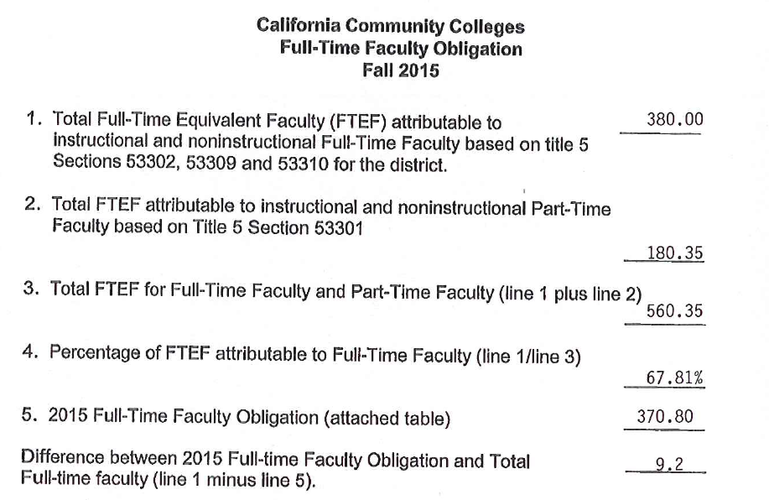
Table 2 Faculty FTE and Expenditure

 | 2010-2011 | 2011-2012 | 2012-2013 | 2013-2014 | 2014-2015
FON District | 373.60 | 365.80 | 348.80 | 368.80 | 370.80
Bakersfield College Actual | 250 | 254 | 250 | 247 | 261
Percentage of Actual/FON | 66.9% | 69.4% | 71.7% | 67.0% | 70.3%
Expenditure on faculty positions (actuals) | 21,311,646 | 21,344,544 | 21,897,231 | 21,658,339 | 21,403,245

A total of 38 positions were approved by the President, but only 34 were filled to start Fall 2015. The remaining four are still in the recruitment cycle: Nursing, lead faculty for simulation lab, Media Arts, and Health Information Technology. The Engineering and BAIS position will be filled with an existing faculty member.

The 2016-2017 Full Time Obligation Number (FON) for Bakersfield College is 22 faculty positions. (see Appendix A2). Forty-one positions were requested by departments on campus in their annual program review. FCDC voted and prioritized the positions at their November 13 meeting. As of November 30, 2015, the President has approved 13 positions of the 22 positions and released the Phase I list:
- Sociology – focus on building online transfer degree (Replacement)
- Academic Development – focus on curriculum redesign and delivery (Replacement)
- English – focus on acceleration and completion (Replacement)
- Child Development – focus on completion (Replacement)
- Nursing – Mental Health/Psychiatric – compliance requirement (Replacement)
- Counselor – EOP&S - support expansion (Replacement)
- Biology – focus on biology major coursework and demand for anatomy/physiology (Replacement)
- Spanish – focus on building an online degree (Replacement)
- Chemistry – focus on meeting needs of STEM majors (Replacement of the one year temporary)
- Counselor – DSPS (Replacement)
- Counselor – SSSP (replacement)
- Agriculture Business – meet increased demand for Ag Pathways courses with CCPT grant (New)
- Paramedic – moving from fee-based to credit program (Conversion)

The remaining four positions from last year will be added to this year’s list. Therefore there are five remaining positions to reach 22. This number might increase if there are resignations or retirements.

Section A2b: Classified Positions
Since last year 10 approved classified positions for 2015-16 have been filled or are in-process pending hire. In addition, the Bakersfield College Equity and SSSP Plans identified 9 classified positions needed to carry out work plans.
 | Department | Status | Funding
1 | DSPS, Assistive Technology Specialist (N) | Job Desc Submitted | DSPS RP008
2 | Enrollment Services, Admissions & Records Technician I (R) | Filled | GU001
3 | Financial Aid, Financial Aid Technician (R) | Filled | RP400
4 | Enrollment Services, Department Assistant II (N) | Filled | GU001
5 | Enrollment Services, Admissions & Records Technician II (N) | Posted | GU001
6 | Nursing, Educational Advisor (Conversion) | Filled | GU001
7 | EOPS/CalWORKS/CARE, Department Assistant II (N) | Posted | RP005
8 | Financial Aid, Educational Advisor (R) | Filled | RP382 / RP400
9 | Financial Aid, Financial Aid Technician (N) (2) | Posted In-House | Categorical
10 | DSPS, Department Assistant III (R) | Filled | DSPS RP008
11 | Ed Advisor | Filled | SSSP RP302
12 | Ed Advisor | Filled | SSSP RP302
13 | Ed Advisor | Filled | SSSP RP302
14 | Executive Secretary | Filled | SSSP RP302
15 | Graphics Designer | Filled | Equity RP382
16 | Outreach, Department Assistant III | Filled | SSSP RP302
17 | Program Coordinator | Filled | GU001 / RP302
18 | Student Services, Department Assistant III | Filled | Equity RP382
19 | Writing Center Lead | Filled | RP010

Table 3 Classified Positions FTE and Expenditure

 | 2010-2011 | 2011-2012 | 2012-2013 | 2013-2014 | 2014-2015
GUI FTE | 136.67 | 141.19 | 141.30 | 128.68 | 132.42
GUI Expenditure (actuals) | 6,327,382 | 6,327,381 | 6,016,797 | 5,887,530 | 5,933,318
Categorical FTE | 34.23 | 33.94 | 33.65 | 33.93 | 37.14
Categorical Expenditure (actuals) | 1,743,468 | 1,696,535 | 1,699,845 | 1,790,012 | 2,052,037

Section B: Technology
$415,018 Mid-Year Fiscal 2015-2016

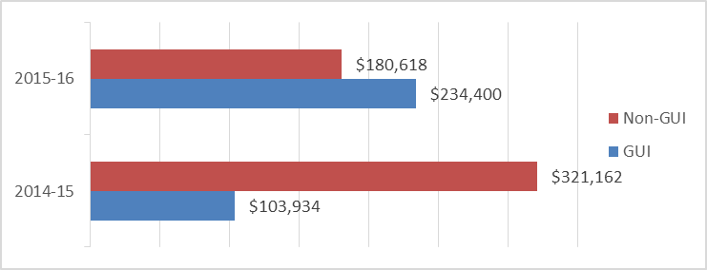
B1: General Technology
For academic year 2015-16, we have spent about $415k for technology. This is an increase of about $45k over the same time period last year. Some of the key purchases were two additional printers for the student open computer lab in the library (Pay-for-print), iPads for the classroom (BSI), laptops and computers for the new student welcome center (SSSP), laptops and carts for Supplemental Instruction and some of our other labs (SSSP), and licensing for software for many of our instructional labs (GUI). Also, money was spent on hardware maintenance agreements for our core switch and wireless infrastructure, upgraded IP telephones, and a new core network switch for the Delano campus (GUI).

B2: Program Review – Technology
Money has not been spent on Program Review requests for this academic year. The Program Review technology requests have come in, and the technology committee (ISIT) is still in the process of prioritizing those requests. The full request list can be found in Appendix B. Typically, these requests are not funded until late in the academic year and the projects are completed over the summer break. The graph at right shows the funding of Program Review technology requests for the last two years.
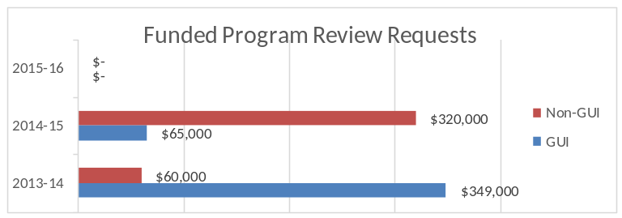
Section C: Facilities
$2,900,000 YTD

C1: General Facilities Update
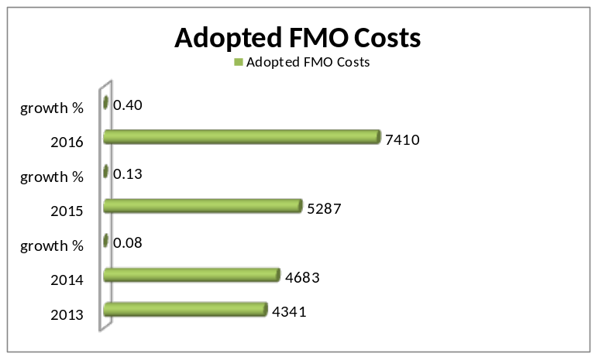Total Facilities, Maintenance, and Operations costs have increased over the past three years. The table indicates that Bakersfield College continual invests in the sustainability of the campus environment
(Extracted from the Bond Brief) In 2002 the voters within the District’s, Kern, Tulare and San Bernardino County serving areas approved a $180 million Safety, Repair, and Improvement District Bond in support of Bakersfield College, Cerro Coso Community College, and Porterville College capital outlay facility needs. The property tax rate equated to $12 per $100,000 of assessed property valuation. This bond became identified as the 2002 SRID (Measure G). Bakersfield College’s allocation of the received bond funds was approximately $100 million.
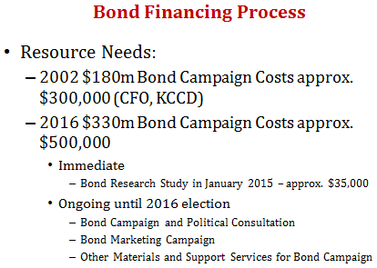
Bakersfield College has exhausted the funds received by completing the majority of projects identified in the 2002 SRID Capital Outlay Bond program (Measure G). However, there is significant facility need remaining. The states assessment of the aging facilities has identified needs of $50 million to modernize the existing facilities built in 1955. The recently completed Bakersfield College Facilities Master Plan identifies significant needs of approximately $300 million for additional infrastructure, including a 200,000 square foot of useable office/classroom/conference space, and $80 million for modernizations, expansion, upgrade, replacement of aging infrastructure and continuing energy conservation projects beyond the funding capacity of the 2002 SRID bond program. Bakersfield College’s Facilities Master Plan totals approximately $330 million.

Facility | Sq.Ft. | % of Sq.Ft. | Usage
Maintenance and Operations | 15,000 | 7.41% | Administration
STEM/MESA | 3,000 | 1,48% | Student/Administration
ABC | 41,000 | 20.27% | Student/Administration
Math, Science, Engineering | 104,000 | 51.41% | Student
Agriculture | 22,000 | 10.87% | Student
Language Arts Swing Space | 12,300 | 6.08% | Student
Women’s Field House | 5,000 | 2.47% | Student
Total Proposed New | 202,300 | 100%

Bakersfield College’s Facilities Master Plan follows the Education Master Plan’s long term vision. The Facilities Master Plan provides an important blueprint for how student services can be delivered in the long-term to maximize student success, particularly for first-generation college students. Under the plan, student support services and basic skills instruction will eventually be consolidated into the same general area of the main Bakersfield Campus. This academic year 2015-16 the Governor’s budget proposal allowed the CCCCO to allocate to KCCD additional monies for scheduled maintenance and instructional equipment, as well as, mandated funds to be used in for facilities. Bakersfield College received approximately $2.9M of the allocated funds. These funds were used to address priority items noted in Appendix C1. In addition, the table displays other projects that are pending to date.

Projects such as the Welcome Center in the Administration Building and the Soccer field have been completed. The soccer field has been rented out to continue to support the community connectedness initiative through the Events and Community Relations department. Also, the Welcome Center staff assists first-time students with the following services: selecting academic programs, completion of the admission application, online orientation, development of ASEP for new students, and registration assists.

Based on input from the campus community the Facilities & Sustainability Committee continues to focus on two areas. The first is the ongoing general campus clean up and maintenance. We continue to move forward with catching up from the previous budget cuts that left the campus in a state of disrepair. Maintenance and Operations continues with the solution by doing projects during summer and holiday breaks. This keeps our disruption to the campus down to a minimum but continues to let us move forward in the cleanup and repair of the campus. With the last summer behind us, the campus has seen $1.6 million spent toward maintenance and repair in just summer projects. Most of these funds came from SRID bond and some came from Bakersfield College general fund. The College will continue to consider facilities upgrades as a priority item for funding for projects. (Appendix C2)

C2: Program Review – Facilities
The Program Review Annual Updates have been completed and the facilities team is in the review process of the requests. We will be looking at the request with focus on safety issues first. Some requests might already be in work orders and may have already been completed. We will notify areas that have work orders created from this process and addressed them through SchoolDude. (Appendix C2).

Section D: Professional Development
Professional Development at Bakersfield College is alive and flourishing. There are always a wide variety of events, work sessions, and conferences to encourage growth in our employees throughout the year. Professional Development has gained the spotlight in the last few years both at Bakersfield College and at the state level. At the state level, Assembly Bill 2558 was introduced and provides some further support for college professional development. At Bakersfield College, we realize that developing our employees is crucial to meeting the needs of our students and so we are hiring a Program Manager of Professional Development. The hiring of that position is in-progress and we look forward to the impact that position will have on the college.

Conferences
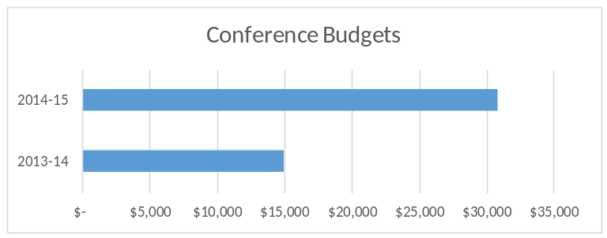Over the last few years, Bakersfield College has been committed to providing professional development opportunities by hosting a variety of conferences on campus. Employees are encouraged to attend the various conferences and typically our sister campuses and other community colleges send people to participate. In fiscal year 2013-14, Bakersfield College hosted two data conferences and an equity conference. In fiscal year 2014-15, Bakersfield College hosted conferences on Student Learning Outcomes, Sustainability, Technology, and Equity. The conferences have been funded by a combination of grants, ticket sales, and the general fund.

Not included in the budget breakdown were: 2014’s Trusteeship Workshop, Kern Agriculture Summit, and Title IX Symposium; 2015’s public event “An Evening with Michael Wesch”.
The list of on-campus conferences can be found at www.bakersfieldcollege.edu/conference.

Professional Development Committee (PDC)
The PDC is responsible for sponsoring the FLEX/Professional Development week prior to each semester. During the week, sessions are offered on a variety of topics from Basic Excel to CPR training to Technology Tools in the Classroom. A complete list of the sessions offered can be found at www.bakersfieldcollege.edu/employees/professional-development/workshops/past. The Professional Development Committee (PDC) also works on several initiatives and has a small allocation this year of $10,000. When the Professional Development Plan was developed, percentages were used to further allocate the money depending on the allocation PDC receives. Below is the percentage table, from the PD plan, based on the $10,000 allocation.

Percentage | Budget | Description | Explanation
20% | $2,000 | On-campus Activities | This money will be used for on-campus activities for classified, faculty and managers.
50% | $5,000 | Scholarships | These are small (up to $500) scholarships awarded to classified, staff or managers to offset costs of professional development training, conferences or events.
10% | $1,000 | Food & Beverages | This money is used to provide food and beverages for Professional Development Committee sponsored events.
10% | $1,000 | Professional Development Academy | This is money to be used for anything related to getting the Professional Development Academy off the ground and into implementation. This can be used to purchase awards and other items recognizing employees for professional development achievements.
10% | $1,000 | Misc. | This can be used to augment another existing category, for books, or for other requests that may come to the committee.

Additional Professional Development Activities
Bakersfield College has recently offered a targeted group of panel discussions revolving around the book Redesigning America’s Community Colleges: A Clearer Path to Student Success. The panels are made up of students, faculty, classified, and administrators and aim to foster campus discussion on student success. Along the lines of safety, Bakersfield College partnered with the Bakersfield Police Department to offer sessions on Active Shooter trainings. The training is offered to all employees with the intention to keep us all thinking about the appropriate reaction, in our respective areas, to an active shooter on campus.

Section E: SSSP and Equity
During the 2014-15 and the 2015-16 fiscal cycles, the college received significant categorical fund increases to fund student success initiatives through the SSSP and Student Equity programs.
Fund | Budget
SSSP | $3,473,756
Equity | $2,088,925
Total | $5,562,681

Over a two-year cycle, this represents an influx of more than $5,000,000 in new funds for the college, allowing a ramp-up of student academic support, advising, student services, IT, budgeting, marketing, and outreach programs serving the college’s main campus and augmenting services for the Rural Initiatives.

Bakersfield College staffing funded through SSSP and Equity include:
- Admissions and Records Tech II (Evaluator)
- Assessment Assistant
- Assessment Assistant, FLB
- Assessment Center Coordinator
- Associate Director, Outreach and School Relations
- Budget Analyst
- Counselor (2)
- Counselor, EOPS
- Counselor, Equity
- Counselor, General Counseling (4)
- Dean
- Department Assistant II, Outreach
- Department Assistant III, Equity
- Director, Equity and Inclusion
- Director, Student Academic Support
- Educational Advisor, Equity
- Educational Advisor, Financial Aid/Outreach
- Educational Advisor, Pre-collegiate
- Educational Advisor, Rural Initiative
- Educational Advisor, Athlete Support
- Educational Advisor, Generalist
- Educational Advisor, MIH
- Educational Advisor, Outreach (x2)
- Educational Advisor, Rural Initiatives
- Educational Advisor, Rural Initiatives
- Executive Secretary, SSSP
- Graphic Designer
- Institutional Researcher
- IR Analyst
- IT Technician
- Professional Expert, Multimedia
- Program Manager (x2)
- Program Manager, Dual Enrollment
- Program Manager, EOPS
- Program Manager, Equity
- Program Manager, Peer Education
- Program Manager, Professional Dev.
- Program Manager, Rural Initiative
- Program Manager, Dual Enrollment Pathways
- Program Manager, Outreach
- Program Manager, Rural Initiatives
- Program Manager, SI
- Program Manager, SSSP
- SSSP Program Director
- Tutor, Math

Section F: Distance Learning
Historically, Bakersfield College has been a leader in instructional technology and in distance education. In the 1990s, we were a pioneer college in offering a wide array of online courses to our students, and we also were a leader in Interactive TV and ITV courses. Over time, attrition in our support structures and lack of innovation saw us move from the front of the pack to somewhere in the middle.

With the newly-hired Instructional Technologist in place, we have begun the process of rebuilding the structures that Bakersfield College needs to become a leader in the area of distance education once again.

We have re-launched the Online Instructors’ Community of Practice. Our intent is to hold regular get-togethers for the purpose of training, sharing, and communication to all online instructors at Bakersfield College. This group met in October, and will continue to meet once or twice each semester.

We are examining future involvement with the OEI. The statewide OEI continues to gain momentum as more community colleges join the OEI course exchange through its early pilot programs. As a college, Bakersfield College needs to examine the benefits, to the college and our students, as well as the costs of potential involvement in this program.

We are evaluating the Canvas CMS for possible adoption. Canvas is the official course management system for the OEI. As such, it is fully funded for all California community colleges through 2018, and possibly beyond that date. Canvas is also a requirement for any college that wishes to offer courses through the OEI exchange. Because of these benefits and others, Bakersfield College is reviewing Canvas for possible adoption, with a very tentative timeline of Fall 2016 (if the college decides to adopt). Approximately 60 faculty have been issued test accounts to try out Canvas for themselves. The college is currently collecting survey data from all faculty, including trial participants, on their position related to Canvas adoption. The Academic Senate has Canvas on their agenda as a standing item, and the ISIT committee will host an open forum on the topic at their final meeting of the calendar year. Results from the survey will presented at that time.

We are beginning the process of looking at standards of quality for online courses. In an effort to make sure that our online courses meet the needs of our students, we are beginning to have discussions related to the development or adoption of quality standards for our courses, and even possible adoption of a faculty certification process for online teaching. It is very early in this process, but in concept there seems to be support from both faculty and administration. Ultimately, the ideal result of these discussions would be to have alignment between policy, training and evaluation related to online courses. Because of the many components involved in such a move, it will be a lengthy process.

The 2014-2015 KCCD Distance Education Report is included below in its entirety. The Instructional Technology section contains longitudinal data for the academic years 2012-2013, 2013-2014, and 2014-2015.

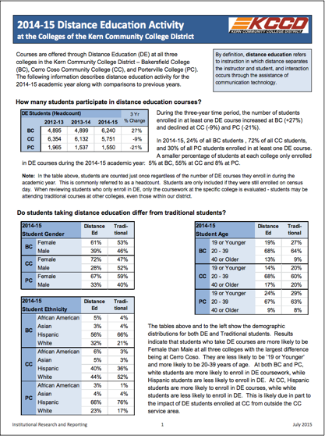

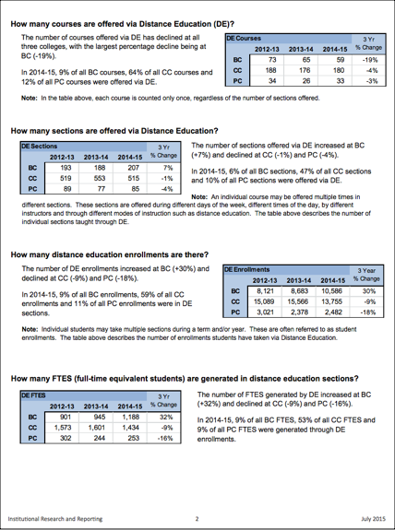

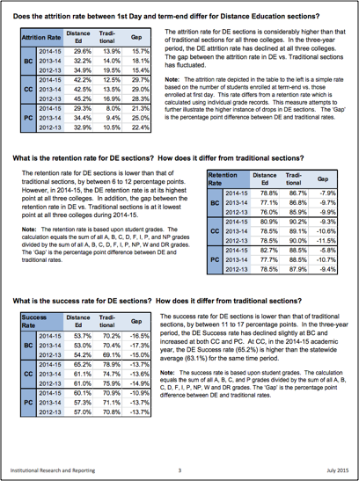
Planning and improvement for online courses is deeply integrated with the planning and improvement of the college as a whole. This blended planning is reflective of the reality that the technologies, services, and even the pedagogies surrounding online learning are shared deeply with many of our face to face classes. From a curricular perspective, there is no difference between our online courses and the same courses when offered face to face. In essence, it would be more difficult to enact a separate planning process for online than it is to practice integrated planning.

As an example, in 2012 Bakersfield College submitted an actionable improvement plan in response to recommendations from the 2012 Accreditation Self Study (Appendix A) related to our instructional programs. Specifically, the actionable improvement plan outlined a four point plan to improve the success of our online students:

To enhance the quality of online distance education courses, the College, under the leadership of the Executive Vice President, Academic Affairs & Student Services, and the Dean of Learning Resources will develop and implement by spring 2013 a detailed plan to improve the services to distance education students to increase their ability to succeed in their courses. The plan will include the appropriate support to implement the following:
- Development of an online student orientation system to better prepare students for online courses with the overall goal of increasing their success in those courses.
- Development of a student signal alert system that would inform students of their current course progress and refer them to appropriate helpful resources.
- Development of an online tutoring program to increase students’ ability to succeed in an online course.
- Development of additional pedagogical training and support for online faculty

This actionable improvement plan was integrated into our participatory planning process. Teams were developed including appropriate administration, faculty and staff, and solutions were developed using the plan as the guiding document. The plan primarily addressed the needs of online students, but most of these recommendations are tied to our face to face classes as well, and the advancements made by Bakersfield College for online student success benefit our face to face students.

Appendix A1: In progress, Administrative Organization Chart 11-20-15
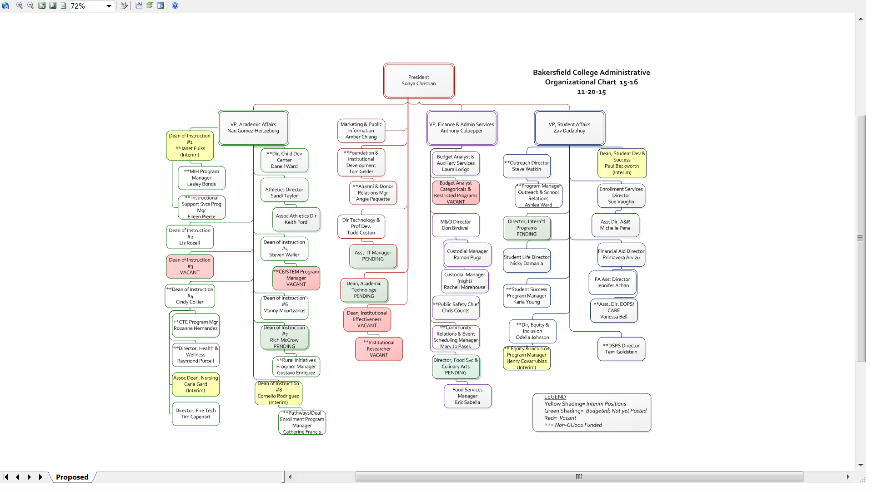

Appendix A1: In progress, Administrative Organization Chart 12-15-14
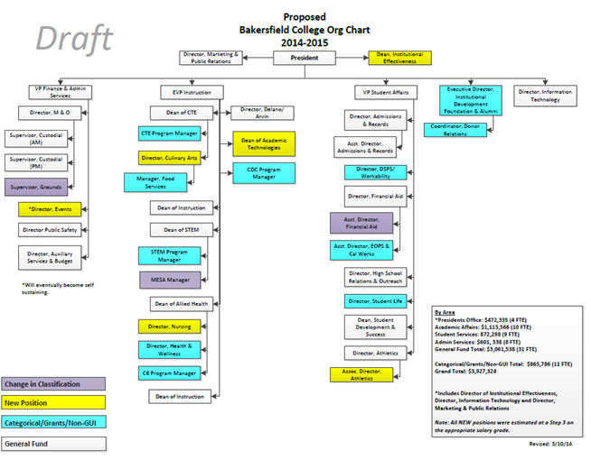

Appendix A2: Faculty Position Requests
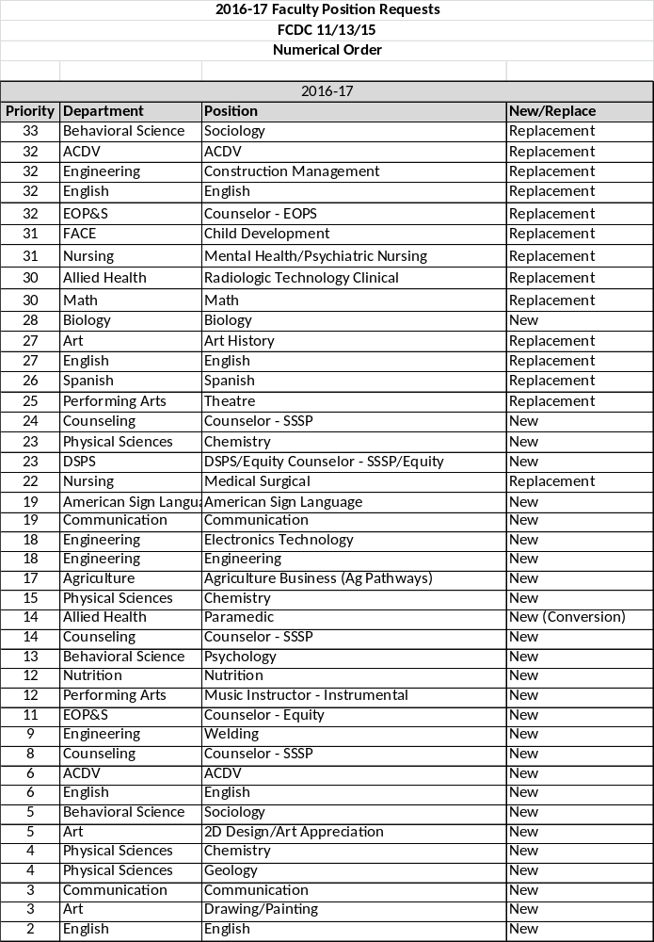

Appendix A2: Classified Position Requests
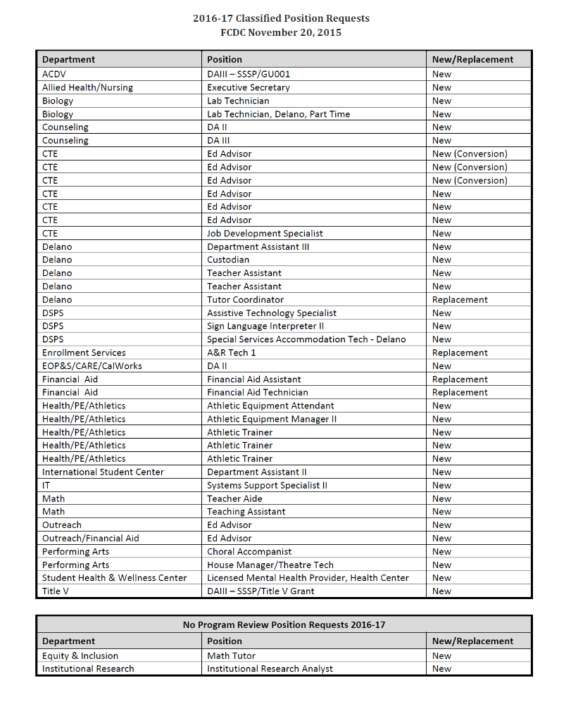
Appendix B: Technology Requests
Aligned with Strategic Goals Student Success and Facilities, Infrastructure & Technology

# | Equipment | Qty | Location | Department | Points | Justification/Notes | Legal
1 | ST Projector Project | 2 | SS 117/206 | Academic Development | 27 | Wants ST projectors in SS 117 & 206
2 | WiFi in Language Arts 1st Floor | ? | Lang Arts | Communication | 23 | Wants WiFi saturation on First Floor LA bldg
3 | Delano Campus Lab Computers | 14 | DST 126 | Delano Campus | 20 | Wants newer computers for lab | No
4 | IT201 Classroom Refresh | 1 | IT201 | Nursing | 20 | Wants IT201 Classroom tech refreshed | No
5 | WiFi & 5 Projector/Computer carts | 5 | RFK Delano | Delano Campus | 18 | Wants Wifi & 5 Projector/Computer Carts | No
6 | ST Projector Project | 1 | LA 113 | ASL | 17 | Wants ST projector & equipment | No
7 | Ford IDS Diagnostic Equipment | 1 | IDT 4 | Automotive Tech | 16 | Wants a Ford Diagnostic scan tool | No
8 | Chrysler Diagnostic Equipment | 1 | IDT 4 | Automotive Tech | 16 | Wants a Chrysler Diagnostic scan tool | No
9 | Delano Tech Classroom Refresh | 14 | Delano | Technology Services (Media) | 16 | Need tech refresh (equip 8 years old) | No
10 | MS Tech Classroom Refresh | 7 | Math Science | Technology Services (Media) | 16 | Need tech refresh MS 2,26, 14,17, 24, 9, 10 | No
11 | Student Services Tech Refresh | 4 | Student Serv | Technology Services (Media) | 16 | Need tech refresh SS 117, 122, 128, 206 | No
12 | Forum Tech Refresh | 2 | Forums | Technology Services (Media) | 16 | Need Tech Refresh of Forum West/East | No
13 | Language Arts Tech Refresh | 11 | LA Classrooms | Technology Services (Media) | 16 | Need Tech Refresh from COW to ST equip | No
14 | Doc Cams for SE Lecture Halls | 4 | SE Lecture | Technology Services (Media) | 16 | Need updated document cameras | No
15 | FACE Tech Refresh | 3 | FACE | Technology Services (Media) | 16 | Need updated tech in FACE 12, 15, 23 | No
16 | FACE Tech Refresh | 3 | FACE | Early Childhood Ed | 16 | Want update of FACE 12, 15, 23 | No
17 | Cabling Doc cams in Business | 4 | Business | Technology Services (Media) | 16 | Need cabling for existing doc cams | No
18 | Humanities Tech Refresh | 10 | Humanities | Technology Services (Media) | 16 | Tech Refresh H-11,12,13,14,15,103,04,05,51 | No
19 | Black & White Printer | 3 | Electronics | Electronics Technology | 16 | Wants Printers for INDT 5, 6,7a | No
20 | New computers | 22 | INDT 7a | Electronics Technology | 16 | Wants new CIM lab Computers | No
21 | 12 Laptop Cart | 1 | Mobile | Communication | 15 | Wants a mobile 12 computer laptop cart | No
22 | Fine Arts 65 tech refresh | 1 | FA 65 | Technology Services (Media) | 13 | Wants ST projector & equipment | No
23 | WiFi in Humanities | 1 | Humanities | History | 13 | Wants WiFi Coverage Saturation in H bldg | No
24 | Fine Arts 60 tech refresh | 1 | FA 60 | Technology Services (Media) | 12 | Wants ST projector & equipment | No
25 | Academic Development Lab | 1 | SS 206 or 3a | Academic Development | 11 | Wants another computer lab for ACDV | No
26 | Media Arts Computer Lab | 1 | Fine Arts 8 | Art | 8 | Wants a computer lab for new Media Arts | No

# | Equipment | Qty | Location | Department | Points | Justification/Notes | Legal
1 | Printer for IT 3 Lab | 1 | IT3 | Automotive | 19 | Wants to add a printer to the existing lab | No
2 | Heavy Duty Battery Testers | 2 | AT 1 | Automotive | 19 | Wants OTC Heavy Duty Battery Testers | No
3 | Genisys Touch Scan Tools | 2 | AT 1 | Automotive | 19 | Wants OTC Genysis Touch Scan Tools | No
4 | Encore Scan Tools | ? | AT 1 | Automotive | 19 | Wants to purchase Encore Scan Tools | No
5 | Power Probe Circuit Trainers | 4 | AT1 | Automotive | 19 | Wants to purchase a few of these trainers | No
6 | Computers for labs | 8 | SE 12.18,26,27 | Chemistry | 19 | Wants 2 computers per lab for student work | No
7 | SciDome Projector | 1 | Planetarium | Physics/Astro | 18 | Needs star projector replaced | No
8 | Projector? Skype Setup | 1 | Student Life | Student Life | 18 | Wants webcam/computer projector? | No
9 | Replacement computers | ? | ACDV | ACDV | 18 | Wants classroom and office computers | No
10 | MacBook Pro-Qlab | 1 | Indoor Theater | Theater | 16 | Wants MacBook Pro to run theater equip | No
11 | Lab redo in SS3 | 1 | Student Srvcs 3 | ACDV | 15 | Wants thin clients out - desktops in | No
12 | Auto Trans Training Units | 12 | IT4 Lab | Automotive | 14 | Wants to add 12 training units to lab | No
13 | ST Tech Refresh | 3 | LA 109, 110, 114 | Communication | 14 | Wants ST Tech in LA 109, 110, 114 | No
14 | BlackBox Multimedia System | 1 | Indoor Theater | Theater | 14 | Wants a projector and cart for presentations | No
15 | Modernize Scoreboard sound | 1 | Stadium | Athletics | 10 | Needs updated sound and scoreboard | No
16 | Modernize Scoreboard sound | 1 | Gym | Athletics | 10 | Needs updated sound and scoreboard | No
17 | ST Projector Project | 1 | Humanities 15 | Political Science | 12 | Wants ST projector in Humanities 15 | No
18 | ST Projector Project | 1 | Humanities 13 | Political Science | 12 | Wants ST projector in Humanities 13 | No
19 | ST Projector Project | 1 | Humanities 11 | Economics | 12 | Wants ST projector in Humanities 11 | No
20 | Modernize Scoreboard sound | 1 | Stadium | Athletics | 10 | Needs updated sound and scoreboard | No
21 | Modernize Scoreboard sound | 1 | Gym | Athletics | 10 | Needs updated sound and scoreboard | No
22 | Ethernet access 24 laptops | 24 | SE 45 | Engineering | 10 | Wants ether net access for 24 laptops | No
23 | Laptops for SE 45 | 26 | SE 45 | Engineering | 10 | Wants 26 laptops for SE 45 | No
24 | Make MS 12 a CAD Lab | 1 | MS 12 | Industrial Drawing | 8 | Wants to turn MS 12 into a CAD Lab | No
 | Add Doc Cams H2 and H7 | 2 | H 2 and H 7 | English | Done | Add Doc Cams to existing technology | No
Non-Instructional Technology
1 | Computers and Software | 2 | Events | Events | 14 | Needs new computers to run events software | No
2015 Would Like to Have Requests

# | Equipment | Qty. | Location | Department | Points | Justification/Notes | Legal
1 | ST Projector Project | 1 | H-103 | History | 12 | Wants a ST projector in H-103 | No
2 | Multimedia Cart/Equipment | 1 | SPArC 107 | Theater | 11 | Wants a multimedia cart | No
3 | ST Projector Project | 2 | Automotive | Automotive | 10 | Wants to update technology | No
4 | BluRay equipment | 1 | SPArC 107 | Theater | 9 | Wants a BluRay Player | No
5 | Portable ST projector | 1 | SE 45 | Engineering | 9 | Wants a Portable ST projector | No
6 | Welding Virtual trainers | ? | Welding | Welding | 7 | Wants welding virtual trainers | No
Non-Instructional Technology
 | Lighting | 8 | Humanities | History | Facilitiy | Wants lighting in classrooms redone | NO
1 | Faculty Computers | 4 | Allied Health | Nursing | 9 | Wants updated faculty computers | NO
2 | Digital Signage | multiple | Locations | Student Life | 5 | Wants in Campus Center/Stadium | NO

Appendix C1: General Facility & Infrastructure Projects & Bond Projects

Request | Funded? | Funding Source | Amount
Completed Projects
MS & Allied Health exterior paint project. | Yes | GU001 | $69,889.00
Football Practice Field turf replacement | Yes | GU001 | $45,000
Soccer field renovation | Yes | GU001 | $71,000
Wrestling Mats for walls | Yes | GU001/23CMOM | $26,000
Student services AHU replacement | Yes | SRID | $1,171,163
Prop 39 lighting- Year 2 | Yes | Grant | $320,00
Supplemental instructional relocation project | Yes | GU001/23CMOM | $32,982
Baseball resurfacing | Yes | GU001/23CMOM | $44,850
Weight room relocation project | Yes | GU001/23CMOM | $50,000
 |  | Completed Projects YTD Total | $1,830,884
On Going Projects
Prop 39 lighting | Yes | Prop 39 | $240,000
Way finding Signage | Yes | GU001 | $410,800
Gym cooling project | Yes | GU001 | $661,232
Stem Building | Yes | SRID/Grant | 1,694,602
Future Projects
BC Swing Space | No | Bond 2016 | $8,000,000
ABC building | Partial (MG) | Bond 2016 | $24,000,000
M&O Building | No | Bond 2016 | $4,774,149

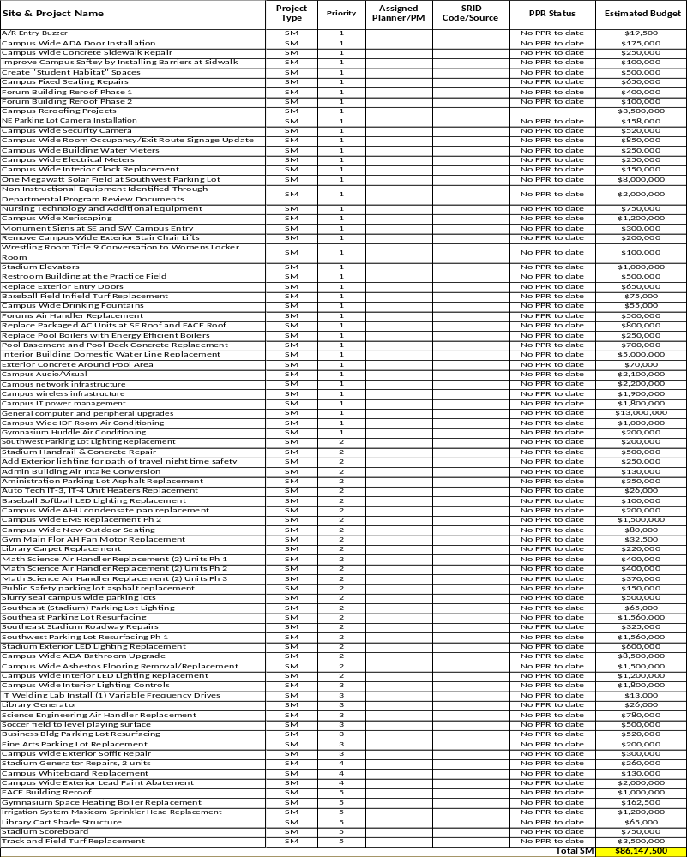
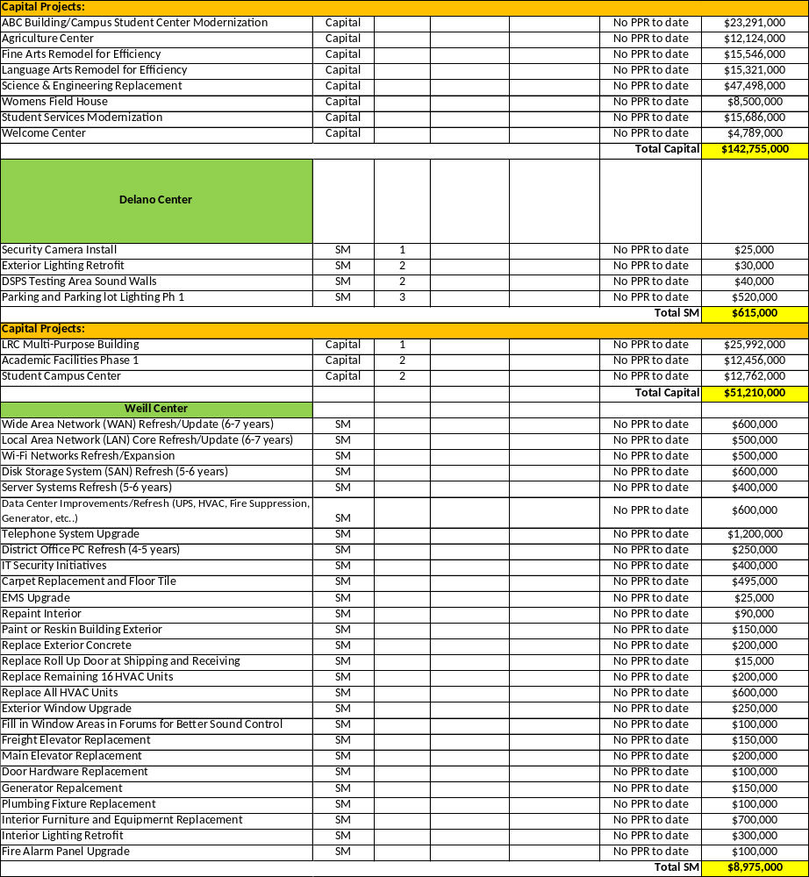

Appendix C2: Annual Program Review Maintenance and Operations Request

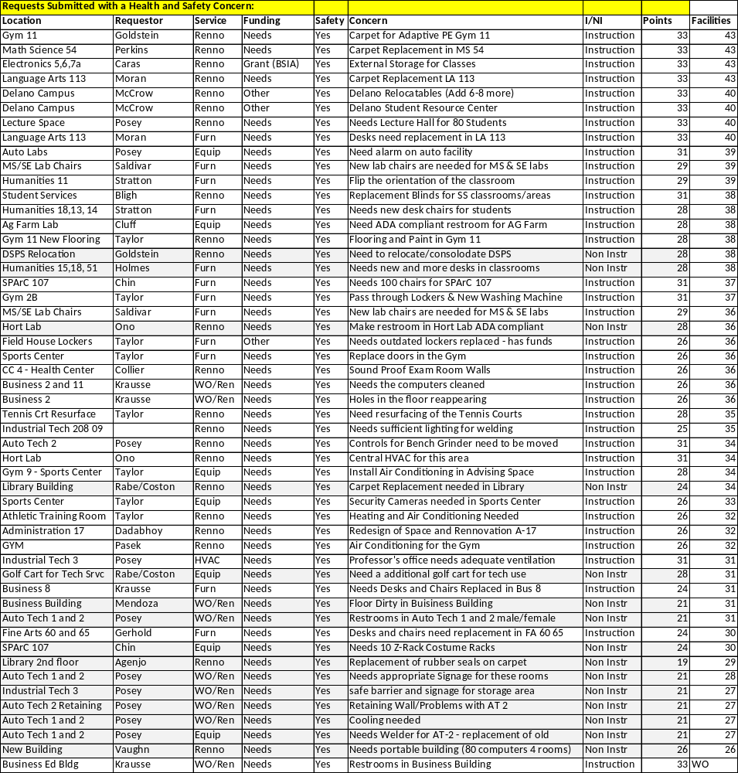

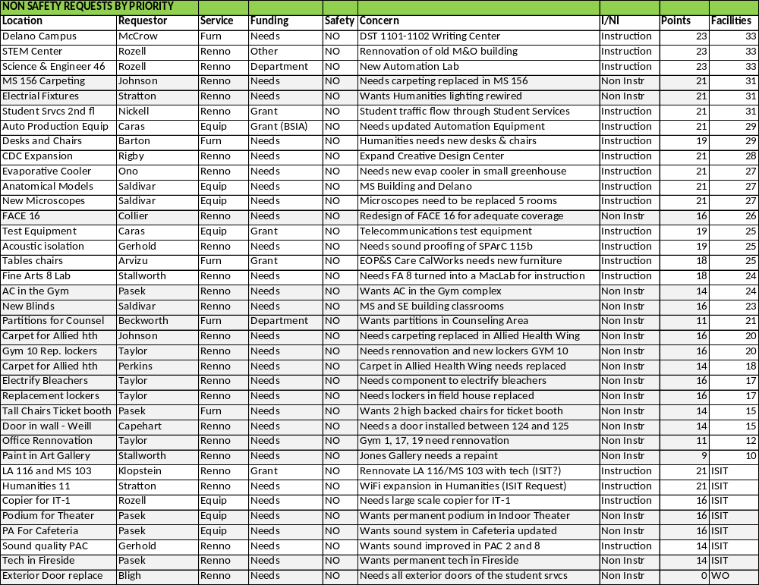
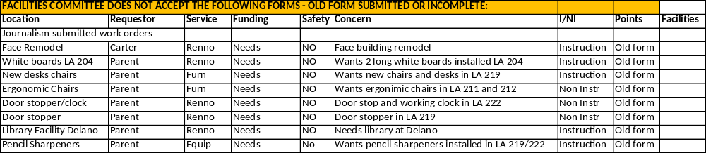

Appendix C3: Projected Allocation of 2016 Bond Funds

Project Type | Budget
Capital | $158,255,000
Drought | $6,225,000
Energy | $13,913,000
Exterior | $2,915,000
Hazardous/Safety/ADA | $16,903,000
Other | $25,119,500
Parking | $5,230,000
Roof | $5,000,000
Utility/Mechanical | $10,342,000
Total | $243,902,500

