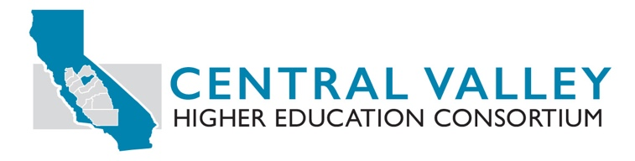

CVHEC Member Mini-Grant Fall 2020 to Spring 2021 Proposal
We are happy to inform you that the Central Valley Higher Education Consortium is once again providing mini-grants ranging from $5,000 to $7,500. In these difficult and uncertain times, the mini-grants are intended to fund activities of faculty and staff for implementation assistance and professional learning associated with Guided Pathways, Leading from the Middle, Math Pathways, implementation of AB 705 and EO 1110 and advancement of Pathways for Associate Degrees for Transfer. In response to the COVID Pandemic and calls for equity and racial justice, we are adding Basic Needs and Equity, Racial and Social Justice to the list of activities the dollars can provide assistance toward.

CVHEC is offering these grants that are broad in scope to assist Central Valley faculty, administrators, and staff as best fits institutional needs. The grant funds are available through the end of April 2021. We encourage you to apply for funding as soon as possible.

Instructions to Apply
Please provide CVHEC a succinct 1-page written request describing (1) the institution’s expected activity, (2) proposed budget for activity, and (3) timeline for use.

In addition, please complete this form and submit with the one-page request, to provide general information on the request.

General Grant Request
- College / University Name:
- Area of Focus / CVHEC Objective. Please select an area of focus / activity area:

- Guided Pathways
- Math Pathways
- Implementation of AB 705
- Implementation of EO 1110
- Basic Needs
- Equity, Racial and Social Justice
- Associate Degree for Transfer (ADT) / Transfer Pathway/Transfer Admission Guarantee (TAG)
- Other (Please explain)

Please select a CVHEC Board Objective that will be satisfied through the above selected area of focus/activity area:

- Persistence
- Time to Degree
- Degree / Completion
- Decrease Equity Gap

- Expected Timeline for when activity will occur:

- Invoicing

Identify the designated contact person(s) authorized for addressing mini-grant funding questions:

Name
Title
Address
Phone
Email

5. Primary Grant Administration Contact
Identify the Administrator or Project Facilitator that will ensure activities are performed and report is submitted.

Name
Title
Address
Phone
Email

6. Grant Invoice

Please plan on expending all dollars. Scope of Work and Mini-grant Invoice must be submitted electronically directly to Angel Ramirez via email at angelr@csufresno.edu

7. Proposed Budget

This is a SAMPLE budget, please be sure to provide costs for all activity and expenditures expected.

Brief Description by Category
Activities | Quantity | Cost | Total
Travel |  |  | Total
Conference | Quantity | Cost | Total
Other
Indirect 0% | 0 | 0 | 0
TOTAL ESTIMATED BUDGET |  | $

8. Reporting Requirements

The Primary Grant Administrator is responsible to submit a Final Activity Report upon the CVHEC Mini-Grant approved activity. Reports will be accepted at the end of activity and should follow the Final Activity Report template provided with this form.

Email Activity reports to: angelr@csufresno.edu

Please initial for Agreement with Reporting Requirement __________

9. Authorized Parties Executing Scope of Work Agreement

CVHEC Member College / University
Name |  | Phone
Title |  | Email
Signature |  | Date
Name |  | Phone
Title |  | Email
Signature |  | Date
Agency
Street Address
City, State, ZIP

Central Valley Higher Education Consortium
Full Name | Benjamin Duran
Title | Executive Director
Organization/Agency | CVHEC
Street Address | 550 E Shaw Ave, Ste 100
City, State, ZIP | Fresno, CA 93710

