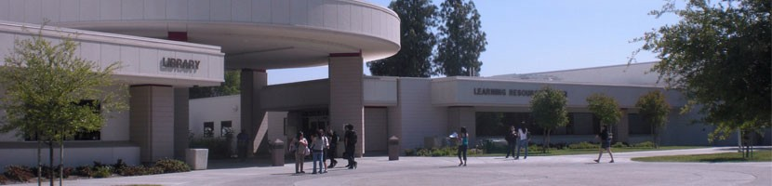

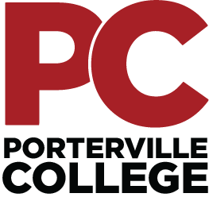

CAREER AND TECHNICAL EDUCATION DIVISION
PROGRAM REVIEW

Spring 2021

Career and Technical Education Division

Administration

Dr. Claudia Habib, President

Dr. Thad Russell, Vice President

Joseph Cascio – Interim Dean of Instruction

Full-Time Faculty

Administration of Justice Brandon Hall, Assistant Professor

Jeff Jacobs, Assistant Professor

Agriculture Craig Britton, Professor

Business Education Dr. Elisa Queenan, Professor

Stephanie Cortez, Assistant Professor

Child Development Mary Jo Jordan, Professor

Information Systems James Carson, Professor/Division Chair

Table of Contents

Introduction 4
Porterville College Mission Statement 4
Career and Technical Education Division Vision, Mission, and Values Statement 6
General Student Learning Outcomes 6
General Analysis of Performance 7
General Summary of Strengths and Areas of Improvement 7
Program-Specific Mission Statements, Program Reviews, and Student Learning Outcomes 8
Administration of Justice 8
Agriculture 14
Business Education 23
Child Development 31
Fire Technology 49
Industrial Technology 55
Information Systems 61
Summary 69

INTRODUCTION

The most effective Career and Technical Education Division is one in which its activities are well coordinated, the general campus community understands its programs, and its efforts integrated college-wide. This report provided the Career and Technical Education Division with an opportunity to assess their programs, identify strengths and areas of improvement, set goals, and establish a connection with the other programs in the division.

The Career and Technical Education Division’s desired outcomes of this report included evaluating program effectiveness; program improvement; looking ahead with established goals; and instilling a division and campus-wide understanding of the strengths and needs of all programs within the Career and Technical Education Division.

In an effort to integrate the Career and Technical Education Division into the operations of the college and the local community, this report provides a linkage between the Career and Technical Education Division with the college's mission statement and strategic plan. This way, the campus community can see the interrelationship of the Career and Technical Education Division's programs, the general campus, and the local community, and how these programs affect student learning, success, and job placement.

Career and Technical Education Programs

Administration of Justice (Public Safety)
Agriculture (Agriculture Production and Agriculture Business)
Business Education (Accounting, Business, Business Administration, Entrepreneurship, and Human Resources)
Child Development (Early Childhood Education)
Fire Technology (Fire Fighter I, Structural Fire Fighter and Wild land Fire Fighter) Human Services
Industrial Technology (Industrial Maintenance, Solar Sales and Power Technician) Information Systems

The Mission of Porterville College
With students as our focus, Porterville College provides our local and diverse communities quality education that promotes intellectual curiosity, personal growth, and lifelong learning, while preparing students for career and academic success.

In support of our values and philosophy, Porterville College will:
- Provide quality academic programs to all students who are capable of benefiting from community college instruction.
- Provide comprehensive support services to help students achieve their personal, career and academic potential.
- Prepare students for transfer and success at four-year institutions.
- Provide courses and training to prepare students for employment or to enhance skills within their current careers.
- Provide developmental education to students who need to enhance their knowledge and understanding of basic skills.
- Recognize student achievement through awarding degrees, certificates, grants, and scholarships.

The Values of Porterville College
Porterville College's core values define the character of the institution and are active ingredients in all that the College does. Through our commitment to these values the College can better serve and be more responsive to its students, staff, and community:
- Collaboration - working together to encourage input and dialogue in a collegial and cooperative manner.
- Respect - treating each other with respect, trust, and dignity.
- Innovation - nurturing and supporting exploration of new ideas, programs, and services to enhance our service to the community.
- Accountability - continuously assessing where we are as a College and to assume responsibility for all that we do.
- Equity – reducing achievement gaps between demographic groups.
- Participation - fostering and encouraging the involvement of staff and students in campus activities and the various aspects of the College decision-making process.

The Philosophy of Porterville College
In support of our mission and values, Porterville College will base its decisions and actions upon the following beliefs:
- All students at Porterville College will be treated with respect and dignity regardless of who they are or the goals they have established for themselves.
- The College staff will provide the best service possible to its students in order for them to meet their individual academic or vocational goals.
- The College will encourage innovation, creativity, and new ideas and will support professional development opportunities.
- As an integral part of the community, the College will develop and enhance partnerships with schools, colleges, universities, businesses and community-based organizations to respond to the educational, workforce, and economic development needs of the region.
- As an integral part of the Kern Community College District, the College will participate in and be actively involved with all district-wide committees and governance structures.

The Career and Technical Education Division is committed to the college's general mission in addition to the vision, mission, and values statements as listed below. The Career and Technical Education Division will maintain its responsibilities, complete its tasks, and serve our students in this spirit and dedication.

Career and Technical Education Division Vision, Mission, and Values Statement
Vision
The Career and Technical Education Division’s goal is to provide a quality education for a diverse population of students with all available resources while contributing to the institution's overall enhancement.
Mission
The Career and Technical Education Division supports the mission of Porterville College by providing programs and instruction for students that will enable them to achieve academic and career goals while meeting the needs of a diverse community. Our programs are continually reviewed and updated to better meet the needs of students whether their aspirations are a certificate, terminal degree, or prerequisites for transfer.
Values
In support of our mission statement, the Career and Technical Education Division is committed to certain core values that define the character of the programs we provide:
- Students – The Career and Technical Education Division values each individual student and is committed to the College Mission Statement’s introductory statement, “With students as our focus…”
- Learning – The Career and Technical Education Division supports student learning and career development and will provide necessary programs and services designed to enhance the overall learning experience of our students.
- Professionalism – The Career and Technical Education Division faculty and staff will work in a professional manner with students, colleagues, and administrators; treating everyone with the respect and dignity they deserve.
- Assessment – The Career and Technical Education Division is committed to an on-going process of assessment designed to monitor and improve the effectiveness of our programs to our students and community.

Career and Technical Education Division General Student Learning Outcomes

The Career and Technical Education Division supports the expectations of the Accrediting Commission for Community and Junior Colleges (ACCJC) in regards to student learning outcomes and their assessment. The following student learning outcomes are either general, i.e., those shared by all Career and Technical Education Division programs at Porterville College, or program-specific, i.e., those relating specifically to a program within the division.
Career and Technical Education Division General Program Learning Outcomes
- Students who actively participate in Career and Technical Education programs will apply ethical decisions related to personal, family, academic, professional, and community issues.
- Students who actively participate in Career and Technical Education programs will demonstrate personal responsibility and explain the principles of effective leadership.
- Students who actively participate in Career and Technical Education programs will separate ideas, texts, artistic expression, or data into parts to study interrelationships and articulate an informed response.
- Students who actively participate in Career and Technical Education programs will create written communication to convey information and express ideas for particular audiences.
- Students who actively participate in Career and Technical Education programs will examine, understand, question, and integrate new information.

The PLOs are assessed using summative assessments such as: multiple choice exams, hands-on projects, and written essays. The information collected on these evaluations will refine future class offerings, textbook choices and assessments.
Analysis of Current Performance
Porterville College career and technical education programs provide students with opportunities to obtain an education that reflects the needs of the community and anticipate changes in
demands in business and industry. Students completing CTE programs at Porterville College are in high demand in the job market.
Research indicates that by 2022 over 65% of all new jobs and 91% of jobs nationally (https://www.bls.gov/opub/mlr/2013/article/pdf/occupational-employment-projections-to-2022.pdf) will require post-secondary education, making vocational training more important than ever.
General Summary of Strengths and Areas of Improvement
The following are the strengths and areas of improvement shared by the majority of programs, as indicated in the individual program reviews. Since the areas of improvement listed below were consistent across the division, these are considered priorities within the Career and Technical Education Division. As college/program staffing, equipment, and facilities plans are being developed for the future, the areas of improvement listed below should be considered.
Strengths
The Career and Technical Education Division's faculty and staff are dedicated to their jobs and the success of our students.
The Career and Technical Education Division is actively working toward building partnerships within the community and with local high schools to develop a solid pathway to college by serving on advisory boards and participating in continuing outreach activities such as High School Senior Day, Career fairs, and College night.
The division is committed to student learning and the assessment of outcomes in an effort to improve and enhance the overall programs offered to the students. All programs in the division are actively assessing Student Learning Outcomes. All programs have completed Program Learning Outcomes. All programs have established timelines for Student Learning Outcomes and Program Learning Outcomes.
The division is actively involved in new curriculum development, program development, and course and program modifications to meet the growing college and local community's needs.
The CTE division employs resources such as the CTE Program Manager, CTE Counselor, and the Job Entrepreneurship Center (JEC) to help students complete meaningful educational goals.
The CTE division has expanded online offerings and now have courses offered in nearly all its programs.
Areas of Improvement
All programs have staffing concerns and require additional full-time, part-time, and additional support staff. The CTE division is currently staffed with six full-time faculty and one full-time contingent on funding faculty to oversee 14 programs.
Continued new program development continues to be a focus. Local high schools have successful pathways, and we strive to accommodate these students.
Perkins funding is a major financial resource for CTE programs. As programs meet Perkins's target requirements, this funding will be reduced, which will require programs to rely upon more on-campus general funds.
Program-Specific Mission Statements, Program Reviews, and Student Learning Outcomes:
It should be noted that the goals listed below for each program are not all-encompassing, but instead, they are highlighted or priority goals during the next program review cycle. Each program has various goals they intend to accomplish each academic year as part of their regular activities, so not all program-related goals are listed in the following program reviews. In addition, the Student Learning and Program Level Outcomes may be modified as assessments are completed reviewed, and programs modified accordingly.
Administration of Justice
Program Mission Statement:
The Administration of Justice program at Porterville College is dedicated to providing students a comprehensive understanding of our nation’s justice system and various actors. Through a student-centered approach, we strive to serve our local and diverse community by teaching students to think critically and maintain high levels of integrity while developing the necessary tools to succeed in their academic and professional journeys.
Student Learning Outcomes:
The student learning outcomes are analyzed yearly, usually occurring within weeks of the semester ending. Porterville College offers 23 Administration of Justice Courses, including a Module 3 and 2 Police Academy certified through California Peace Officers Standards and Training (POST). All 23 courses have Student Learning Outcomes (SLO) that have been approved by the Porterville College Curriculum Committee. The Administration of Justice program offers an Associate of Science- Transfer (AS-T), an Associate of Science (AS) in Public Safety, and an Administration of Justice Certificate. The Administration of Justice program is well-rounded and offers courses that meet our student population's inquisitive desires at Porterville College.
Program Learning Outcomes:
The Administration of Justice program is designed to meet the ever-changing and fluid demands of social justice, protection, apprehension, and understanding of a complex criminal justice system. The learning outcomes include but are not limited to identifying procedures involved in the justice system from initial contact through supervised release; identifying and exploring the criminal justice system as a complex series of agencies all working towards a common goal of public safety, protection, and rehabilitation; exploration of all three components of the criminal justice system; identify the components and elements of social justice; explore and identify the principles of implicit bias and bias based policing; along with the required learning domains associated with the modular police academy. The program assessment included an overview of success and foundational knowledge transfer to those students past and present. The analysis included the success rate of quizzes, final exams, and written essays and reflection papers. The program evaluates the potential of transferring some course content to online educational resources (OER), making the courses more accessible to students.
The outcome cycles for this program review have been completed. Some key observations made were the potential for revision of several course SLO’s, the identification of courses which meet IGETC requirements, but are not designated as such in the course catalog, evaluating courses being offered that are not in the C-ID and overlap with other courses, and the value of modifying an existing course to better serve transferring students.
After review, future / in progress program changes include: IGETC designations for qualified courses, an evaluation of current course offerings (SLO’s, degree paths, relevance to students’ needs), and the modification of an existing Administration of Justice course to meet the Cal State University diversity requirements for 2022 (Education Code 89032).
The request for IGETC designation for core courses has been submitted through articulation. The revisions to a currently offered course to meet the Cal State University diversity requirement are in progress, as are conversations about the future evolution of the program and course offerings.
Program Analysis and Trends:
Changes in Program over the Last Three Years
The last three years have seen significant changes within the Administration of Justice Program. Two years ago, the program added a second full-time faculty member to help offset the increasing demand for courses. At the conclusion of the 2019/2020 school year, the Administration of Justice program experienced a tenured faculty member's retirement. During the Fall 2020 semester, a newly hired full-time-faculty member joined the program.
Data Review
The following table summarizes enrollment data, overall course count, census enrollment, and FTES data for the past 3 years. As you will notice, the Administration of Justice program consistently enrolls over 900 students per semester with an impressive 94% retention and an 86% success rate. This past year 2019/2020, we experienced a 7.8% increase in students.
Year | Sections | Enrollment | FTES/FTEF | % Retained | %Succeeded
2017-18 | 21 | 922 | 15.4 | 91.2% | 83.6%
2018-19 | 22 | 973 | 14.8 | 91.7% | 82.7%
2019-20 | 23 | 1045 | 15.2 | 94.1% | 86.4%

The current job market analysis for the Motherload Regions (Kern, Tulare, Kings, Fresno) predicts a shortage of Law Enforcement professionals exceeding 13,000 job openings by 2021. Law Enforcement careers continue to be well paid, with a median wage from ($80,008 to $154,607). The added benefits of health insurance and retirement possibilities increase this desire to pursue a career in Law Enforcement. The overall increase of approximately 5% is expected to increase the hourly wage to a median range of $52.00-$74.33/hr, according to EMSI.

The continued growth and success within the Administration of Justice program indicate the increased demand for law enforcement professionals. Police, Probation, Parole, and Correctional Officers are in high demand, and the need to fill these positions with educated individuals whose career path traverses through the Community College system.

There is little doubt the recent impacts and demands for social justice and equity will continue for years to come. Fortunately, at Porterville College, our Administration of Justice program has been discussing these issues for years. This desire for inclusion, transparency, honest communication, and trust are foundational to our program.
Program Strengths
The Administration of Justice program at Porterville college is highly desirable and remains relevant and current in today’s workforce. Enrollment within the Administration of Justice program remains strong and is consistently one of the most sought-after programs offered at Porterville College. The continued success and training Cadets receive within the Modular Police Academy directly impact the overall safety and security of our communities. The POST Academy, in conjunction with the diverse offering of Administration of Justice courses, serves our student population’s needs and wants well at Porterville College.
Areas for Improvement
Seek Intersegmental General Education Transfer Curriculum (IGETC) certification for foundational Administration of Justice courses.
Refine course descriptions and Student Learning Outcomes (SLO)
Evaluate extraneous courses for alignment with C-ID and streamline degree and certification paths to ensure they serve students’ needs.
The growth and popularity of the program necessitates hiring a full-time Administration of Justice professor. Currently, the program has a full-time COF position. The program has large waitlists and graduation rates. The COF position is necessary to meet the needs of students. If this position were to not be funded in the future, the program and students would suffer.

Goals

Goal(s) | Completion Date | Needed resources | Person(s) Responsible | Obstacles to completion (if any)
1. Refine course descriptions and Student Learning Outcomes | December 2021 |  | FT ADMJ faculty

Which of the numbered items under the Mission Statement (see page 1 of this document) will be furthered if this goal is completed? (select all that apply)

Item 1_X__ Item 2___ Item 3_X__ Item 4_X__ Item 5_X__ Item 6_X__

Progress on Goal:

____Revised (Date )

Comments:

Staffing Request:
Staff Resources:
Current Staffing Levels  Full-time Staff |  |  | Part-time Staff
Faculty |  | 2 | Faculty |  | 6
Temporary |  |  | Temporary
Classified |  |  | Classified
Management |  |  | Management
Project dates of temporary staff:

Request for New/Replacement Staff
Use one line for each position requested. Justify each position in the space below.

 | Title of Position |  | Classification  (Faculty, Classified, or Management) | Full or Part  Time |  | New or Replacement
Position 1 | ADMJ Instructor |  | Faculty | Full-time |  | New
Position 2
Position 3
Justification:
The Administration of Justice program has always been one of the most popular programs on campus. With class sizes consistently over 45 and perennial wait-lists, the CTE division recently added a Full-time (contingent on funding) position. This position has been a great benefit to our program. However, the nature of COF funding makes this position temporary.
Technology Request:
Technology Need | Justification
Item 1 | N/A Technology needs are currently being met by the division.
Item 2 | N/A

Facilities Request:
Facilities Need | Justification
Item 1  Dedicated Law Enforcement Academy Room | Currently, the college’s law enforcement academy students share space with other program(s). A dedicated space would be desired due to the potential need for a space to change out of uniforms and into physical training (PT) gear during the course of a day of instruction. Additionally, law enforcement training has sensitive program-specific equipment and materials which require safe, secure, and private storage separate from other programs.
Item 2

Safety and Security Request:

Safety & Security Need | Justification
Item 1 | N/A Safety and Security needs are currently being met by the division.
Item 2

Professional Development Request:

Professional Development Need | Justification
Item 1 | N/A Professional Development needs are currently being met by the division.
Item 2

Budget Request:

 | Current Budget | Amount of Change | Revised Total
2000 (Student Worker Only)
4000 | $500 |  | $500
5000
Other
Justification:
Program’s budgetary needs are currently being met with the existing budget.

Agriculture
Program Mission Statement:
The Agricultural Department supports the mission of Porterville College by providing instruction for students that will enable them to achieve their academic and career goals while addressing the needs of the community. These programs will enhance educational opportunities that lead to increased employment prospects in the technical fields in agricultural. We are committed to a continuous process of evaluating our program to better meet the needs of students whether their aspirations are a certificate, an AA Degree as a terminal degree or preparation for transfer to a four-year institution.
Student Learning Outcomes:
The following courses have identified student learning outcomes that have been approved by the Curriculum Committee. The assessment of these outcomes is ongoing with all of the assessments in each course being completed every two years. These assessments are bring used to make adjustments to the program to enhance comprehension and mastery of the subject areas.

Course Number & Name Curriculum Committee Approved SLO
Agri P101 Introduction to Agribusiness Approved
Agri P102 Agricultural Economics Approved
Agri P103 Agricultural Sales Approved
Agri P105 Farm Accounting Approved
Agri P104 Computer Apps in Ag Approved
Agri P106 Intro to Soil Science Approved
Agri P107 Agricultural Marketing Approved
Agri P117 Plant Propagation/Production Approved
Agri P131 Intro to Plant Science Approved
SLO assessments have been completed on Plant and Soil Science and assessments are ongoing on the balance of the courses. CTE is on a 2-year assessment plan with all of the courses being assessed semi-annually.
The SLO’s are assessed using True/False, multiple choice and subjective exams, hands-on projects, and laboratory analysis. With the current pandemic, adjustments have been required to the hands-on aspects and the laboratory component of the ag science course have been converted to PC staff prepared videos that the students are to watch and complete the labs based on their observations rather than actually conducting the experiments themselves.

Program Learning Outcomes:

Criteria for assessment:
Because Course Student Learning Outcomes are tied to Program Student Learning Outcome’s and visa-versa, grades in the course will be used to assess program Student Learning Outcome’s. Each Instructor will determine assessment tools in each of their courses that will directly assess the Program Student Learning Outcome’s for that cycle. Percentages of passing (70%) and mastery (90%) of the Student Learning Outcome’s will be submitted to the Division Chair.
The Program Level Outcomes are as follows:
- Demonstrate a comprehensive understanding of various types business practices and their role in our agricultural economy and society.
- Demonstrate an understanding of the anatomy and physiology of plants in their roll in providing the world with food, feed and fiber
- Demonstrate an understanding of the roll of healthy, productive soil as a medium in which we grow the food, feed and fiber.
- Demonstrate an understanding in the processing, marketing, distribution of food, feed and fiber to the world in a form that enhances the demand for various agricultural commodities.

Program Analysis and Trends:

Changes in Program-

The Ag Program has, and will continue to be modified to meet industry needs and standards. We added the AST in Agribusiness 2 years ago to address expressed needs of the industry and give students additional options within the Ag Industry. The Associate of Arts (“AA”) in Ag Production is being changed to an Associate of Science Degree to better match what other Community Colleges are offering and to better match what the CSU system is accepting.
Areas in the programs that are looked at are: Demographics (the majority of Porterville College’s student body are of Hispanic descent. To many, Agriculture is the boogie man and they equate “Agriculture” to working in the fields. Recruiting into the Ag Programs has been an uphill battle because of that misperception. In recent years, we have changed that perception by adding a new degree and modifications to the existing degree), retention/completion in the programs and transfer rates are reviewed to make adjustment to the degrees to better meet student needs by removing obstacles to their success.

Labor Projections Short and long term:
California Short-term employment projections show and increase statewide in the short term (2021) of 1.94% or 134,090 over 2019, that is a change of 12,000 jobs. The medium annual salary range is $46,291 with a bachelor’s degree down to $32,261.
The regional Long-Term (2016-2026) projections including; Bakersfield, Fresno, Hanford/Corcoran and Visalia/Porterville.
Bakersfield/Kern County shows a projected increase in employment demand of 15.12%, or 59,150 over the 10 year period. The medium annual salaries range from $38,902 with a bachelor’s degree down to $30,617.
Fresno Long-Term shows a projected increase in employment demand of 61,8600 over the 10 year period. The medium annual salaries range from $45,549 with a bachelors degree down to $25,385.
Visalia/Porterville shows a projected increase in employment demand of 51,040 over the 10 year period. The medium annual salaries range from $36,000 with a bachelor’s degree down to $25,772
Hanford/Corcoran shows an increase of 15.03%, or 8,600 jobs. The medium annual salaries range from$52,450 with a bachelor’s degree down to $31,269.
Overall in our immediate service area the job prospects look positive for the foreseeable future with and ever-increasing demand for those individuals with a formal education.
Program Strengths:
The faculty in the Ag Program, both full time and adjunct, having worked in many facets of the Ag industry offer the students many years of hands-on practical experience both from the ag business side and the ag production side. Students in the program, both as ag majors and students taking ag courses that fulfill Gen-Ed graduation requirements, leave the program with a better understanding of what the Ag industry provides to the overall economy, what it takes to get products from the farm to the final consumer and finally what job opportunities exist locally, nationally and internationally. One of the areas that faculty try to emphasize is that every country south of our southern border (with the exception of Brazil) speak Spanish and being bi-lingual English/Spanish is a huge advantage in the marketing and distribution of US produced food and fiber.
Areas for Improvement:
Staffing is always an area for improvement. It is difficult for find qualified adjunct faculty. Those that meet our qualifications are generally working full time elsewhere. It is also difficulty to find adjunct that have experience in Ag Business, Ag Production and in the classroom. We will continue to solicited solid applicants for our Adjunct pool with part of our focus being on international trade as the US is very dependent on export to lower commodity surpluses to strengthen prices domestically.
Goals
Goal(s) | Completion Date | Needed resources | Person(s) Responsible | Obstacles to completion (if any)
1. We have added an additional degree (AS-T Agribusiness) to increase opportunities for students | 2018 | Additional faculty | Craig Britton | Finding qualified applicants with background in Ag Production, agribusiness and teaching.

Which of numbered items under the Mission Statement (see page 1 of this document) will be furthered if this goal is completed? (select all that apply)
Item 1_X__ Item 2___ Item 3___ Item 4___ Item 5___ Item 6___
Progress on Goal:
_X___Completed (Date )
____Revised (Date )
Comments:

Goal(s) | Completion Date | Needed resources | Person(s) Responsible | Obstacles to completion (if any)
2. All of the courses taught in the Ag department are 100 series transferable courses |  | Additional faculty | Craig Britton | Finding qualified applicants.

Which of numbered items under the Mission Statement (see page 1 of this document) will be furthered if this goal is completed? (select all that apply)
Item 1___ Item 2___ Item 3__X_ Item 4___ Item 5___ Item 6___
Progress on Goal:
____Completed (Date )
____Revised (Date )
Comments:

Goals
Goal(s) | Timeline for Completion | Needed resources | Person(s) Responsible | Obstacles to completion (if any)
1. Reinstitute the Principles of Pesticide Use to fulfill a need in the industry | Fall 2021 | n/a | Craig Britton | Restructuring the course and rewriting the curriculum.  Finding qualified faculty to teach the course.

Which of numbered items under the Mission Statement (see page 1 of this document) will be furthered if this goal is completed? (select all that apply)
Item 1___ Item 2___ Item 3___ Item 4_X__ Item 5___ Item 6___
Progress on Goal: The curriculum will be revised into 6- ½ unit classes to better fit what is needed for continuing Ed for PCA’s and PCO’s. Rather than a 54-hour 3-unit course, it needs to be changed to 6-1/2 unit modules which will shadow the categories for the California Department of Pesticide Regulations PCA/PCO license
____Completed (Date )
____Revised (Date )
Comments:

Goal(s) | Timeline for Completion | Needed resources | Person(s) Responsible | Obstacles to completion (if any)
2. Revisit offering a Mechanized ag program to dovetail into the Industrial Maintenance program | Fall 2021 | To be determined | Craig Britton | Budget restraints

Which of numbered items under the Mission Statement (see page 1 of this document) will be furthered if this goal is completed? (select all that apply)
Item 1___ Item 2___ Item 3___ Item 4___ Item 5__X_ Item 6___
Progress on Goal: We have the curriculum that was developed by CSU Fresno. We tried to hire a full-time faculty 2 years ago to teach the Ag Mechanization and the Industrial Maintenance programs but were unsuccessful in drawing an acceptable applicant pool. This should be revisited with the new administration.
____Completed (Date )
____Revised (Date )
Comments: This additional program and a full-time faculty would allow for better utilization of current facilities

Staffing Request:

Staff Resources:
Current Staffing Levels  Full-time Staff |  |  | Part-time Staff
Faculty |  | 1 | Faculty |  | 4
Temporary |  |  | Temporary
Classified |  |  | Classified
Management |  |  | Management
We currently have 2 adjunct faculty that are teaching the maximum number of units allowed. More classes could be offered if we could find additional adjunct to teach them.

Request for New/Replacement Staff

 | Title of Position |  | Classification  (Faculty, Classified, or Management) | Full or Part  Time |  | New or Replacement
Position 1 | Ag Production & Agribusiness |  | Faculty | 1 full time |  | Replacement
Position 2 | Ag Production and Agribusiness |  | Adjunct faculty | Part time |  | New and replacement
Position 3
Justification:
- The one full time instructor will be retiring in the next couple of years and if the Ag Program is to continue to provide valuable, high demand classes and continue to grow, another fulltime instructor will be necessary.
- Adjunct faculty in this subject area of Ag Science and Agribusiness are hard to find because they are generally already working full time.

Technology Request:

Technology Need | Justification
Item 1  A Computer cart | This would provide access to research in class. Now that all of these courses have been offered online and the curriculum has been revised to be delivered in an online format, I see the integration of Canvas as a benefit of a hybrid environment.
Item 2 | Additional Laboratory equipment to update and enhance what we currently have.

Facilities Request:

Facilities Need | Justification
Item 1 | None needed at this time
Item 2

Safety and Security Request:

Safety & Security Need | Justification
Item 1 | The first aid kit to the Soils lab has been depleted over time and either needs to be replaced or restocked.
Item 2

Professional Development Request:

Professional Development Need | Justification
Item 1 | None needed at this time.
Item 2

Budget Request:

 | Current Budget | Amount of Change | Revised Total
2000 (Student Worker Only)
4000
5000
Other

Justification:

Historically this program has been funded with VTEA funds and three accounts (from donations and PC Aggies fund raisers) that the program has in the Business office, and no additional funds were necessary

Business Education

Program Mission Statement:
The Business Education program supports Porterville College's mission by providing instruction for students that will enable them to achieve their academic and career goals while addressing the needs of the community. We are committed to a continuous process of evaluating our programs to better meet the needs of students whether their aspirations are an Associate’s degree, preparation for transfer, and/or a certificate.
Student Learning Outcomes:
The Business Education program has five areas of emphasis; Accounting, Business Administration, Entrepreneurship, Human Resources, and Logistics. There are a collective total of 34 courses in these areas. All scheduled courses and programs have approved student learning and program-level outcomes. All active courses have had at least one student learning outcome assessed with timelines in process to complete the assessment of all course level student learning outcomes within the four-year cycle.
The continual semester review of our student learning outcomes forced a more comprehensive review of the entire Business curriculum. There were a number of learning outcomes that were misaligned which required revision. For example, BSAD 155 Business Statistics, had a student learning outcome related to Macroeconomics. In 2020, the majority of Business courses were sent through curriculum for an initial SLO revision. During the 2021AY a second round of courses are being sent through curriculum again to further refine SLOs.
After review of the Business curriculum it was determined that Business is contributing to the confusion within counseling because there is very little crossover between the Associate of Science degrees and the Associate of Science for Transfer degree. This is requiring further revising of all Business degrees.
Program Level Outcomes:
There are currently five programs with degree and certificate awards
- Associate of Science for Transfer Degree- Business Administration
- Analyze business, economic, or financial principles and explain their application to the real-world.
- Apply written and verbal communication skills in a business relationship, a teamwork setting or a leadership position.
- Apply the importance of Ethical behavior in the business environment.
- Demonstrate technological competency by using technology effectively in the business environment or workplace.
- Explain the significance of international cooperation to the success of global business.

The PLOs are assessed using summative assessments such as multiple-choice exams, hands-on projects, and written essays. The information collected on these evaluations will refine future class offerings, textbook choices, and assessments.

- Associate in Science Degree- Accounting /Entrepreneurship/Human Resources/Logistics
- Analyze business, economic, or financial principles and explain their application to the real-world.
- Apply written and verbal communication skills in a business relationship, a teamwork setting or a leadership position.
- Apply the importance of Ethical behavior in the business environment.
- Demonstrate technological competency by using technology effectively in the business environment or workplace.
All Associate of Science degrees have one program learning outcome evaluated each year through a summative assessment.
The PLOs are assessed using summative assessments such as: multiple choice exams, hands-on projects, and written essays. The information collected on these evaluations will refine future class offerings, textbook choices and assessments.
- Accounting – Certificate of Achievement
- Demonstrate knowledge in accounting for external financial reporting and managerial applications.
- Research accounting literature for both structured and unstructured problems in external financial reporting, tax and auditing.
- Recognize and analyze ethical problems in practical accounting situations; select and defend a course of action.
- Effectively communicate complex accounting concepts, both orally and in writing.

The PLOs are assessed using summative assessments such as: multiple choice exams, hands-on projects, and written essays. The information collected on these evaluations will refine future class offerings, textbook choices, and assessments.
- Entrepreneurship – Certificate of Achievement
- Analyze business, economic, or financial principles and explain their application in an entrepreneurial setting.
- Apply written and verbal communication skills in an entrepreneurial business relationship, a teamwork setting, and entrepreneurial leadership position.
- Apply the importance of ethical behavior in the entrepreneurial business environment.
- Demonstrate technological competency by using technology effectively in the entrepreneurial business environment.

The PLOs are assessed using summative assessments such as: multiple choice exams, hands-on projects, and written essays. The information collected on these evaluations will refine future class offerings, textbook choices and assessments.
- Human Resources – Certificate of Achievement
- Identify the legal and ethical context of Human Resource Management.
- Explain the Federal, State, and local laws that affect public and private employers.
- Describe the importance of staffing an organization including planning, job analysis, recruitment, and selection of staff.
- Explain labor relations and collective bargaining agreements in the public and private sectors.

The PLOs are assessed using summative assessments such as: multiple choice exams, hands-on projects, and written essays. The information collected on these evaluations will refine future class offerings, textbook choices and assessments.
- Logistics – Certificate of Achievement
- Prepare students in warehousing, operations, supply chain, distribution, transportation, purchasing, and global logistics to enter into or advance within management career patterns of the logistics industry.
- Provide an opportunity for students to complete a short-term intensive, hands-on program preparing them for employment in the logistics field.

The PLOs are assessed using summative assessments such as: multiple choice exams, hands-on projects, and written essays. The information collected on these evaluations will refine future class offerings, textbook choices, and assessments.
Timelines for assessment are being developed to assess the program learning outcomes within four years.

Analysis of Current Performance:
Porterville College’s Business program goal is to provide a quality education for a diverse population of students with all available resources while contributing to the institution's overall enhancement. The program currently offers degrees and certificates in Accounting, Business Administration, Entrepreneurship, Human Resources, and Logistics.
Degrees Issued:
Business Education issued 68 transferable Associate Degrees during the 2019-2020 academic year. AS-T degrees increased by 34.09% from the 2018-2019 academic year; 96.6% increase from the 2017-2018 academic year.
Program Student Completion:
Student completion rates have stayed within the 92% range since 2017, with 92.9% during the 2019-2020 academic year

Course Enrollments:
Looking at the core subjects within Business Education: Accounting, Business Administration and Economics enrollment has increased between the 2017-2018 and 2019-2020 academic years.

Subject | 2017-2018 | 2019-2020 | Total Enrollment % Change
Accounting | 114.0 | 163.0 | 42.98
Business Administration | 415.0 | 782.0 | 88.43
Economics | 145.0 | 236.0 | 62.75

Course Count, Section Count, FTES
Looking at the core subjects within Business Education: Accounting, Business Administration and Economics there was an increase in section counts and FTES between the 2017-2018 and 2019-2020 academic years.
Subject | 2017-2018 |  |  | 2019-2020
 | Course Count | Section Count | FTES | Course Count | Section Count | FTES
Accounting | 2.0 | 4.0 | 11.93 | 2.0 | 5.0 | 16.86
Business Administration | 8.0 | 20.0 | 39.03 | 9.0 | 24.0 | 75.82
Economics | 2.0 | 4.0 | 15.20 | 2.0 | 6.0 | 20.09
Student Success Rates:
Student success rates have fluctuated within the core subjects of Accounting, Business Administration and Economics between the 2017-2018 and 2019-2020 academic years. This is likely due to the increase in enrollment and section offerings.

Subject | 2017-2018 | 2019-2020
 | Success Rates | Success Rates
Accounting | 92.1 | 84.3
Business Administration | 83.4 | 75.0
Economics | 77.2 | 86.3

Degree Awards by Ethnicity:
The diversity of the program is reflected in the following 3 year totals:

Race | Degree Type | Totals
African American | A.S.-T Degree | 1
 | A.S./A.A. Degree | 0
 | Certificate of Achievement | 0
 | Job Skills Certificate | 1
Asian/Filipino | A.S.-T Degree | 2
 | A.S./A.A. Degree | 1
 | Certificate of Achievement | 0
 | Job Skills Certificate | 0
Hispanic/Latino | A.S.-T Degree | 105
 | A.S./A.A. Degree | 12
 | Certificate of Achievement | 5
 | Job Skills Certificate | 3
Two or More Races | A.S.-T Degree | 3
 | A.S./A.A. Degree | 1
 | Certificate of Achievement | 0
 | Job Skills Certificate | 0
White | A.S.-T Degree | 21
 | A.S./A.A. Degree | 2
 | Certificate of Achievement | 0
 | Job Skills Certificate | 0

Looking at projected occupational openings within Tulare County it is challenging to narrow down what occupations are the best fit for an individual who has earned a degree in Business Administration. This process is challenging because the skills acquired within Business Education are incredibly broad. Additionally, we want to identify occupations which produce a living wage for our students. Searching within the long-term occupational sphere of Office and Administrative Support Occupations and positions which make over $12.00 per hour, there is 1 projected occupation (100 projected open positions) which requires an associate degree, 1 which requires some college, no degree, and 30 which require a high school diploma.
According to BLS, on a national level, this field is projected to decline 5 percent by 2029, with technology replacing approximately 959,700 of the positions. This field's annual wage was $37,580, which is below the median wage for all occupations.
Program Strengths and Areas for Improvement:
The Business Education program offers 1 transferable degree, 4 A.S. degrees, 4 certificates of achievement and 4 job skill certificates. Each certificate is stackable and embedded into a degree.
Porterville College as a whole, CTE and Business Education have worked closely with all the major area high schools to establish several dual enrollment courses and works with the PUSD Business pathway advisory boards to assess and support student needs. The strength of the Business Education program is the ability to enable students with enduring and essential skill which will carry over into any academic program or career pursuits.
While the Business Education program has prided itself on the depth of courses and degrees offered, the current COVID climate, the shift in the labor market, and anticipated budgetary constraints for the next few years require a detailed look at our current roadmap. After reevaluation, the Business Education department has decided to:
Inactivate our Logistics A.S. degree, certificate of achievement, and job skills certificate
There have not been qualified faculty within this field since the creation of the degree & after meeting with local businesses, there isn’t community demand.
Inactivate our Customer Service Academy
Move away from remedial courses to streamline students' use of financial aid and time to degree completion.
Revise our transfer degree to align with the newest Transfer Model Curriculum and
Re-submit every Business Education course through curriculum to ensure all student learning outcomes are aligned to meet the need of our COVID environment.
Additionally, the lack of demand for individuals with an earned associate’s degree in business within the Central Valley is prompting the Business Education department to re-evaluate how to empower students to use their education in a way that augments their personal economy the most. We believe that using our mission to reframe our degree is most important, and we see two paths which can benefit our students. An earned Business Administration degree would provide a competitive edge for the numerous jobs within Tulare County which only require a high school diploma. Additionally, the same degree provides a cost-efficient and solid platform with which students can use to complete their bachelor’s degree at the university level.

Goals

Goal(s) | Timetable for  Completion | Needed resources | Obstacles to  completion (if any)
1. Revise the entire Business Education degree models | By Fall 2021 | Time | Time

Which of numbered items under the Mission Statement (see page 1 of this document) will be furthered if this goal is completed? (select all that apply)
Item 1_X__ Item 2___ Item 3__X_ Item 4_X__ Item 5__X_ Item 6_X__

Our entire mission is focused on equipping students with skills in demand and meeting community needs.

Progress on Goal:

Completed (Date )
Revised (Date )

Staffing Request:
Staff Resources:
Current Staffing Levels  Full-time Staff (FTE) |  |  | Part-time Staff (FTE)
Faculty |  | 2 | Faculty |  | 4
Temporary |  |  | Temporary
Classified |  |  | Classified
Management |  |  | Management
Request for New/Replacement Staff
Use one line for each position requested. Justify each position in the space below.
 | Title of Position |  | Classification  (Faculty, Classified, or Management) | Full or Part Time |  | New or Replacement
Position 1 | N/A

Budget Request:
 | Current Budget | Amount of Increase | Revised Total
2000 (Student)
4000 | $250 | $2000 | $2250
5000
Other

Justification:
Estimated amount for general office supplies and equipment. Currently, the program uses Perkins money to assist in funding new ventures. However, there is little money for the maintenance and daily operations in the current budget. Restrictions on Perkins money do not allow funds to be used for daily operations and supplies. Instructional and Non-
Instructional supplies will need to be addressed in the college budget.

Child Development
Program Mission Statement:
Porterville College Child Development has three major responsibilities: academic preparation, workforce development and leadership. The Child Development Program provides students with academic courses based on child development theory and best practices in early care and education. Child Development students are provided with courses that orient them to the field of early care and education; providing the opportunity to develop the knowledge, skills and abilities to be successful in the workforce. Early Childhood Education/Child Development faculty engage in leadership through collaboration with educational, community, industry, state and federal partners.
Student Learning Outcomes:
- Students will assess their own skills and abilities and apply knowledge of development and major theoretical frameworks to child observations.
- Students will demonstrate knowledge of and explain children’s development from conception through adolescence in the physical, social, emotional, and cognitive domains.
- Students will demonstrate critical thinking skills when describing the cultural, economic, political, and historical contexts that impact children’s development.
- Students will demonstrate effective communication and comprehension skills while describing strategies for collaboration with families to support children’s development and learning that are respectful, reciprocal, and engaging.

Child Development faculty and adjunct faculty use the results of assessment along with other indicators to maintain the quality and effectiveness of Early Childhood Education Courses that the students receive at Porterville College. The process of outcomes assessment may include curricular changes, pedagogical changes, or a recommendation of changes from the Child Development instructors and Child Development Advisory members. Assessments of SLO’s are conducted on a one year cycle.
Child Development noticed that students are doing very well on SLO 1, 2, and 3. Child Development did notice SLO 4 wasn’t working as well as hoped, so instructors are modifying their curriculum to emphasis the need to collaborate with families to support children’s development and learning within our community.

Program Learning Outcomes:
1. Synthesize child development research with principles and practices for early childhood teaching to create early learning environments that are respectful, supportive, and challenging for all children, from infancy through adolescence.
2. Design inclusive, culturally and linguistically appropriate learning environments, based on child development, child observations, family information and knowledge of culturally diverse child rearing practices.
3. Incorporate strategies for building respectful, reciprocal family and community relationships in order to support families with their children’s development and learning.
4. Assess children’s learning through observation, documentation, and interpretation, using results to guide curriculum and teaching strategies.
5. Recommend developmentally appropriate and culturally relevant approaches to teaching and learning that include respectful, supportive relationships with children and families, and curriculum that supports foundational skills and concepts in language, math, science, art, and social relationships
6. Demonstrate practices that maintain standards of health, nutrition, and safety in group care early childhood settings.
7. Apply ethical standards of behavior accepted by the profession of early childhood education.
The PLO’s are assessed using summative assessments such as: multiple choice exams, hands-on projects, and written essays. The information collected on these evaluations will refine future class offerings, textbook choices and assessments.
Timelines for assessment are being developed so that the program learning outcomes may be assessed within a four-year period.Program Analysis and Trends:
Program Analysis and Trends:
Changes in Program over Last Three Years
Child Development Program at Porterville College added an Early Childhood Education Associate in Science for Transfer Degree.
Child Development Program at Porterville College added two new Child Development Certificates of Achievement. These new Certificates of Achievement are, The Early Child Care Administration Specialization Certificate and Early Intervention Assistant Certificate.
Child Development at Porterville College recognizes that there are multiple regulatory agencies that determine requirements for employment. Child Development remains current in all regulatory updates surrounding each of these including the California Department of Social Services, Community Care Licensing Division which is responsible for monitoring compliance with Title 22 basic safety regulations in all licensed child care programs and family child care homes, California
State Department of Education, Child Development Division which is responsible for monitoring compliance with Title 5 care and education regulations in State funded centers and there are additional regulations and expectations set by specific employers and funding sources.
The State Department of Education, through Title 5, has established the Child
Development Permit, which is the basis for a career ladder for persons working in early care and education programs. The California Commission on Teacher Credentialing issues these permits after reviewing the education and experience of applicants. The Child Development Permit Matrix for Child Development Preschool and School Age Children have been revised to meet the ever changing needs of the field this last year. These updates and changes within the above listed agencies are all ongoing.
Child Development grants have had recent changes in funding due to the California State Budget reductions in Early Care and Development. The California Early Childhood Mentor Program will only be funded through July 1, 2021. This funding reduction will eliminate both the Mentor Teachers and Director Mentors for community colleges statewide. The impact on Porterville College is that Child Development Students will no longer have the opportunity to do their lab portion of classes with a Mentor Teacher. The elimination of the Porterville College Campus Child Care center will cause students to connect with State and Federally funded centers to complete their labs connected to course work. This will increase the work load for the Child Development full time faculty as contracts between Kern Community Colleges and Child Care centers in the area will need to be established.
The Child Development Training Consortium Grant has been replaced by the Training Consortium Educational Support Grant. Porterville College Child Development full time faculty is being updated on edibility requirement for student to receive funding by means of stipends.
Child Development remains focused in meeting the Porterville College student’s needs in this ever changing program of study.
Data Review
The KCCD Office of Institutional Research and Reporting has provided most of the data provided here in this data review of the Child Development Program at Porterville College. This data review has been broken down in appropriate sections. If any data was provided from other than the KCCD Office of Institutional Research and Reporting, it will be stated.
Demographics:
Ethnicity:
The majority of enrollments in the Child Development Program are students of ethnic backgrounds, predominantly of the Hispanic/Latino background. The next highest enrollment is of those students with Caucasian backgrounds. This enrollment trend reflects an accurate representation of our college wide enrollment statistics and can be seen below.

Child Development Ethnic Enrollment
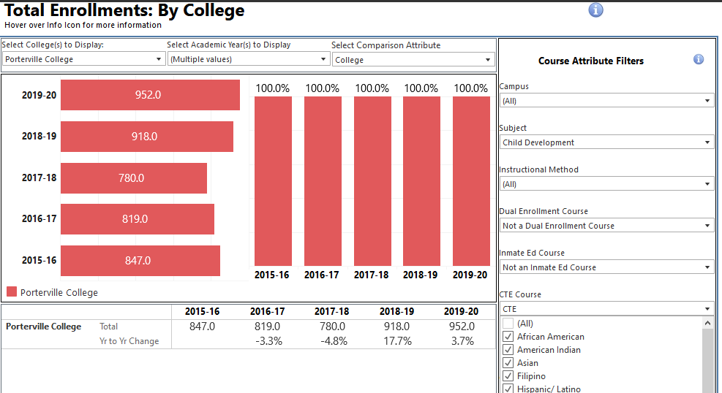

Child Development Hispanic/Latino Enrollment
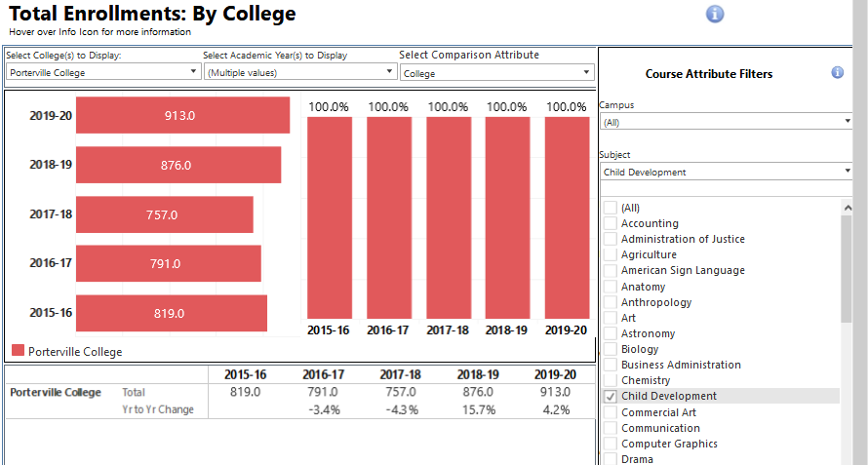

Child Development Caucasian Enrollment
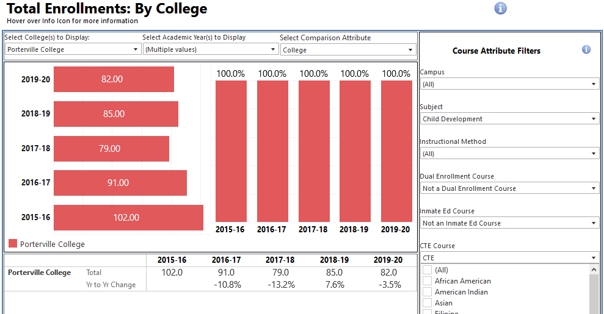

Campus Wide Ethnic Enrollment
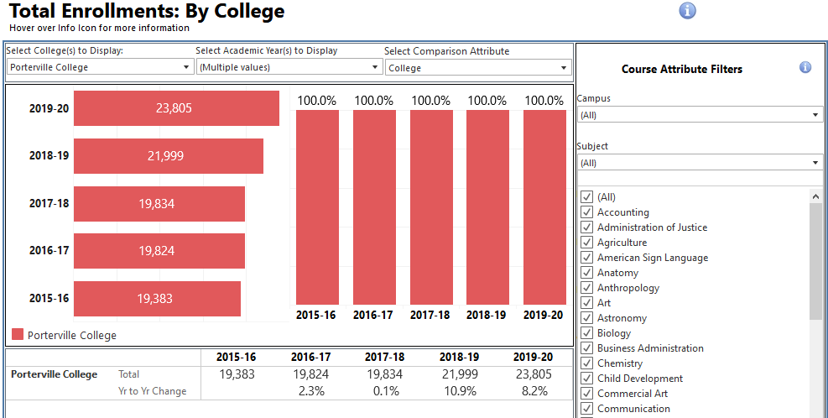

Campus Wide Hispanic/Latino Enrollment
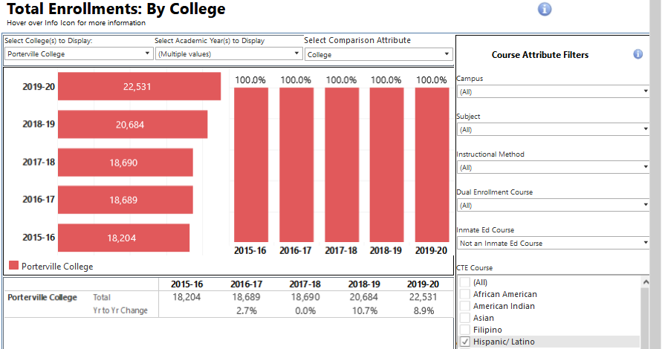

Campus Wide Caucasian Enrollment
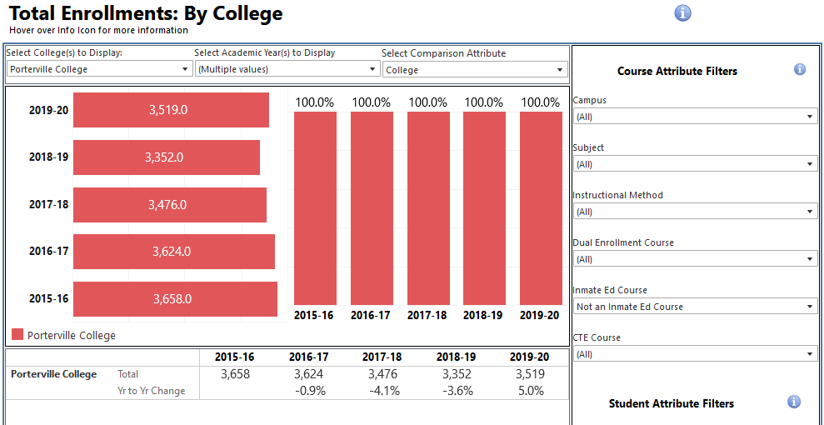

Gender:
When looking at enrollment through the lens of gender it is easy to see a significant difference when it comes to male and female enrollment in the Child Development Program. Women have always been more prominent than men in these programs whether it is Porterville College or any other college state wide. Male enrollment numbers have been on the rise over more recent years. There should be a focus to reach out to more male students to enroll in the Child Development Program.
Child Development Female Enrollment
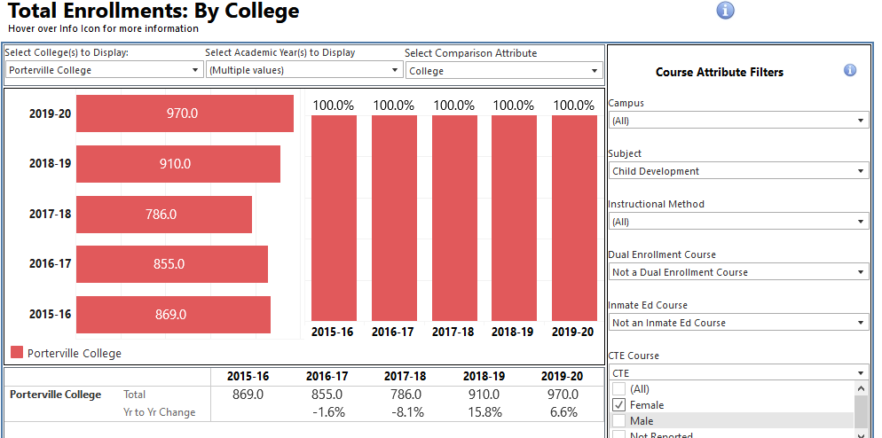
Child Development Male Enrollment
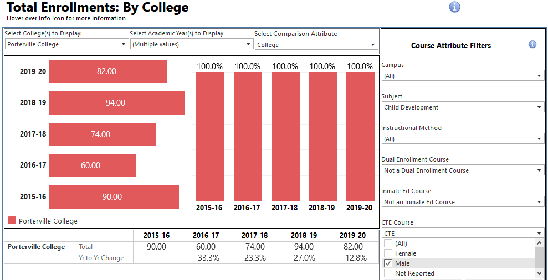
Child Development is one of the programs on campus that receives a higher volume of enrollment from students that are 30 years of age or older. This could be because often time’s older students can find the Child Development Program to be a relatable subject matter since they have life experience of raising their own children. Also, we offer a Certificate in Early Childhood Education that is attainable within a semester and can insert them back into the workforce quickly while they continue to earn their degree.

Child Development students 30 and older enrollment
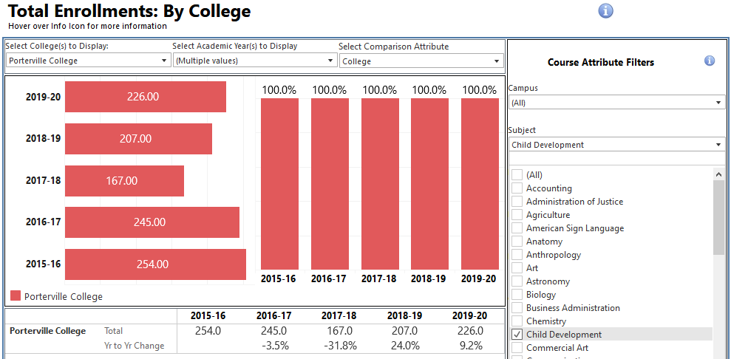

Campus wide students 30 and older enrollment
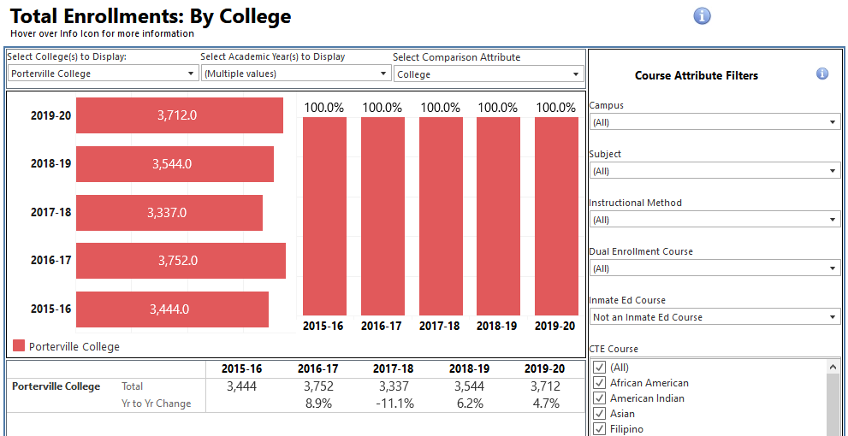
Enrollment in the Child Development Program has been on the rise for the past few years, with a significant jump from the 2017-2018 year to the 2018-2019 year. Enrollment has continued to increase year after year, while the sections available have remained at 15. There could be a possibility of expanding the program to include a degree for Human Development. This additional degree would offer students more avenues for success in the field of Family and Consumer Sciences. In addition, a new degree could potentially lead to the waitlist numbers dropping as the Child Development Program continues to grow.
Course Enrollment for Child Development
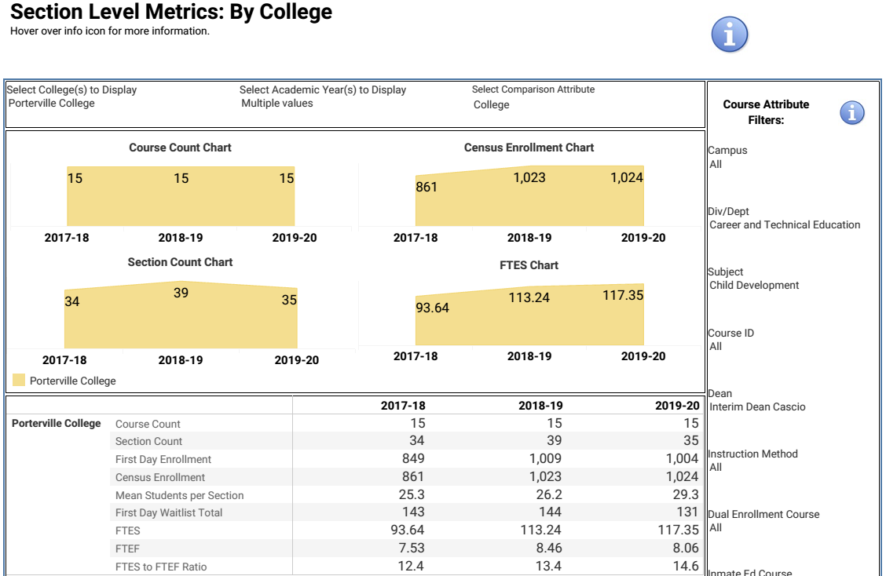
Enrollment for Child Development
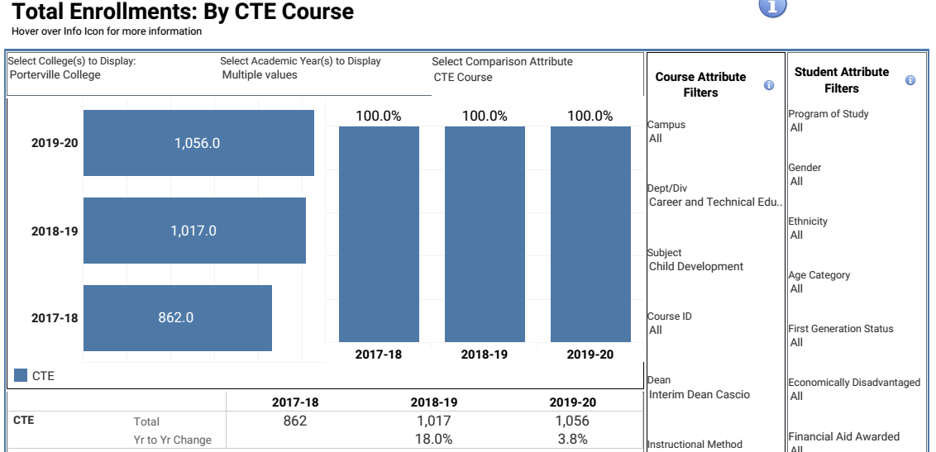

Student retention and success numbers have been high for the Child Development Program. Over the past five years there has been a steady increase in both retention and success percentages. In the last year (2019-2020) there was a drop in both retention and success percentages. This could be due to the switch to distance learning because of the pandemic. Some students were struggling with the shift from in-person learning to distance learning.

Retention/Completion for Child Development
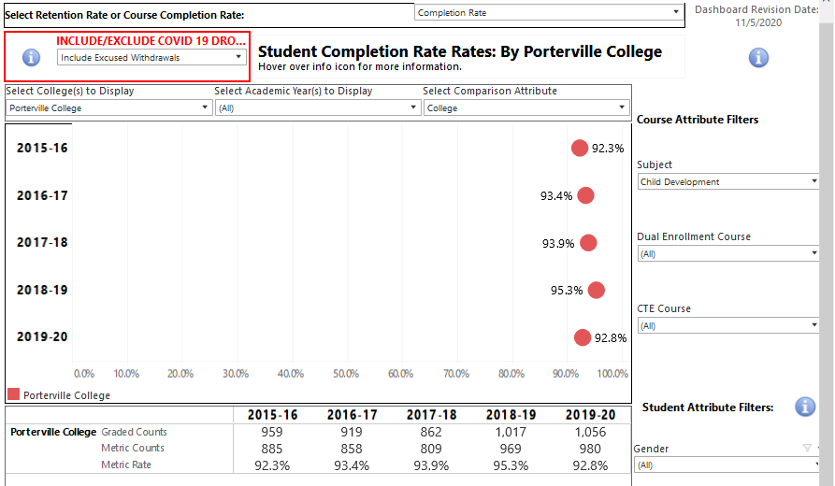

Success Rate for Child Development
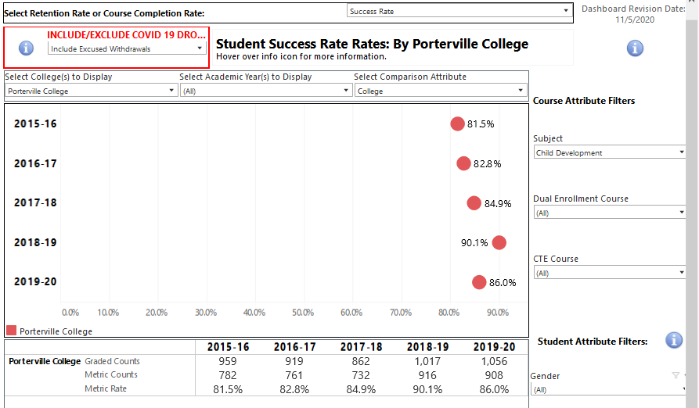
Awards:
Over the last five years the Child Development Program has increased the amount of awards given each year substantially, almost doubling the amount given just five years ago. With our success and retention rates on the rise it was inevitable that we would see an increase in the amount of awards earned by the students. When comparing the Child Development Program awards to that of the KCCD you can see that we contribute significantly to the awards earned throughout our district in the field of Child Development.
The Child Development Program also has two new certificates that were added in the 2019-2020 year that were not represented in the data because students haven’t had enough time to complete the new certificates, so in the future there should be an even larger increase in awards earned for the program.

Awards for Child Development Program at Porterville College
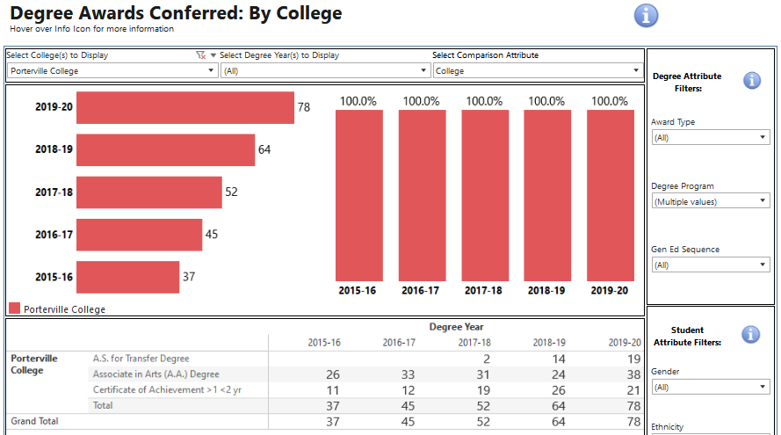
Awards for KCCD Child Development Programs
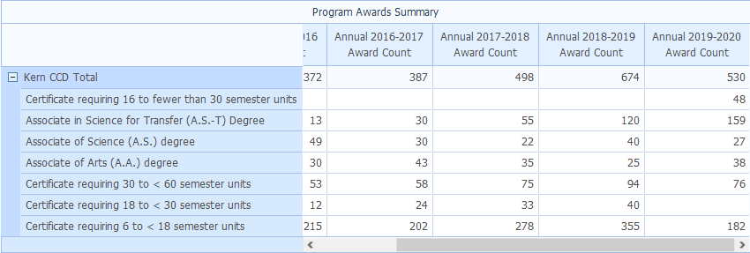
*this data was provided by https://datamart.cccco.edu/Default.aspx
Program Strengths
The Child Development program has been steadily growing over the last five years. The program success and retention rates have been high and steadily growing and express the devotion to Child Development students’ needs. There has been one degree and two certificates added to our program in recent years. This growth in the program allows more ways for our students to have access to achieving their goals.

Areas for Improvement
The Child Development Program needs to focus on recruiting and enrolling more male students in the program. The current statistics reflect this and point and this issue. There should be a concentration on ways to reach out to get male students interested in the Child Development Program. Adding a new degree program in Human Development may attract more males as it would give students a means to work with all ages of humans.
Previous Goals Assessment
Goal(s) | Completion Date | Needed resources | Person(s) Responsible | Obstacles to completion (if any)
1. Collaborate with ROP/C and High School child development departments to strengthen educational pathways for students. Participate in outreach in the community including high schools, community agencies and four-year institutions. | Fall 2019 | N/A | Mary Jo Jordan | N/A

Which of numbered items under the Mission Statement (see page 1 of this document) will be furthered if this goal is completed? (select all that apply)
Item 1_x__ Item 2_x__ Item 3_x__ Item 4_x__ Item 5_x__ Item 6_x__
Progress on Goal: Completed
_X_Completed (Date: Fall 2019 )
____Revised (Date )
Comments: Child Development classes are being offered at Porterville Unified Butterfield Charter High School. This has completed the goal set in the previous program review for the Child Development Program.

Previous Goals Assessment
Goal(s) | Completion Date | Needed resources | Person(s) Responsible | Obstacles to completion (if any)
1. Collaborate with ROP/C and High School child development departments to strengthen educational pathways for students. Participate in outreach in the community including high schools, community agencies and four-year institutions. | Fall 2019 | N/A | Mary Jo Jordan | N/A

Which of numbered items under the Mission Statement (see page 1 of this document) will be furthered if this goal is completed? (select all that apply)
Item 1_x__ Item 2_x__ Item 3_x__ Item 4_x__ Item 5_x__ Item 6_x__
Progress on Goal: Completed
_X_Completed (Date: Fall 2019 )
____Revised (Date )

Comments: Child Development classes are being offered at Porterville Unified Butterfield Charter High School. This has completed the goal set in the previous program review for the Child Development Program.

Goal(s) | Completion Date | Needed resources | Person(s) Responsible | Obstacles to completion (if any)
2. Replace the Child Development position left vacant by retirement | Ongoing | Board Approval | Mary Jo Jordan | Campus Budget

Which of numbered items under the Mission Statement (see page 1 of this document) will be furthered if this goal is completed? (select all that apply)
Item 1_x__ Item 2_x__ Item 3_x__ Item 4_x__ Item 5_x__ Item 6_x__
Progress on Goal:
____Completed (Date )
____Revised (Date )
Comments: The Child Development Program remains with only one full time faculty.

New Goals
Goal(s) | Timeline for Completion | Needed resources | Person(s) Responsible | Obstacles to completion (if any)
1.Creation of a Human Development Degree or Certificate Program | Fall 2023 | College Approval and Funding for Staff |  | Funding and Facility Space
Which of numbered items under the Mission Statement (see page 1 of this document) will be furthered if this goal is completed? (select all that apply)
Item 1_x__ Item 2_x__ Item 3_x__ Item 4_x__ Item 5_x__ Item 6_x__
Progress on Goal:
____Completed (Date )
____Revised (Date )
Comments:

Goal(s) | Timeline for Completion | Needed resources | Person(s) Responsible | Obstacles to completion (if any)
2.Secure OEI Approval for Child Development Online Courses | Ongoing | College Approval and Funding |  | College Approval and Funding
Which of numbered items under the Mission Statement (see page 1 of this document) will be furthered if this goal is completed? (select all that apply)
Item 1_x__ Item 2_x__ Item 3_x__ Item 4_x__ Item 5_x__ Item 6_x__
Progress on Goal:
____Completed (Date )
____Revised (Date )
Comments:

Staffing Request:
Staff Resources:
Current Staffing Levels  Full-time Staff |  |  | Part-time Staff
Faculty |  | 1 | Faculty |  | 4
Temporary |  |  | Temporary
Classified |  |  | Classified
Management |  |  | Management
Project dates of temporary staff:

Request for New/Replacement Staff
 | Title of Position |  | Classification  (Faculty, Classified, or Management) | Full or Part  Time |  | New or Replacement
Position 1 | None
Position 2
Position 3
Justification:
(Address each position requested)

Technology Request:

Technology Need | Justification
Item 1 | None
Item 2

Facilities Request;
Facilities Need | Justification
Item 1 | None
Item 2

Safety and Security Request:
Safety & Security Need | Justification
Item 1 | None
Item 2

Professional Development Request:
Professional Development Need | Justification
Item 1 | None
Item 2

Budget Request:
 | Current Budget | Amount of Change | Revised Total
2000 (Student Worker Only) | 0
4000 | 0
5000 | 0
Other | 0

Justification:
(Include justification for each change requested.)

Fire Technology
Program Mission Statement:
The Fire Technology program supports the mission of Porterville College by providing instruction that helps the student achieve their academic and career goals while at the same time meeting the needs of the community. Fire Technology will be continually reviewed and updated to better meet the needs of students and the community.
Student Learning Outcomes:
The Fire Technology program has two areas of emphasis; Structural Firefighter and Wildland. There is a collective total of 9 courses in these areas. All scheduled courses and programs have approved student learning and program learning outcomes. All active courses have had at least one student learning outcome assessed with timelines in process to complete the assessment of all course level student learning outcomes within the four- year cycle.
There are currently two programs with certificate awards. Program Level Outcomes are as follows:
Structural Firefighter Certificate:
- Define fire department organization and culture and the expectations of entry- level fire department personnel.
- Demonstrate knowledge of fire department equipment through the selection and application of equipment for given firefighting tasks.
- Analyze and assess fire fighter hazards inherent to the profession.
- Demonstrate the ability to communicate effectively through multiple methods of communication including: written, electronic, face to face, and radio transmitted messages.
- Demonstrate knowledge of strategies, tactics and incident command through the selection and implementation of firefighting methods, and the application of the Emergency Command System.
- Describe the history, purpose and scope of fire departments and their sub functions.
- Describe the educational requirements, duties, and information sources for various occupations in fire protection.
- Identify the basic components of fire as a chemical reaction, the major phases of fire, and the primary factors that influence fire behavior and fire spread.
- Identify the types of common fire department apparatus, equipment, and personal safety equipment used for firefighting.
- Identify the various organizations, codes, standards and ordinances, which regulate fire protection.
- Identify the various types of public and private fire protection and water supply equipment and systems.
- Describe the basic firefighting strategies and tactics.
- Describe the basic elements of fire fighter safety and survival.
- Describe and demonstrate the proper patient assessment procedure for medical emergencies, trauma emergencies, airway management, breathing, and circulation interventions.
- Describe and explain the patho-physiology of common diseases in the pre- hospital setting.
- Describe the role and identify the responsibilities of the EMT-Basic.
The PLOs are assessed using summative assessments such as: multiple choice exams, hands-on projects, and written essays. The information collected on these evaluations will refine future class offerings, textbook choices and assessments.
Wildland Job Skills Certificate:
- Identify basic fire service organization and command and control systems.
- Identify basic elements of wildland fire behavior.
- Identify basic wildland fire control terminology, principles and procedures.
- Demonstrate ability to perform essential basic fire ground tasks with minimal supervision.
- Demonstrate ability to use, inspect and maintain basic wildland firefighting tools/equipment.
- Identify basic fire line safety principles and procedures.

The PLOs are assessed using summative assessments such as: multiple choice exams, hands-on projects, and written essays. The information collected on these evaluations will refine future class offerings, textbook choices and assessments.
Program learning outcomes are assessed using a four-year cycle.
Analysis of Current Performance:

Between 2017-18 and 2019-20, the FIRE Program offered an average of 13sections of classes annually with enrollments ranging from 99-134.
Productivity figures averaged from 27.7 in 2017-18 to 17.4 in 2019-20. The FIRE program consistently leads to immediate employment for most Wildland Fire students upon completion.
The following is a table summary of enrollment data and related performance indicators:
Year | Sections | Enrollment | FTES/FTEF | % Retained | % Succeeded
2017-18 | 3 | 99 | 27.7 | 98.0% | 78.8%
2018-19 | 3 | 134 | 24.9 | 91.1% | 71.8%
2019-20 | 6 | 112 | 17.4 | 96.2% | 47.3%

The diversity of the program is reflected in the following 3 year totals:

Ethnicity | Degree/Certificate Completers
American Indian | 0
Asian/Filipino | 0
Hispanic/Latino | 9
Two or More Races | 0
White | 4

Gender | Degree/Certificate Completers
Female | 2
Male | 10
Unknown/Unreported | 0

Completing the SLO cycle has allowed the program to make minor adjustments to how courses are taught.
This program is heavily regulated by state agencies and there is not the typical amount of leeway that other programs might enjoy. The program has refined the hands on and safety portions of the program based upon the analysis of the outcomes. The continued improvement of the training grounds (owned by the City of Porterville) has allowed the program to address these minor deficiencies. Feedback from the local fire agencies also allows the program to practice continuous improvement in terms of instruction and local agency needs.
Occupational forecast for Fire Technology programs:
EMSI data indicates that firefighter occupations have declined within the four- county region by 7% 2017-2020. For fire inspectors and investigators, forest fire inspectors and prevention specialists the expected growth for the five-year period is 5%. Average hourly earnings for 2020 are $35.45 for fire fighters. Average hourly earnings for fire inspectors and investigators are $43.31 and $41.46 for forest fire inspectors and prevention specialists respectively.
Program Strengths and Areas for Improvement:
The prospect of growing the program will be difficult without the addition of a Public Safety Director. The Fire Technology program is a thriving program within the CTE division. Two certificates have been developed and implemented into the program; Structural Firefighter Certificate and a Wildland Job Skills Certificate. The program has had a high amount of success with students receiving high paying, high growth jobs.
The Firefighter I Academy a Porterville College utilizes the Porterville Fire Department Training facility during the to handle much of the hands-on training. These current facilities include modern classrooms, drill tower, and other fire service training props. Additionally, Porterville College has two mobile trailers fully equipped with modern fire training equipment for line fire training at other sites as required. This allows for students to complete real-world exercises and exposes them to situations that are difficult to simulate in the classroom. The program is taking possession of a fire truck that has recently been decommissioned by the City of Porterville. The strength of the program is heavily tied to the relationship between the college and area firefighting agencies. These local fire agencies are key to the program staffing. Additionally, the program has created a pipeline of quality firefighters that eventually end up employed by these agencies. The goal of the program is to become a destination educational program. Our current program has the potential to bring in students from around the state to take advantage of our unique training capabilities. The current Porterville College Wildland Fire Academy is the only one in the state to be hosted by and taught by both CAL FIRE and US Forest Service instructors. Our students are trained in a wide variety of techniques and are prepared for a wider range of fire issues than any other program in the state.
If the college expands this program in to a degree program, it will be necessary to have a full-time Public Safety Director to oversee the program. The program is currently staffed by Academy instructors who are full-time professional Firefighters, Company Officers or Chief Officers (or recent retirees) selected for their expertise in the various aspects of fire department operations, firefighting, rescue and other topics taught in the Academy. The program is coordinated by a retired fire department chief officer with over 35 years of “hands-on” fire experience and an extensive fire service training background. There are various professional experts who instruct components of the Fire Academy and are screened and overseen by the Fire Technology coordinator. While having local agencies provide instructors is a great way to teach currently used skills and practices, it can also cause issues. One such issue is when these local instructors are unable to meet their academic responsibilities due to fires, trainings, or other issues from their main employers.

Growth of the program will require a Director of Public Safety to handle the increased demands, accreditation duties, and processing students as they are applying to the program.

Goal(s) | Timetable for  Completion | Needed resources | Obstacles to  completion (if any)
1. Enhance programs to become a destination educational program within the industry. | Spring 2023 | Increased staffing | Funding to provide increased staffing

Which of numbered items under the Mission Statement (see page 1 of this document) will be furthered if this goal is completed? (select all that apply)

Item 1_X
Item 2
Item 3_X
Item 4_X
Item 5
Item 6 X
Progress on Goal:
_ Completed (
Revised (Date )

The program is increasingly more difficult to manage with part-time employees.
Staffing Request:

Staff Resources:
Current Staffing Levels  Full-time Staff (FTE) |  |  | Part-time Staff (FTE)
Faculty |  |  | Faculty |  | 1
Temporary |  |  | Temporary
Classified |  |  | Classified
Management |  |  | Management
Request for New/Replacement Staff
Use one line for each position requested. Justify each position in the space below.
 | Title of Position |  | Classification  (Faculty, Classified, or Management) | Full or  Part Time |  | New or Replacement
Position 1 | Director of Public Safety |  | Management | Full |  | New
Position 2
Position 3
Justification:

Position 1:
The program is coordinated by a retired fire department chief officer with over 35 years of “hands- on” fire experience and extensive fire service training. This person was selected for their expertise in the various aspects of fire department operations, firefighting, rescue and other topics taught in the Academy. There are various professional experts who instruct components of the Fire Academy and are screened and overseen by the Fire Technology coordinator. It has become increasing difficult to manage the program with an adjunct coordinator.

Budget Request

 | Current Budget | Amount of Increase | Revised Total
2000 (Student)
4000 |  | $2,500.00 | $2,500.00
5000
Other
Justification:
Currently, the program is being funded heavily with Perkins funds. In the future, restrictions on these funds may make this impossible. Instructional and Non- Instructional supplies will need to be absorbed into the college budget.

Industrial Technology

Program Mission Statement
The Industrial Technology program supports the mission of Porterville College by providing instruction that will help students achieve their academic and career goals while at the same meeting the needs of the community. Industrial Technology will be continually reviewed and updated to better meet the needs of students and the community.
Student Learning Outcomes
The Industrial Technology program has 3 areas of emphasis: Industrial Maintenance, Welding, and Programmable Logic Controls. There is a collective total of 5 courses in these areas. All scheduled courses and programs have approved student learning and program level outcomes. All active courses have at least one student learning outcome assessed with timelines in process to complete the assessment of all course level learning outcomes within the four-year cycle.
There is currently one program with a Certificate of Achievement. The Program Level Outcomes are as follows:
Industrial Maintenance
- Identify the terms used in industry in the subject areas of pneumatics, hydraulics, mechanical equipment, electrical controls, machine tool technology and welding.
- Identify the principals of electrical theory, electric motor theory, timers, industrial sensors, direct current motors, variable frequency drives and conveyor systems.
- Demonstrate a knowledge of mechanical devices, refrigeration and air conditioning systems, pumps and piping systems.
- Demonstrate the fundamentals of industrial fluid power, including hydraulics and pneumatics.
- Identify the functions and methods of entering and the programming of Programmable Logic Controllers.
- Demonstrate an ability to perform the necessary mathematical computations required for industrial applications.
- Identify and use teamwork, communication, and conflict resolution skills.
- Complete and pass an OSHA 10 program.
There are currently two Job skills certificates, Industrial Maintenance and Welding Technology.
Industrial Maintenance Job Skills Certificate
- Identify the terms used in industry in the subject areas of pneumatics, hydraulics, mechanical equipment, electrical controls and machine tool technology.
- Identify the principals of electrical theory, electric motor theory, timers, industrial sensors, direct current motors, variable frequency drives and conveyor systems.
- Demonstrate a knowledge of mechanical devices, refrigeration and air conditioning systems, pumps and piping systems.
- Demonstrate the fundamentals of industrial fluid power, including hydraulics and pneumatics.
The Outcomes are assessed by having the students perform various lab exercises that are graded by the instructor. These were evaluated on merit and approved for acceptable examples of industrial work. In addition, multiple safety exams along with a comprehensive final exam were given at the end of each course.
Students worked diligently on exercises in the lab and performed well. They asked for additional guidance where needed and it showed in the overall performance of the class. Students are encouraged to develop good work habits and understand the need to show up on time, and be prepared to complete assigned tasks.

Welding Technology Job Skills Certificate
Welding Technology falls within the Industrial Technology area. A Job Skills certificate was developed for Welding Technology. Upon successful completion of the Welding Certificate:
- The student will be able to demonstrate skills in SMAW (shielded metal arc welding), OFW and OFC (oxy fuel welding and cutting), and plasma cutting.
- The student will be able to demonstrate skills in GMAW (gas metal arc welding).
- The student will be able to demonstrate skills in GTAW (gas tungsten arc welding) on mild steel, stainless steel, and aluminum in all positions and all joint configurations.
- Students will receive training for entry-level job employment in welding shops, sheet metal shops, metal fabrication, and maintenance.
- The student will be able to demonstrate a knowledge of safety practices and tool usage.
- The student will Complete 6 units within 3 years of the first enrollment.
The Outcomes are assessed by having the students perform 50 lab exercises in the welding lab and presented to the instructor for examination. These were evaluated on merit and approved for acceptable examples of required welds. In addition, multiple safety exams along with a comprehensive final exam were given at the end of the course.
Students worked diligently on exercises in the lab and performed well. They asked for additional guidance where needed and it showed in the overall performance of the class. Most students’ made-up course work if they missed a class, however, extended absences have been problematic for positive learning outcomes. On the written final exam, two areas were identified as problematic for the students: the metallurgy section and the consumable selection section. The instructor will be placing more emphasis on the problematic areas in the future.
Programable Logic Controllers
- The student will learn the theory of programable logic controllers.
- The student will learn the installation of programable logic controllers.
- The student will learn the programming of programable logic controllers.
- The student will learn the operation of programable logic controllers.
- The student will learn troubleshooting of programable logic controllers.
- Students will understand digital and analog controllers.
The Outcomes are assessed by having the students wire up various control scenarios that are graded by the instructor. These were evaluated on merit and approved for acceptable examples of various control circuits. In addition, multiple safety exams along with a performance final exam were given at the end of each course.
Students worked diligently on exercises in the lab and performed well. They asked for additional guidance where needed and it showed in the overall performance of the class. Students are encouraged to develop good work habits and understand the need to show up on time and be prepared to complete assigned tasks.
Analysis of Current Performance:
The Industrial Maintenance program has been in existence since fall 2006. The community has eagerly supported this program by being involved in the development process for new Certificates of Achievement to better meet the needs of the community. Annual program FTES have been 2017/2018: 9.39, 2018 /2019: 13.74 and 2019/2020: 14.26 Retention rates for 2017/2018: 91.2%, 2018/2019: 96.8%, and 2019/2020: 94.7%. Success rates for 2017/2018: 79.5%, 2018/2019: 89.9%, and 2019/2020: 85.6%. Retention and success rates remain consistent for the past three years.
Occupational forecast for Industrial Technology programs:
EMSI data indicates that manufacturing and industrial technology occupations are projected to grow within the four-county region by 3.1% 2020-2023. Installation, maintenance, and repair occupations specifically expect a projected five-year growth of 6.8% regionally and 7.1% state wide. Average hourly earnings for 2020 are $25.18.

Year | Sections | Enrollment | FTES/FTEF | % Retained | % Succeeded
2017-18 | 2 | 54 | 14.1 | 91.2% | 87.0%
2018-19 | 3 | 77 | 14.2 | 96.8% | 79.5%
2019-20 | 3 | 87 | 10.5 | 94.7% | 89.9%

Ethnicity | Degree/Certificate Completers
American Indian | 0
Asian/Filipino | 5
Hispanic/Latino | 43
Two or More Races | 1
White | 3

Gender | Associate Degrees
Female | 1
Male | 50
Unknown/Unreported | 2

Program Strengths and Areas for Improvement:
The Industrial Technology program has been offered at Porterville College for 15 years and has continued to keep high enrollment, often times with a waiting list for most courses. The program has had a high amount of success with students receiving high paying, high growth jobs.
The overall breadth of the programs needs to keep pace with the introduction of new technologies being developed. To stay current, courses need to be updated to include such technology as cross-linked polyethylene (PEX), computerized numerical control machining, and computerized numerical control metal cutting and 3D printing.

Goals

Goal(s) | Timetable for  Completion | Needed resources | Obstacles to  completion (if any)
1. Obtain funding to bolster management of the program. | Within 5 years | Adequate funding and campus approval. | Current and looming budget issues.

Which of numbered items under the Mission Statement (see page 1 of this document) will be furthered if this goal is completed? (select all that apply)

Item 1_X
Item 2_
Item 3 X
Item 4 X
Item 5_
Item 6_X
Progress on Goal:

Completed (Date )
X Revised (Date: Fall 2026)

Staffing Request:

Staff Resources:
Current Staffing Levels  Full-time Staff (FTE) |  |  | Part-time Staff (FTE)
Faculty |  | 0 | Faculty |  | 4
Temporary |  |  | Temporary
Classified |  |  | Classified
Management |  |  | Management
Request for New/Replacement Staff
 | Title of Position |  | Classification  (Faculty, Classified, or Management) | Full or  Part Time |  | New or Replacement
Position 1 | Industrial Technology  Instructor |  | Faculty | Full-Time |  | New
Justification:

Position 1:
The program has grown to the point where there is a need for a full-time Instructor. The curriculum has been expanded to include two Certificates of Achievement, one Job Skills Certificate and five new courses. The staffing, budgeting, curriculum development, and community response needs are currently not being sufficiently met.

Budget Request:

 | Current Budget | Amount of Increase | Revised Total
2000 (Student)
4000 | $5,000.00 | $2,500.00 | $7,500.00
5000
Other

Justification:
Currently, the program is being funded heavily with grants. In the future, restrictions on these funds may make this impossible. Instructional and Non-Instructional supplies will need to be absorbed into the college budget.
Information Systems
Program Mission Statement:
The Information Systems (INFS) Program at Porterville College is committed to providing students, both transfer and non-transfer level, with a solid understanding of information systems and technologies and the critical roles they play in our society. We strive to teach our students to think critically, to learn continuously, to grow professionally, and to conduct themselves ethically and responsibly.
Student Learning Outcomes:
Porterville College currently offers 13 Information Systems courses. 100% of these courses have Student Learning Outcomes that have been approved by the Curriculum Committee. There is currently one program in Information Systems and it has identified program-level Student Learning Outcomes. Within this program, we have 3 degrees and 2 Job Skills Certificates.
The Program Learning Outcomes are as follows:
- Demonstrate a comprehensive understanding of various types of information systems and their roles in our economy and society.
- Exhibit proficiency in using common computer hardware, software, and the Internet
- Design, construct, and troubleshoot computer programs.
- Design, construct, and implement data communications networks.
- Demonstrate an understanding of the systems development process and plan, analyze, design, and implement information systems.
- Discuss social, ethical, privacy, and security issues involved in the use of information systems.
The PLOs are assessed using multiple choice exams, hands-on projects, and written essays. In the past two years, the evaluation of the PLO results has prompted change in the delivery of basic Information Systems content. Specifically, the program has adopted an electronic textbook and training exercise platform called Cengage Unlimited. The Mindtap software within Cengage Unlimited gives examples, videos, guided lessons, and exams that can significantly increase retention and success.
The outcomes cycle has been completed in the Information Systems program (PLOs) and all courses (SLOs). The Information Systems instructors have used this data to drive new directions in coursework. There is now a new push to involve more security issues throughout the program. Additionally, the data obtained in the SLO process has allowed all Information Systems instructors to compare effective methods of instruction. This has led to a more uniform approach to instructors that have taught different sections of the same course. The SLO process has led the faculty to re-evaluate the current software package (MindTap). While this program has many benefits, the application of skills to real-life situations needs to be bolstered in the INFS P100 (Introduction to Information Systems) course.
Analysis of Current Performance:
Between 2017-18 and 2019-20, the Information Systems Program offered an average of 32 sections of classes annually with enrollments ranging from 647-718.Productivity figures averaged from 12.33 from 2017-18 to 2019-20. Our courses have become more popular due to the marketing of our refined degrees and certificates.

While many students arrive at Porterville College with computer skills, the skills that they typically possess are not enough to advance their careers. In today’s society, many students can navigate social media, video games, music platforms, and free services like Google Docs and more. Our goal is to merge their existing skills into ones that are in demand by business, industry, government, and more. Productivity software is taught throughout the program. This software will make our graduates more employable in a wide range of industries.
The following is a table summary of enrollment data and related performance indicators:
Year | Sections | Enrollment | FTES/FTEF | % Retained | % Succeeded
2017-18 | 33 | 718 | 11.02 | 87.3% | 71.3%
2018-19 | 30 | 686 | 11.63 | 89.3% | 75.7%
2019-20 | 33 | 647 | 10.26 | 87.5% | 74.6%

The diversity of the program is reflected in the following 3 year totals:

Ethnicity | Degree/Certificate Completers
American Indian | 1
Asian/Filipino | 1
Hispanic/Latino | 24
Two or More Races | 2
White | 10

Gender | Associate Degrees
Female | 3
Male | 35
Unknown/Unreported | 1

Most recent job statistics and projection data for the four-county region (Inyo, Kern, Mono, and Tulare) indicate that computer and information technology careers are still among the highest paying jobs ($45,717-$101,109). Careers in computer engineering, programming, support, security, database, network, and web/cloud development are also among the fastest growing in demand. The overall growth for the top Information Systems Occupations is projected at 11.4% with a $38.44/hr. median wage from 2017-2020 (Based on EMSI data).
Program Strengths and Areas for Improvement:
The Information Systems program revamped the degrees and certificates 4 years ago. In the past, Porterville College offered an Associate Degree and a Certificate of Achievement in Information Systems. The program now offers 2 local Associate Degrees (Computer Information Systems and Business Information Systems) and a Model Curriculum Degree (Advanced Information Systems). The Advanced Information Systems Associate Degree was designed using the state adopted curriculum by C-ID. The program now also includes 2 Job Skills Certificates (Basic Computing JSC and Advanced Computing JSC). These new degrees and certificates (along with more intense marketing) have made the program’s numbers consistently higher than many other colleges in the area.
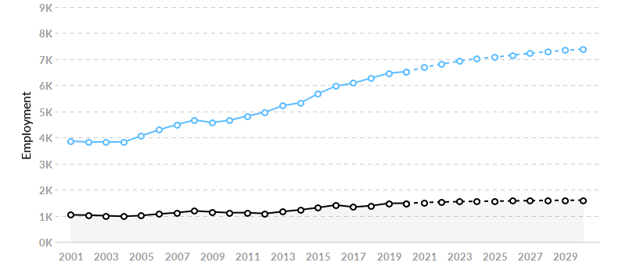

The above chart shows that the demand for jobs in Information Systems related fields is predicted to increase slightly (lower, black line) versus nationally (upper, blue line). This does not take into account the transfer students that will like find easier employment opportunities in this field when looking outside of our immediate area. Additionally, there is a trend toward working remotely that might increase the growth predictions for our area.

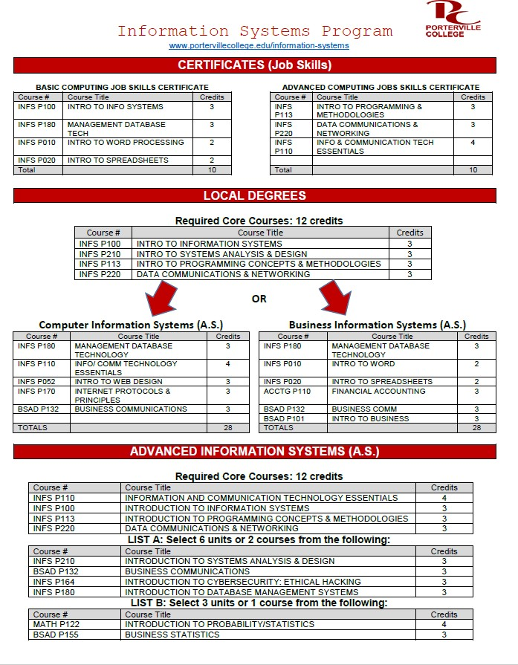

The current Information Systems program has only one full-time faculty member. The program lost a faculty member to retirement and that position has not been replaced in several years. In past Program Reviews, the Information Systems program has requested replacing that faculty member. The CTE Division is now considering a move to consolidate the Information Systems program with our Business program. We believe that this will allow us more flexibility in terms of instructors and the courses that they teach.
The Information Systems program includes many upper-level, specialized courses that require instructors with specific skill sets that are very difficult to find in the greater Porterville area. The program currently has 4 adjunct instructors that help teach the current course load. If one of more of these instructors leave, it may put the program in a tenuous position. We will continue to cater to the needs of our current adjunct instructors.
The program has worked closely with all of the major area high schools. The full- time faculty member has taught several dual enrollment courses on the high school campuses. Additionally, the Information Systems program has hosted and been a member of a joint high school/Porterville College advisory committee that targeted Information Technology. The large, multi-school advisory board has since disbanded and the Information Systems program now works individually with separate advisory boards. It should also be noted that the full-time faculty member in this program recently ran for and was elected to the Porterville Unified School Board. This will, hopefully, allow the program to further collaborate with the local schools and create a pipeline to the Information Systems program.
Two local high schools (Granite Hills and Monache High) have discussed revamping their IT based pathways. Only Granite Hills has produced a pathway program that works closely with Porterville College’s Information Systems program. There are a number of dual enrollment courses that are in the process of being taught at Granite Hills at this time.
While numbers of students have slightly decreased over the past couple of years, the graduation rates have increased. This is due to the fact that the program has decreased the number of basic computing courses by nearly 5 sections per semester. More and more students are entering college with basic computing abilities and these courses were not deemed as practical anymore. There is a need, however, to teach students from all disciplines the use of such software as word processing, spreadsheets, databases, and electronic slideshows. Even though many new students have perceived skills in social media and electronics, most are unable to use software and information systems to perform basic job functions.
The challenge moving forward is to stay current in terms of technology and industry needs. The college also needs to figure out a way to give ALL students training in information technology to help them become better students and ultimately more employable in increasing competitive job markets.
Goals

Goal(s) | Timetable for  Completion | Needed resources | Obstacles to  completion (if any)
1. Increase INFS number of graduates by 25% | By Fall 2022 | Marketing money for brochures and flyers | College budget constraints

Which of numbered items under the Mission Statement (see page 1 of this document) will be furthered if this goal is completed? (select all that apply)

Item 1_X
Item 2
Item 3_X
Item 4_X
Item 5
Item 6_X

Progress on Goal:
Completed (Date )
Revised (Date )
Comments: The new degrees and certificates should have a positive effect on enrollment. The challenge is marketing the new program to our students, staff, and area high school students.

Goal(s) | Timetable for  Completion | Needed resources | Obstacles to  completion (if any)
1. Establish a lab in the CT building | By Spring 2022 | Funding and facility space. | College classroom/lab space constraints.

Which of numbered items under the Mission Statement (see page 1 of this document) will be furthered if this goal is completed? (select all that apply)

Item 1_X
Item 2
Item 3_X
Item 4_X
Item 5
Item 6

Progress on Goal:

Completed (Date )
X_Revised (Date Spring 2018)
Comments:
Having a lab in the CT building would allow us to use portable demonstration panels that we can store in our building. An example would be a framed wall on wheels that we can use to demonstrate networking and installation of wiring. The new Allied Health building may allow us to recapture a room that is currently used for nursing courses for this project.
Staffing Request:

Staff Resources:
Current Staffing Levels  Full-time Staff (FTE) |  |  | Part-time Staff (FTE)
Faculty |  | 1 | Faculty |  | 4
Temporary |  |  | Temporary
Classified |  |  | Classified
Management |  |  | Management
Request for New/Replacement Staff
Use one line for each position requested. Justify each position in the space below.
 | Title of Position |  | Classification  (Faculty, Classified, or Management) | Full or Part Time |  | New or Replacement
Position 1 | N/A

Budget Request:

 | Current Budget | Amount of Increase | Revised Total
2000 (Student)
4000 | $250 | $2000 | $2250
5000
Other
Justification:
Estimated amount for general office supplies and equipment. Currently, the program uses Perkins money to assist in funding new ventures. However, there is little money for the maintenance and daily operations in the current budget. Restrictions on Perkins money do not allow funds to be used for daily operations and supplies. Instructional and Non-
Instructional supplies will need to be addressed in the college budget.

CTE Division Summary

The faculty and staff of the Career and Technical Education Division dedicates itself to using the mission statements of Porterville College and the division as guides to serving our students, and will additionally strive to link the efforts of our programs with divisions campus wide as well as with the college’s strategic plan. These linkages will ensure that the activities within the division continue to be integrated into the overall efforts of our college.
The faculty and staff are committed to ongoing program review and assessment in order to evaluate and improve our programs for students. The results of the Student Learning Outcome assessments will be used to modify programs as appropriate. The faculty and staff will continually review, discuss, and modify as appropriate its activities and programs. Therefore, reviews will be ongoing and service modification and enhancements continuous.

