State of Bakersfield College-Delano Campus and Rural Initiatives
Prepared by: Abel Guzman, Interim Director- Delano Campus and Rural Initiatives
Submitted: 11/9/2017

OVERVIEW:
For several decades, Bakersfield College’s Delano Campus has provided access to higher education for the historically underserved community of Delano. In recent years, the staff and faculty of the Delano Campus have expanded their service area to many new locations. With courses being offered beyond the Delano Campus at local area high schools, McFarland, Wasco, Shafter, and Arvin, Bakersfield College has been able to create equitable access to higher education for residents of some of the most disadvantaged communities in Kern County.
This report will include an update on courses and enrollment in Delano and rural communities, as well as special projects happening in those locations.
MISSION:
The mission of the Bakersfield College Delano Campus-Rural Initiatives is to provide ready access to the high quality education necessary for our socially and ethnically diverse students‐‐whether they be vocational, transfer‐oriented, developmental, or some combination of these‐‐to thrive in a rapidly changing world. The Delano Campus- Rural Initiatives is responsible for quality instruction and services that include the unit’s strategic initiatives not just in Delano, but also in other rural communities in Kern County:
‐Improve Kern County Rural area student access, retention, and success
‐Provide effective learning and earning pathways for students in rural communities
‐Support student learning through appropriate technology
‐Support student learning through streamlined systems and processes

Bakersfield College’s mission to provide educational opportunities to a diverse population is facilitated in the rural communities of Kern County by the Delano Campus-Rural Initiatives staff. In cities like Arvin, McFarland, Wasco, and Shafter a lack of an institution of higher education has contributed to the low degree attainment rates, which ultimately correlates with the high unemployment rates. In recent years, Bakersfield College has been able to collaborate with schools and community agencies in those communities to provide an array of college courses. Through the work in the rural initiatives, Bakersfield College has enhanced its mission not just in Bakersfield, but in other towns in the county.
STRATEGIC DIRECTIONS:
- Student Learning- A commitment to provide a holistic education that develops curiosity, inquiry, and empowered learners.
  - Our goal in Delano and at other rural sites is to offer as many general education courses as possible, so that students have access to a variety of fields of study.
    - Delano- FTES increased from 1,092, to 1,310 in just one year (2015-2016 to 2016-2017). Total enrollments increased from 8,948 to 10,992. This is largely due to an increase of sections offered from 336 to 415. The expansion in courses on campus, as well as growth in dual enrollment and inmate education helped enhance our ability to provide more opportunities for students.
    - Rural Initiatives- The momentum in growth in just one year didn’t just occur in Delano. Between classes offered in Arvin, McFarland, Shafter, and Wasco, enrollments increased from 1,165 to 2,195. FTES jumped from 148.9 to 261. This is a result of almost doubling the number of sections offered from 59 to 106.
- Student Progression and Completion- A commitment to eliminate barriers that cause students difficulties in completing their educational goals.
  - Being able to offer more courses all around rural Kern County in the last year, ensured that more students in those communities were able to get closer to their educational goals. Transportation to the main campus is often the biggest barrier for many students in rural communities. Now they are able to access more of their required courses closer to home.
  - On top of all of the new courses that we now offer in rural communities, we have begun to enhance our student support services in those areas. For example, we added a full time-temp counselor who spends a couple of days on the Delano Campus, two more at Arvin High School, and fills in the gaps with traveling to the different communities to promote the college and facilitate workshops. In addition, we have been able to add tutoring and writing support for adult learners in North Kern through the support of the Adult Education Block Grant.
- Facilities- A commitment to improve the maintenance of, and secure funding for, college facilities, technology, and infrastructure for the next thirty years.
  - The passing of Measure J was a huge success for Bakersfield College. This signified that Bakersfield College-Delano Campus would soon be able to upgrade and expand its facilities. Particularly, the construction of the Delano Learning Resource Center became more of a reality.
  - Although the Delano Campus has outgrown its physical capacity, the Delano Campus staff has been able to build strong working relationships with KHSD, DJUHSD, WUHSD, and MUSD to be able to offer more courses at their respective high school and adult school sites. Any course that is offered in Arvin, Shafter, Wasco, and McFarland is held at a high school site.
  - Bakersfield College recently re-acquired the Delano Campus-Randolph site. Although the campus now has over 30 classrooms (generously donated by the Wonderful Company), we are still in the process of strategizing how to best utilize the space. Currently, there are plans to begin to offer classes in a couple of the classrooms in the coming year, and potentially leasing out additional space to educational partners. The campus was reacquired November of 2017, and is currently undergoing upgrades and maintenance in preparation for future semesters.
    - Specific programs potentially being targeted to be housed at the Randolph site are HVAC, Industrial Automation (related courses), Veterinary Technology (related courses), as well as other general education courses.
  - In partnership with the City of Shafter, Bakersfield College will begin to offer more courses during the day at the Shafter Learning Center. This partnership will bring more courses and student services to the community of Shafter, as well as its neighboring town of Wasco.
- Oversight and Accountability- A commitment to improve oversight, accountability, sustainability, and transparency in all college processes.
  - Bakersfield College has a responsibility to the entire community to provide the highest level of education and services for students. In Delano and other rural communities, the residents really look at Bakersfield College as the beacon of light for their families. As a result, we often invite the community to any special event we hold so that they feel a connection to the campus. Especially after the passing of Measure J, the community is looking closely to make sure that we follow through on our word.
  - Within the campus community, we have begun to hold student roundtables. Students are invited to the roundtable to express any concerns or recommendations to the campus director. We have found this platform very informative and helpful in planning.
- Leadership and Engagement- A commitment to build leadership within the College and engagement with community.
  - Historically, staff and faculty in Delano have seemed to function separately from the main campus. In the last year we have been intentional about participating in any trainings, meetings, and conferences to connect Delano and Rural Initiatives to the main campus. All staff on the Delano Campus are encouraged to attend their respective department meetings on the main campus.
  - In order to best serve the rural communities, Delano Campus staff continue to participate in community based organizations and events. For example, Bakersfield College-Delano regularly hosts the Delano Community Alliance meetings. Staff also participates in festivals, parades, and other resource fairs various rural towns. One of the goals of Bakersfield College-Delano is to have a strong and regular presence in all rural communities.

SPECIAL PROJECTS:
Early College Project (Fall 2017): The Early College Project is designed to provide high school students at Arvin High School an additional pathway towards higher education attainment. More importantly, the project will leverage the resources of the three participating partners to create a strong foundation and support system to ensure student success. This is a partnership between Arvin High School, Grimmway Academy, and Bakersfield College. Bakersfield College has placed a counselor at Arvin High School twice a week to support this project.
- Goal: Students will complete an AS-T in Communication, or will receive additional support to complete one of the pathways in the Game Changer plan.
    - Students will take college courses during the school day as dual enrollment, and in the evenings as concurrent enrollment.

- Co-Curricular Activities
- Students will be required to participate in CAS workshops throughout the academic year.
  - Habits of Mind
  - Math Skills
  - English Skills
  - Study Skills
  - Life Skills
Game Changer (Re-vamp Fall 2017): The purpose of the “1+1+2=Game Changer” is to provide students of Arvin High School (AHS) an opportunity to be a part of a program that will change their lives for the better. The elements of our plan are not new, but the extensive partnership introduces elements and factors that change the existing situation in a significant way and provides a game changer for Arvin High School Students. Students will jumpstart their careers, as they will have access to higher education courses and the resources and technology needed to succeed. AHS students will have access to state of the art interactive classrooms and modern/ high-tech agriculture equipment. “1+1+2=Game Changer” allows students to pursue multiple pathways that can lead to GE certification, associate degree, and/or baccalaureate degree.

Although the project has been underway for over a year, and students are already enrolled in classes, Bakersfield College is working to revamp the program. Our goal is to hire an additional staff member to be located at Arvin High School to support this program. Additionally, we have had a counselor on site a couple of times a week since the launch of the program.

In summer 2017, grant funds were utilized to establish an interactive classroom at Arvin High School. Through this technology, Bakersfield College will be able to offer more courses for Arvin High School students who are part of not just the Game Changer cohorts, but also those that are part of the Early College Project.

Rural Initiatives Distance Education (RIDE) Project: Through generous financial support from the County of Kern for the Game Changer project, as well as a grant from the California Community Colleges Chancellor’s Office to support student equity, Bakersfield College was able to launch the Rural Initiative Distance Education (R.I.D.E) Project. The R.I.D.E Project establishes distance education classrooms at Arvin High School, Delano High School, and Cesar E. Chavez High School. In order to meet the shortage of master prepared instructors for dual enrollment courses, these interactive technology classrooms will be used to stream college courses to various sites. The equipment will be utilized to transmit classes from Bakersfield College to the high school sites, and high school site to high school site. The current cost of the project is nearly $300,000.

- Technology:
Each high school district committed one classroom per site (Arvin HS, Delano HS, Cesar E. Chavez HS). The classrooms are equipped with the same technology as that in the Bakersfield College interactive classrooms. There are two flat screens in the front of the room for student’s to view instructor and content, one flat screen in the back for instructor and student interaction, and high definition cameras mounted at the front and back of the rooms. Classrooms are equipped with microphones and speakers throughout the ceiling, as well as an instructor/equipment cart at the front of the room. School staff and administration are trained on how to use equipment at the completion of the installation process.

- Instructional Delivery:
For all courses transmitted via the R.I.D.E Project technology, the teacher of record will be either a Bakersfield College faculty member, or a high school instructor approved by the college to serve as an adjunct faculty member. Those teachers on the receiving sites that are not adjunct faculty members, will serve as co-teachers. They will assist with supplemental instruction and other instructional matters. The teacher of record will be in charge of primary instruction and content delivery, as well as grading (including inputting grades).

Bakersfield College will make every effort to schedule the courses during the sites’ time blocks. As dual enrollment courses, the sections will take place during the regular high school day. The course will be open to regular/traditional college students at main campus or at the Delano Center. That particular section will have a different CRN assigned to it than those of the high school students.

The instructor of record will provide technical and curriculum assistance and guidance to co-teachers. All participating department chair and deans will be involved in approving schedules, instructor assignments, and instructor loads. Program Managers and other administrative staff in the Rural Initiative team will take the lead in working with the respective high school districts for initial scheduling, but will involve dual enrollment team, deans, and department chairs.

- Goals and Objectives
Goal:
Expand and diversify the dual enrollment course offering at partner high schools.

Objectives:
- Make current Dual Enrollment courses available to other high school sites that do not have an instructor in respective subject matter that meets Bakersfield College’s minimum qualifications.
- Offer at least two additional courses per semester that meet a pathway pattern, A-G requirements, or community college general requirements for which the high schools do not have a qualified instructor.

- RIDE and Bakersfield College Strategic Directions

Direction #1: Student Learning
A commitment to provide a holistic education that develops curiosity inquiry, and empowered learners.
- The project will support the expansion of distance education by offering more courses that high school students would otherwise not access.
- Technology can also be used for things such as counseling workshops, guest lectures, and supplemental instruction.

Direction #2: Student Progression and Completion
A commitment to eliminate barriers that cause students difficulties in completing their educational goals.
- The project can help with lowering the number of students in remediation by offering more dual enrollment courses via RIDE to help students enter college at or near college level.
- The technology can be used for outreach and orientation activities, to help reach a greater audience with less staff.

Direction #3: Facilities
A commitment to improve the maintenance of and secure funding for college facilities, technology, and infrastructure for the next thirty years.
- The success of the RIDE Project can help secure funding for additional classrooms throughout partner high school districts in Kern County, and in doing so allowing the college to expand its reach to rural communities without needing to build or rent facilities.

Direction #5: Leadership and Engagement
A commitment to build leadership within the College and active engagement with the community.
- Project will allow Bakersfield College full-time faculty to coach and mentor high school dual enrollment instructors on how to best develop and deliver college level curriculum.
- The RIDE project will allow the college to train more faculty and staff on how to effectively run a successful distance education program.
- Project will increase access to courses and services in rural communities.

- Pilot:

In the fall of 2017, we piloted our first ever RIDE class. Through the support of the dean and department chair in the social sciences department, we were able to pilot a History 17A section. Because Robert F. Kennedy High School in Delano has not yet installed an interactive classroom, we used the interactive classroom at the Bakersfield College Delano Campus. The dual enrollment history instructor from Robert F. Kennedy High School walks his students next door to Bakersfield College to teach his class, and it is streamed out to a group of students at Cesar E. Chavez High School across town.

While there were some technology hiccups at the beginning of the semester, this pilot has been an overall success. Because of the use of this technology, a group of students has access to a college class that otherwise wouldn’t have been possible.

- Installation progress:

Classrooms at Cesar E. Chavez High School and Delano High School were completed in May of 2017. Arvin High School classroom was completed in early June 2017.

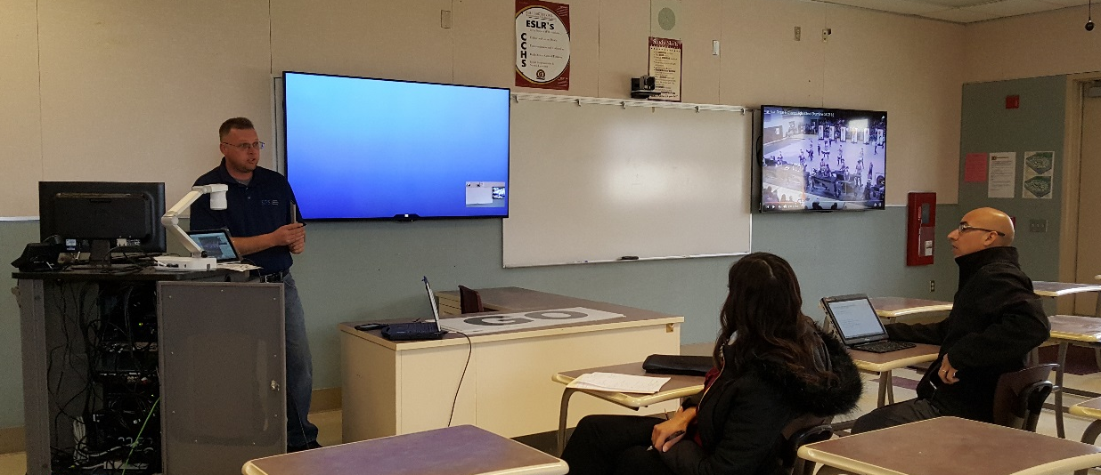
Cesar E. Chavez High School

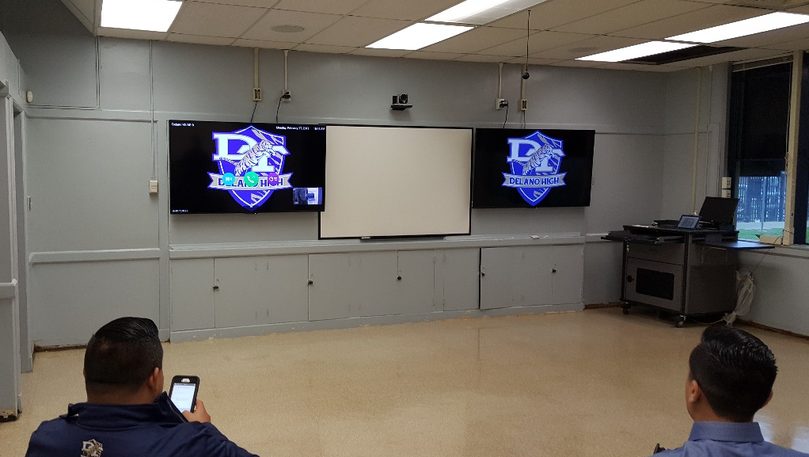
Delano High School

UPDATES FROM STAFF AND FACULTY

Digital Delano: Bakersfield College-Delano Campus is proud to have some of the hardest working and passionate staff and faculty. History professor, Dr. Oliver Rosales, along with librarian, Elisabeth Sundby have established the “Digital Delano” Project.

“It is exciting to be implementing the National Endowment for the Humanities grant program "Digital Delano: Preserving an International Community's History" through the end of fiscal year 2018. The grant is in partnership with the BC Social Justice Institute and the BC Delano Campus Library to preserve local archival and family histories and to help promote local research and place-based curriculum. A website for the project has been developed and is available on the BC Library homepage and the project was recently discussed at the NEH project headquarters in Washington D.C. NEH made it clear that the organization is interested in investing more financial resources in rural California, especially around the issue of faculty development at community colleges and dual enrollment instruction.”
– Dr. Oliver Rosales

English for Multi-Lingual Students in Delano: Bakersfield College-Delano Campus is excited to have our new full time EMLS faculty member, Michael Westwood. Professor Westwood is very passionate about helping his students, and regularly goes above and beyond to support them inside and outside of the classroom (as is evident in his statement below).

“I am offering two sections of EMLS courses, B50 and B70. The courses are going well and I hope that students' word of mouth will be a positive recruitment tool. Also, I am in contact with Kim Collins [BC AEBG Academic Liaison] regarding ways to encourage students currently taking adult ed courses to try our courses. One challenge I have is helping students with young children. As an example, today I received an email from a student about how difficulties with her babysitter are making it difficult to attend class and complete homework. I know that the Panorama campus has a child enrichment center. Would it be possible to explore opening something similar, or possibly partner with a local child care program? As I consider recruitment and retention, difficulties with childcare seem like a hurdle that we could help students overcome.”

-Professor Michael Westwood

Adult Education Block Grant: One of the newest members to the Delano Campus team is our Program Manager for Adult Education Block Grant. Endee Grijalva, along with the AEBG team of Kim Collins (Academic Liaison), Jessica Flores (Academic Liaison), and Jesus Jimenez (Tutor) is helping to build the bridge from adult schools to college for many students around Kern County.

“Bakersfield College Adult Education is new to serving Kern County. However, there are already many exciting things happening via program efforts. On October 30th, the first Sample a Course event was held and saw 30 attendees from Adult Education collaborations with the Bakersfield Adult School and Migrant Education. Designed to highlight our EMLS courses and connect Adult Learners to our Main Campus, it also gave participants a direct insight into the college experience. This event would not have been possible without multi-departmental collaboration and most importantly the AEBG partnership with the Bakersfield Adult School/ KHSD. Additionally, spring will welcome four BC classes on site at the new BAS Job Spot location; 2 non-credit EMLS courses and 2 BSAD B40: Personal Finance courses. Along with accessible course offerings, an Academic Liaison and Educational Advisor will be fully dedicated to serving Adult learners directly on site. These efforts are only the beginning as we continue to focus staff and resources to Adult Ed sites throughout Kern County.”
-Endee Grijalva, Program Manager
ENGAGEMENT AND ACCOUNTABILITY:
With so many new projects, grants, and events going on in Delano and around rural Kern, it is becoming increasingly difficult for everyone to keep up with what’s going on. Because of that, we have established regular staff and faculty collaborative meetings. Although most faculty and staff have direct supervisors on the main campus, there is a need to meet and cross-train as a Delano team.

In addition, our SGA representative has established student roundtables so that the campus director can hear directly from students in regards to their needs and concerns. Furthermore, Delano staff continues to stay involved in the communities which it serves.

CONCLUSIONS AND SNAPSHOT:
The Delano Campus has evolved in the past several years. No longer is it simply a center that serves students on campus, but rather one that leverages its community partnerships, technological capacities, and grant opportunities to serve a wider range of students. Just in the last year, the enrollment of the Delano Campus has increased by over 1,300 students. With new grant work, dual enrollment initiatives, and an increase of sections on our campus, we expect the trend in enrollment to continue. Our staff has been able to ensure the success of the programs. However, the campus has reached a point in which additional support is a must. In order to increase courses offered and enrollment, as well as to enhance student support services, new support personnel must be put in place.

Although the work done in the rural communities still comes out of the Delano Campus, the work itself has evolved into a department of its own. Between Arvin, Shafter, McFarland, and Wasco the FTES are currently 261.1. As we increase dual enrollment section offerings in McFarland, Wasco, Shafter, and Arvin, BC’s presence will rapidly expand. In addition, we are working to develop in McFarland, Shafter, and Wasco what we have established in Arvin. We want to make sure we offer more courses in the evenings for students that live in or near those particular communities, and in doing so diminishing the burden of having to travel to the main campus to complete their education. To be able to accomplish all of this work, we will need to plan for additional support staff, management, and faculty.

