College Council Agenda
October 31, 2014
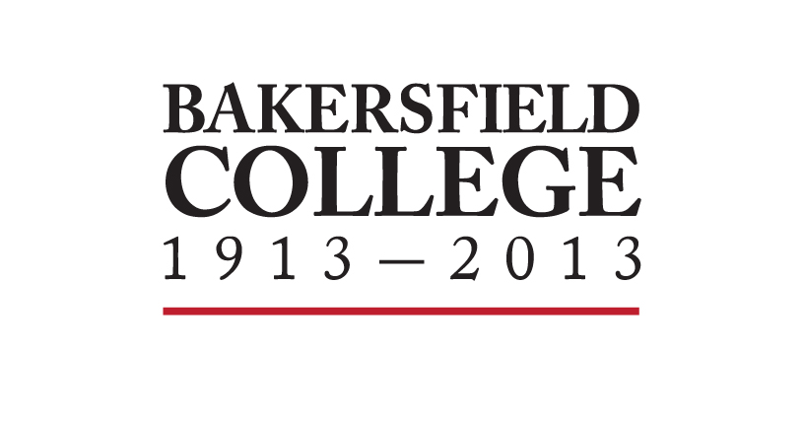
8:30am – 9:00am. Collins Conference Room
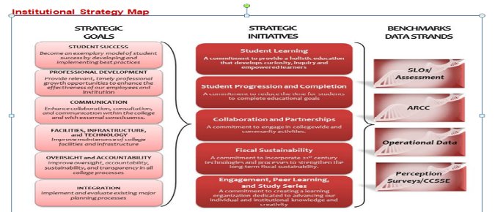

Supporting documents may be accessed on the College Council Committee website at https://committees.kccd.edu/bc/committee/collegecouncil

- WELCOME & REVIEW OF THE AGENDA |  |  |  |  | 2 min
- REVIEW AND APPROVAL OF MINUTES |  |  |  | 3 min
- COUNCIL BUSINESS
A. | President’s Report  No report due to Accreditation Lab | Christian
B. | Student Equity Plan (approval) | Arvizu | Action | 15 min
C. | College Mission Statement Review Policy | Pluta | Discussion & Action | 5 min
D. | Educational Master Plan (approval) | Gomez-Heitzeberg | Action | 5 min
G. | Consultation Council:  No report due to Accreditation Lab | Holmes, Johnson, Vaughn
- INFORMATION ITEMS 5 min
 | - AIQ Report  - PRC Report  Dates to Calendar:  - October 31: Accreditation Lab  - November 6, 9:30-1pm: VetFest  - November 12: Kern Energy Summit  - November 13: Board of Trustees Meeting, Delano  - November 17: Learning Outcomes Conference. Learn@BC!  - January 14, 2015. 11:30 to 4:30 p.m. Spring Opening Day at the Delano Campus  - Feb 5, 2015: Technology Conference. Learn@BC!  - April 23: Equity Conference. Learn@BC!  - May 6: Chicano Commencement Celebration  - May 7: Honor’s Reception  - May 8: Closing Day  - May 15, 2015: 7:00 p.m. Graduation |  | Written Reports  Marden |  | 5 min
NEXT SCHEDULED MEETING – November 14, 2014



