**Porterville College**

**Budget Committee Agenda**

**February 5, 2021**

**8:30-10:00 AM**

**Via Zoom**

**Chairs:** Arlitha Williams-Harmon/Joel Wiens

**Members:** Primavera Arvizu, Vern Butler, Joseph Cascio, Erin Wingfield, Matthew Flummer, Jodie Logan, Theodore “Diran” Lyons, Michelle Miller-Galaz, Jay Navarrette, Jennie Porreco, Miguel Ruelas, Thad Russell, Classified (vacant) ASPC Rep (vacant)

1. **Call to Order**
2. **Approval of Agenda**
3. **Approval of Minutes**

November 20, 2020

1. **Budget Calendar Review**
2. **Grants Update**
3. **Governor’s FY21-22 Budget -** <https://ccleague.org/sites/default/files/pdf/state-advocacy/final_2021_joint_analysis_governors_budget_1-8-21.pdf>
4. **COVID Funding Update**
   1. Higher Education Emergency Relief Fund (HEERF) I Quarterly Report – see attached
   2. Higher Education Emergency Relief Fund (HEERF) II Allocation – see attached (<https://www.portervillecollege.edu/financial-aid/cares-act-funds-disclosures>)
   3. COVID-19 Response Block Grant Federal Report (CRF) Districtwide Report – see attached (the below table is just my notes)

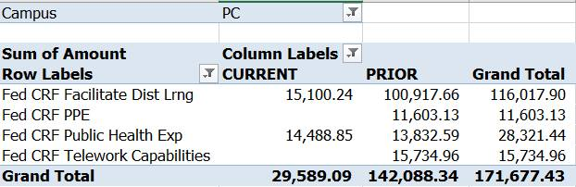

1. **Other**

Suggestion Box (on going)

1. **Future Agenda Items**
   1. Revise Budget Calendar (ongoing)
2. **Adjournment**

**Next Meeting: February 19, 2021**