Bakersfield College Institutional Scorecard
Visual Map
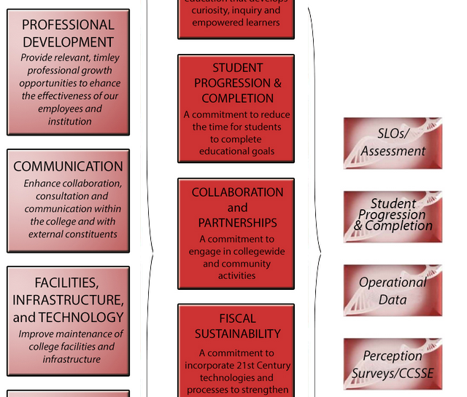
Student Progression and Completion Metrics
- Completion – certificates, degrees and transfer or transfer ready CCCCO Metrics (5 year comparisons on all this)
    - Prepared vs underprepared
 | 2003-04 | 2004-05 |  | 2005-06 |  |  |  | 2006-07 |  |  | 2007-08
%prepared | 16% | 19% |  | 13% |  |  |  | 15% |  |  | 16%
%remedial | 84% | 81% |  | 87% |  |  |  | 85% |  |  | 84%
Completion  prepared | 74.7% |  | 73.3% |  | 71.6% |  |  |  | 73.7% |  |  | 67.2%
remedial | 44.8% |  | 43.0% |  |  | 40.3% | 40.6% |  |  | 34.8%

  - student course completion rate ACCJC
    - Prepared vs underprepared
  - student degree completion ACCJC
  - student certificate completion ACCJC
  - student transfer to 4-year colleges/universities ACCJC
    - Number (not rate) of transfers to each system – over 5 years
  - CTE
- Persistence – (= retention??) The percentage of degree and/or transfer - seeking first - time students who enroll in three consecutive primary terms CCCCO Metrics
- student retention percentage ACCJC
- a college - level course in the same discipline. CCCCO Metrics
- Remediation -The percentage of credit students who start out at any levels below transfer in English, Mathematics, and/or ESL and are followed for six years to determine if they successfully completed CCCCO Metrics
Perception Data CCSSE and Faculty Eval (?)
- Active and Collaborative Learning
  - HSI, BC & Similar
- Student Effort
  - HSI, BC & Similar
- Academic Challenge
  - HSI, BC & Similar
- Student-Faculty Interaction
  - HSI, BC & Similar
- Support for Learners
  - HSI, BC & Similar
- Habits of the Mind Benchmark
- Focus Critical Thinking –perception from student feedback thru aggregated and scrubbed Faculty Evaluation results question #9
SLO Data
- Number of programs assessing
- Number of courses assessing
- Assessment data on ILOs
  - Start with Critical thinking – use John’s model value added; learning gain
  - Response to multicultural and global thinking at First Gen
- Something more meaningful about learning HOM?
Operational
- Rate of SEPS tracked over 3 years (statewide 20% BC about 14.8%)
- Counselor per FTES
- Number of TMCs – Rate
- Number of C-ID – Rate
- Percentage of Program Reviews Turned in
- FTES (track 5 years) total Full time equivalents (??number funded and number unfunded + value or lost funding from unfunded)
- % Prepared vs underprepared (track 5 years)
- Full time vs Part time faculty
- $ per FTES track 5 years
- Annual Allocation track 5 years
- Number list $ of all grants

Not using
  - 30 unit Momentum point

