BAKERSFIELD COLLEGE STRATEGIC FOCUS 2013-14
Updated August 12, 2013

Sonya Christian
Todd Coston
Nan Gomez-Heitzeberg
Jennifer Marden
Manny Mourtzanos
Kate Pluta
Cornelio Rodriguez
Sue Vaughn

EXECUTIVE SUMMARY
This updated Bakersfield College Strategic Focus 2013-14 represents an evolution in thinking as the College developed its strategic plan, engaged in the Accreditation renewal process, and secured new college leadership.

In 2011, with the participation of the colleges and the district office, the Kern Community College District developed its strategic plan. At the same time College Council was reviewing its process for developing and evaluating college goals. After research and work with focus groups, in Spring 2012 College Council decided to move from annual goals to three-year goals. The College Council Strategic Plan Work Group then developed the college strategic plan, which was approved in College Council and Academic Senate in Spring 2012. It integrates District and College strategic goals as well as Actionable Improvement Plans from the Accreditation Self Evaluation process.

The new College President initiated a review and analysis of the Strategic Plan in December 2012. Two members of the 2012-13 Strategic Planning Work Group analyzed the following key Bakersfield College documents:
- 2012-2015 Strategic Plan
- 2012 Self Evaluation with Actionable Improvement Plans
- 2011-14 Educational Master Plan
- 2012 Annual Program Review Summary of APR Process and Outcomes
- 2012 Program Viability Criteria
- Budget Criteria
- Decision-Making Document
- Committee Reports

The members organized these documents by College Strategic Goals (“Achieving Fiscally Sustainable Quality Progression and Completion” pages 11-12 in Bakersfield College Strategic Focus 2013-14) and cited all relevant documents used to prepare the synthesis. This new document further refines the 2012-13 Strategic Plan to link strategic goals, strategic initiatives, and benchmark data strands.

The College President presented the document at Opening Day, January 11, 2013. The authors presented and reviewed the document at College Council and Academic Senate.

In summer 2013, the College President convened a broader group to update the Bakersfield College Strategic Focus 2013-14 document. They reviewed the Strategic Plan, the Strategic Focus, and the most recent Committee Reports in order to develop the original Strategic Initiatives (page 3 of the January 9, 2013 document). Each Strategic Initiative represents a college commitment to achieving its goals. As the group reviewed the strategic goals, it decided to broaden Goal Three’s title from “Facilities & Infrastructure” to “Facilities, Infrastructure and Technology.”

The updated Bakersfield College Strategic Focus 2013-13 was presented at a retreat for College Council and Committee Co-Chairs on August 12, 2013. The College President presented the summary document at opening day, August 21, 2013. College Committees will continue to complete annual Action Plans and include progress in fall reports. The updated 2013-14 Strategic Focus now includes a sixth goal of Professional Development.
INSTITUTIONAL STRATEGY MAP

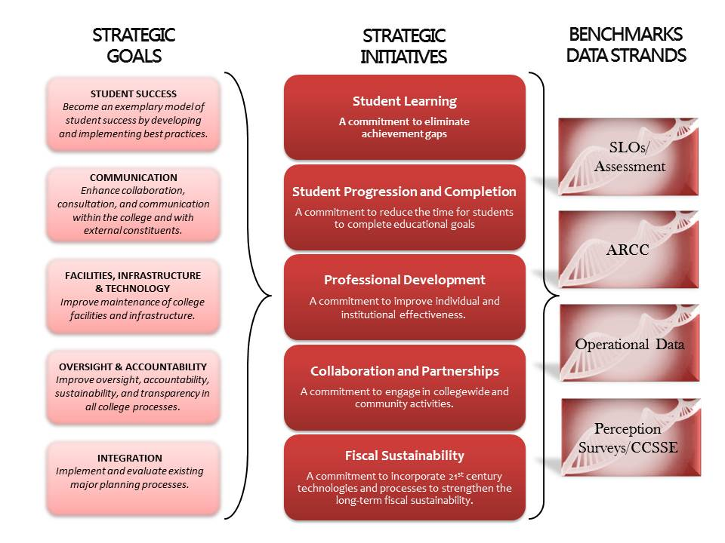
CORE VALUES of BAKERSFIELD COLLEGE

Integrity
We continue to develop and follow an ethical and moral consciousness which places the collective wellbeing and health above the self; this principled environment teaches us to trust each other’s educational vision so that we may be useful and effective in providing support, resources, and encouragement.

Wellness
We believe that a holistic education improves all aspects of the individual and the collective including the mind, body, and spirit; through education, we will positively impact the health of the natural environment and the global community.
Diversity
We value and promote diversity recognizing that multiple perspectives lead to a better education and knowledge of the world; listening and witnessing different experiences helps us to understand and contextualize the politics related to gender, race, class, religion, disability, and sexuality in terms of access and barriers to resources and opportunities.
Community
We maintain strong ties with the surrounding communities, and we respond to their educational needs by serving as an open institution which welcomes all students, faculty, and staff; on our campus, we have built and will continue to build an environment in which all members participate as a community through democratic engagement.
Academics
We foster student inquiry, curiosity, critical thinking, and creativity within a safe and rigorous academic environment so that we might be empowered to radically transform an inequitable world into one that gives voice and power to all people.
Sustainability
We understand our responsibility for continuing and maintaining this institution which has been shaped by 100 years of resolute and tenacious labor and judicious foresight, so we unceasingly place our energies into imagining how the spirit of our campus might be sustained into the future.

INSTITUTIONAL WORK PLAN FOR 2013-14

Student Success
Become an exemplary model of student success by developing and implementing best practices.

Student Success Vision Statement
Bakersfield College is committed to providing holistic educational experiences that foster student learning and academic success. Through concerted institutional efforts and strategic initiatives, Bakersfield College seeks to support student learning and success through improving progression and completion toward their academic and personal goals. In so doing, the educational environment at BC promotes opportunities for students to:
- Acquire new knowledge, skills, competencies and characteristics to prepare them for the next phase of their personal, professional and/or academic pursuits.
- Think critically and independently.
- Develop lifelong habits and skills of inquiry and curiosity.
- Achieve intrinsic motivation for learning

Bakersfield College’s Approach to Student Success
The vision of fostering student learning and academic success at Bakersfield College is realized through:
- Improving student achievement and learning outcomes for all students, thereby creating an educational environment in which all students have shared opportunities and resources to succeed.
- A commitment to student equity through the elimination of achievement gaps among various student populations as identified through the process of collecting, disaggregating and analyzing data on student success, progression and completion across all student groups, especially among at-risk student populations.
- Identifying, addressing and resolving barriers to student success, progression and completion, including institutional policies and protocols that inadvertently encumber students’ academic progression along their journey toward completion.
- Developing an institutional culture in which data is frequently collected, reviewed and assessed to inform and refine Bakersfield College’s student success priorities and resource allocations.
- Strategic implementation of initiatives and programs to advance Bakersfield College’s student success priorities, as well as the allocation of appropriate resources to support those initiatives.
- Ongoing support throughout all phases of students’ academic progression, including:
  - Point-of-Entry services (matriculation, assessment, placement, registration, orientation, and educational planning)
  - Academic advising
  - Student learning and support services
  - Academic progression
  - Retention and persistence, and
  - Graduation.
- A steadfast and ongoing commitment to continuous institutional self-assessment and improvement.
- Transparent communication with, and intentional inclusion of, Bakersfield College’s educational stakeholders to share and discuss information pertaining to student performance measures, outcomes, and institutional initiatives to improve student success.
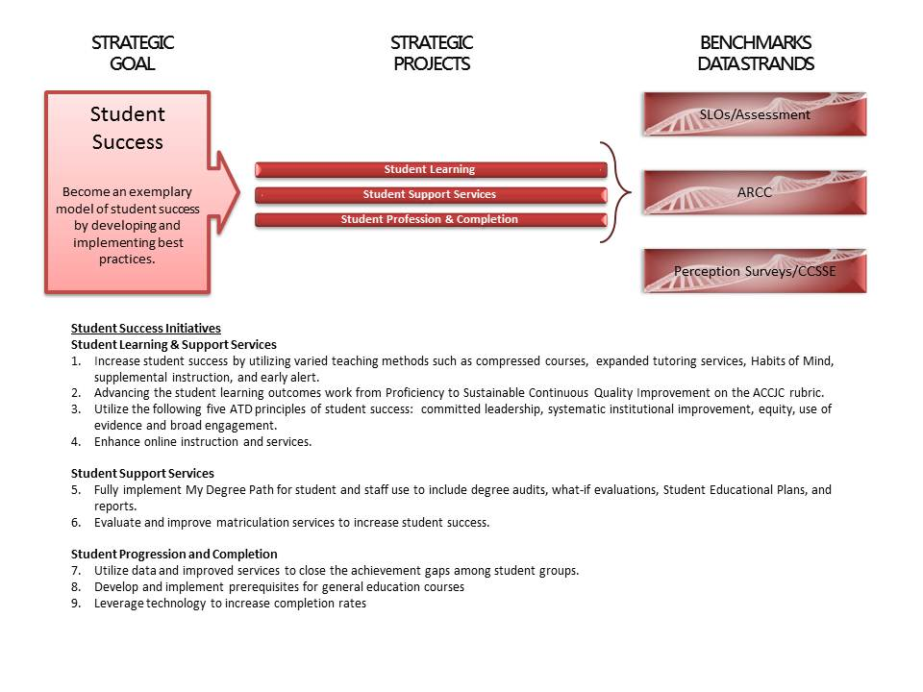

Professional Development
Provide relevant, timely professional growth opportunities to enhance the effectiveness of our employees and institution.
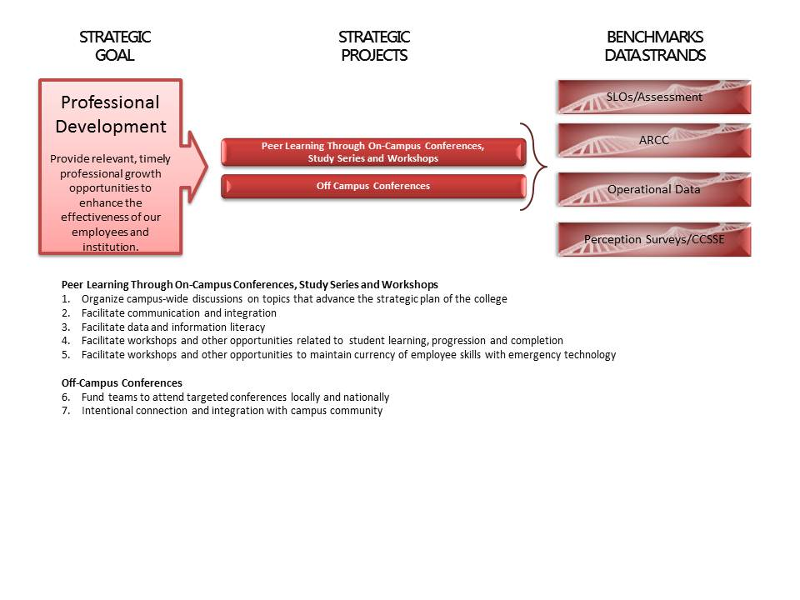
Communication
Enhance collaboration, consultation, and communication within the college and with external constituents.
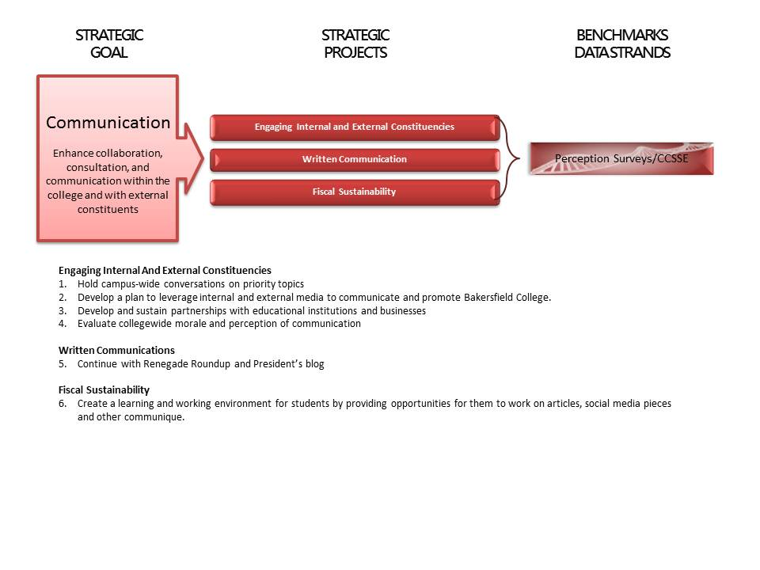
Facilities, Infrastructure and Technology
Improve maintenance of college facilities, technology and infrastructure.

Student Learning, Progression and Completion
- Update and modernize facilities and technology in the classroom
- Upgrade and expand wireless access across the BC campuses
- Develop a media rich, online student orientation

Communication
- Create the web representation of the college score card with the four data strands
- Increase wireless coverage on campus

Fiscal Sustainability
- Upgrade and refresh facilities, infrastructure and technology and move to a goal of developing a scheduled maintenance plan
- Update technology plan
- Update facilities plan

Integration, Collaboration and Institutional Effectiveness
- Resolve CurricUNET Assessment module issues
- Identify collegewide learning environment and operational space needs

Oversight and Accountability
Improve oversight, accountability, sustainability and transparency in all college processes.

Student Learning
- Continue to identify and represent what students have learned; ie what they know and can do.
- Determine strengths and weaknesses of the curriculum implementation and review process
- Identify and highlight four (4) superior assessment plans to improve student learning
- Explore options for implementing a Master Teacher curriculum to improve instructional techniques among faculty

Student Progression and Completion
- Continue to improve student progression towards their educational goals and improve their time to completing a degree or certificate
- Develop an Achieving the Dream student success plan for implementation in AY 2014-2015
- Collaborate with stakeholders to promote an institutional culture focused on student success principles
- Intentionally analyze, review and respond to data on student progression and completion to inform institutional priorities and improve student success

Integration and Collaboration
- Aligning data elements from the institutional score card with the four data strands
- Integrating the work of governance committees with Program Review.

Fiscal Sustainability and Accountability for Institutional Effectiveness
- Improve the system of reallocating and repurposing technological resources
- Develop procedures to monitor progress on Strategic Plan objectives
- Monitor progress on Actionable Improvement Plans
- Evaluate instructional program viability criteria
- Develop student and administrative services viability criteria

Integration
Implement and evaluate existing major planning processes.

Student Learning
- Continue to identify and represent what students have learned; ie what they know and can do.
- Enhance the Adjunct Faculty Orientation experience to include a more diverse offering of sessions and workshops
- Continue efforts to ensure relevant professional development opportunities for personnel

Student Progression and Completion
- Improve student progression towards their goals and improve their time to completing a degree or certificate
- Develop an Achieving the Dream Implementation Plan to guide college efforts in closing the achievement gap for various student groups and populations
- Provide guidance, support and accountability for academic programs with eligible Transfer Model Curricula (TMCs) to secure approval for offering Associate Degrees for Transfer (AA-T or AS-T )

Integration, Collaboration and Communication
- Integrate the work of college-wide and governance committees
- Ensure integration of systems and processes related to program review, assessment and curriculum
- Develop collaboratively an Integrated Program Review process proposal
- Continue with the Renegade Roundup and President’s Blog
- Continue with the Community Voices pieces in the Bakersfield Californian
- Expand on BC news items in local journals like the Kern Business Journal

Fiscal Sustainability and Accountability for Institutional Effectiveness
- Improve district-wide assessment through collaborative events
- Explore further integration of the institution’s budget development process
- Ensure internal deadlines are met
- Evaluate college planning processes

IMPLEMENTATION: MAKING IT HAPPEN
College President and College Council are responsible for implementation of the Bakersfield College Strategic Plan. The following table illustrates other responsible committees, councils and executive leadership.

Student  Success | Professional Development | Communication | Facilities, Technology & Infrastructure | Oversight & Accountability | Integration
Primary:  - Academic Senate  - Assessment  - ATD Data Team  - Curriculum  - PRC | Primary:  - Admin Council  - SDCC | Primary:  - College Council  - All governance committees | Primary:  - Admin Council  - Facilities Cmte  - ISIT | Primary:  - Admin Council  - ATD Data Team  - FCDC | Primary:  - All governance committees  - Admin Council
Secondary:  - FCDC  - ISIT  - PRC  - SDCC | Secondary:  - All governance committees | Secondary:  - All college departments | Secondary:  - FCDC | Secondary:  - All governance committees | Secondary:  - ATD Data Team
Exec. Leadership:  - VP, Academic Affairs  - VP, Admin Services  - VP, Student Affairs (primary) | Exec. Leadership:  - VP, Academic Affairs (primary)  - VP, Admin Services  - VP, Student Affairs | Exec. Leadership:  - VP, Academic Affairs  - VP, Admin Services  - VP, Student Affairs | Exec. Leadership:  - VP, Academic Affairs  - VP, Admin Services (primary)  - VP, Student Affairs | Exec. Leadership:  - VP, Academic Affairs  - VP, Admin Services  - VP, Student Affairs | Exec. Leadership:  - VP, Academic Affairs  - VP, Admin Services  - VP, Student Affairs

College-wide and governance committees: College Council, Curriculum Committee, Assessment Committee,
Information Services and Instructional Technology, Facilities Committee, Budget Committee, Safety Committee,
Program Review, Accreditation Steering Committee, Enrollment Management
BAKERSFIELD COLLEGE KEY DOCUMENTS

- Bakersfield College Strategic Plan, 2012-13 through 2014-15

- 2012 Self Evaluation of Institutional Effectiveness and Educational Quality – Actionable Improvement Plans

- Strategic Focus Document, January 9, 2013

- Committee Reports

