Institution-set Standard Report: Increasing Transfer-level Math success in the first year

Executive Summary

At College Council in October 2018, President Christian directed the Accreditation and Institutional Quality (AIQ) committee to work with the Office of Institutional Effectiveness (OIE) to produce a plan to increase the college’s performance on the Transfer Level Math Achievement Year 1 Institution-Set Standard. In the development of this report, we solicited feedback from math faculty, psychology faculty, and administrators. This report makes the following recommendations, which align with the college’s Guided Pathways framework:

- Curricular redesign to meet AB 705 requirements (Clarify the Path)
- LCP completion teams work to get students on the correct math path in the first semester (Get Students on the Path)
- Increase Academic Support Services, particularly to those math classes without planned corequisite support (Math B4, Math B23, Psych B5) (Ensure Learning)

Background

In October 2018, it was determined that BC had fallen substantially below its Institution-Set Standard (ISS) for the percentage of incoming students who completed transfer-level math in the first year, as shown in Figure 1.

Figure 1. Five year-trend in Transfer-level math completion in the first year
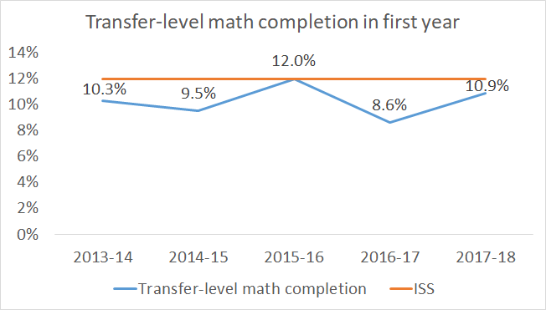

The process for addressing this situation involves the Office of Institutional Effectiveness developing a report that examines the probable causes and remedies for this situation (see Appendix A). In this report, we look at factors that may have caused the institutional bottleneck in transfer-level math throughput. We also examine which math pathways are historically associated with the greatest throughput and the distribution of enrollments into those courses. Finally, we suggest some possible courses of action to improve transfer-level math throughput.

Factors Contributing to Institutional Bottleneck in Transfer-Level Math Throughput

Student Educational Goals

An examination of the educational goals of BC’s student body over the past five years found a consistent and stable distribution of educational goals such that, among those with a declared educational goals, approximately 70% were interested in attaining a Bachelor’s degree (indicating that they require a transfer-level math course) and about 10% were interested in pursuing a terminal Associate’s degree. The remaining students indicated a variety of other educational goals, including short-term certificates, skills builders, and “reverse-transfer” university students picking up courses which do not necessarily require math coursework.

A 2018 analysis of BC’s programs of study by OIE found that about 70% of BC’s programs could have their math requirement fulfilled by a transfer-level math course such as statistics (Math B22 or Psyc B5) or math for elementary teachers (Math B4A). This report is available to the public through the OIE website: https://www.bakersfieldcollege.edu/oie/resources. The remaining programs mostly required a calculus pathway. Even among terminal associate degree programs, transfer-level math remains a viable option for fulfilling math degree requirements--and it leaves the door open for possible future decisions to transfer and attain a Bachelor’s degree.

Given the distribution of student ed goals at BC, the reason for low transfer-level math attainment does not appear to be due to lack of student interest in the math pathway.

Delay in Math Entry

Delay in math entry describes the decision by a student to not enroll in a math class in the first semester. The 2018 October Peter Bahr study reports that that a significant proportion of BC students do not enroll in a math course in their first semester.

Low persistence to throughput

The October 2018 Peter Bahr study shows which math pathways are associated with the greatest throughput, after controlling for various factors including gender, age (binary: under 20 vs. 20+), URM status, term of entry, FT/PT status in first term and whether they were placed via the test or multiple measures.

Figure 2. Predicted Probabilities of Completing Transfer-level math within one year disaggregated by HS GPA and initial math course (Bahr, 2018)
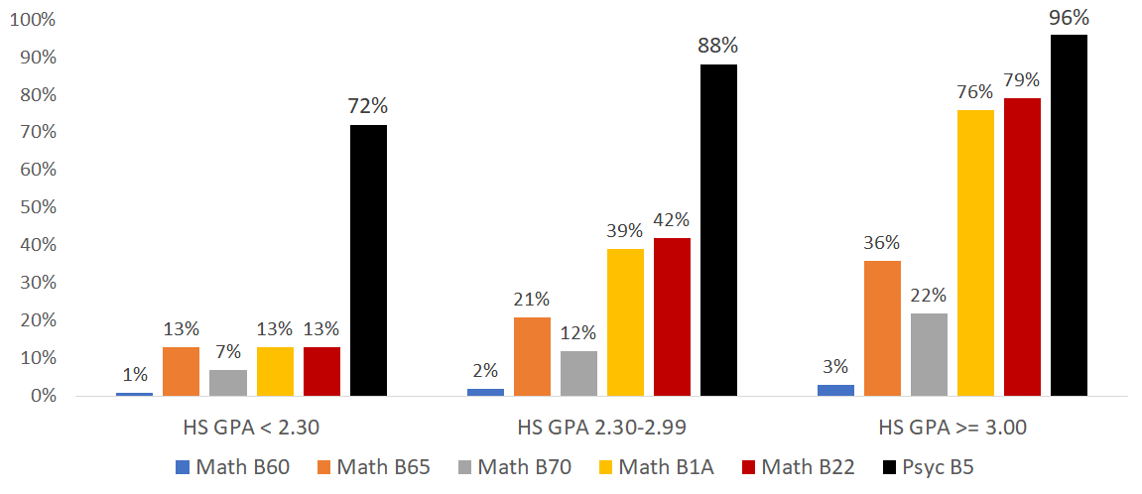

Figure 3. Percentage of students starting in a given math class compared to the predicted throughput for students in the mid-tier GPA band (2.30 – 2.99)
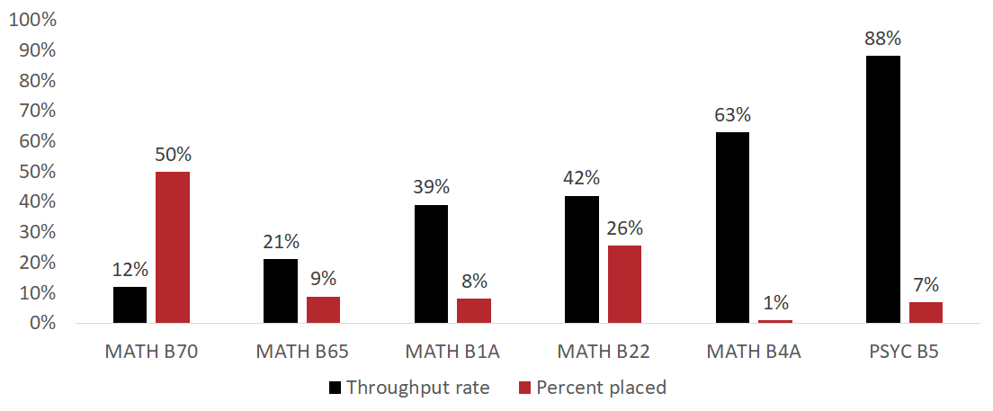

Figure 4. Observed throughput rates for students starting in selected math classes by High School GPA
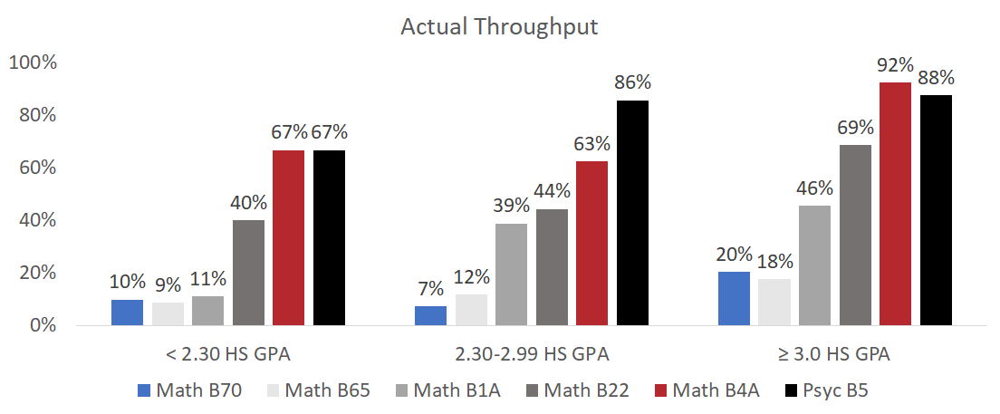

Curricular Redesign
In response to AB 705 requirements, the math department has substantially redesigned its course offerings to incorporate embedded support within transfer- level math courses (See Appendix).

Delay in Math Entry
Counseling & advising will be key to ensuring students take the correct math course in a timely manner. Research conducted by Bahr (2018) suggests that a significant proportion of BC students do not enroll in a math course in their first semester.

a. Leverage the LCPs. B. Counselors & advisors need to prepped for these changes so they understand how to appropriately advise & schedule students’ math coursework in light of their program of study, educational goal, and placement.

Table 1: Selected course-taking behaviors by first math course attempted (Bahr, 2018)

 | N | % delayed first math | average number of terms from college entry to first math | % successful  in first math  (first attempt)
ACDV B72 | 1,070 | 46% | 0.8 | 61%
Math B60 | 1,435 | 46% | 0.6 | 54%
Math B65 | 146 | 52% | 0.8 | 59%
LRNC B530 (Math B60) | 68 | 68% | 1.1 | 85%
Math B70 | 938 | 44% | 0.6 | 53%

*Get students into the correct pathway

Enrollment management

2. Scheduling will be critical to ensuring that students are able to enroll and progress in a timely manner.
- Increasing Math B4A
- Exploring Finite Math
- Reg 365 / block scheduling
- About half of incoming students do not enroll in math in their first term (Bahr, 2018)
- Upcoming changes to Math placement & curriculum in fall 2019.

Based on a September 2018 forecast from the Office of Institutional Effectiveness, we can expect that in fall 2019 about 15% of incoming students will be eligible to place directly in Precalculus I or II based on their strong academic performance in high school, with another 3% being eligible for Precalculus I with concurrent support, per the Chancellor’s Office default rules. Another 15% of students will be eligible for direct placement into Statistics, Finite Math, or Math for Elementary Teachers (aka, SLAM), as appropriate for their pathway. The remaining 67% of incoming students will be eligible for placement into transfer-level SLAM coursework with concurrent support.

What is unknown is the percentage of the incoming cohort that will not have completed Algebra II/Intermediate Algebra in high school and yet will still wish to pursue a BSTEM program of study that requires a calculus-based math pathway. A statewide analysis from MMAP found that few students who did not complete Algebra II in high school pursue transfer-level BSTEM coursework. In other words, students who pursue STEM programs of study tend to be students with stronger backgrounds in math. On the other hand, Business is a popular area for students and many incoming students wish to pursue a program of study in this area. Thus, to the extent that there are students who have not completed Algebra II who wish to pursue BSTEM programs of study, they will need access to Intermediate Algebra (MATH B70 or equivalent) as the first step in their math journey.

Recommendations

Reduce delay in math enrollment. Take action to avoid math enrollment delay. In addition to involvement by counselors and ed advisors, Learning and Career Pathway completion teams should be addressing the timely enrollment of students in an appropriate math pathway. (Get Students on the Path)
Enrollment management. Ensure that adequate numbers of appropriate, high throughput math sections are available for students to enroll in.

Curricular development. Math is currently developing concurrent support courses for Math B22 as well as innovative two-semester courses that are intended to maximize throughput. This innovation should be supported and evaluated for efficacy in a timely manner to provide formative feedback to these efforts. (Clarify the path)

Expand high throughput courses. Two courses stand out in this report as having high throughput, even among students with lower high school GPAs: Psyc B5 and Math B4A. The college should consider expanding offerings of these courses so that more students are able to take advantage of them.

Increase application of multiple measures. Despite BC’s early experimentation with multiple measures, the college was only able to successfully apply high school performance information to about 30% of students in the placement process. With recent developments in the use of CalPASS Plus and CCCApply high school performance data, the college should be able to at least double and perhaps triple that rate, which will increase the number of students with direct access to transfer-level courses by further reducing underplacement.

Expand support services and ensure learning. Provide targeted academic support services to math classes without embedded support (Math B4A, Math 23, and PSYC B5) via Tutoring and Supplemental Instruction. The SPSS statistical program has been installed in one of the computers in the tutoring center. Additional computers (a total of 6) will have SPSS installed. This is a cost-effective solution because BC has an institutional license for SPSS and no additional fees will be generated by adding the software to these computers. This will increase access to support services for PSYC B5 students because other labs on campus don’t have SPSS installed. Ensure Learning & Keep students on the math.

Appendix A. Math Department Proposed Redesign

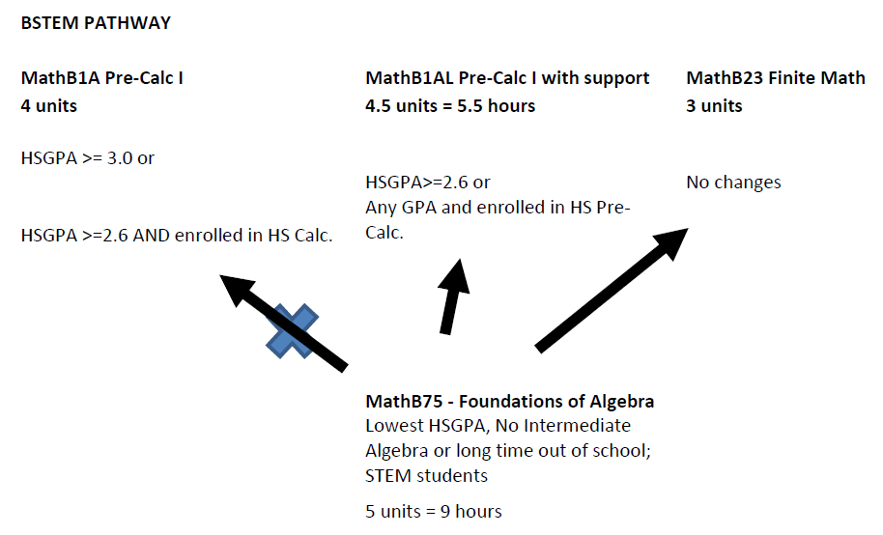

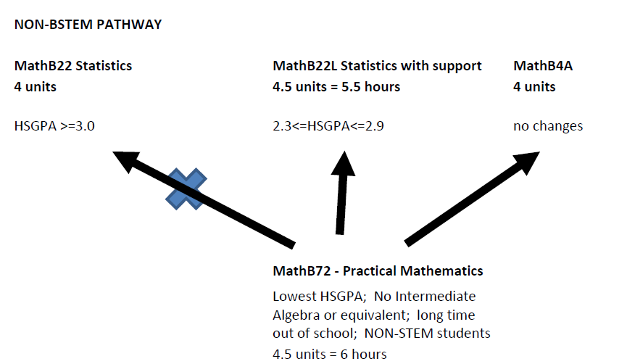

Proposed redesign as of 11/13/18

