Porterville College Mission Statement:

With students as our focus, Porterville College provides our local and diverse communities quality education that promotes intellectual curiosity, personal growth, and lifelong learning, while preparing students for career and academic success.

In support of our values and philosophy, Porterville College will:

- Provide quality academic programs to all students who are capable of benefiting from community college instruction.
- Provide comprehensive support services to help students achieve their personal, career and academic potential.
- Prepare students for transfer and success at four-year institutions.
- Provide courses and training to prepare students for employment or to enhance skills within their current careers.
- Provide developmental education to students who need to enhance their knowledge and understanding of basic skills.
- Recognize student achievement through awarding degrees, certificates, grants, and scholarships.

Program Mission Statement:

The mission of the Admissions and Records Office is to facilitate student access to the educational opportunities offered by Porterville College through comprehensive enrollment services while providing responsive, respectful and welcoming service to students, faculty, staff and the community we serve.

Current Service Area Outcomes (SAO):

SAO 1: Upon completion of the college application, new students will understand the next steps
leading to an academic pathway and course enrollment. The target goal will be 80% understanding and satisfaction with student support services, resources, communication and technologies.
Assessment Method: Students will complete a survey.

SAO 2: Students will be able to understand the graduation evaluation process and apply for certificates and/or degrees by the appropriate deadlines. The target goal will be 80% understanding and satisfaction with student support services, resources, communication and technologies.
Assessment Method: Students will complete a survey.

SAO 3: Students will understand that all fees are due 10 days after registration and the resulting consequences of unpaid balances. The target goal will be 80% understanding and satisfaction with student support services, resources, communication and technologies.
Assessment Method: Students will complete a survey.

Additional Comments: Current service area outcomes will be assessed with Comevo surveys/questionnaires sent to students’ email accounts. Also, beginning in Spring 2021, access/satisfaction surveys will be conducted via orientation workshops and during registration events.

The target goal will be 80% understanding and satisfaction ratings with student support services, resources, communication and technologies. Students will also receive a welcome email regarding next steps after completing their CCCApply admission application to Porterville College as well as Student Success Checklists that will outline resources and important information needed to be successful during their academic journey.

Prior Service Area Outcomes (SAO):

SAO 1: Upon completion of the college application, new students will understand the next steps
leading to course enrollment.

SAO 2: Student usage of the DegreeWorks system will increase by 3% annually to assist with
success outcomes in degree completion.

SAO 3: Students will continue to maintain a high level of student satisfaction with the services
provided by the Enrollment Services staff such as application process, registration and academic
policies/procedures.

SAO 4: Students will be able to order their Porterville College transcripts using TranscriptsPlus.

Prior Service Area Outcome 1 was based on students being informed about next steps leading to course enrollment. It was assessed by monitoring notifications/emails sent out using a Cognos report that lists students that have been admitted to the college but have not enrolled yet. The report is downloaded and staff communicate with students using CampusCast/Navigate to send text messages and emails to students explaining next steps for enrollment.

Prior Service Area Outcome 2
While our goal was to assess the usage of DegreeWorks (MyDegreePath) via data accessed from District Office, it came to our attention that the DegreeWorks system was not able to determine usage. We have no way to know how many users are logging into DegreeWorks for any particular period of time. We can only query how many users are logged in at the moment, however, there is nothing in the application recording logins for a given period. Over the past three years, MyDegreePath workshops have been offered throughout the year for students. All students are provided access once they enroll in courses. DegreeWorks is a degree audit system that monitors progress toward degree completion and clearly indicates which course requirements have been met. Counselors complete student education plans for students using this platform and students login to view progress in order to stay on track for graduation/completion.

Prior Service Area Outcome 3 was assessed via an online Student Services Satisfaction Survey. The survey was made available during the spring 2019 semester and emailed to all students who had completed an admission application for the 18-19 year. Questions included in the survey involved placement, orientation, completing an education plan, meeting with a counselor, use of student services technology, student services resources available, recommending Porterville College to others, ethnicity, student groups, gender and high school attended. There were 119 survey responses returned.

Porterville College students utilized several of the technology platforms with an average of 99% of students operating Canvas. Throughout the survey it was evident students are unaware of the resources that are available to them. For instance, only 2.1% of students are informed of the online counseling (Cranium Café) option. The level of satisfaction in Porterville College support services had a high percentage of excellent and good scored on each resource that is available to students. A small percentage of each support services were rated poorly, but on average the majority of students are happy with the support services that are offered to them at Porterville College.

Many students would recommend Porterville College to others based on their experiences thus far. The population is extremely diverse, over 81% of students are first generation college students. The majority of the student population does identify as female which is 73.5% compared to males at 26.5%. Porterville College has a predominant population of individuals identifying as either Hispanic or Latino with a response of 74.3%.

Many students attended and transferred from Monache and Porterville High School at the highest rate compared to other schools in the area.

The recommendations and suggestions that were noted in the survey are more courses offered in the evening, counselors/advisor provide more thorough advising, and cafeteria offering more healthy food options. Overall, many students admired the counselors and the campus for the remarkable services and resources that are available to students and the benefits from the tight knit environment of the Porterville College campus.

Prior Service Area Outcome 4 was assessed by monitoring Transcripts Plus delivery trends and completed orders by service type data. A data analysis shows a 16% increase in student usage from academic year 2018-2019 to the 2019-2020 year via the online Transcripts Plus link. Students have the ability to order online or in-person via the Admissions and Records Office. Students requests pdf copies, electronic copies and printed copies to be sent to other colleges, universities, employers, insurance purposes, etc.

Program Analysis and Trends

The Admissions and Records Office is critical to college operations as it is often the first office contacted by new or returning students seeking information about Porterville College. The Office provides comprehensive services to prospective and continuing students from entry/onboarding through students’ completion of their academic program.

Admissions and Records is comprised of several specific units with different functional roles. These units are:

1. Admissions
2. Residency
3. Registration
4. Records
- Transcripts
- Petitions
- Subpoenas
- Document Management
- Confidentiality of Student Records
5. Evaluations
6. Roster and Faculty Support
7. MIS, Student Data
8. 320 Submission
9. Academic and Progress Dismissals
10. Collection of Fees
11. Commencement
12. International Student Program

The primary services provided by the Admissions and Records Office are admissions, records, and registration assistance to students and faculty. Most of the office’s functions are provided outside the customer service arena. These "behind the scenes" services include processing of payments, online applications, registration, petitions, transcripts, evaluations, document imaging, faculty support, etc.

Because timely processing of documents is so critical to the smooth operation of the office and to the coordination of services with other areas of the College, deadlines are carefully established and strictly met.

New Funding Formula/Vision for Success:

- Completion/Evaluator works with Advisor regarding graduation petition deficiencies
- Transfer/Be Grad Ready Workshops, transcript evaluations, graduation petitions, communication with counseling/advising
- Reducing unit accumulation/30-48+ unit student contact campaigns, following student education plan, no longer allowing students to change major until they meet with a counselor first.

Admissions and Records is heavily tied to compliance, policies and procedures:
- Board Policy/Procedures
- Title 5
- California Ed Code
- MIS data
- Attendance Reporting – 320 Report
- Auditing

Changes in Program over Last Three Years

Increase in Awards/Certificates

There has been a significant increase in awards over the past five years. This is attributed to students participating in the Be Grad Ready efforts, marketing and outreach regarding on-time completion. Also, students are completing the requirements for multiple degrees/certificates in which they are now awarded multiple degrees/certificates upon graduation from Porterville College.

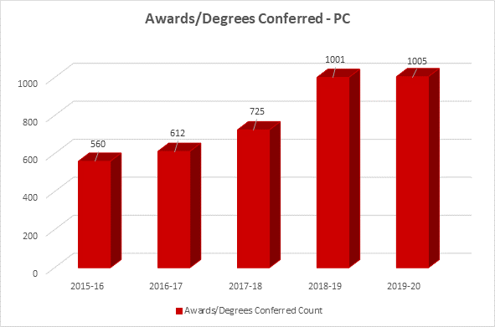

Be Grad Ready Workshops
- Implemented Fall 2018.
- Offered on campus and virtually since Covid. 10-18 students participated in each workshop.
- We received 598 petitions for Spring 2020 and 240 petitions for Fall 2020. Admissions and Records continues to accept late petitions and offer Be Grad Ready workshops each month to support students with the process. For the current academic year 2020-2021, a total of 12 workshops have been planned to assist students with the application process.

Implementation of Banner 9
The Ellucian Banner system was implemented on our campus in 1998. The management system recently underwent a system update in Fall 2018. Staff underwent months of training/workshops to become accustomed with the changes. Porterville College uses the following modules of Banner:
  - Student
  - Human Resources
  - Financial Aid
  - Finance

Document Imaging Changes
Changes with different imaging systems over the past three years:
  - Hershey-2007/2017
  - Onbase-2017/2019
  - Banner Document Imaging (BDM)-current system implemented in June 2020
  - Admissions and Records is completely implemented as of June 2020. Counseling/Advising is next.

DegreeWorks Upgrade
DegreeWorks is used by students, counseling/advising and Admissions and Records. It is a web-based auditing and planning tool that is used to evaluate a student's academic progress towards completion of his/her degree. The tool provides an organized, convenient and accessible way for college students to be aware of where they are academically and how they can plan for their graduation. The system underwent a recent upgrade in November in which staff from counseling/advising and admissions received updated training.

Increase in Dual Enrollment/Courses

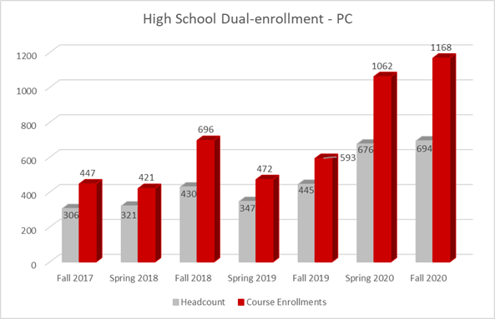
- Spring 2021 Sections = 43
- Dual Enrollment Process-High School Certification Forms/Placement. Admissions and Counseling work closely to review approximately 1000 forms each semester.

Online Chatbot
- Patches is an artificially intelligent chatbot available to answer Student Services questions including Admissions and Records.

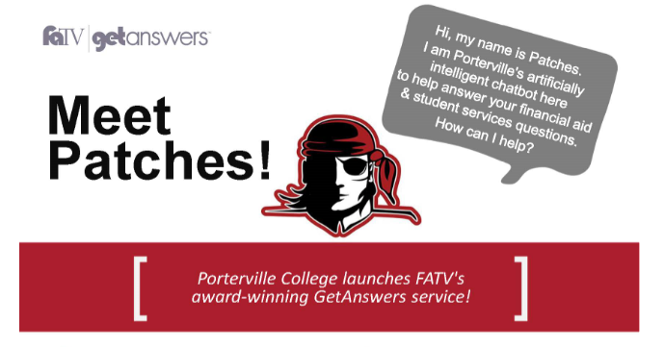
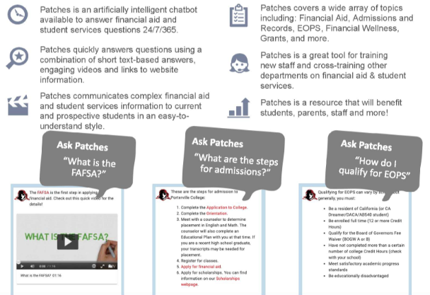

Elumen Catalog
We have just transitioned to an online/interactive catalog using Elumen. Implementation is currently underway and we will go live with the 2021-2022 catalog in summer 2021. Using role-based workflows and preview functionality, it will make it easy to flow approved courses and programs for the academic calendar year into the catalog. Departments can manage their unique catalog needs/updates online via the portal.

NextGen Dynamic Forms
Using Dynamic Forms, we now have multiple departments using the online platform to sign necessary forms electronically. This project was implemented in August 2020. The following Admissions and Records forms can be signed electronically/online by staff, faculty, parents, administrators, etc.:

  - AB540
  - FERPA
  - Transcript Evaluation
  - Extenuating Circumstance
  - Drop
  - Repeat
  - Time Conflict
  - Program Change

Increase in CCCApply Applications
- PC received 4563 applications during the 2019-2020 year (Fall, Spring and Summer.
- Inactive applications-Educational Advisors reach out to applicants who did not finish their application to see how they can assist with questions or registration needs.
- Fraudulent applications are on the rise and monitored closely. Staff monitor the CCCApply spam filter and reject any potential fraudulent applications.

Covid 19 Pandemic/Online Services
- Drive-thru events to support students
- All services are moved online
- Dynamic Forms implementation of electronic forms
- Staff availability by phone and email during business hours
- Spring changes to grading due to Covid (Special Withdrawal, EW)
- Extenuating Circumstances continuing through December 2020
- Essential Staff/campus visits each week
- Admissions and Records Virtual Office Hours implemented Spring 2021
- Student Services Virtual Office Hours (Student Workers available to answer questions)

Drop for Non-Payment Process
Now, before any drops for non-payment occur, students are contacted via email, text and phone calls before they are dropped. The curtesy contacts have been helpful to remind students and give them a deadline to pay their fees before being dropped for non-payment. This has helped cut the number of students on the drop list in half each semester.

Data Review
Enrollment Trends

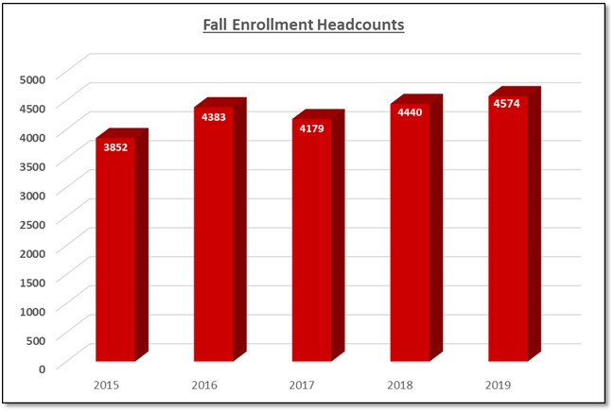

Outgoing Transcript Requests

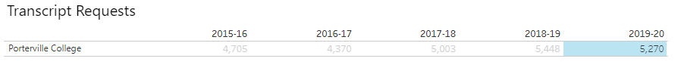

Incoming Transcripts from Other Colleges/Universities

- As of today, evaluators have received 360 Transcript Evaluation form requests since January 2020.
- Often times there are more than one college/transcript to review listed on each evaluation form submitted. We have seen up to 6 colleges listed on forms.
- Transcript evaluations run approximately 4-6 weeks for review/placement on PC transcripts. Early review aids counselors on the front-end to complete Comprehensive Student Educational Plans (CSEPS).

Program Strengths

Timely processing of documents-The Office completes timely processing of documents to ensure smooth operation and the coordination of services with other areas of the college. Deadlines are carefully established and met.

Collaboration with Instruction and other Student Services Departments-The Office collaborates with many departments on a daily basis. Departments that include regular interaction include: Counseling/Advising, Outreach, Athletics, Access Programs, Instruction/Academic Affairs, Academic Divisions/Chairs, and Veterans Resource Center.

Fast Track Dual and Concurrent Enrollment-The Office coordinates closely with the Program Director of CTE/Dual Enrollment to ensure High School Certifications are processed and students are enrolled. One Admissions and Records Technician is assigned to Dual Enrollment and 50% of her time is assigned to the process and working closely the high schools, Dual Counselor, Program Director and Director of Enrollment Services.

Increased Certificates/Degrees Awarded-The Office has worked hard to increase student awareness of the graduation petition process and deadlines in the past two years. The Office implemented the Be Grad Ready Campaign and Outreach efforts to encourage students to apply early. Students participate in various workshops offered throughout the year and receive guidance and support completing the appropriate paperwork to petition for graduation. Awards have gone from 725 in 2017-2018 to 1005 in 2019-2020.

Early Transcript Evaluation-The Office has moved from evaluating transcripts from other colleges/universities when students would petition for graduation to now evaluating transcripts on the front-end when a student begins their academic pathway. Transcripts are now evaluated within 4-6 weeks after receiving the transcript/evaluation form. This provides both students and counselors with accurate information early on to aid with the completion of an educational plan at the beginning of a student’s journey.

CCCApply Workshops at High Schools-The Office collaborates closely with the Outreach Team to plan workshops at the beginning of the school year for all area seniors attending high schools within Porterville Unified and Burton School Districts. Workshops are coordinated around the Career and Major Exploration Workshops to ensure students select the correct choices when completing their CCCApply college admission application.

Enrollment Events-The Office works closely with the Outreach team to plan several enrollment events throughout the year. These events include: PC Connection, RegFest, Pirate in a Day and ESL Express Enrollment. These events take time to coordinate and plan. Most departments in Student Services plays a role in assisting and helping students enroll/apply for support services during the events.

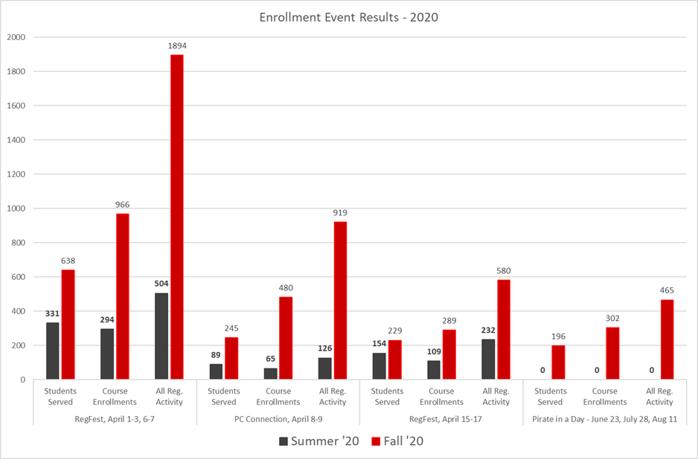

Areas for Improvement

- Document Retention Process
- A new document retention policy/procedure/timeline will be created in the spring of 2021 across the district for the three campuses. The campuses will use Banner Document Imaging to store documents and outline how long documents need to be maintained for compliance. A consultant is working with District Office to complete the project with the Directors.
- CCCApply Additions
  - Implement Non-Credit Application-Working with Bakersfield, Cerro Coso and District Office to implement the non-credit application.
  - Career Interest Supplemental Questions-We have reached out to CCC Tech Center to receive a demo regarding the CCC MyPath customizable options for supplemental questions.
- Auto-Awarding/Certificates
- A new completion report is available to determine those students who have completed all the requirements for a degree/certificate. We are starting with auto awarding certificates in the spring of 2021.

Goals (This section is for you to report on progress on previously established goals. If your program is addressing more than 2 goals, please duplicate this page)

Goal(s) | Completion Date | Needed resources | Person(s) Responsible | Obstacles to completion  (if any)
1. Create an Admissions and Records Faculty Resource Guide | Fall 2018 | Staff time | Director-Enrollment Services | Staff time

Which of numbered items under the Mission Statement (see page 1 of this document) will be furthered if this goal is completed? (select all that apply)

Item 1_X__ Item 2___ Item 3_X__ Item 4_X__ Item 5___ Item 6_X__

Progress on Goal:

__X__Completed (Date Spring 2018 )
____Revised (Date )

Comments:
An actual full guide has not been completed, however, a Start of Term Information guide is now provided to faculty at the beginning of each semester along with the latest Academic Calendar. Any changes or updates from Admissions and Records is communicated out via email to pc_faculty or pc_adjunct as well as updates provided at faculty orientations.

Goal(s) | Completion Date | Needed resources | Person(s) Responsible | Obstacles to completion  (if any)
2. Implement Onbase Document Imaging | Summer 2018 | Staff time/training | Director, Enrollment Services and District Office | Adequate computers/scanners required for full implementation

Which of numbered items under the Mission Statement (see page 1 of this document) will be furthered if this goal is completed? (select all that apply)

Item 1___ Item 2_X__ Item 3_X__ Item 4___ Item 5___ Item 6_X__

Progress on Goal:

__X__Completed (Date July 2018 )
____Revised (Date )

Comments:
Imaging project completed in July of 2018 in the Admissions and Records Office. Admissions staff as well as Counseling/Advising staff were trained to use Onbase to view transcripts in both areas.

Goal(s) | Completion Date | Needed resources | Person(s) Responsible | Obstacles to completion  (if any)
3. Create and Implement a Document Retention Destruction of Records Process/Manual | Summer 2019 | Staff time | Director, Enrollment Services and District Office | Staff time

Which of numbered items under the Mission Statement (see page 1 of this document) will be furthered if this goal is completed? (select all that apply)

Item 1___ Item 2_X__ Item 3_X__ Item 4___ Item 5___ Item 6_X__

Progress on Goal:

____Completed (Date )
____Revised (Date )

Comments:
Goal not completed as we have identified a consultant to help with this project for all three campuses (Porterville, Bakersfield and Cerro Coso). We are working with District Office in Spring 2021 to establish policies and procedures across the district for document retention. We will utilize the new Banner Document Imaging (BDM) for the project as well as Legacy Document Imaging for older records. This goal will be moved to a current goal for this program review.

Goals (This section is for you to report new goals for your program. If your program is creating more than 2 goals, please duplicate this page)

Goal(s) | Timeline for Completion | Needed resources | Person(s) Responsible | Obstacles to completion  (if any)
1. Create a Document Retention Policy/Process | Summer 2021 | District Office support and staff time | Director, Enrollment Services and District Office

Which of numbered items under the Mission Statement (see page 1 of this document) will be furthered if this goal is completed? (select all that apply)

Item 1___ Item 2_X__ Item 3_X__ Item 4___ Item 5___ Item 6_X__

Progress on Goal:

____Completed (Date )
____Revised (Date )

Comments:

Goal(s) | Timeline for Completion | Needed resources | Person(s) Responsible | Obstacles to completion  (if any)
2. Admissions and Records Staff Manual | Summer 2022 | Staff Time | Director, Enrollment Services and Admissions Staff

Which of numbered items under the Mission Statement (see page 1 of this document) will be furthered if this goal is completed? (select all that apply)

Item 1___ Item 2_X__ Item 3_X__ Item 4___ Item 5___ Item 6_X__

Progress on Goal:

____Completed (Date )
____Revised (Date )

Comments:

Goal(s) | Timeline for Completion | Needed resources | Person(s) Responsible | Obstacles to completion  (if any)
3. Admissions and Records Faculty Member Resource Binder | Fall 2022 | Staff time | Director, Enrollment Services and Admissions Staff

Which of numbered items under the Mission Statement (see page 1 of this document) will be furthered if this goal is completed? (select all that apply)

Item 1_X__ Item 2___ Item 3_X__ Item 4___ Item 5___ Item 6___

Progress on Goal:

____Completed (Date )
____Revised (Date )

Comments:

Goal(s) | Timeline for Completion | Needed resources | Person(s) Responsible | Obstacles to completion  (if any)
4. Auto-Awarding, Incorporate DegreeWorks reporting with degree evaluations | Fall 2021 | Staff time | Director, Enrollment Services, Evaluator

Which of numbered items under the Mission Statement (see page 1 of this document) will be furthered if this goal is completed? (select all that apply)

Item 1_X__ Item 2___ Item 3_X__ Item 4___ Item 5___ Item 6___

Progress on Goal:

____Completed (Date )
____Revised (Date )

Comments:

Goal(s) | Timeline for Completion | Needed resources | Person(s) Responsible | Obstacles to completion  (if any)
5. CCCApply: Implement Non-Credit Application and Career Interest Supplemental Questions. | Fall 2021/Spring 2022 | Staff time | Director, Enrollment Services, District Office

Which of numbered items under the Mission Statement (see page 1 of this document) will be furthered if this goal is completed? (select all that apply)

Item 1_X__ Item 2___ Item 3_X__ Item 4___ Item 5___ Item 6___

Progress on Goal:

____Completed (Date )
____Revised (Date )

Comments:

STAFFING REQUEST

Staff Resources:
Current Staffing Levels  Full-time Staff |  |  | Part-time Staff
Faculty |  |  | Faculty
Temporary |  |  | Temporary
Classified |  | 3 | Classified |  | 2
Management |  | 1 | Management
Project dates of temporary staff:

Request for New/Replacement Staff
Use one line for each position requested. Justify each position in the space below.

 | Title of Position |  | Classification  (Faculty, Classified, or Management) | Full or Part  Time |  | New or Replacement
Position 1
Position 2
Position 3
Justification:

N/A, last staff member hired in April 2020.

TECHNOLOGY REQUEST
Use this section to list any technology needs for your program. If you have more than two technology needs, add rows below.

Technology Need | Justification
Scanners | Banner Document Imaging (BDM) was just implemented, currently there is only one scanner in Admissions and Records. We would like for each window to have a scanner and one more scanner in the back of the office.

FACILITIES REQUEST
Use this section to list any facilities needs for your program. If you have more than two facilities needs, add rows below.

Facilities Need | Justification
Admissions roll down windows to not lock securely. | We would like to request new roll down windows to be installed at the front Admissions counter. Currently, staff have to manually roll down each window and secure it with a plier. The time it takes to manually roll down the windows is a cause of concern if there is an emergency situation on campus.

SAFETY & SECURITY REQUEST
Use this section to list any safety & security needs for your program. If you have more than two safety & security needs, add rows below.

Safety & Security Need | Justification
Admissions roll down windows to not lock securely. | We would like to request new roll down windows to be installed at the front Admissions counter. Currently, staff have to manually roll down each window and secure it with a plier. The time it takes to manually roll down the windows is a cause of concern if there is an emergency situation on campus.
Item 2

PROFESSIONAL DEVELOPMENT REQUEST
Use this section to list any professional development opportunities you would like to have available for your program. If you have more than two professional development needs, add rows below.

Professional Development Need | Justification
Item 1

Item 2

BUDGET REQUEST
(Do not include staff increases in this section)

 | Current Budget | Amount of Change | Revised Total
2000 (Student Worker Only) | $0 | $0 | $0
4000 | $6600 | $0 | $6600
5000 | $12,680 | $0 | $12680
Other

Justification:
(Include justification for each change requested.)

