ESA Advisory Agenda
Draft
February 20, 2018 3:45 p.m.
MHS Mrs. Driver's classroom (3rd Tuesday)

Members: Brian Rueger, Brianna Johnson, Bud Darwin, Jason Biagio, Kevin Elliott, Nancy Bruce, Richard Goode, Charles Fenwick, Nicole Arbelo, Brenda Merzoian Ex Officio: Diane Rankin, Amanda Driver, Mimi Schuler

Welcome and Introductions
Additions to agenda:
Senior Project update-

Reports:
P8 Report & City of Porterville: (Jason Biagio)

Student Representatives (Brianne)

Academy Lead (Amanda Driver)

Administration (Diane Rankin)

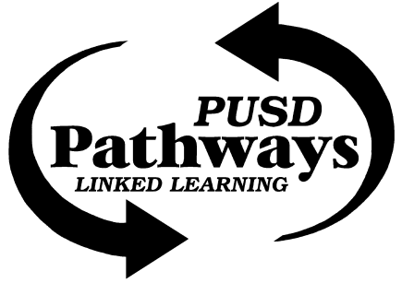
Porterville College (Richard Goode)

Pathway Office (Mimi Schuler)

Circle J Ranch (Nancy Bruce)-
- Habitat Restoration planting day March 17 from 10:30 a.m. - 3:30 p.m.
Sequoia Riverlands Trust (Bud Darwin)-
- Carbon Project
- Blue Oak Stewardship
Success Lake/USACE (Charles Fenwick)-

WildPlaces ()
- Goldman Environmental Prize Ceremony Monday April 23 from 4:30 - 10:30 p.m.

Adjournment

Next Meeting: Need to reschedule! How about Tuesday March 27, 2018 @ 3:45 p.m.?

