ESA Advisory Agenda
Draft
May 16, 2017 3:45 p.m.
MHS Mrs. Driver's classroom
(3rd Tuesday)

Members: Brian Rueger, Bud Darwin, Jason Biagio, Kevin Elliott, Nancy Bruce, Richard Goode, Charles Fenwick, Nicole Arbelo, Brenda Merzoian Ex Officio: Diane Rankin, Amanda Driver, Mimi Schuler

Welcome and Introductions
Additions to agenda:

Board Officer Nominations and Election
Reports:
P8 Report: (Nicole Arbelo)

Ryan Leisure
- Using Google Classroom for Senior Projects
Student Representatives (Zarina Cadiz, Rebecca Pacheco)

Academy Lead (Amanda Driver)

Administration (Diane Rankin)

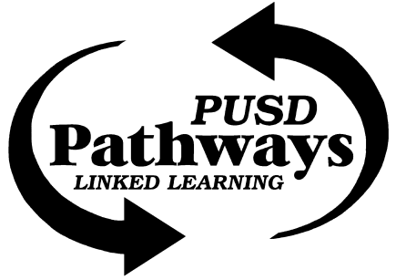
Porterville College (Richard Goode)

Pathway Office (Mimi Schuler)
- Save the Date June 2 for Pathways Social
City of Porterville (Jason Biagio)

Sequoia Riverlands Trust (Bud Darwin)-

Success Lake/USACE (Charles Fenwick)-

Circle J Ranch (Nancy Bruce)-
- Turtle Research @ Circle J May 17 - 20 ~ 10:00 AM; Circle J Research Forum Friday June 9

Adjournment

Next Meeting:

