ESA Advisory Agenda
Draft
Oct. 17, 2017 3:45 p.m.
MHS Mrs. Driver's classroom (3rd Tuesday)

Members: Brian Rueger, Bud Darwin, Jason Biagio, Kevin Elliott, Nancy Bruce, Richard Goode, Charles Fenwick, Nicole Arbelo, Brenda Merzoian Ex Officio: Diane Rankin, Amanda Driver, Mimi Schuler

Welcome and Introductions
Additions to agenda:

Reports:
P8 Report & City of Porterville: (Jason Biagio)

Student Representatives (Brianne)

Academy Lead (Amanda Driver)

Administration (Diane Rankin)

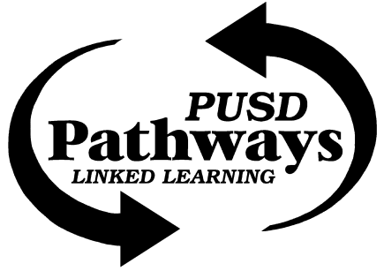
Porterville College (Richard Goode)

Pathway Office (Mimi Schuler)

Circle J Ranch (Nancy Bruce)-
- Habitat Restoration planting day(s)!
Sequoia Riverlands Trust (Bud Darwin)-

Success Lake/USACE (Charles Fenwick)-

WildPlaces (Josh Moore)

Adjournment

Next Meeting: Tuesday December 19, 2017 (or do we want to skip December and meet in January?)

