ESA Advisory Agenda
Draft
Oct. 17, 2017 3:45 p.m.
MHS Mrs. Driver's classroom (3rd Tuesday)

Members: Brian Rueger, Bud Darwin, Jason Biagio, Kevin Elliott, Nancy Bruce, Richard Goode, Charles Fenwick, Nicole Arbelo, Brenda Merzoian Ex Officio: Diane Rankin, Amanda Driver, Mimi Schuler

Welcome and Introductions
Additions to agenda:
Discussion about Senior Projects: Project Deliverables, rubrics,
Google Classroom
Reports:
P8 Report: (Jason Biagio)

Student Representatives (Aisha)

Academy Lead (Amanda Driver)

Administration (Diane Rankin)

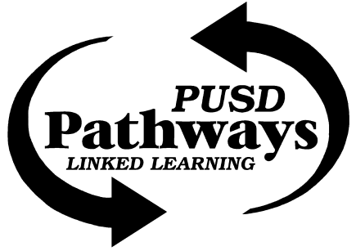
Porterville College (Richard Goode)

Pathway Office (Mimi Schuler)

City of Porterville (Jason Biagio)

Sequoia Riverlands Trust (Bud Darwin)-

Success Lake/USACE (Charles Fenwick)-

Circle J Ranch (Nancy Bruce)-
- Circle J Research & Restoration Saturday October 28;

Adjournment

Next Meeting: Nov 21, 2017 (That's Thanksgiving week- does that date work? Or shall we rescedule?)

