Bakersfield College
Assessment Handbook
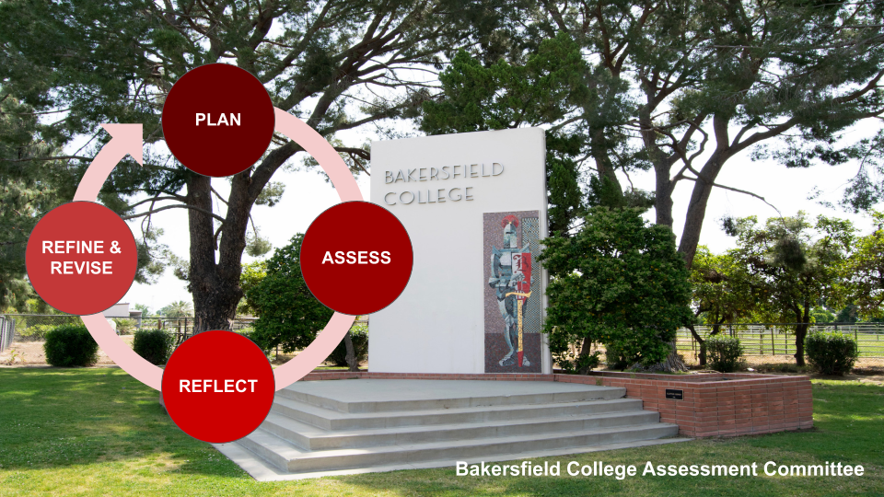
Updated April 2022

Bakersfield College
Assessment Handbook 2
- Introduction 2
- BC Mission Statement 2
- Handbook Purpose 2
- Importance of Assessment 2
- Who Benefits from Assessment 3
- Student Learning Outcomes (SLOs) 4
- SLO Basics 4
- Difference Between Learning Outcomes and Objectives 4
- Assessment Cycle 6
- BC is “On PARR” with Assessment 6
- PARR Cycle Explained 7
- Guiding Principles for SLO Assessment 7
- Methods of Assessment 9
- Why Final Grades are Not Enough 9
- Direct Assessment 9
- Types of Assessment 10
- Choosing an Appropriate Assessment Measure & Tool 10
- Assessment Reporting 12
- Closing the Loop 13
- References 15
- Attachments 16
Attachment A: Bloom’s Revised Taxonomy 16
Cognitive Domain (Knowledge) 17
Affective Domain (Attitudes) 18
Psychomotor Domain (Behaviors, Skills) 19
Attachment B: Learning Outcome Review Checklist 20
Attachment C: Types of Assessment Measures 21
Course-Embedded Assessments 21
Cross Course Measures 21

Bakersfield College
Assessment Handbook

Introduction

BC Mission Statement
Bakersfield College provides opportunities for students from diverse economic, cultural, and educational backgrounds to attain Associate and Baccalaureate degrees and certificates, workplace skills, and preparation for transfer. Our rigorous and supportive learning environment fosters students’ abilities to think critically, communicate effectively, and demonstrate competencies and skills in order to engage productively in their communities and the world.

Handbook Purpose
This handbook is meant to be used by
- The Assessment Committee of Bakersfield College
- The faculty of Bakersfield College.
Committee members and/or faculty should use this handbook as a guide to understand
- What assessment means at Bakersfield College
- The Assessment Committee’s Assessment Cycle
- How to define and create student learning outcomes at Bakersfield College
- How to assess learning outcomes at Bakersfield College.

Importance of Assessment
The Accrediting Commission for Community and Junior Colleges (ACCJC) requires that institutions define and assess student learning outcomes (SLOs), discuss the data, and make improvements based on the data (ACCJC, 2014, Standards I.B and II.A.1, 2, and 3).

Bakersfield College faculty recognize that a full commitment to developing and assessing student learning outcomes fosters a student centered approach to teaching that reflects the core of the college’s mission, allowing us to strengthen our courses, programs, and institution. Furthermore, SLO assessment is used as a foundation for data driven decision making with regard to institutional planning and budgeting. We accept that, as faculty members, part of our professional responsibility is to participate in the SLO assessment process to ultimately strengthen institutional performance and public accountability.

Who Benefits from Assessment
One of the great advantages of SLO assessment is that when done in a systematic way, the process benefits students, faculty and administration.

For students, participating in SLO assessment will:
- communicate clear expectations about what is important in a course or program.
- inform them that they will be evaluated in a consistent and transparent way.
- reassure them that there is common core content across all sections of a course

For faculty, participating in SLO assessment will:
- help them determine what is and what is not working in their courses and/or programs.
- facilitate valuable interdisciplinary and intercampus discussions.
- provide powerful evidence to justify needed resources to maintain and/or improve programs.
- allow them to tell their story to individuals outside their area (e.g. administrators, employers, prospective students, transfer institutions, politicians, accreditors, etc.).
- provide reassurance that all faculty teaching a specific course agree to address certain core content.

For administrators, participating in SLO assessment will:
- demonstrate an institutional commitment to continually improve academic programs and services offered by the college.
- provide valuable data to support requests for funds from state and local government, and private donors.
- demonstrate accountability to funding sources.
- provide valuable data for academic planning and decision-making.
- enable them to inform elected officials, local businesses, and potential donors about the college's impact on our students and our community in a very compelling and convincing way (Cartwright, Weiner, & Streamer-Veneruso, 2010).

Student Learning Outcomes (SLOs)

SLO Basics
- SLOs are concise, measurable statements about what a student should know, think or be able to do upon completion of the course and are clearly stated on all syllabi.
- The outcomes may involve knowledge (cognitive), skills (behavioral), or attitudes (affective) that provide evidence that learning has occurred as a result of a specific course, program activity, or process. SLO refers to an overarching outcome for a course, program, degree or certificate, or student services area (such as the library).
- Outcomes are written using action verbs which follow higher-order skills on Bloom’s Taxonomy (See Attachment A).
- Typically, three to five outcomes are sufficient to cover a single course. If the course outline currently lists more than five outcomes, they likely are not outcomes but are course objectives, small steps that lead toward a goal (the SLO).

Difference Between Learning Outcomes and Objectives
Course SLOs are the intended learning outcomes–the overarching skills you hope students will take away from your course. Objectives are the things that must be taught/covered in order to achieve those learning outcomes (ACCJC, 2009, p. 3).
Objectives specify distinct steps taken to achieve an outcome. Objectives are the means, not the ends.
  - Writing SLOs for Your Course
- Review your course description – what is the class about?
- Consider asking yourself: what are the three to five key skills students should learn in this class?
  - (If you ran into a student who had taken your class the previous semester, what would you hope the student would say about what he/ she took away from your course? (Iredale et al, 2016).
- Review the major assignments and exams for the course. What knowledge, skills and abilities do the students demonstrate on these measures?
- Consider how the course relates to others above or below it in a sequence, as there should be some parallelism and a building of skills and knowledge.
- Does your department or program have any thematic outcomes that should be included? For example, many courses within the health professions include outcomes relating to multiculturalism and professionalism.
- When stating expected learning outcomes, it is important to use verbs that describe exactly what the learner(s) will be able to do upon completion of the course.
  - The Assessment Committee recommends that verbs used in learning outcomes be from the top 4 levels of Bloom’s Taxonomy (see Attachment A).
  - Examples of good action words to include are: compile, identify, create, plan, revise, analyze, design, select, utilize, apply, demonstrate, prepare, use, compute, discuss, explain, predict, assess, compare, rate, critique, outline, or evaluate.

For more guidance on developing effective student learning outcomes. See the following ATTACHMENTS:
  - SEE ATTACHMENT A- Bloom’s Revised Taxonomy with 3 domains
  - SEE ATTACHMENT B - Learning Outcome Review Checklist

Assessment Cycle

BC is “On PARR” with Assessment
The assessment cycle provides for ongoing and continuous assessment of student learning outcomes. The steps of the assessment cycle were developed using the ASCCC’s ten guiding principles, as defined in section III.B.

The assessment cycle at BC is shown below.
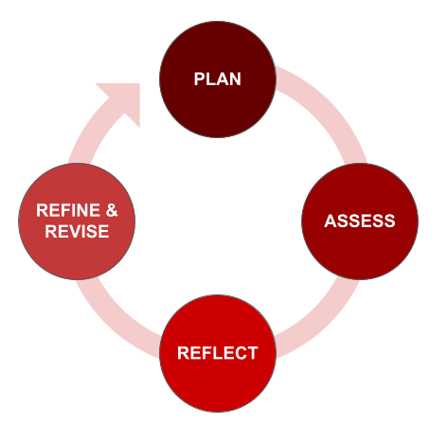

 | Before semester starts | During semester | At end of semester | Subsequent semester(s)
PLAN | ✔
ASSESS |  | ✔
REFLECT |  |  | ✔
REFINE & REVISE |  |  | ✔ | ✔

P

PARR Cycle Explained
Each of the four steps in the assessment cycle are defined below:
- Plan the assessment.
  - Look up which SLO should be assessed that semester/academic year (assessment plans can be found on the Assessment Committee website).
  - Review the SLO (find it in eLumen, the course syllabus, or from the course outline of record (COR)) and determine what type of summative assessment will work best (i.e., test/project/activity/essay/video/speech/etc.).
  - Review or develop the assessment tool that will be used to assess whether students have met the SLO.
- Assess the SLO & input data.
  - At some point during the semester, conduct the assessment planned in step 1.
  - Gather the student data from the assessment.
  - Input assessment data into eLumen at or by the end of the semester.
- Reflect on the data gathered during the assessment.
  - Overall - How did the data inform your teaching practice? ex. What went well? What did not go well? What will you do differently next time?
  - Conclusions drawn - ex. Discuss the assessment tool’s effectiveness in providing evidence whether students achieved SLO
- Refine & Revise the course based on the conclusions drawn in step 3.
  - Create an improvement plan - discuss how the results from steps 2 and 3 will be used to improve student learning and what changes will be made to improve student attainment of the SLO.
  - In the following semester(s), implement changes to teaching, curriculum, course delivery, etc. utilizing the plan for improvement. See section VI. Closing the Loop for examples of revision based on assessment data.
  - Discuss timing of implementation.
- Start the P-A-R-R cycle again, assess the impact of the change and share results during the next assessment cycle. During subsequent semester(s), reassess SLOs and analyze results. Document reassessment results.

Guiding Principles for SLO Assessment
BC faculty recognize the value in meaningful assessment of student learning outcomes and subscribes to the following ASCCC (2010) guiding principles for SLO assessment:
- Faculty have the primary responsibility for developing assessment tools and determining the uses of data that are collected, and therefore faculty engagement and active involvement in SLO assessment is essential.
- Outcomes assessment is a process that should involve all appropriate participants at each level of the college, not just select groups or individuals.
- SLOs and SLO assessment should be connected to the overall culture of the college through the college vision or values statement, program review processes, and college curriculum, planning, and budgeting processes.
- SLOs should be clearly mapped and aligned throughout a course sequence and among various levels (course, program, institution) to achieve the most efficient and effective assessment.
- SLO assessment should be as authentic as possible and should be minimally intrusive to the educational experience of students and the instructional planning and performance of faculty.
- Rather than relying on one assessment method for all situations, effective assessment may benefit from a variety of methods, even within a single course, that can respond to different learning outcomes, teaching styles, and student learning needs.
- Assessment data does not exist in a vacuum and must be analyzed alongside all other factors that may impact attainment of outcomes.
- SLO Assessment processes and grading are different but mutually compatible activities and should complement rather than conflict with each other.
- Effective outcomes assessment requires a college commitment of sufficient staff and resources.
- SLO assessment of student learning outcomes is a process that is separate from faculty evaluation.

Methods of Assessment

Why Final Grades are Not Enough
It is tempting to ask why we cannot just look at final grades to determine whether a course is successful. Although counting letter grades is easy, it does not give us specific information about how students perform on specific learning outcomes across various sections of a course.

There is one key distinction between scoring an outcome and grading a student:
Final grades are an aggregate assessment of a student’s entire body of work for a course.
Consequently, looking at a distribution of final grades may provide only vague information about the degree to which students have learned each discernable outcome that has been identified for the course. For example, although one might easily determine that a student’s average grade in English B1A is a B, that doesn’t tell us about the degree to which the student has achieved various outcomes, such as essay organization, research documentation, or reading comprehension.

In short, grades do not provide specific information about students’ performances on discrete tasks and outcomes or consistent data across sections. Scoring student performance on specific outcomes, however, can give us that information (Iredale, Baxley, & Demarest, 2016, p.6-7).

Direct Assessment
Direct assessment uses methods for assessing actual samples of student work to provide evidence of student performance relative to the learning outcomes. As instructors, we are very well practiced in the area of direct assessment. Every time we ask our students to write an essay, conduct an experiment, take an exam, solve an equation, or demonstrate an activity, we are asking them to show us what they know or what they can do. In this way, we are directly assessing the degree to which they have mastered a learning outcome. Best practice suggests that we should assess our students directly when we are trying to gauge students’ knowledge and skills.

Common direct assessment tools:
- Student Portfolio Evaluation
- Student Performances
- Tests and Examinations
- Thesis Evaluation
- Pre-test/Post-test Evaluation.
(See Attachment C for more information about assessment tools.)

Types of Assessment
Two types of direct assessment are formative and summative as defined below:
- Formative Assessment
Formative assessment monitors student learning to provide ongoing feedback that can be used by instructors to improve their teaching and by students to improve their learning.

More specifically, formative assessments:
- help students identify their strengths, weaknesses, and target areas that need work
- help faculty recognize where students are struggling and address problems immediately

Formative assessments are generally low stakes, which means that they have low or no point value. Examples of formative assessments include asking students to: draw a concept map in class to represent their understanding of a topic, submit one or two sentences identifying the main point of a lecture, or turn in a research proposal for early feedback.

- Summative Assessment
Summative assessment evaluates student learning at the end of an instructional unit by comparing it against some standard or benchmark. Summative assessments are often high stakes, which means that they have a high point value. The Assessment Committee recommends that SLO assessments be summative assessments, as SLO assessments should assess higher-level skills.

Examples of summative assessments include: a midterm exam, a final project, a paper, a senior recital, etc.

Choosing an Appropriate Assessment Measure & Tool
You will need to consider a variety of factors as you choose your method, including alignment with the outcome, ability to get faculty consensus, and ease of scoring. It is difficult to separate the method from the instrument; however, it is useful to step back at this point and consider the method separately from the actual assignment. Considering the general approach to the assessment will allow you to determine the most appropriate method and develop a useful assessment instrument.

- Alignment
Probably the most important consideration when choosing or developing an assessment method is whether it is aligned with the Student Learning Outcome. In other words, is what you’re asking the students to do in your assessment going to provide you with solid evidence about whether or not they have achieved the desired outcome? If your outcome deals with a student’s ability to make a persuasive speech, a research paper is not a good instrument to measure this outcome.

Aligning outcomes with methods may seem like an obvious recommendation, but it’s not uncommon to see a disconnect between the outcome and the assessment instrument.

- Ease of scoring
We all know that writing good multiple choice questions takes a lot of time, but scoring them is fast. Writing a good essay question is less time-consuming than grading a stack of student essays. You should consider the time involved in scoring the instrument and reporting the data. When choosing an assessment method you must weigh time against meaningful results.

- Assess multiple SLOs with one method
One way to balance meaningful results with time spent scoring is to use one assessment instrument to measure more than one outcome. This technique can be used successfully in many disciplines. This approach works especially well if you have both skill- and knowledge-based outcomes to assess. In many ways, this approach is more authentic to student learning because it asks students to integrate knowledge and skills. Assessing each outcome alone certainly works, but combining them gives us a better picture of how students perform in a more “real world” setting. When scoring an assessment which assesses two or more outcomes, you will assign separate scores for each outcome as well as having an overall score.

- Writing the assessment instrument
Once you’ve chosen your assessment method (exam, paper, etc.) it’s time to write the actual instrument that will be handed out to students. We all have experience with writing assessment instruments; it’s one of the major tasks we have as teachers. Again, you should make absolutely certain that the assessment instrument you use measures how well the students meet the expected outcomes, rather than something else. Additionally, make sure the instructions to the student clearly explain the expectations for the assignment. See Table 1 below.

- Developing an assessment tool
No matter which method and tool that you use, it is vital that you are able to analyze and answer the following questions (Table 1) to ensure the tool is valid and reliable in assessing whether students have achieved the specific SLO(s) you are assessing and will provide sufficient data and information to measure the learning outcome being addressed:

Table 1 - Assessment Creation Rubric | YES or NO
- Does the assessment adequately evaluate academic performance relevant to the desired outcome?
- Does this assessment tool enable students with different learning styles or abilities to show you what they have learned and what they can do?
- Does the content examined by the assessment align with the content from the course?
- Can multiple people use the scoring mechanism and come up with the same general score?
- Does the assessment provide data that is specific enough for the outcome being assessed?

For more assistance, the following links are useful:
- Assess Teaching & Learning, Eberly Center, Carnegie Mellon University
- Choosing Assessment Methods, University of the Frasier Valley
- Tools & Templates: Assessment Resources, University of North Carolina Greensboro
- Linking Classroom Assessment with Student Learning, ETS

Assessment Reporting
SLO assessment data as reported in eLumen allows for the mapping of course level Student Learning Outcomes to Program Learning Outcomes, General Education learning outcomes and Institutional Learning Outcomes. This aids instructors in evaluation of not only their courses, but gives them aggregate level data about program outcomes, general education learning outcomes and institutional outcomes without having to get access to the course level data. For further instructions on entering data and reflections in eLumen, see the BC Assessment Committee website (or, for Committee members, the Assessment Committee Canvas shell).

Closing the Loop
The power of SLO assessment is the importance it gives to “closing the loop” as reflected in the Revise portion of the PARR acronym. This means using the results to improve whatever it was that was being assessed. Thus, it is vital that we discuss the results and use them to celebrate and build on its strengths and to discuss and remediate its weaknesses.

The “assessment loop” is closed once a program takes findings from its assessment results and implements changes based on those findings. Generally, assessment findings may indicate a need to modify the assessment process, as in the examples below.

- Student Learning Outcomes
Re-assessing learning outcomes provides a structure for reviewing student learning outcomes. Based on findings from the student learning outcome assessment results, a program may want to retain, modify, or eliminate an outcome.

- Assessment tool
In addition to changing outcomes, there might be a need to change the type of data collected. If results obtained were not as expected, it is also important to know if better information could be collected to demonstrate student learning. This change could vary from modifying items on a multiple-choice test to creating a new rubric for reviewing essays.

- Data collection procedures
In addition to having the correct tool, it is also important to consider how data were collected in previous student learning assessments. Knowing who was included in the assessment data, and when data were collected are important to understanding if changes need to be made in data collection procedures.

- Changes in the academic program
Results from the student learning assessment may indicate that program curricula need to be reviewed and adjusted. Mapping student learning outcomes to the curriculum is the first step to understanding if changes are necessary. Changing how concepts are introduced and the timing of that introduction to students are two common findings from student learning assessments.

- Mapping outcomes to the curriculum
Results may indicate a need to understand where students are introduced to concepts defined in the learning outcomes. Mapping learning outcomes to program courses is the first step in understanding where students are introduced to the material they need to master.

- Examining concept reinforcement
Often programs will discover that students are introduced to the concept in the curriculum, but course assignments and planned experiences are not sufficient to help students master those concepts. This may lead to considering modifications in assignments, readings, or general teaching approaches to reinforce concepts with students. A program may also discover that a new course needs to be created to sufficiently address a learning outcome.

- Examining course sequencing
Sometimes faculty will discover that the course provides sufficient support for the student to master the material, but course sequencing should be adjusted so that students are introduced to concepts that build on and complement each other. The student learning assessment process can be used as an audit of the programmatic educational experience.

- Consider resources
Closing the assessment loop may require the use of additional resources. Discovering the need for additional course sections or courses may require resources beyond current budgets. In addition to fiscal resources, there are other resources such as time to consider. Modifying tests or creating new materials requires time, which is a valuable resource.

- Taking action
Opportunities to improve the assessment process and curriculum may emerge from assessment results, but will not be realized without planning and implementation. The assessment loop is only closed if actions are taken to make modifications where necessary. Answering who, what, when, and where questions about assessment modifications are helpful to planning and implementing any changes.

References
ACCJC (2014). Retrieved from Standards. https://accjc.org/wp-content/uploads/AccreditationStandards_-Adopted-June-2014.pdf
Accrediting Commission for Community and Junior Colleges (ACCJC) (2009). ACCJC News March 2009.
Cartwright, R., Weiner, K., & Streamer-Veneruso, S. (2010, May). Student Learning Outcomes Assessment Handbook [PDF]. 5, Montgomery County: Montgomery College.
Fulks, J & Pacheco, B. (unk). Student Learnings Outcome Assessment. Reedley College. Retrieved from https://www.reedleycollege.edu/faculty-and-staff/college-planning/outcomes-and-assessment/assessment.html
Guiding Principles for SLO Assessment (2010). The Academic Senate for California Community Colleges (ASCCC). Retrieved from https://www.asccc.org/sites/default/files/publications/SLO-paper-Fall2010_0.pdf
Iredale-Kline, S., Baxley, G., & Demarest, S. (2016). Student Learning Outcome and Assessment Handbook. Cuesta College. Retrieved from https://www.cuesta.edu/about/documents/inst_research/Cuesta_SLOA_Handbook_2016.pdf
Kuh, G. D., Ikenberry, S. O., & Jankowski, N. (2015). Using Evidence of Student Learning to Improve Higher Education. John Wiley & Sons.
Kumar, A. (2016). Bloom’s Taxonomy. MaxVibrant: Integrated Personal Development Project. Retrieved from http://www.maxvibrant.com/bloom-s-taxonomy/bloom-s-taxonomy
Marymount University (2018, February). Assessment Handbook. Retrieved from https://www.marymount.edu/marymount.edu/media/PlanningInstitutionalEffectiveness/Assessment-Handbook-02062018.pdf
Nunley, C., Bers, T., & Manning, T. (2011, July). Learning Outcomes Assessment in Community College. Retrieved from http://learningoutcomesassessment.org/
Texas Tech University (unk). Writing and Assessing Course-Level Student Learning Outcomes. Retrieved from https://www.depts.ttu.edu/opa/resources/docs/Writing_Learning_Outcomes_Handbook3.pdf

Attachments

Attachment A: Bloom’s Revised Taxonomy
Learning taxonomies or classifications are commonly utilized as a way of describing different kinds of learning behaviors and characteristics that we wish our students to develop. They are often used to identify different stages of learning development and thus provide a useful tool in distinguishing the appropriateness of particular learning outcomes.

Bloom's taxonomy refers to a classification of the different objectives that educators set for students (learning objectives). It divides educational objectives into three "domains": cognitive, affective and psychomotor. See full explanations of the 3 domains on the tables on pages 16-18.

Within the domains, learning at the higher levels is dependent on having attained prerequisite knowledge and skills at lower levels. A goal of Bloom's taxonomy is to motivate educators to focus on all three domains, creating a more holistic form of education. Bloom's taxonomy is considered to be a foundational and essential element within the education community. See a simplistic version of Bloom’s Taxonomy in Image 1 below.

Image 1
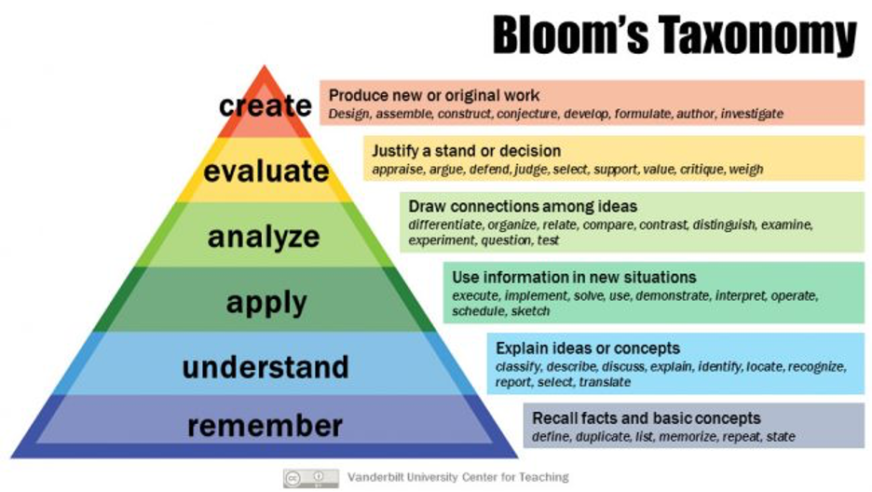

Cognitive Domain (Knowledge)
The cognitive domain involves knowledge and the development of intellectual skills. This includes the recall or recognition of specific facts, procedural patterns, and concepts that serve in the development of intellectual abilities and skills.

Category (lowest to highest) | Examples | Verbs
Remembering: Recall previously learned information. | Recite a policy. Quote prices from memory to a customer. Knows the safety rules. | Defines, describes, identifies, knows, labels, lists, matches, names, outlines, recalls, recognizes, reproduces, selects, states.
Understanding: Comprehending the meaning, translation, interpolation, and interpretation of instructions and problems. State a problem in one's own words. | Rewrites the principles of test writing. Explain in one's own words the steps for performing a complex task. Translates an equation into a computer spreadsheet. | Comprehends converts, defends, distinguishes, estimates, explains, extends, generalizes, gives an example, infers, interprets, paraphrases, predicts, rewrites, summarizes, translates.
Applying: Use a concept in a new situation or unprompted use of an abstraction. Applies what was learned in the classroom into novel situations in the workplace. | Use a manual to calculate an employee's vacation time. Apply laws of statistics to evaluate the reliability of a written test. | Applies changes, computes, constructs, demonstrates, discovers, manipulates, modifies, operates, predicts, prepares, produces, relates, shows, solves, uses.
Analyzing: Separates material or concepts into component parts so that its organizational structure may be understood. Distinguishes between facts and inferences. | Troubleshoot a piece of equipment by using logical deduction. Recognize logical fallacies in reasoning. Gathers information from a department and selects the required tasks for training | Analyzes, breaks down, compares, contrasts, diagrams, deconstructs, differentiates, discriminates, distinguishes, identifies, illustrates, infers, outlines, relates, selects, separates.
Evaluating: Make judgments about the value of ideas or materials. | Select the most effective solution. Hire the most qualified candidate. Explain and justify a new budget | Appraises, compares, concludes, contrasts, criticizes, critiques, defends, describes, discriminates, evaluates, explains, interprets, justifies, relates, summarizes, supports.
Creating: Builds a structure or pattern from diverse elements. Put parts together to form a whole, with emphasis on creating a new meaning or structure. | Write a company operations or process manual. Design a machine to perform a specific task. Integrates training from several sources to solve a problem. Revises and process to improve the outcome. | Categorizes, combines, compiles, composes, creates, devises, designs, explains, generates, modifies, organizes, plans, rearranges, reconstructs, relates, reorganizes, revises, rewrites, summarizes, tells, writes.

Affective Domain (Attitudes)
The affective domain (Krathwohl, Bloom, Masia, 1973) includes the manner in which we deal with things emotionally, such as feelings, values, appreciation, enthusiasms, motivations, and attitudes.

Category (lowest to highest) | Examples | Verbs
Receiving Phenomena: Awareness, willingness to hear, selected attention. | Listen to others with respect. Listen for and remember the name of newly introduced people. | Asks, chooses, describes, follows, gives, holds, identifies, locates, names, points to, selects, sits, erects, replies, uses.
Responding to Phenomena: Active participation on the part of the learners. Attends and reacts to a particular phenomenon. Learning outcomes may emphasize compliance in responding, willingness to respond, or satisfaction in responding (motivation). | Participates in class discussions. Gives a presentation. Questions new ideals, concepts, models, etc. in order to fully understand them. Know the safety rules and practices them. | Answers, assists, aids, complies, conforms, discusses, greets, helps, labels, performs, practices, presents, reads, recites, reports, selects, tells, writes.
Valuing: The worth or value a person attaches to a particular object, phenomenon, or behavior. This ranges from simple acceptance to the more complex state of commitment. Valuing is based on the internalization of a set of specified values, while clues to these values are expressed in the learner's overt behavior and are often identifiable. | Demonstrates belief in the democratic process. Is sensitive towards individual and cultural differences (value diversity). Shows the ability to solve problems. Proposes a plan for social improvement and follows through with commitment. Informs management on matters that one feels strongly about. | Completes, demonstrates, differentiates, explains, follows, forms, initiates, invites, joins, justifies, proposes, reads, reports, selects, shares, studies, works.
Organization: Organizes values into priorities by contrasting different values, resolving conflicts between them, and creating a unique value system. The emphasis is on comparing, relating, and synthesizing values. | Recognizes the need for balance between freedom and responsible behavior. Accepts responsibility for one's behavior. Explains the role of systematic planning in solving problems. Accepts professional ethical standards. Creates a life plan in harmony with abilities, interests, and beliefs. Prioritizes time effectively to meet the needs of the organization, family, and self. | Adheres, alters, arranges, combines, compares, completes, defends, explains, formulates, generalizes, identifies, integrates, modifies, orders, organizes, prepares, relates, synthesizes.
Internalizing values (characterization): Has a value system that controls their behavior. The behavior is pervasive, consistent, predictable, and most importantly, characteristic of the learner. Instructional objectives are concerned with the student's general patterns of adjustment (personal, social, emotional). | Shows self-reliance when working independently. Cooperates in group activities (displays teamwork). Uses an objective approach in problem solving. Displays a professional commitment to ethical practice on a daily basis. Revises judgments and changes behavior in light of new evidence. Values people for what they are, not how they look. | Acts, discriminates, displays, influences, listens, modifies, performs, practices, proposes, qualifies, questions, revises, serves, solves, verifies.

Psychomotor Domain (Behaviors, Skills)
The psychomotor domain includes physical movement, coordination, and use of the motor-skill areas. Development of these skills requires practice and is measured in terms of speed, precision, distance, procedures, or techniques in execution.

Category (lowest to highest) | Examples | Verbs
Imitation: Observing and patterning behavior after someone else. Performance may be of low quality. | Copying a work of art. Performing a skill while observing a demonstrator. | Copy, follow, mimic, repeat, replicate, reproduce, trace
Manipulation: Being able to perform certain actions by memory or following instructions. | Being able to perform a skill on one's own after taking lessons or reading about it. Follows instructions to build a model. | Act, execute, perform
Precision: Refining, becoming more exact. Performing a skill within a high degree of precision. | Working and reworking something, so it will be “just right.” Perform a skill or task without assistance. Demonstrate a task to a beginner. | Calibrate, demonstrate, master, perfectionism
Articulation: Coordinating and adapting a series of actions to achieve harmony and internal consistency | Combining a series of skills to produce a video that involves music, drama, color, sound, etc. Combining a series of skills or activities to meet a novel requirement. | Adapt, constructs, creates, modifies
Naturalization: Mastering a high level performance until it becomes second-nature or natural, without needing to think much about it | Maneuvers a car into a tight parallel parking spot. Operates a computer quickly and accurately. Displays competence while playing the piano. Michael Jordan playing basketball or Nancy Lopez hitting a golf ball. | Design, development

Attachment B: Learning Outcome Review Checklist
After reading the informational items (course title, course description, course objectives), evaluate the quality of the student learning outcomes listed by following the checklist below.

Learning Outcomes (SLO and PLO) Checklist | Yes | No
Does the course have an Assessment Mapping Form uploaded as an attachment in the Cover Info section? If not, check the Assessment Mapping section below the Learning Outcomes section to see if the mapping has been completed. If mapping appears in neither place, make a comment. If there is mapping, verify that it has been fully completed.
- Remember to check whether the course is part of a program (in the Associated Programs section) so you know whether the course should have PLO mappings.
- Similarly, look in the Transferability & Gen. Ed. Options to see whether the course is a GE course and needs GELO mappings. If a course is marked Y, this means the course is NOT a GE course and does not need GELO mappings.
Are the SLOs (PLOs) sequentially numbered? (1,2,3...)
Does each SLO (PLO) start with the following sentence?
“Upon successful completion of the course (program), the student will be able to...”
Does each SLO (PLO) include active verbs that focus on the top 4 levels of Bloom’s Taxonomy?
Is each SLO (PLO) measurable?
Are the SLOs (PLOs) written as outcomes rather than as objectives?
- Outcomes address what a student will be able to do at the completion of the course as well as student competency rather than content coverage.
- Outcomes are overarching concepts versus objectives, which specify distinct steps taken to achieve the outcomes. (Objectives are the means, not the ends.)
Are the SLOs (PLOs) appropriate for the course (program)?
- Consistent with course(s) description
- Represents a fundamental result of the course(s)
- Aligns with other courses in a sequence, if applicable
- Represents collegiate level work
As a reviewer, outside of the discipline, do you understand the outcomes the student will be expected to learn by the end of the course (program)?

Attachment C: Types of Assessment Measures

Course-Embedded Assessments
Course-embedded assessments are direct measures which use student work in specific courses to assess student learning. Students are already motivated to do their best on these assessments because they are conventionally graded on them. For example, if one learning outcome requires students to synthesize the literature on a topic in the field, student research papers may be evaluated using a rubric to assess how well they meet the learning outcome. Many classroom assignments can be used for course-embedded assessment as long as they assess a program’s student learning outcome. Course embedded assessment measures are often selected because they take place in the classroom, take advantage of student motivation to do well, and directly assess what is taught in the classroom.

- Examinations: Many SLOs can be assessed by examinations given within the course. In some cases the measured outcomes will be identical to the PLOs and the exam questions will assess both course and program outcomes. In programs without capstone courses, it might be possible to write a coordinated set of exam questions that provide a fuller picture of student learning when administered in exams across a series of courses.

- Course papers: Course papers can be used as measures for SLOs. Because students create these papers for a grade, they are motivated to do their best and these papers may reflect the students’ best work. Faculty committees can also read these same papers to assess the attainment of PLOs. In most cases, this second reading should be done by someone other than the instructor or by others along with the instructor, as the purpose for the assessment is different than grading. Scoring rubrics for the papers, based on the relevant learning outcomes should be developed and shared with faculty raters prior to rating to promote interrater reliability

- Course projects and presentations: Products other than papers can also be assessed for attainment of SLOs and PLOs. For example, if students are required to give oral presentations, other faculty and even area professionals can be invited to these presentations and can serve as outside evaluators using the same rubric as other raters.

- Student performances: In some areas, such as teaching or counseling, analysis of student classroom teaching, mock counseling sessions or other performances can provide useful measures of student learning. A standardized evaluation form is necessary to ensure consistency in assessment. One advantage of using performances is that they can be videotaped for later analysis

Cross Course Measures
Cross course measures are direct measures of student work across the program. Cross course measures examine students’ work that incorporates multiple dimensions of knowledge, skills and abilities developed throughout the entire program. The most common types of cross course measures are capstone course papers and projects, and student portfolios.

- Capstone courses: Capstone courses provide an opportunity to measure student learning, because this is where students are most likely to exhibit their cumulative understanding and competence in the discipline. One of the purposes of capstone courses is to provide an opportunity for students to "put it together," which typically requires students to integrate the knowledge, skills and abilities found in the program’s learning outcomes.

- Student portfolios: Compilations of students’ work in their major can provide a rich and well rounded view of student learning. The program usually specifies the work that goes into the portfolio or allows students to select examples based on established guidelines. By compiling a range of student work, portfolios can be used as the measure for more than one learning outcome. Portfolios can also be valuable for the student by providing a reflection of their skills and abilities. Portfolios do require strong, well-constructed rubrics to make the process of extracting assessment data manageable.

- Standardized and certification exams: In some disciplines, national standardized or certification exams exist which can be used as measures if they reflect the program's learning outcomes. The examination usually cuts across the content of specific courses and reflects the externally valued knowledge, skills and abilities of a program.

- Internship supervisor evaluations: If the program has a number of students who are doing relevant internships or other work-based learning, standard evaluations by supervisors using a rubric designed to measure a particular learning outcome across the duration of the internship may provide data on attainment of learning outcomes. In addition, when programs exercise control over the content of internships, those settings can serve as capstone experiences where students can demonstrate their knowledge, skills, and abilities.

