AB 86 Adult Education Program Development
Course Offerings & Gap Analysis

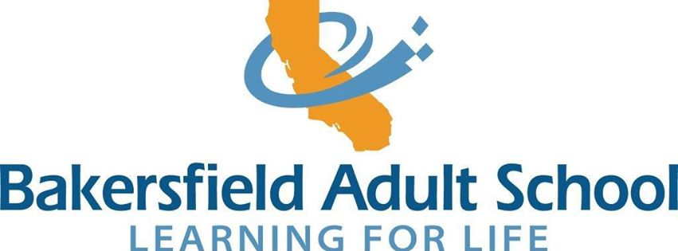

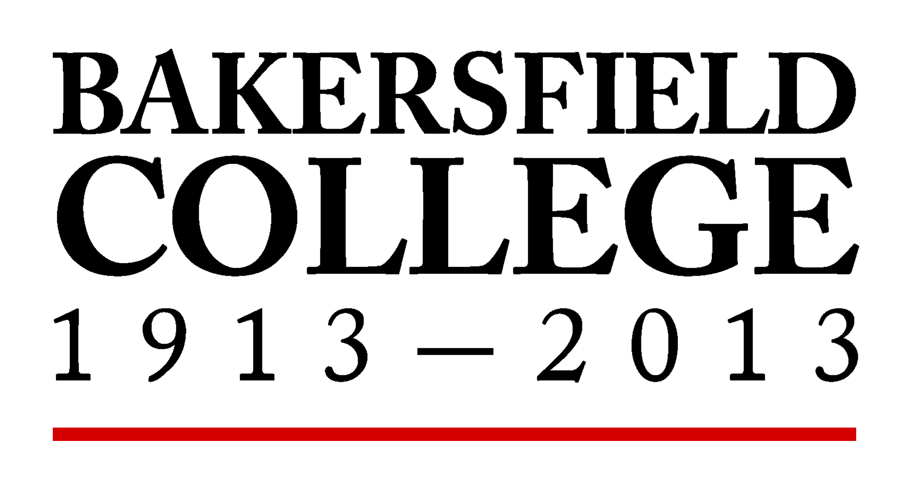

Primary writer: Ann Tatum
Contributors: Roman Aguilar, Leah Carter, Sonya Christian, Kevin Danely,
Pam Gomez, Sue Granger-Dickson, Jodi Loeffler, Jeannie Parent, Mark Wyatt

December 18, 2013
Background and Introduction

Adult education has played a role in educating Californians 18 years and older for more than 100 years. It trains and educates adults from some of California’s most vulnerable populations: immigrants, unemployed (and underemployed) single parents, the homeless, the incarcerated, the disabled, and/or adults from disadvantaged backgrounds (“Adult Education—CalEdFacts”). Because a healthy economy is dependent on the participation of all community members, adult education will continue to play a key role, empowering its students with the skills they will need in order to participate more fully than they have been able to in the past. California’s AB 86 has been created to “better position California . . . to expand and improve the provision of adult education” (Harris & Torlakson, see Appendix A).

In order to “expand and improve” adult education, the state has appropriated $25 million for the creation of consortia that will work to develop regional plans for adult education. Bakersfield College (part of the Kern Community College District) and Bakersfield Adult School (part of the Kern High School District) will be working together to implement AB 86.

The letter sent out by Brice Harrison and Tom Torlakson (Appendix A) outlines the populations the consortia are meant to serve and the instruction they will need: classes for adults who need elementary and basic skills (this includes diploma and GED courses); classes for immigrants (including English language, citizenship, and CTE courses); programs for disabled adults; programs for short-term/high employment potential CTE areas; and programs for apprenticeships. The letter also identifies five points all plans should include. Today’s presentation is meant to begin addressing the first of those points: “evaluation of level and types and needs of adult education programs . . . and plans to address gaps.” Although the details of the plan will be developed over the two-years allotted for the grant, today’s presentation will share current course offerings at both campuses and identify possible areas of overlap as well as gaps in service.

English as a Second Language

Bakersfield Adult School (BAS) provides classes to English language learners for citizenship as well as more traditional ESL courses that cover speaking, reading, and writing. Bakersfield College (BC) provides only the more traditional ESL courses, but at a higher level.

Due to collaboration between faculty at both campuses, there is not a duplication of efforts: students who complete BAS’s level 5 ESL course will be ready to enter BC’s ENSL 70 (see Appendix B).

Basic Skills
At both BAS and BC, Basic Skills courses are designed to address the needs of those students who have low academic skills; however, only BAS provides classes that can lead to a high school diploma or GED. BAS also provides classes for students below 9th grade. BC attempts to pick up where BAS leaves off, but there is some overlap. As the chart below shows, the greatest overlap is in BC’s Academic Development courses (see Appendix C). Some duplication of basic skills courses has been necessary due to the tremendous needs of our local student population.

Career and Technical Education
BAS offers CTE courses that are pathways to jobs. Pathways at BAS include Business Education, Digital Arts, Industrial Technology, and Health Careers. BAS offers a number of courses that articulate with courses offered at BC, giving BAS students who are interested in transferring to a long-term program a head start. It also ensures students don’t have to take the same courses they took at BAS at BC. This kind of collaboration contributes to meeting AB 86’s goals of seamless transitions, accelerated student progress, and increased student success.

BC also offers a number of CTE courses that are pathways that lead to jobs. A listing of the CTE programs can be found Appendix D. Pathways at BC include Agriculture and Natural Resources, Arts, Media and Communication, Business Management and Technology, Engineering and Industrial Technology, Health Services, and Public and Human Services. The college offers both short-term and long-term programs: Job Skills Certificates require fewer than 18 units, Certificates of Achievement are 18 units or more, and Associate Degrees require at least 60 units. BC’s goal is to increase CTE pathways and partner with industry to identify potential job skills growth areas.

Apprenticeship Programs

Only BC has apprenticeship programs: 4-year to 5-year programs that prepare students for careers as Carpenters, Electricians, Operating Engineers, Plumbers & Steamfitters, or Sheet Metal workers (see Appendix E). Students must be accepted into the program, and the details of these programs are determined by the various trade unions. Students in apprenticeship programs must have trade-specific job placement, and they will complete the program with Journeyman level status.
Programs for Disabled Adults

Only BAS offers specific programs for disabled adults. Working with Bakersfield Association for Retarded Citizens (BARC), BAS offers courses to develop both social and technical skills, offering courses ranging from socialization skills to landscape maintenance. BC offers accommodations for students with disabilities (sign language interpreters, materials transcribed to Braille, etc.), but there are no programs specifically designed for disabled adults.

Student Support Services

The adults who make up the student population AB 86 seeks to address are often in need of additional services not mentioned specifically. Both campuses identified a need for specific services that need to be considered in the plan in order to ease transitions from BAS to BC: outreach services, a matriculation officer, a shared counselor, case managers, and professional development for faculty and staff. These duties, in conjunction with training via professional development, must be considered in order for any plan to be successful.

Gap Analysis

Between the two campuses, many students are being served; however, there were a few areas where gaps were noted. Outlying areas are often underserved, especially for family literacy courses. There is enough of a demand to increase ABE courses. Some CTE programs, like welding, construction, and diesel mechanics, are not offering enough courses to meet the community’s needs. There are also some policy issues that could cause gaps: students do not qualify for financial aid if they do not have a high school diploma or GED. For students who do have a diploma or the equivalent, not all courses that are available at BAS are open to students. For example, students who have a diploma/GED but test too low on BC’s placement test or cannot pass BC’s basic skills courses could be left without a place to go to improve their academic skills.

Planning Needs

The evaluation performed by BAS and BC revealed some areas that will need additional funding in order to facilitate any plan:
- Funding for research and personnel who will coordinate/facilitate the research needed to evaluate the needs of adult education, including an assessment of possible gaps.
- Funding to assist faculty and staff in development of integrated programs that would provide seamless transitions from adult education into secondary education and the workforce.
- Funding for a coordinator who will work with both campuses to create integrated programs and will evaluate and expand CTE pathways with the goals of creating seamless transitions through articulated classes and accelerating students into CTE classes at the postsecondary level.
- Funding for professional development for faculty and staff in order to coordinate the facilitation between BC and all partners within the Consortia.

