Co-Chairs: Thad Russell, Elizabeth Buchanan, Vern Butler

**MINUTES**

**Present:**

Claudia Habib, Thad Russell, Primavera Arvizu, Arlitha Williams-Harmon, Michelle Miller-Galaz, Osvaldo Del Valle, Erin Wingfield, Kim Behrens, Jasmine Quinones, Frank Ramirez, Joe Cascio, Jay Navarrette, John Ward, Julian West, Johana Fisher, Michael Carley, Robert Simpkins, Karen Bishop, James Carson, James Thompson, Elizabeth Keele, Patty Serrato, Sherie Burgess, Kendra Haney, Elizabeth Buchanan, Melissa Long, Chris Ebert, Jay Hargis, Vern Butler.

**Absent:**

ASPC President, ASPC Vice President, Tiffany Haynes, Todd Dearmore, Vickie Dugan, Terry Crewse, Errin Sullivan-Arcos, and Shauna Williams.

**Guest:**

None

1. **Call to Order**

Thad Russell called the meeting to order at 3:05 pm.

1. **Adoption of Agenda**

Motion made to approve the September 20, 2021 agenda.

**M/S/C:** Mike Carley/Elizabeth Keele

1. **Approval of Minutes**

Motion made to approve the amended May 3, 2021 minutes.

**M/S/C:** Primavera Arvizu/James Thompson

1. **Old Business-Action Items**
2. **HR Staffing Plan – Dr. Claudia Habib (10 minutes)**

HR staffing plans 22-23 academic year. Three classified members and four faculty are retiring this year. Mid-October recommendations from Academic Senate for new hiring requests need to be ready to allow management to assess all requests and move them forward. College Council will need to have two reads in November and December to review all these requests in order for the recruitment process timeline to begin recruitment by late December or early January.

We are currently looking to replace all retiree positions. Faculty Obligation Number (FON) funds were accepted by the district to hire additional faculty. 27 positions were approved for the district but due to low enrollments and new budgeting formulas those numbers need to be reevaluated, taking into account retirees and new positions. Feedback for areas that have a lot of potential for growth is appreciated.

1. **Budget Update – Dr. Arlitha Williams-Harmon (15 minutes)**

FY 21-22 Adopted Budget presentation was shared with the committee to review. Direct link to updated budget reports on chancellor’s website was put into the chat for review. College Council was not able to review prior to the report going to the Budget Committee adopting the budget due to scheduling dates. Budget Committee was provided an official mid-term update with fiscal year information and project status. Highlights reflected in the report include:

* The Cost of Living allowance.
* Addition 1% increase for STRS.
* Various other minor changes to Workers Compensation and Unemployment.
* District Wide Reserve
* Met Compliance for 50% Law.

1. **New Business-Announcement/Information/Discussion Items**
2. **Revise Program Review Schedule-Mike Carley (5 minutes/1st read/Discussion)**

Revised Program Review Schedule was presented to the council. Program review is on a three year cycle where every program on campus goes through every 3 years including each of the academic and non-instructional areas. These areas are organized according to Vice-President reporting structure. The Information desk is now the Welcome Center and is now part of Student Services. There was a question regarding the Wellness Center because currently there is no nurse on campus. At this point it will be left on the schedule until a finalized decision has been made.

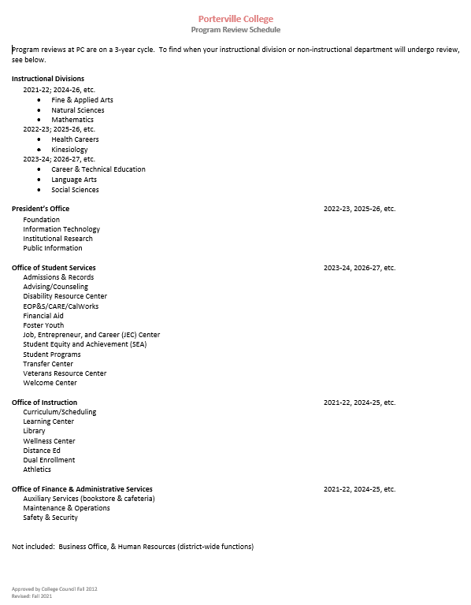

Typo was noted in schedule; this will be corrected and brought back to next College Council for second read.

1. **Revise Program Review Forms for Approval-Mike Carley (15 minutes/1st read/Discussion)**

New Program Review forms were presented to the council for first read. These will be brought back to next meeting for final approval. For those who have already started on old form, that is acceptable. On the new form most of the information is the same; a new table has been added to make the document cleaner. The Mission Statement is included and it is asked that all goals are tied back to the six items on the mission statement. Outcomes area was simplified to make it easier to understand. Instructional area was asked to provide some timeframe and tools being utilized. All SLO’s do not need to be listed; however, it must be clear that SLO’s are being assessed on a regular cycle and improvements are being made based on program improvements. Integration of Guided Pathway Pillars has also been incorporated into the document. Other changes include minor clarifications and more clarification surrounding budget.

The Non-instructional form was also introduced to the committee for first read and will be brought back to next meeting for approval.

New forms will not be rolled out until approved by committee.

1. **Project Priorities-Dr. Claudia Habib (20 minutes/Discussion)**

The college was recipients of the $7 million gift from MacKinsey Scott and her husband. The funds came about because we were recognized for our efforts in serving underserved population and communities. Only eight colleges in California received this transformational gift. The intent is to have a collaborative effort that everyone participates in to brainstorm ideas on how to use these monies. Ideas need to be long lasting that impact the majority of our student, faculty, campus, or community that honors the spirit of the gift. The Committee was asked to start thinking of framework ideas to be brought back to the committee by utilizing feedback from faculty, staff, and students with the hope of moving forward with processes within the next four months. Written report is due by end of year to have a plan on how monies will be spent. The Foundation was utilized to accept the funds and hold them until the college is ready to utilize them. Funds were initially placed into a bond until the college developed a plan to distribute funds accordingly. A collaborative workgroup will be developed to bring ideas back to future committee meetings. No restrictions have been placed on how these funds are utilized. The Committee was asked to keep in mind that long term commitments such as personnel, as the college may not be able to support those positions after the funds are utilized.

1. **ILO’s-Melissa Long** **(15 minutes/1st read/Discussion/Action)**

ILO overview was provided to the council including process for assessment. Process includes the following steps:

1. Collect the outcome assessments.
2. Analyze collected assessments.
3. Identify actions based on analysis to improve instruction, services, assessment, and/or outcomes.
4. Implement the actions identified.

The committee walked through the implementation Plan for ILO#4 and assigned person responsible and complete date or progress check in date to finalize.

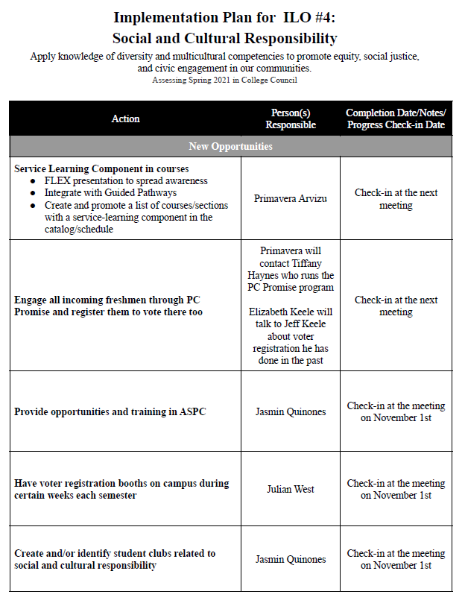

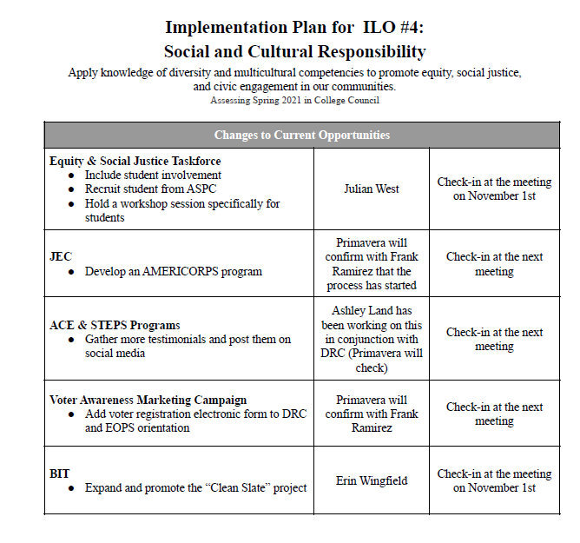

The Committee was asked to be prepared to go over ILO#5 Personal Development at the next meeting.

1. **FY 21-22 Scheduled Maintenance & Instructional Material Allocation-Dr. Arlitha Williams-Harmon (3 minutes/Discussion)**

HEERF sheets were sent out to departments for future planning ideas. Looking for innovating ideas to address our environment or support students. These items do not need to be directed only to the classroom. Items that support students such as the additional outdoor seating areas were completed.

Installation of a coffee kiosk to provide additional spacing so students are not cramped in the cafeteria is being considered. Phase 1 of classroom projects bids are currently being reviewed. Phase 1 includes the Library, LRC classrooms, theater, and forum--converting these to high FLEX classrooms. John Ward will be working with key stakeholders to review these configurations. Phase 2 will include all other classrooms on campus, converting them to high FLEX rooms. Faculty will have direct input regarding Phase 2 to address classrooms so we have additional capabilities for teaching modalities.

Chancellor’s office will provide $511 million for Community Colleges to address their scheduled maintenance or instructional material budgets or needs. Looking to use 1.5 million allocated to Porterville College to support scheduled maintenance. These monies will be used for the following:

* Restroom renovations at the Student System
* Fire Life Safety system upgrade
* HVAC for Server Rooms
* Roof replacement-Library
* Roof replacement-Gymnasium and Fitness Center

Measure J dollars will support this, however looking to reserve those funds for future capital projects since these funds are directed towards maintenance only.

1. **FY 22-23 Budget Planning-Dr. Arlitha Williams-Harmon (3 minutes/Discussion)**

A Doodle Poole will be sent out to schedule training on the new Axiom software system. This new software system is replacing the current spreadsheet. This software will tie into our planning documents, granting the ability to consolidate resources requests for M&O, IT, Marketing, and professional development. Current process is not effective or efficient. The new system will streamline processes so individuals can get support and budget requests easier.

The District wide budget committee is moving forth with a new allocation model that should be in place by December 2021 for Board approval in January 2022 to apply to our tentative budget for fiscal year 2023. Handbook and model will be presented at a future meeting.

1. **Achieving the Dream Prioritizing Adult Community College Enrollment (PACCE) Grant-Primavera Arvizu (3 minutes/Discussion)**

The college is working on a submission for the Achieving the Dream Grant of $75,000. This application went through the grants committee and district to inform them of application. The aim is to build the pipeline of our adult student 25 years and older, including expansion of non-credit pathways that focus on the workforce. Focus will be directed to expand ESL programs and expand ESL programs to really concentrate on the adult population to align with CTE programs and build new CTE programs. The development process of grant application started before the council met so prior to submitting the finalized application, it will be brought to this meeting for approval.

1. **College Council Charge-Primavera Arvizu (3 minutes/Discussion)**

The chairs of College Council and new format of agenda including reporting process for subcommittees was changed over the summer. The charge, goals, and functions of the council was brought to the council’s attention and will be discussed at the next meeting. The purpose of College Council is to assess the Mission of the college. Due to COVID, this process ran behind; however, through accreditation it was identified that this process needs to be addressed. The Mission, Values, and Philosophy of the college need to be re-evaluated to meet accreditation standard, so council was asked for volunteers to review these areas as a subgroup or task force. Mike Carley volunteered to organize this group and will include Primavera Arvizu and Vern Butler.

1. **College Council Sub-Committee-Primavera Arvizu (3 minutes/Discussion)**

Subcommittee chairs need to meet a couple of times to review the logic model and compete a logic model exercise. Subcommittees will be contacted to see where they are in completing the logic models and making sure everyone has access to see one another’s and then moving forward from there.

1. **Guided Pathways-Primavera Arvizu & Dr. Robert Simpkins (5 minutes/Discussion)**

In an effort to advance goals on multiple fronts over the course of a year, rather than completing things we know sequentially that we’re moving forward on several at once. The 2-year plans for students needs to be standardized and available to students in the form of a generalized map that show how a student can complete a program in 2-years as part of a college individualized plan. We are hoping to roll these out prior to the next cohort. There has been outreach from UC Merced and Central Valley Higher Education Consortium to have more of the colleges align their pathways with senior centers of potential transfer. Teams will be participating in a program on November 4th that will hopefully facilitate the ability to have our students going to the closest UC campus to PC. Roger Perez is working on a website revamp structured around Guided Pathways with an electronic catalog that should be unveiled soon. Professional development plan continuous ongoing institutionalized faculty professional development with Guided Pathways and Achieving the Dream framework.

1. **Subcommittee Reports**
2. Identification of Committee Chairs. New Sub-Committee Reporting Process-Dr. Thad Russell

Instead of doing report outs for subcommittees in this meeting, we are asking that all subcommittee chairs submit reports ahead of time electronically and then those reports will be distributed to council members prior to the meeting for review. Questions surrounding these reports will be discussed at this meeting to provide the opportunity to dig a little bit deeper or get clarification on things in the time allowed. Reminders will be sent to subcommittee chairs in advance of upcoming council meetings. Subcommittee chairs include:

* Accreditation-Dr. Thad Russell
* Enrollment Management-Dr. Thad Russell
* Budget-Dr. Arlitha Williams-Harmon
* Strategic Planning-Michael Carley
* Pathway and Student Success-Primavera Arvizu & Dr. Robert Simpkins
* Grant-Dr. Arlitha Williams-Harmon
* Facilities-John Ward
* IT-Jay Navarrette
* Title 9-Johanna Fisher
* Outreach-Erin Wingfield & Roger Perez

Subcommittee structure will be discussed at next council meeting.

1. **Other Reports**
2. **President**

Dr. Claudia Habib asked that everyone utilize the KCCD Tracing App and submit vaccination status. Campus wide encouragement of students to also utilize the KCCD Tracing App.

1. **Academic Senate**

Division chairs have been asked to start preparing the requests for new faculty positions and those will be presented at a future meeting. There was a discussion on the revision of language for how to recognize emeritus faculty on campus, and that is in process. A Task force was called on to look at Online Educational Resources and Zero Textbook Cost (OER/ZTC) etc., in coordination with the Office of Instruction. Academic Senate is looking at playing a bigger role in the new faculty orientation, and that relates to Guided Pathways. Faculty has shown a lot of interest in Academic Senate. Senate Presidents were asked by the district’s legal counsel, Chris Pine, to find out about the local policies on the free speech, and report back to him.

1. **Outcomes**
2. **CCA**

CCA has negotiated with the district, and this will be voted on October 6, 2021, covering the adoption of COVID protocols requiring mask wearing and vaccinations.

1. **CSEA**

Currently in negotiations with health and welfare benefits and the increase for the CAP. There is currently about six MOUs that are being voted on. Further notification of outcomes will be addressed at future council meetings.

1. **ASPC**

Currently no students and elections are set to occur at the end of the week.

1. **Future Agenda Items**

IT Program Review will be added to next agenda.

1. **Adjournment**

Meeting adjourned at 5:02pm.