Co-Chairs: Primavera Arvizu, Robert Simpkins, Vern Butler

**MINUTES**

**Present:**

Primavera Arvizu, Rebecca Baird, Kim Behrens, Elizabeth Buchanan, Sherie Burgess, Vern Butler, Michael Carley, James Carson, Joe Cascio, Todd Dearmore, Vickie Dugan, Chris Ebert, Lupe Guillen, Claudia Habib, Kendra Haney, Jay Hargis, Tiffany Haynes, Gerred Link, Melissa Long, Michelle Miller-Galaz, Jay Navarrette, Frank Ramirez, Thad Russell, Patricia Serrato, Robert Simpkins, James Thompson, Miles Vega, Shauna Williams, Arlitha Williams-Harmon and John Word

**Absent:**

ASPC President, ASPC Vice President, Terry Crewse, Johana Fisher, Errin Sullivan-Arcos and Erin Wingfield

**Guest:**

Reagen Dozier and Joel Wiens

1. **Call to Order**

Vern Butler called the meeting to order at 3:01 pm.

1. **Adoption of Agenda**

Motion made to approve the May 3, 2021 agenda.

**M/S/C:** Lupe Guillen/Michael Carley

1. **Approval of Minutes**

Motion made to approve the amended April 19, 2021 minutes.

**M/S/C:** Joe Cascio/Elizabeth Buchanan

1. **Information/Announcement Items**
2. **HR Staffing Plan – Dr. Claudia Habib (10 minutes)**

Ten positions are retiring, three gave their intention prior to the District retirement program was implemented and the other seven will retire over the next 18 months (June 2021, December 2021, June 2022, and December 2022).

Three positions are already being replaced (Biology, English, Math). We are still waiting to see if the other seven positions will be straight replacement or new positions. More discussion to come.

1. **Budget Update – Dr. Arlitha Williams-Harmon (15 minutes)**

The budget open forum is Wednesday, May 5th at 1:00pm.

Dr. Williams-Harmon reviewed the questions the budget committee will ask the District CFO, see questions on next page.

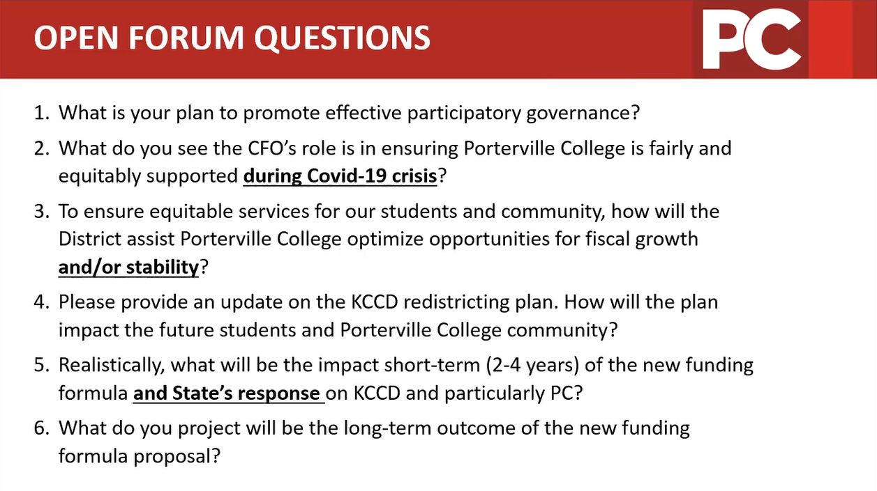

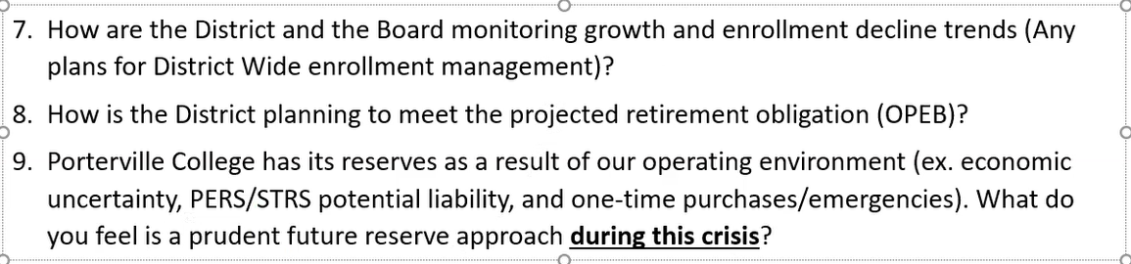

There have been some changes to the 21-22 proposed budget.

* Step & Column – not budgeting with the premise of those steps being frozen (everyone will step/column raise).
* Benefits
* STRS (1.42%) decrease & PERS (10.68%) increase in the employer contribution
* Unemployment – up from .05% to 1.23% (2360% increase)
* Workers Comp – increased 3.37%
* Faculty – 3 retirements and 4 replacements
* Classified – replacement of staff
* Management – replacement of vacancies
* Temporary Labor – no changes
* Adjunct Faculty
* Overload
* Stipends
* Department/Division
* Restoration and increase in service contracts
* Partial restoration of in-person travel and continuation of online training
* No interfund transfer supports – Child Development Center closed
* Return & Remote Learning – Supplement
* HEERF funding
* Immediate Action Package
* State Block Grant

See proposed FY21-22 Budget below.

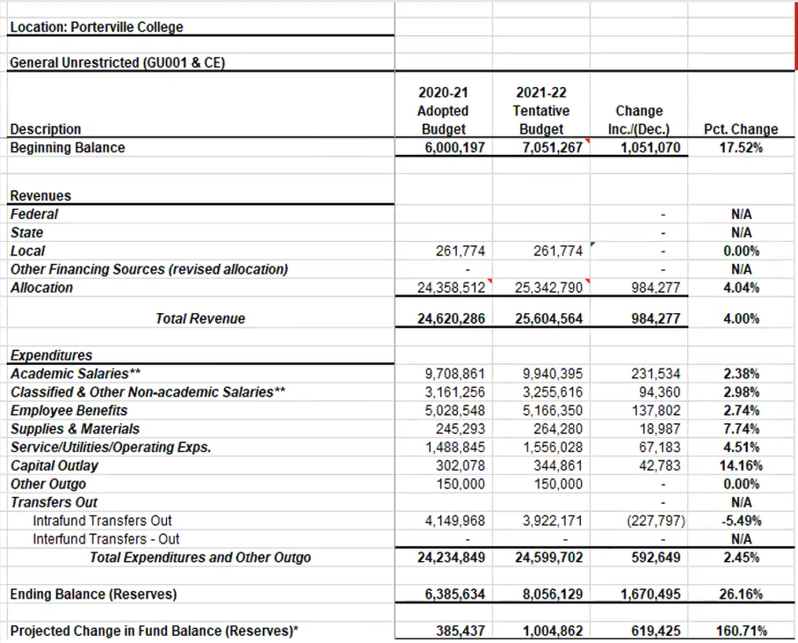

1. **Core of the Core Update – Dr. Arlitha Williams-Harmon (10 minutes)**

Met at beginning of spring and again at end of the end of spring; have continued to work on the non-academic departments on campus. Foresee discussion to continue into the fall semester.

1. **Discussion/Action Items**
2. **CC Co-chair Faculty and Administrator Vote – Co-chairs (5 minutes/2nd read/Action)**

Nomination for faculty co-chair was Karen Bishop. Professor Bishop prefers an existing faculty member take the co-chair position. Elizabeth Buchanan volunteered to become faculty co-chair.

***Motion,*** *“for Elizabeth Buchanan to represent faculty as co-chair”*

**M/S/C:** Miles Vega/Joe Cascio

Thad Russell and Primavera Arvizu were both nominated for the administrator co-chair. VP Russell stated he will accept the co-chair position.

***Motion,*** *“to accept Thad Russell as administrator co-chair”*

**M/S/C:** Miles Vega/Arlitha Williams-Harmon

1. **CC Restructure Proposal – Co-Chairs (15 minutes/1st read/Discussion)**

The workgroup has been discussing the feedback from the CC Retreat, see feedback below.

* Meetings are too long
* Every sub-committee does not need to report out to CC
* The meetings can be organized in a different format
* Having a few actionable items that we can work on during CC is more meaningful
* Reduce time spent in meetings
* Utilize the committee webpages and spend more time on recommendations to the President
* Reform committee organization, pre- and post-meeting expected actions, reporting back, sharing, reminder of where to find information
* Promote campus operational awareness through self-guided SharePoint exploration
* Redundancy – information is shared multiple times
* Committee Bloat
* More participation between committee members
* Duplication in committee membership
* Information gaps/flow

The work group first tackled the reorganization of the agenda, see recommended format changes below.

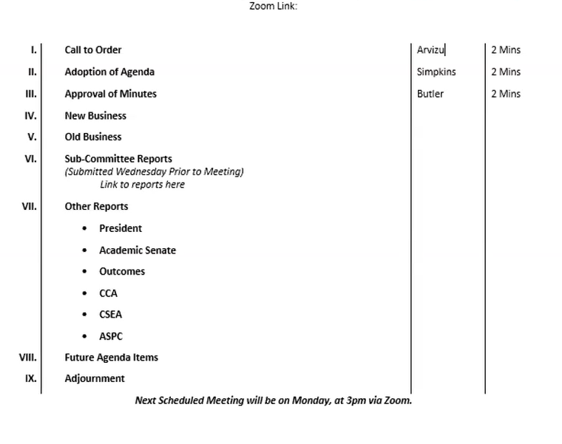

As the committee can see, sub-committee reports no longer will be verbally given (submitted through an online form prior to meeting) unless the co-chair(s) requests to be added to the agenda.

Feedback:

* Other reports should also be submitted through the online report form to allow more time for in-depth discussions.
* The new format eliminates the distinction between information and discussion/action items.

In the column where it lists who will be addressing the committee, it will state if the item is information, discussion, or action.

CC Sub-committee report form will be available on the committee page and will look like this:

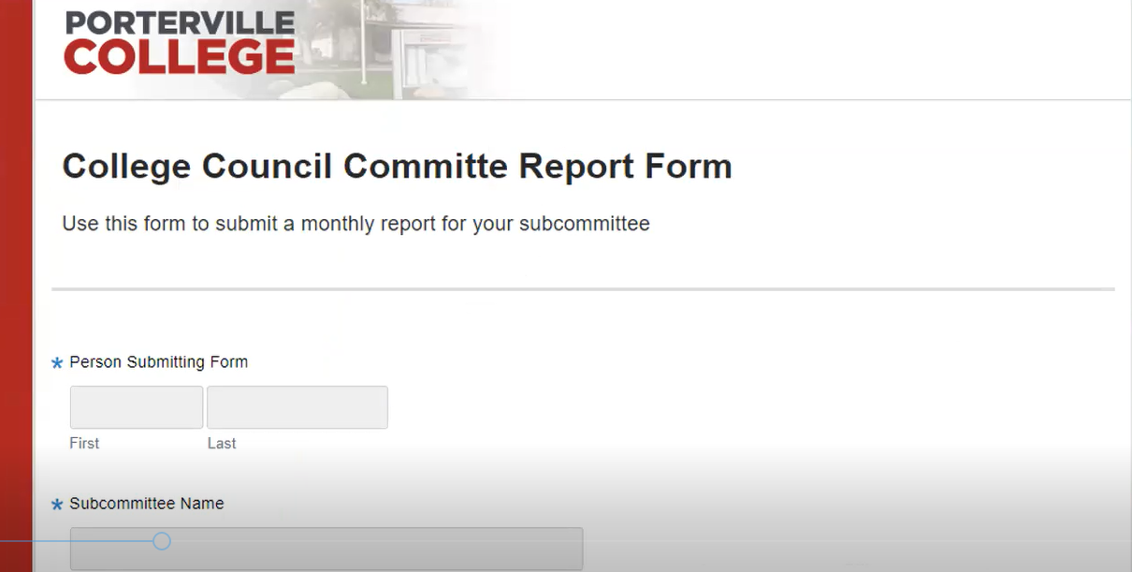

The report will be submitted the Tuesday before CC.

Feedback:

* Having the reports submitted 6 days prior to when CC meets, means that some of the sub-committees have not met yet and will have a delay in communication.

The sub-committee report will just go to the following meeting. If there is an urgent matter that needs to be discussed in CC that can be added to the agenda. The delay in information to committees is not unusual.

VP Arvizu has gathered the feedback from the CC Logic Model discussions, see below.

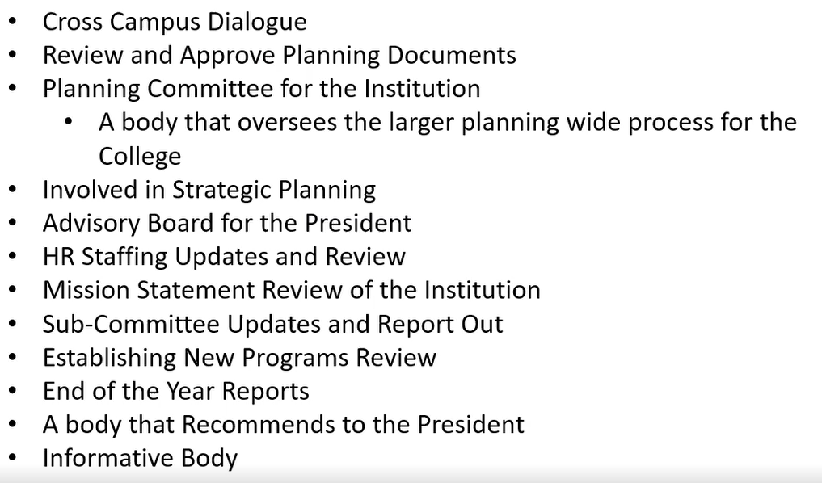

Next Steps:

* Workgroup is discussing the current CC charter; taking into count the information/feedback from all the discussion (CC Retreat, Logic Model Trainings, CC discussion items).
* Review progress and effectiveness of shared governance
* Transparent dialogue on core issues
* Data
* Achievement gaps/equity
* Advocate District level on college-wide issues
* Coordination and development of institutional planning
* Establish college priorities
* Development of procedures, policies, guidelines, and evaluation
* Vision for Success
* CC Goals and Functions
* Membership

1. **20-21 End of the Year Reports – Co-Chairs (5 minutes/1st read/Discussion/Action)**

The End of Year Reports were provided to the committee for review and there were no questions regarding any of the reports.

Vern asked for a motion to approve the 20-21 End of Year Reports.

***Motion,*** *“to approve”*

**M/S/C:** Thad Russell/Arlitha Williams-Harmon

*PDF provided to committee.*

1. **VRC Program Review – Maria Roman/Erin Wingfield** **(5 minutes/1st read/Discussion/Action)**

IR Director Carley informed the committee of some highlights on the VRC Program Review in the absence of Maria Roman and Erin Wingfield.

Vern asked for a motion to approve the VRC Program Review.

***Motion,*** *“so moved”*

**M/S/C:** Miles Vega/Lupe Guillen

*PDF provided to committee.*

1. **Language Arts Program Review – Elizabeth Buchanan (5 minutes/1st read/Discussion/Action)**

Professor Buchanan went over the highlights of the Language Arts Program Review.

Vern asked for a motion to approve the Language Arts Program Review.

***Motion,*** *“to approve”*

**M/S/C:** Frank Ramirez/Kendra Haney

*PDF provided to committee.*

1. **EOP&S/CARE Program Review – Araceli Carranza/Frank Ramirez (5 minutes/1st read/Discussion/action)**

Director Ramirez went over the highlights of the EOP&S/CARE Program Review.

Vern asked for a motion to approve the EOP&S/CARE Program Review.

***Motion,*** *“to approve”*

**M/S/C:** Lupe Guillen/Michael Carley

*PDF provided to committee.*

1. **DRC Program Review – Errin Sullivan-Arcos/Frank Ramirez (5 minutes/1st read/Discussion/Action)**

Counselor Sullivan-Arcos went over the highlights of the DRC Program Review.

Vern asked for a motion to approve the DRC Program Review.

***Motion,*** *“so moved”*

**M/S/C:** Miles Vega/James Thompson

*PDF provided to committee.*

1. **Financial Aid Program Review – Tiffany Haynes (5 minutes/1st read/Discussion/Action)**

Assistant Director Haynes went over the highlights of the Financial Aid Program Review.

Vern asked for a motion to approve the Financial Aid Program Review.

***Motion,*** *“to approve”*

**M/S/C:** Frank Ramirez/Kendra Haney

*PDF provided to committee.*

1. **Academic and Career Pathways Proposal – Dr. Robert Simpkins (5 minutes/1st read/Discussion/Action)**

Have been working on several areas of Guided Pathways; one major change was renaming the major clusters to Academic and Career Pathways.

We examined what other colleges across CA were doing and begin a process to reexamine what we have done to make our Guided Pathways align with other community colleges.

Want approval to change major clusters to Academic and Career Pathways and approve the current direction of Guided Pathways.

***Motion,*** *“so moved”*

**M/S/C:** Michael Carley/Lupe Guillen

*PDF provided to committee.*

1. **Subcommittee Reports**
2. **Accreditation**

* No report

1. **Budget**

* See item IV.B above

1. **Strategic Planning**

* Continuing to get close to a complete Strategic Plan Draft.
* One or two program reviews to assess and should come to CC this summer or fall.

1. **Enrollment Management**

* Introduced the new Program Director of Dual Enrollment/CTE, Ref Rodriguez
* Discussed several aspects of Guided Pathways
* Zero textbook cost in OER
* Student complaint procedure and altering the catalog language

1. **Pathways, Success and Equity**

* Sharing work with Guided Pathways and getting feedback from committee
* Put together work on Pillar 4: Ensure Learning
* Discussed prep for CCRC Institute
* Continuing work on 2-year plans
* Meeting with the K-12 school leads to make sure their pathways align with ours.

1. **Grant Oversight/Grant Progress Reports**

* ADH – Rachel (English) and CSUB collaborate on grant for Profession Learning Community for Virtual Reality (faculty stipends)
* Department of Education TRIO Grant (Gear Up) – cohort of students from 6th grade to graduation.

1. **Facility Planning Advisory**

* Wednesday is an open forum meeting
* Continue to use the contact tracing and temperature scanners
* cleaning and sanitation schedule
* event manager to schedule implementation
* Continuing Bipolar Ionization installation
* Furniture replacement
* Put in work order for personal protective equipment
* Hosting COVID vaccinations and test bus

1. **Information Technology**

* Working on getting exterior wi-fi set up
* Computer Commons computer updates

1. **Title IX Advisory/Safety and Security**

* No report

1. **Outreach**

* Planning Pirate in Day end of May throughout summer
* Mini retreat for Onboarding (Guided Pathways)

1. **Other Reports**
2. **President**

* PC was the only college in California selected to participate in the CCRC Institute at no cost to the college.
* Working on message regarding summer and fall semester return

1. **Academic Senate**

* Welcomed Dr. Simpkins as the Academic Senate President

1. **Outcomes**

* No report

1. **CCA**

* Had elections: Jay Hargis, Sherie Burgess and Rebecca Baird all reelected
* MOU passed.

1. **CSEA**

* One time 3% for salaries

1. **ASPC**

* Handing out hygiene bags to enrolled students during the Drive-thru pantry this Thursday

1. **Other**
2. **Future Agenda Items**
3. **Adjournment**

Meeting adjourned at5:07pm.