Enrollment Management Minutes

3:00pm – 5:00pm  May 10, 2021  Zoom

Our Mission
With students as our focus, Porterville College provides our local and diverse communities quality education that promotes intellectual curiosity, personal growth, and lifelong learning, while preparing students for career and academic success.

Members: Thad Russell, Primavera Arvizu, Joe Cascio, Michelle Miller, James Thompson, Mike Carley, Kim Behrens, Robert Simpkins, Jim Carson, Lupe Guillen, Karen Bishop, Sarah Phinney, Kendra Haney, Sherie Burgess, Elizabeth Buchanan, Vickie Dugan, Frank Ramirez, Judy Fallert, Patty Serrato, Ref Rodriguez, Claudia Habib, Miranda Warren.

- Call to Order – the meeting was called to order at 3:10 pm.
- Approval of Agenda - Motion to approve agenda M/S/C – M/ Carley/ P. Arvizu

- Approval of Minutes - Motion to approve minutes M/S/C – K. Bishop/ B. Simpkins

- Full audience - Information Items
- Banner 9 Update – No updates at this time.
- Student Services Update – Concentrating on virtual commencement – currently have 273. Wrapping up CTE certificate campaign. Will start focusing on summer and fall registration. Main theme this summer is to reach out to every single incoming freshman student. Frank – ongoing recruitment for incoming school year.
- Counseling Update – INST courses will now be Student Success courses; the change is going through curriculum for approval. Continue to let counselors know when you hold your division meetings so they can attend.
- 2-Year Plan Template and Next Steps – Bob shared his screen – Will have a stipend available and looking for volunteers – keep an eye out on your emails this summer as Bob will be reaching out for feedback.

- Full audience - Discussions Items
1.a Introduction – Dr Rodriguez – Our new CTE/Dual Enrollment Program Director.
1.b Banner Course Section Numbers – The section number listed under course section information in Ellucian. Discusion ensued about Online, Hybrid, and Face to face courses possibly having their own section numbers.
1.c Zero Textbooks Cost – Each Division will have a representative to discuss ZTC as well as Chris Ebert from the Library and DJ from IR.
1.d Division Chair Retreat Agenda Items – Add fill rates/ demands to the agenda.
1.e AB-705 Enrollment Data – enrollment comparison last fall to this fall by student type. What is the impact of AB-705 on our enrollment? 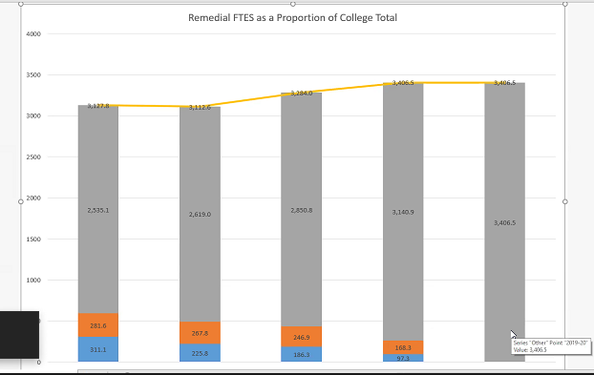
1.f Faculty Co-chair – Elizabeth Buchanan is confirmed the faculty co-chair for the 2021-2022 year.
M/S/C: M. Carley/ K. Haney

- Chairs – Information Items – Deans have been hired, Michelle Miller has accepted the position and our new Dean will start July 1st.

- Chairs – Discussion Items
1.a Semester knows and unknowns –

- Other

- Future Agenda Items

- Adjourn – meeting adjourned at 4:54 pm

- 2017-2022 Enrollment Management Goals
  - Increase number of declared majors
  - Increase awareness of instructional program offered
  - Increase the number of dual enrollment offerings and track the success of those offerings
  - Increase the percentage of students who take 15 units per semester
  - Increase percentage of students who complete 30 unites by end of 1st year of college
  - Increase awareness of career options within programs/pathways of study
  - Increase the number of students receiving associate degrees and certificates
  - Increase number of students who transfer to university
  - Increase number of students with ready resume, job applications

