Co-Chairs: Thad Russell, Elizabeth Buchanan, Vern Butler

**MINUTES**

**Present:**

Claudia Habib, Thad Russell, Primavera Arvizu, Osvaldo Del Valle, Michelle Miller-Galaz, Vern Butler, Kim Behrens, Johnathan Miranda, Jasmine Quinones, Frank Ramirez, John Ward, Jay Navarrette, Michael Carley, Robert Simpkins, Karen Bishop, Vickie Dugan, Melissa Long, James Carson, James Thompson, Elizabeth Keele, Patty Serrato, Kendra Haney, Elizabeth Buchanan, Chris Ebert, Jay Hargis, Shauna Williams, Carlos Rodriguez, , Erin Wingfield, Julian West, Sherie Burgess, Joe Cascio, and Patty Serrato.

**Absent:**

ASPC Vice President, Johana Fisher, Tiffany Haynes, Melissa Long, and Errin Sullivan-Arcos.

**Guest:**

Sarah Phinney

1. **Call to Order**

Elizabeth Buchanan called the meeting to order at 3:04 pm.

1. **Adoption of Agenda**

Motion made to approve the March 7, 2022 agenda.

**M/S/C:** Primavera Arvizu/Karen Bishop

1. **Approval of Minutes**

Motion made to approve the February 7, 2022 minutes.

**M/S/C:** James Thompson/Jonathan Miranda

1. **Action Items-First Read (Robert Simpkins/Primavera Arvizu 20 Minutes)**
2. **Program Review Mathematics (Sherie Burgess)**

Sherie Burgess reviewed the updated program review with the council. COVID has impacted overall success rates however the department is doing very well. No questions were asked.

**M/S/C:** Primavera Arvizu/Kendra Haney

1. **Program Review Library (Chris Ebert)**

Chris Ebert reviewed highlights on the updated Program Review for the library with the council. Lending library over $800,000 was saved by students with the ability to check out text books from the lending library and over $500,000 in laptops. Barnes & Noble donation has stopped. This is how books on reserved was funded. So moving forward faculty will have to place supply these books. Joe Cascio asked what happened with the Barned & Noble donation, Chris Ebert informed council that donation was transferred to gift cards that were given directly to the students.

**M/S/C:** Karen Bishop/James Thompson

1. **Program Review Office of Instruction (Thad Russell)**

Tabled to next meeting.

1. **Pathways to Success & Equity Committee Re-Structure and Committee Charge/Guided Pathways Progress and Update (Primavera Arvizu/Robert Simpkins)**

Robert Simpkins reviewed the updates with council that was suggested by College Council and Guided Pathway committees. Administrative Assistant will just be required to attend the full committee meeting to assist with minutes. Educational advisors have been added to the pathway teams. Slight language changes throughout the document have be updated.

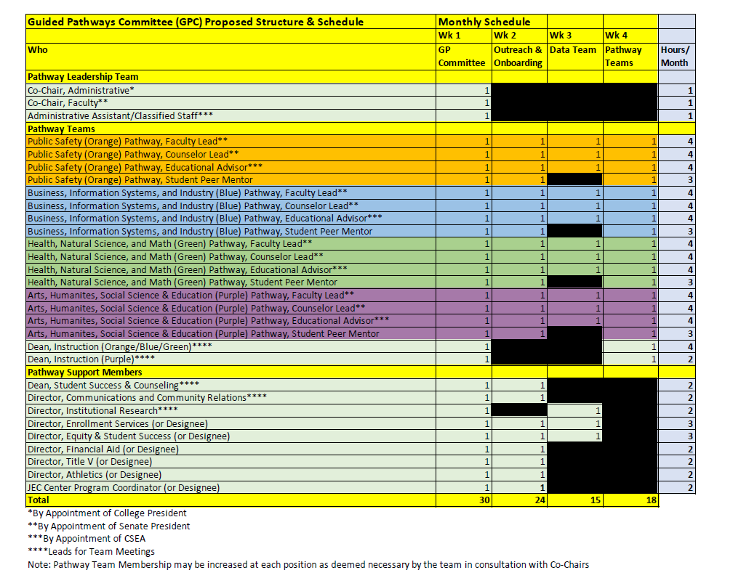

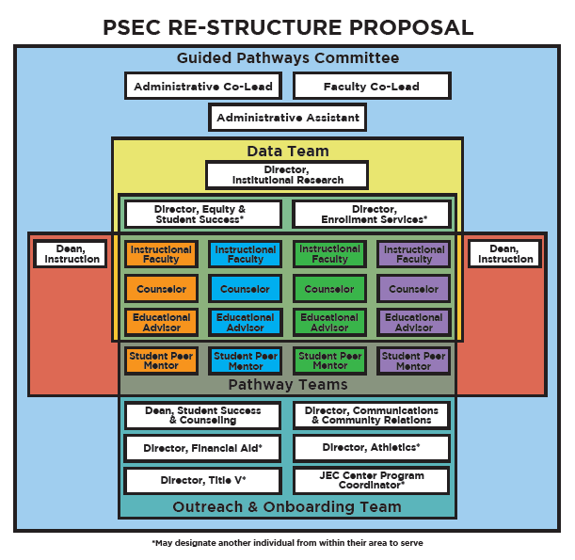

**M/S/C:** Thad Russell/James Thompson

1. **New Business-Announcement/Information/Discussion Items**
2. **Equitable Mindset of PC Employees Survey (Julian West)**

**Julian West reviewed a presentation with council showing survey result highlights.**

The survey was conducted prior to the break. This was a survey that was developed to assess the equitable mindset of PC employees (It is based on a survey developed by CCEAL). This was shared in the Social Justice Action Committee Meeting.

The main takeaway points from these results are as follows:

* There needs to be a focus on increasing the expectations that PC has of its students - Particularly as it relates to PC students' ability to transfer.

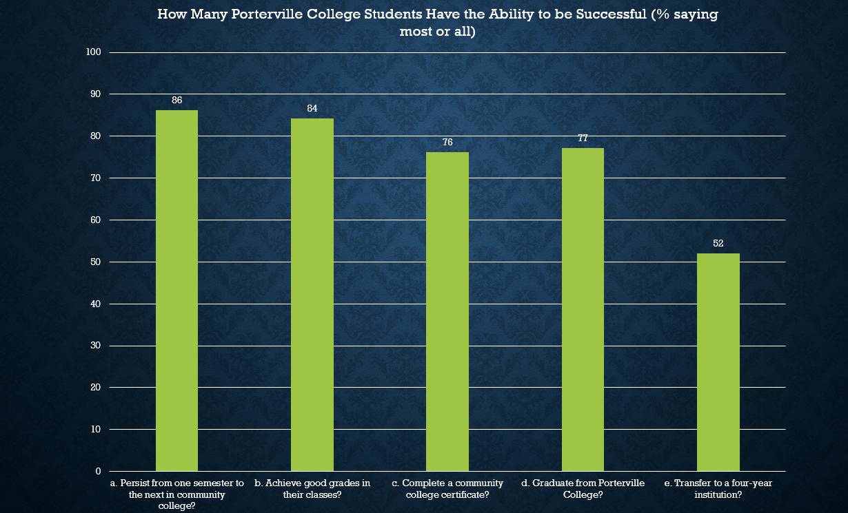

* There should be an emphasis on relationship building at PC and how it contributes to student success.

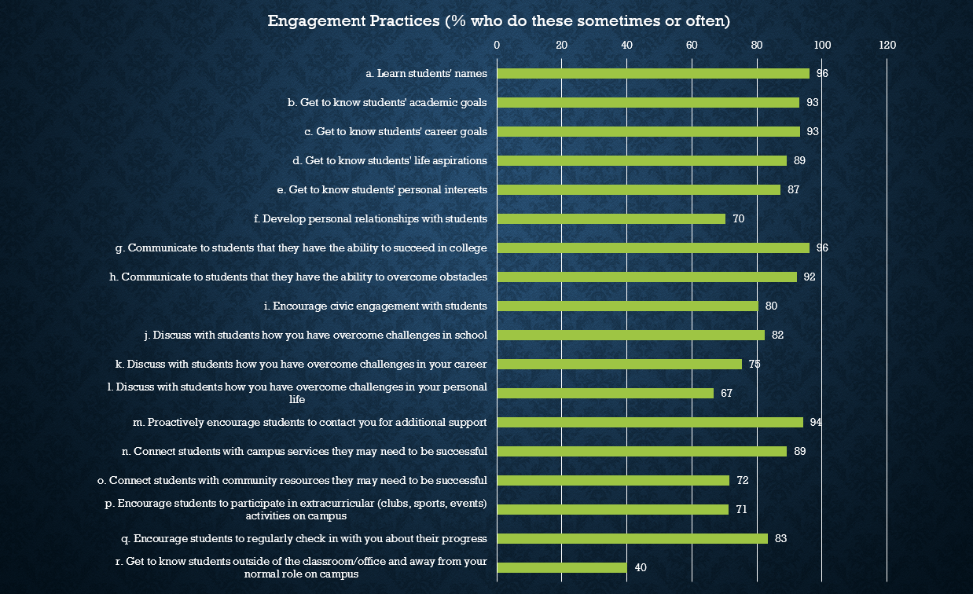

* There is some lack of knowledge as it pertains to exclusionary practices and systems that lead to outcome disparities.

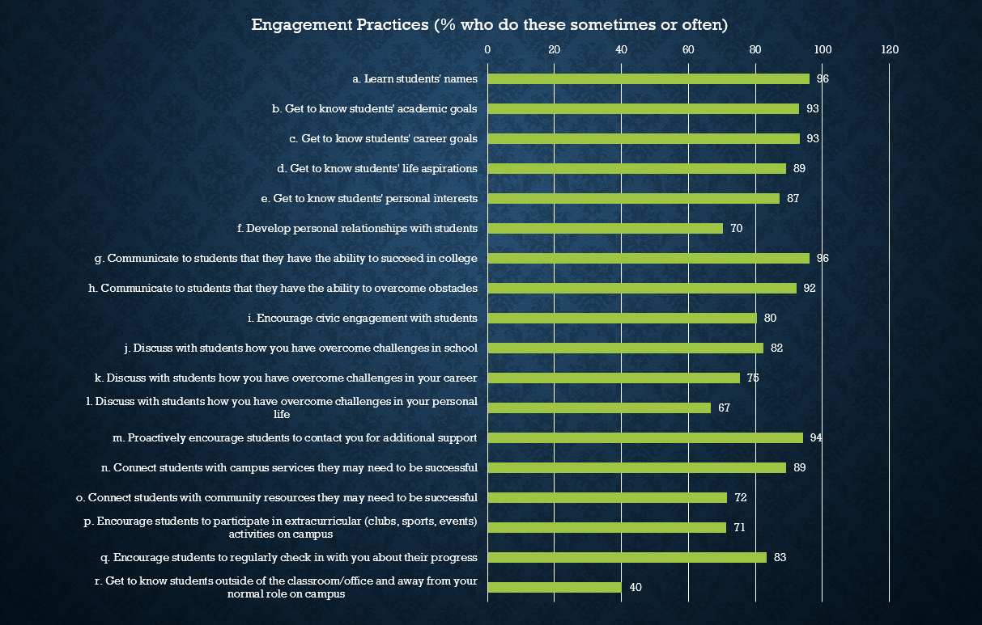

* Adjunct instructors generally scored lower across the board in terms of their comprehension of equity concepts - May exemplify a need for more adjunct training.

1. **Subcommittee Reports**

Subcommittee reports were sent out for review prior to meeting. Jay Navarrette reminded everyone that if anyone is purchasing any software of hardware run this by IT prior to purchasing through Vendor. Grants that have technology components need to have approval through IT prior to sending to district for approval.

Thad Russell differentiated the mid-term and annual report are different so the report is correct in the verbiage.

1. **Other Reports**
2. **President**

Dr. Claudia Habib updated the council that updates on mask mandate will be sent out soon. Porterville College is looking at moving into a strongly recommended mask mandate. Further more detailed communication to come. Second, Presidents Office Hour will be held so that anyone can have face-to-face time directly with president. These meetings will have time limits and must sign up ahead of time to reserve time.

1. **Academic Senate**

Robert Simpkins asked about tenure updates from the president. Tenure celebrations are typically held in fall. Letters from the president’s office have been sent out. Distinguished student reward ceremonies are being planned for end of April. Faculty have been asked to send in student nominations. Dr. Habib updated that Wednesday April 20, 2022 will be in person for years of service and retirement celebration ceremony.

1. **Outcomes**

Absent.

1. **CCA**

No Report.

1. **CSEA**

Vern Butler shared the newly developed Teams for PC Classified for all communications for classified staff to access and review to be up to date and remain in consistent communication.

1. **ASPC**

Jasmin Quinones shared that all seats on senate are full. Every other ASPC meeting there will be training held to implement the leadership portion.

1. **Additions**

Dr. Habib suggested that the College Council Teams is used for regular communication.

1. **Future Agenda Items**

None.

1. **Adjournment**

Meeting adjourned at 4:12 pm.