Co-Chairs: Thad Russell, Kendra Haney, Vern Butler

**MINUTES**

**Present:**

Claudia Habib, Thad Russell, Osvaldo Del Valle, Primavera Arvizu, Joe Cascio, Michelle Miller-Galaz, Ricardo Marmolejo, Michael Carley, Robert Simpkins, Vickie Dugan, Maria Battisti, Kendra Haney, Karen Bishop, Shauna Williams, James Thompson, Jay Navarrette, Jeff Keele, Stephanie Olmedo-Hinde, Jasmin Quinones, Sherie Burgess, Frank Ramirez, Tiffany Haynes, Elizabeth Keele, Fernando Jimenez, Kim Behrens, Elisa Queenan, Cameron Anderson, Melissa Long.

**Absent:**

ASPC President Shawn Taya Jeanes, Chris Ebert, Vern Butler, Erin Wingfield, Jonathan Miranda.

**Guest:**

1. **Call to Order**

Thad Russell called the meeting to order at 3:01 pm.

1. **Adoption of Agenda**

Motion made to approve the March 6, 2023 agenda. **M/S/C: Elizabeth Keele/Joe Cascio.**

1. **Approval of Minutes**

Motion made to approve the February 6, 2023 minutes with minor spelling and grammar changes. **M/S/C: Robert Simpkins/Melissa Long**.

1. **Action Items-First Read**
   1. **Rising Scholars (Michelle Miller-Galaz)**

Michelle Miller-Galaz proposed to council that Rising Scholars become a sub-committee of the council. Discussion surrounding the necessity of Rising Scholars reporting directly to College Council concluded that the council is to think on the topic of participatory governance overall and have outside conversations on the topic with Michelle and for now the topic will be tabled.

1. **New Business-Announcement/Information/Discussion Items**
2. **ILOs (Melissa Long)**

Melissa Long discussed CCSSE and CCFSSE responses with regards to ILO #1 Communication.

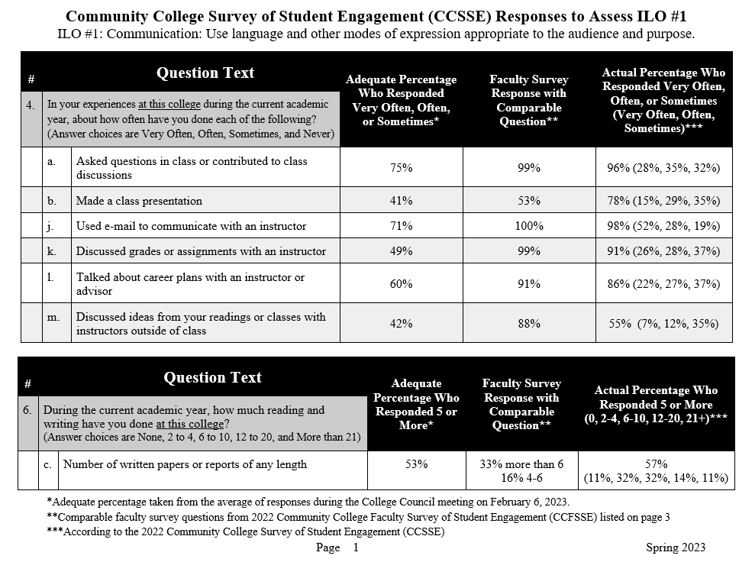

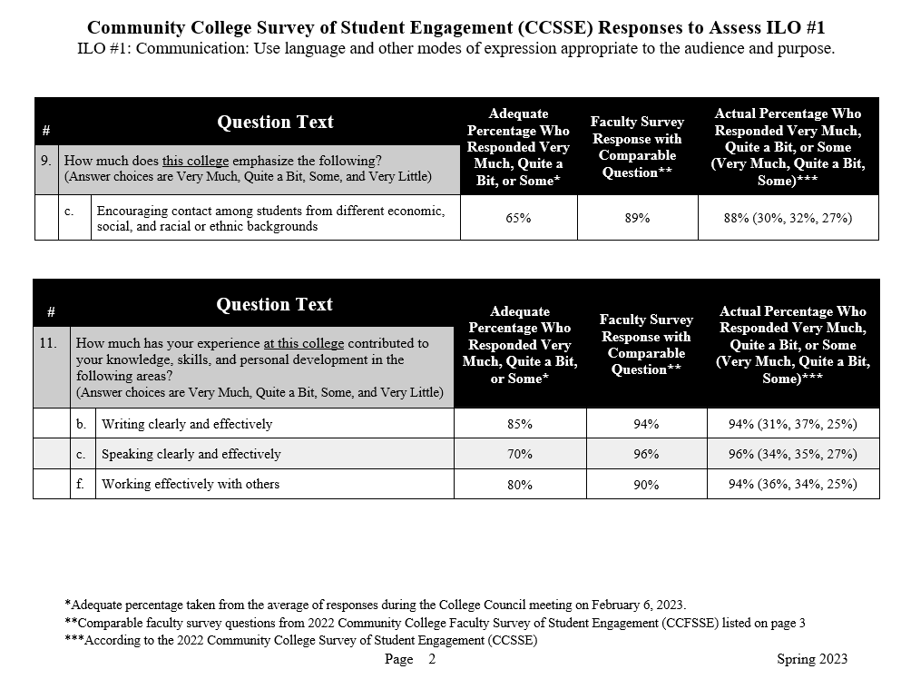

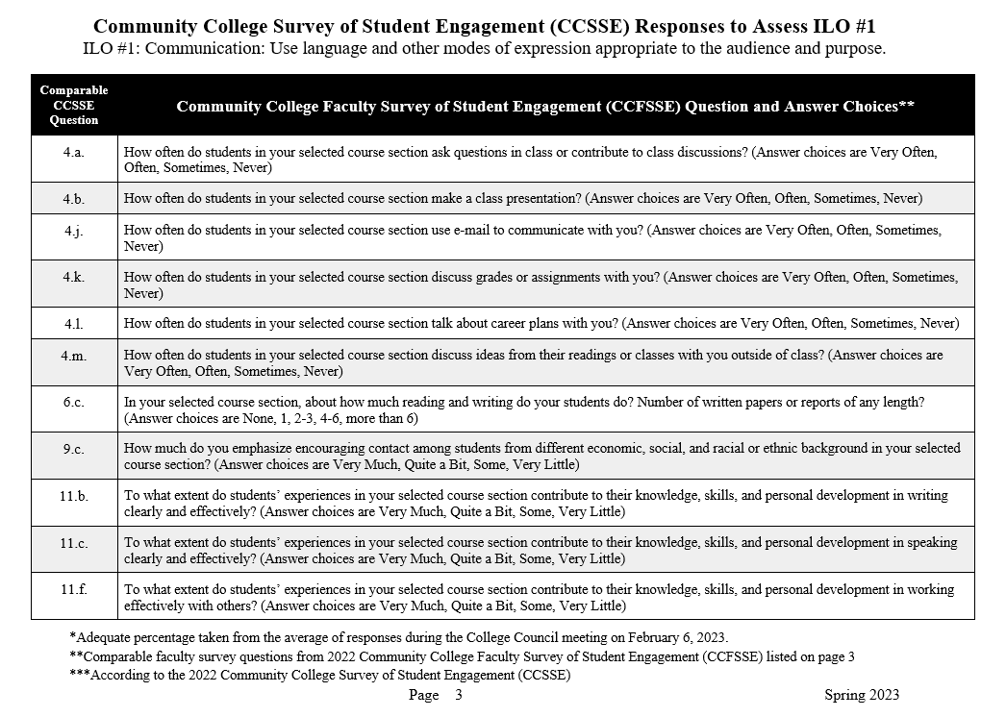

1. **Sub-Committee Reports**

No questions.

1. **Other Reports**
2. **President**

Dr. Claudia Habib asked the group to welcome Fernando Jimenez as the new Facilities Director. Council was updated that the feasibility study concluded that Porterville College along with Cerro Coso College would benefit from student housing. Approval to move forward with construction plans will be go to the next board meeting. Once those are finalized state will make final decision to fund project by August 2023.

1. **Guided Pathways**

Finalization of Ensure Learning Plan is in the works and focus on proposed welcome day for the second day of Flex is being finalized. Program Mapper for 2022-2023 is going to open so division chairs will be contacted. CSUB event that occurred on Friday March 3, 2023 was highly successful.

1. **Academic Senate**

Next meeting will be held on Friday so more updates at the next meeting.

1. **Outcomes**

Accreditation is quickly approaching therefore Learning Outcome must be updated prior to the accreditation report is due in August 2023.

1. **CCA**

Negotiations continue.

1. **CSEA**

**Negotiations begin soon.**

1. **ASPC**

Focus has been on leadership and student taking charge in assigned councils and committees along with communication. ASPC elections will open tomorrow with upcoming campaigning and voting to occur.

1. **Additions**

Educational Master Plan listening sessions to be held this week and all employees are heavily encouraged to attend.

1. **Future Agenda Items**

None.

1. **Adjournment**

Meeting adjourned at 4:18 pm.