Co-Chairs: Thad Russell, Elizabeth Buchanan, Vern Butler

**MINUTES**

**Present:**

Claudia Habib, Thad Russell, Primavera Arvizu, Osvaldo Del Valle, Michelle Miller-Galaz, Vern Butler, Kim Behrens, Johnathan Miranda, Jasmine Quinones, Frank Ramirez, John Ward, Jay Navarrette, Michael Carley, Robert Simpkins, Karen Bishop, Vickie Dugan, Melissa Long, James Carson, James Thompson, Elizabeth Keele, Patty Serrato, Kendra Haney, Elizabeth Buchanan, Chris Ebert, Jay Hargis, Shauna Williams, Carlos Rodriguez, Tiffany Haynes, Erin Wingfield, Julian West, and Patty Serrato.

**Absent:**

ASPC Vice President, Arlitha Williams-Harmon, Joe Cascio, Johana Fisher, Sherie Burgess, and Errin Sullivan-Arcos.

**Guest:**

Sarah Phinney

1. **Call to Order**

Vern Butler called the meeting to order at 3:04 pm.

1. **Adoption of Agenda**

Motion made to approve the February 7, 2022 agenda. Motion was made to move Guided Pathways Progress and Update up to Action Items-First Read.

**M/S/C:** Primavera Arvizu/Robert Simpkins

1. **Approval of Minutes**

Motion made to approve the December 6, 2021 minutes.

**M/S/C:** Primavera Arvizu/Robert Simpkins

1. **Action Items-First Read (Robert Simpkins/Primavera Arvizu 20 Minutes)**
2. **Pathways to Success & Equity Committee Re-Structure and Committee Charge/Guided Pathways Progress and Update**

Robert Simpkins presented a power point presentation with an overview of the work that is currently in progress with Academic and Career Pathways. Redevelopment on the student onboarding experience to include students to meet with counselor or advisor before the start of their first class, creating opportunities for students to meet and interact with people who share comment interests beyond the college, ensuring they are enrolled in classes that relate to area of interest making sure they have a personalized plan. The plan is to revise the student orientation to include these changes. Student first year experience will transition into Pathway-based approach to include: orientation, meet-and-greet opportunities, Career and Transfer workshops, and Short-term Pathway-based student success courses. Development of Pathway Team to include faculty, counselor/advisor, and student peer/mentor. Pathway programs will be represented at orientation, campus events, and outreach events in addition to offering virtual and in-person office hours, point of contact for each pathway program, refer students to appropriate college staff and services and advise students for their Pathway program. The purpose is to build a community specific to each Pathway. First semester goals are to meet with counselor, select degree program, complete a personalized ED plan, connect with faculty in area of interest, and build community with peers in area of interest.

The overall goal is to move away from the list oriented approach moving into a mapping approach and PC has partnered with Concentric Sky to develop program mapper.

Primavera Arvizu provided an overview of program mapper which is customizable visual representation of the college catalog organized by academic and career pathway groups of similar programs that are designed to help students select their program of study. This will allow student access to video program learning outcomes to deepen their understanding of each pathway and transfer information to keep students on tract. Career information will also be included that specifies salary and additional pertinent information specific to their pathway so that students can make an informed decision about their Pathway choice. Program is currently in development.

PC is currently working with UC Merced on a transfer alignment project to develop a Pathway for transfer to UC Merced.

Quality faculty professional development work to invest in faculty to ensure quality instruction. This includes faculty professional development, continuation of Quick Tips for teaching success and Achieving the Dream learning seminar opportunities. Guided Pathways Academy will continue in spring 2022.

Robert Simpkins added that finalization of onboarding process including who will be on the Pathway teams needs to be accomplished. Creation of New pathway-based Student Success Courses, unveil Pathway-based Website/Program Listing, and Promote Pathway-based thinking. This requires coordination across campus including planning, communicating, and thinking.

Pathways to Success & Equity Committee (PSEC) proposal was released to committee for review. Proposed to have PSEC committee as a sub-committee to College Council and renaming it as Pathways Committee. Proposal is to develop a Guided Pathways committee monthly meeting structure which would include first week have full committee meeting to review prior month’s work and set current months goal, second week have Outreach/Onboarding team meeting, third week would be Data team, and fourth week would be Pathway teams. This is in an effort to limit the amount of meetings requires since several of the same members are on multiple committees already. Update structure and required time shown below.

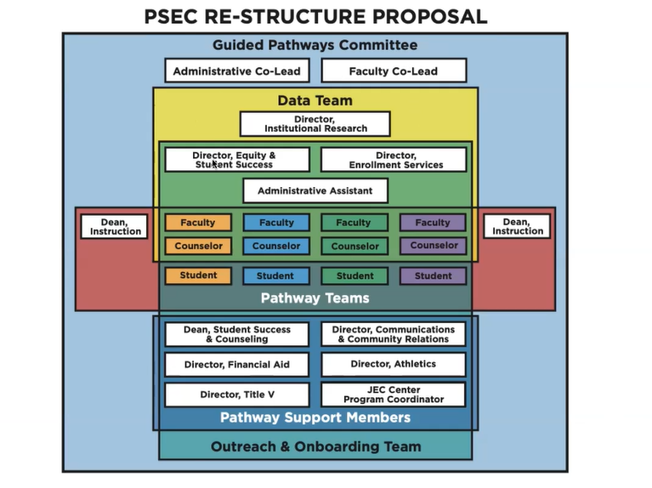

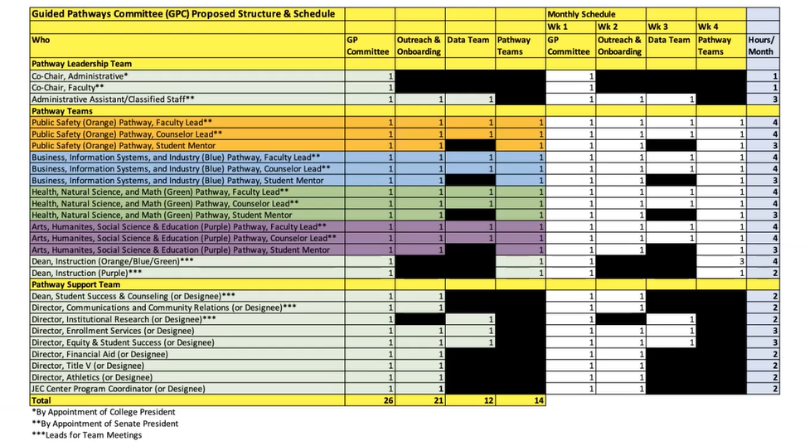

Conversation arose around the administrative assistant role requirement and alignment of language on proposal and visual graphic. Final document will be brought back to College Council.

**First Read accepted as presented with modification as discussed: M/S/C: Thad Russell/Johnathan Miranda**. Guided Pathways affirmed as presented.

1. **Action Items-Second Read**
2. **Social Justice Action Committee Charge (Julian West 5 Minutes)**

Julian West updated the council with Social Justice Action Committee Charge as a second read requesting that it is changes from a taskforce to a sub-committee of College Council. Dr. Claudia Habib questioned the size of the membership due to the large size and the sustainability of the committee. If the committee decides to change membership it will be brought back to College Council for approval.

**Second Read: M/S/C: Primavera Arvizu/ Robert Simpkins. Accepted as submitted.**

1. **New Business-Announcement/Information/Discussion Items**
2. **Program Review Distance ED (Sarah Phinney 5 Minutes)**

Sarah Phinney presented the updated Program Review Distance ED. Survey was delivered to faculty for their preparedness and action was needed. Faculty asked for additional training therefore online training was expanded. Survey to students was not able to be conducted due to workload. Student survey will be conducted in the near future. Request for position change from classified to management as Manager of Distance Learning when budget available. Michael Carley requested that College Council approve this item.

**Second Read: M/S/C: Karen Bishop/Elizabeth Keele. Accepted as submitted.**

1. **ILO’s (Melissa Long 15 Minutes)**

Melissa Long provided an update to the council on ILO #4 and #5.To assess ILO #5, the following sources of evidence was developed:

* Mental Wellness Annual Report
* CCSSE questions
* Vaccine clinics and Covid testing
* Sports programs
* ASPC beginning a mental awareness campaign with videos every Monday with testimonies about mental health beginning in spring 2022
* Student Services has mental health workshops for cohorts of students
* BIT referrals (Primavera will send a report with how many students are following through)
* Student Mind(?)-- celebration months (i.e. Hispanic Heritage Month) each include a mental health aspect (Jasmin will send a report on the registrations and instructors requiring the students to write reports)

Melissa Long will compile as much of this information as possible so that analysis can begin for discussion in the spring.  In the meantime, council was asked for to email additional ideas of what can be looked at for assessment for ILO #5.

To assess ILO #5, we came up with the following sources of evidence:

* Mental Wellness Annual Report
* CCSSE questions
* Vaccine clinics and Covid testing
* Sports programs
* ASPC beginning a mental awareness campaign with videos every Monday with testimonies about mental health beginning in spring 2022
* Student Services has mental health workshops for cohorts of students
* BIT referrals (Primavera will send a report with how many students are following through)
* Student Mind(?)-- celebration months (i.e. Hispanic Heritage Month) each include a mental health aspect (Jasmin will send a report on the registrations and instructors requiring the students to write reports)

I will compile as much of this information as possible so that we can begin analyzing and discussing in the spring.  In the meantime, if you have other ideas of what we can look at to assess ILO #5, please let me know.

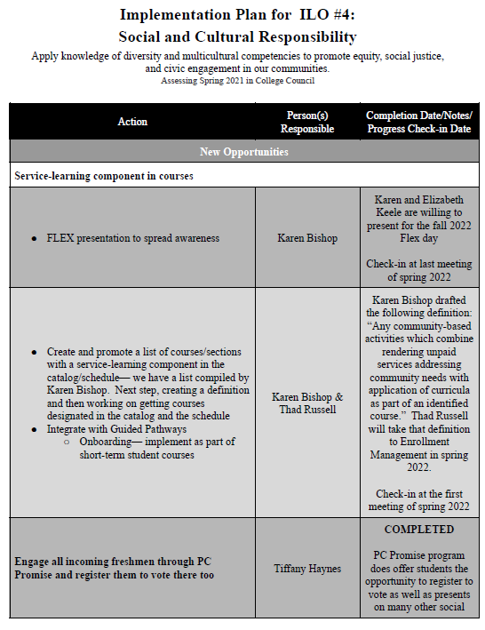

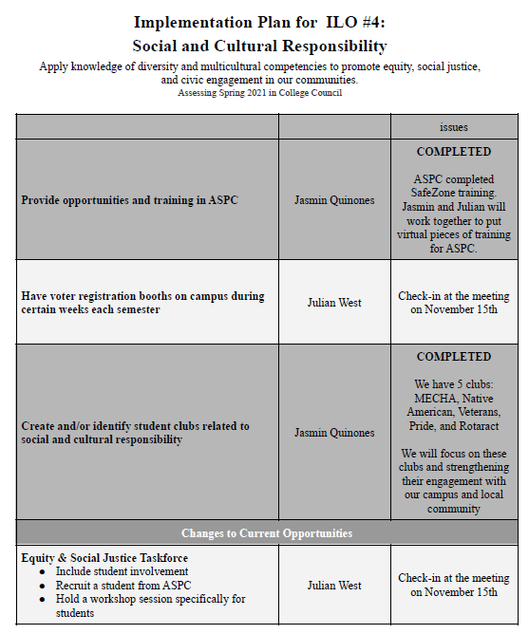

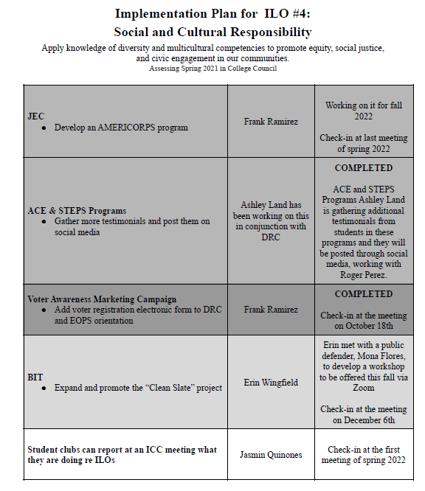

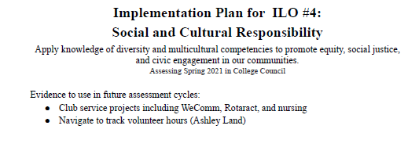

1. **Fall 2021 Strategic Planning Survey (Michael Carley 15 Minutes)**

Michael Carley shared the results of the Strategic Planning Survey that was conducted in the fall 2021. This survey is conducted every three years. Highlights include:

* Small decline in percentage of people that state they are familiar and acknowledge there is a decline in goals.
* Almost all surveyed responded they are familiar with ILO’s in their area.
* Only 55% people say that they have student participation.
* Decline in current committee structure provides effective college-wide participation in decision-making for all segments.
* Decline in those who say they have had sufficient opportunity to provide input into college-wide planning processes.
* Increase in those who say the college bases its technology on needs of educational programs.
* Comparison how college is doing from past survey asking about links between mission and planning, program review and planning, planning process and budget decision, and quality of dialogue on campus about planning issues are about the same or worse than previously.

Suggestion was made my Kendra Haney to develop a communication email or text notification about events that are occurring on campus so everyone is more aware about what is happening on campus.

1. **Equitable Mindset of PC Employees Survey (Julian West 15 Minutes)**

Tabled until next council meeting.

1. **CAMP Grant (Michelle Miller-Galaz/Primavera Arvizu 3 Minutes)**

Primavera Arvizu informed the council of the submission of CAMP grant application that would assist student who are migratory or seasonal farm workers and/or children of workers assisting them in getting signed up for college. Grant would provide a summer bridge aligning with student success courses, making sure the student educational planning and they are in the correct Pathway.

This grant application was not ran through the grants committee due to the committee not meeting prior to application deadline.

Michelle Miller-Galaz wanted to share with the council that in the future they would like to apply for an additional grant for high school equivalency program that they currently did not apply for due to limited infrastructure.

1. **Subcommittee Reports**
2. **Other Reports**
3. **President**

Dr. Claudia Habib spoke about the SIM Academy that is sponsored by the State Chancellors office that focuses on adult learners and how the college can pull these population back in and sign up for classes. Second council was updated on status of returning to campus for the following week. Currently the COVOD-19 trend is moving in the right direction in the county however there still is a high number of cases within PC staff and students. Remote availability will be available with an official notification to be released later in the week.

1. **Academic Senate**
2. **Outcomes**

Please support your outcomes representatives.

1. **CCA**
2. **CSEA**
3. **ASPC**
4. **Additions**
5. **Future Agenda Items**
6. **Adjournment**

Meeting adjourned at 5:04 pm.