Co-Chairs: Thad Russell, Kendra Haney, Vern Butler

**MINUTES**

**Present:**

Claudia Habib, Thad Russell, Osvaldo Del Valle, Primavera Arvizu, Joe Cascio, Michelle Miller-Galaz, Ricardo Marmolejo, Erin Wingfield, Michael Carley, Robert Simpkins, Vickie Dugan, Maria Battisti, Kendra Haney, Karen Bishop, Shauna Williams, Kim Behrens, James Thompson, Jeff Keele, Stephanie Olmedo-Hinde, Jasmin Quinones, Sherie Burgess, Jonathan Miranda, Melissa Long.

**Absent:**

ASPC Vice President, Elizabeth Keele, Chris Ebert, Cameron Anderson, Jay Navarrette, Vern Butler, Frank Ramirez, Elisa Queenan, Tiffany Haynes, Carlos Rodriguez, Elian Ramos.

**Guest:** DJ Vanderwerff,

1. **Call to Order**

Kendra Haney called the meeting to order at 3:02pm.

1. **Adoption of Agenda**

Motion made to approve the February 6, 2023 agenda. **M/S/C: Robert Simpkins/James Carson.** Motion to amend the agenda to add ILO’s as agenda item and to switch the first two items on agenda. **M/S/C:** **James Thompson/Erin Wingfield**

1. **Approval of Minutes**

Motion made to approve the December 5, 2022 minutes. **M/S/C: Robert Simpkins/Thad Russell**. Motion to make amendments to minutes. **M/S/C: Claudia Habib/Robert Simpkins.**

1. **Action Items-Second Read/Final Approval**
2. **Educational Master Plan (Claudia Habib)**

Dr. Claudia Habib introduced Lori Bennett from Collaborative Brain Trust (CBT) whom is working with Porterville College on the Educational Master Plan (EMP). Council was asked for volunteers to work on task force to assist with the EMP. First meeting will be held on Thursday February 9, 2023. Porterville College has asked the board for an extension of the 2017-2022 EMP plan to cover until new EMP is completed. Plan is to complete this updated plan by September 14, 2023 to present to the board during this board meeting which will be held at Porterville College.

1. **Collaborative Brain Trust EMP Process & Timeline (CBT)**

Lori Bennett and Nicki Harrington from Collaborative Brain Trust provided the council with a presentation on what they do and how they will assist the college on working on a new on Educational Master Plan. Council was shown the process and timeline.

1. **Participatory Governance Plan (Kendra Haney)**

Kendra Haney updated the council on the status of the Participatory Governance Plan. Task force has been initiated to start working on updating the document. Michelle Miller-Galaz will initiate scheduling the meetings so that task force can begin updating the document. Faculty representation needs to be added to the task force. Once completed this will be brought back to College Council for approval.

1. **Staff Development Plan (Thad Russell)**

Thad Russell updated the council on conversations surrounding the initiation of the Staff Development Committee. Division chairs were asked if they has questions or concerns about the recreation of Staff Development Committee to drive this forward. Overall consensus was there is interest in a more flexible approach in staff development however more information on details is needed. Classified representation needs to be included. Once the Assistant Director Academic Technology and Professional Development position is hired they will be responsible for leading this committee. Until then Thad will oversee this moving forward with the initiation of a task force with assigned charge will be reported to College Council by the April 17, 2023. Large portion of this is ensuring that professional development is written into GU001 funds and not only dependent on categorical funds.

1. **Grants Oversight Committee (Thad Russell)**

Thad Russell asked the council if the Grant Oversight Committee should be reinitiated and how should it be formatted. Commonly grant decisions are required to be made on last minute schedule when grants are assigned. It was suggested to make this a team under the budget committee defining priorities and ensure that all grants meet preset guidelines. Maria will create proposal to move Grant Oversight Committee to a subcommittee of the Budget Committee and will present at the March 20, 2023 College Council meeting.

1. **New Business-Announcement/Information/Discussion Items**
2. **ILOs (Melissa Long)**

Melissa Long conducted an activity to compare what the council’s perception of what the student responses would be compared to actual responses to CCSSE that focused on ILO number 1. Findings as follows:

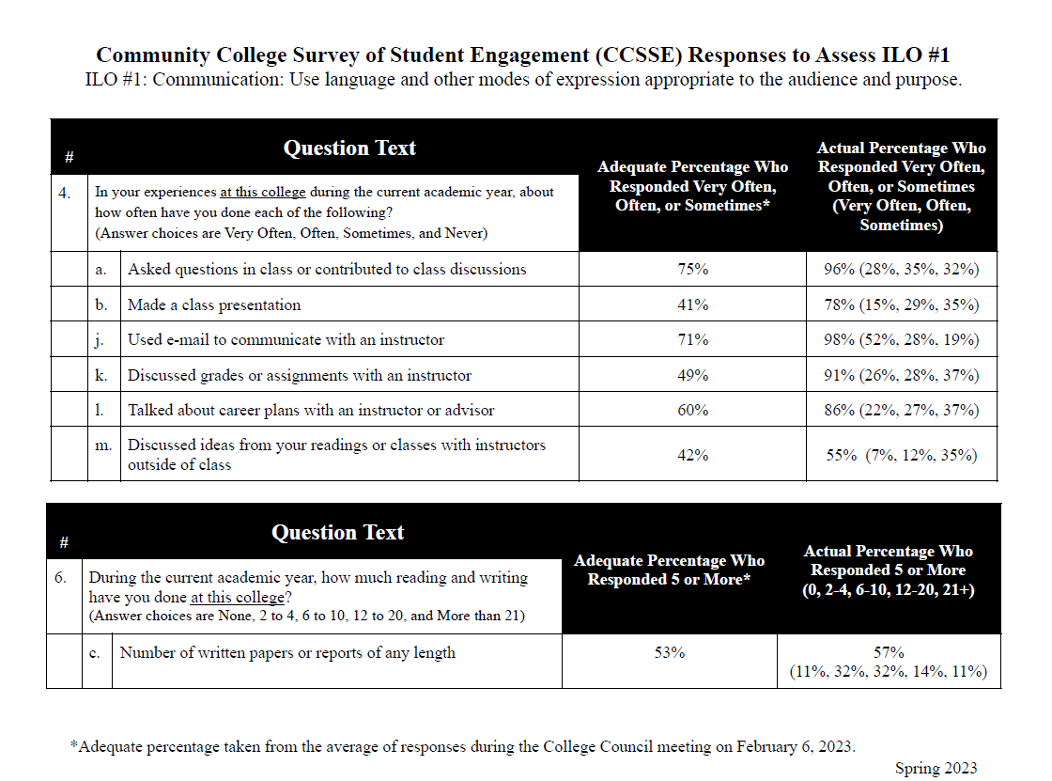

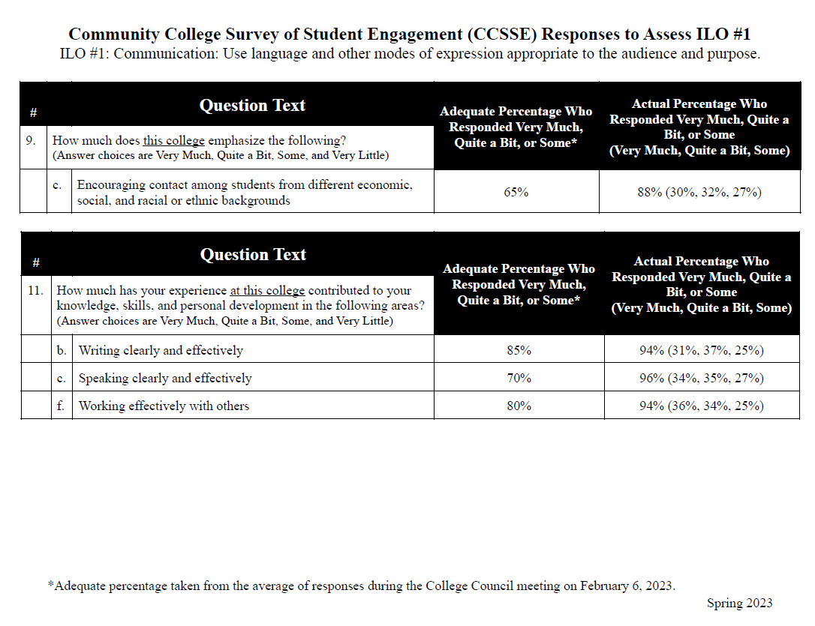

1. **Sub-Committee Reports**

No questions.

1. **Other Reports**
2. **President**

Dr. Claudia Habib informed the council that there are two basketball games coming up this week. District is organizing a professional development opportunity to be held at Bakersfield College next Wednesday February 15, 2023, 1st Annual KCCD Conference. Transportation will be available for those who signed up to attend. National PTK selected 17 colleges to receive a grant and Porterville College as chosen as one of the three colleges in California to receive grand funds to create an honors program.

1. **Guided Pathways**

Robert Simpkins informed the council thatthe Guided Pathways Committee is reviewing the first draft for the Ensure Learning (Pillar 4) Plan.  Related to this is the upcoming district wide event, The Teaching-and-Learning Exchange Festival or TALE FEST, on April 14th in Bakersfield.  There is also a districtwide task force promoting Guided Pathways Pillar 4: Ensuring Learning, and Robert Simpkins has joined it as a faculty representative.

We're also working on a new approach to Onboarding, linking our events into a master plan that goes from early contact to registration and orientation.  Our work in Program Mapper is nearing completion for all Associate's degrees, but will require more updating and correcting.  Marketing is also working on a plan for Guided Pathways materials to provide for students at events to help explain the pathways-approach and the Student Journey.

1. **Academic Senate**

Robert Simpkins informed the council thatthe Distinguished Student Awards Ceremony is scheduled for 4/28/23 in the cafeteria, we will be requesting the lists of graduating students for faculty to select from.  The Scholar of the Year will also be announced at that event.

The Senate has now approved the draft calendars for AY 2023-24, 2024-25, & 2025-26, which will then go the Board, after which we make our local version with our own spring break indicated.  These will then be posted on the KCCD website.  Calendars were behind schedule, but this will get us caught up.

1. **Outcomes**

Melissa Long reminded the remaining divisions that have not yet had Outcomes training to please get this scheduled and completed.

1. **CCA**

No Report.

1. **CSEA**

Absent.

1. **ASPC**

Student representative will attend the next College Council meeting. Club rush to continue this week. Black History Month has two speakers scheduled this month with a final event everyone is asked to bring a quote from their favorite African American and quotes will be displayed. Hosting Student Leadership Conference April 14, 2023 7:30-1:00 titled Level Up.

1. **Additions**
2. **Future Agenda Items**
3. **Adjournment**

Meeting adjourned at 5:10 pm.