Program Review – Assessment Report Instructions
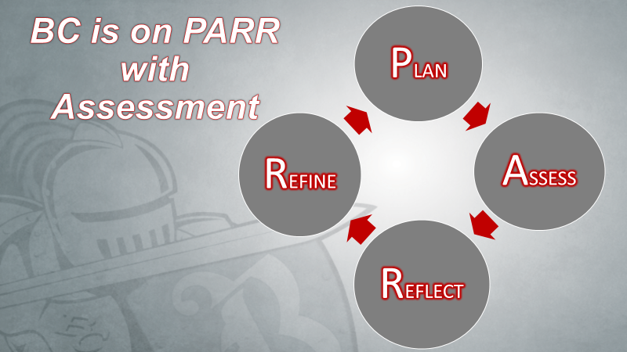
Instructions:
- In eLumen, the department chair (utilizing the Report Creator role), or the Assessment Committee representative, over the program needs to generate the report titled “SLO Performance - By Department, Course, CSLO”. The report should be generated for each required course and elective listed in the program (e.g., if a math course is part of the psychology program, then the above report should be pulled for both mathematics and psychology courses). When running the report be sure to include fall, spring, and summer terms for the prior academic year. See handout “eLumen Training for Department Chairs” on the Academic Technology webpage for more detailed instructions: www.bakersfieldcollege.edu/academic-technology/elumen-assessment
- Assessment Table - Column 1: list each required course and elective for the program.
- Assessment Table - Columns 2 – 6: At the end of each course in the above report, there is a table titled “Totals for CSLOs” that contains the data necessary to complete the Assessment Table. Be sure that all rows that contain data total to 100% for Column 6.
- Complete one Assessment Report per program and return the completed form(s) to the Program Review Committee. Write your responses in the textbox, the textbox will expand as needed.

Program Review – Assessment Report
Name of Program:
Write your response here. The textbox will expand as you type.

Plan – Describe the process used to assess the courses for this program.
Write your response here. The textbox will expand as you type.

Assess – Fill in the table using the data from the report SLO Performance - By Department, Course, CSLO
Courses | % Students Exceed | % Students Meets | % Students Doesn’t Meet | % Students N/A | Total

Reflect – Based on the SLO performance data listed in the table, describe both the strengths and weaknesses of the program.
Write your response here. The textbox will expand as you type.

Refine – Summarize the changes that discipline faculty plan to implement based on the program’s strengths and weaknesses listed above.
Write your response here. The textbox will expand as you type.

Dialogue – Explain when, or how often, discipline faculty meet to discuss the assessment process (e.g., planning, data collection, and results) for this program (e.g., department meeting).
Write your response here. The textbox will expand as you type.

