Co-Chairs: Thad Russell, Elizabeth Buchanan, Vern Butler

**MINUTES**

**Present:**

Claudia Habib, Thad Russell, Primavera Arvizu, Arlitha Williams-Harmon, Osvaldo Del Valle, Michelle Miller-Galaz, Vern Butler, Kim Behrens, Johnathan Miranda, Jasmine Quinones, Frank Ramirez, Joe Cascio, John Ward, Johana Fisher, Jay Navarrette, Michael Carley, Robert Simpkins, Karen Bishop, Vickie Dugan, Melissa Long, James Carson, James Thompson, Elizabeth Keele, Patty Serrato, Sherie Burgess, Kendra Haney, Elizabeth Buchanan, Chris Ebert, Jay Hargis, Shauna Williams, Carlos Rodriguez, and Felisa Hannah.

**Absent:**

ASPC Vice President, Tiffany Haynes, Erin Wingfield, Julian West, Errin Sullivan-Arcos, Patty Serrato, and Jay Navarrette.

**Guest:**

None

1. **Call to Order**

Thad Russell called the meeting to order at 3:07 pm.

1. **Adoption of Agenda**

Motion made to approve the December 1, 2021 agenda. Modification was made to agenda to move Arlitha-Williams Harmon’s item under old business.

**M/S/C:** Elizabeth Keele/Primavera Arvizu

1. **Approval of Minutes**

Motion made to approve the November 15, 2021 minutes.

**M/S/C:** Michael Carley/Karen Bishop

1. **Old Business-Action Items**
2. **Introductions**

Thad Russell introduced Carlos Rodriguez as the ASPC President.

1. **HR Staffing Plan-Dr. Claudia Habib (20 minutes/discussion)**

Dr. Habib updated council in regards to hiring priorities. Low enrollments causing the FON to not meet threshold is limiting the ability for Porterville College to hire additional faculty; therefore, the number of faculty positions remains at five. After in-depth conversations with academic senate and this council about the need of additional faculty position to support enrollment growth, concerns have been addressed with the Chancellor’s office proving there is a demand at Porterville College to fill additional faculty positions so we can grow. Dr. Habib reminded the Chancellors office that prior to Covid-19 Porterville College data was trending in a positive direction and without the resources to recover from this Covid-19 the college cannot regain those enrollments because students will be forced to go elsewhere. These conversation were heard and will continue drawing on the topic of systematic inequities within the district that is affecting students. Conversations with district and other college presidents are moving in a positive direction and they are starting to see our position.

Replacement faculty positions include: Physical Science, Earth Science, Agriculture, Psychiatric Technician, and Counseling faculty positions.

Future faculty positions for consideration: History, Industrial Maintenance, Nursing, Ethnic Studies.

Program growth areas: Soccer, Track and Field, and Nursing.

Classified positions: Executive Secretary, Education Medial Specialist, Learning Center Tech, Learning Tech II, Learning Center Tech (11 month/19 hour), Department Assistant I and II (Counseling), and Alternative Media Specialist (DRC-COF).

Proposed new positions: Instruction office specialist, Gear-Up Program Tech (COF), Financial Aid Program Tech (COF), Athletic Trainer, Library Tech II (Evenings), Department Assistant (FT or PT) Athletics.

Management Positions: Director of Enrollment Services, Gear-Up Grant Program Manager (COF), Budget Analyst, VP Fiscal and Administration Services.

Dr. Habib officially announced that Soccer will be added in Fall 2022 and Track and Field in Spring 2023.

Council was informed that Dr. Arlitha Williams-Harmon has officially accepted the role as CFO at the district office. New hiring committee for her replacement will need to be developed. The district has approved to hire an Interim to fill the position until a replacement can be found.

Motion made to adopt the staffing plan as presented. **M/S/C:** Primavera Arvizu/Joseph Cascio.

1. **DRAFT Mission Statement**

Michael Carley shared the final draft of Mission Statement for approval. Draft was shared with ASPC with no suggestions. ASPC representation really liked the PIRATES acronym. Updated Mission Statement was shared with council.

**M/S/C:** Karen Bishop/Elizabeth Keele. Mission Statement approved as presented.

1. **DRAFT Strategic Plan**

Michael Carley shared the final draft of Strategic Plan for approval. The newly approved Mission Statement will be updated into the Strategic Plan upon acceptance.

**M/S/C:** Kendra Haney/Joe Cascio. Strategic Plan approved as presented.

1. **Request for One-Time Funds Approval**

Dr. Arlitha Williams-Harmon shared request for one-time funds from Vickie Dugan for equipment repairs in Gym. Contract is intact with CALFITNESS but additional repairs need to be completed. Complaints have been received from Foundation members who are paying for courses and equipment is not useable. Total amount of request is $8,535.79

Two requests from M&O for additional return to campus funds one for $55,000 and the other for $17,000. Most of M&O funds had to be used for HVAC upgrades and additional return to campus requirements.

M/S/C: James Thompson/Joe Cascio. One-Time Funds Requests approved as presented.

1. **New Business-Announcement/Information/Discussion Items**
2. **ILO’s – Melissa Long (15 Minutes/Discussion/Action)**

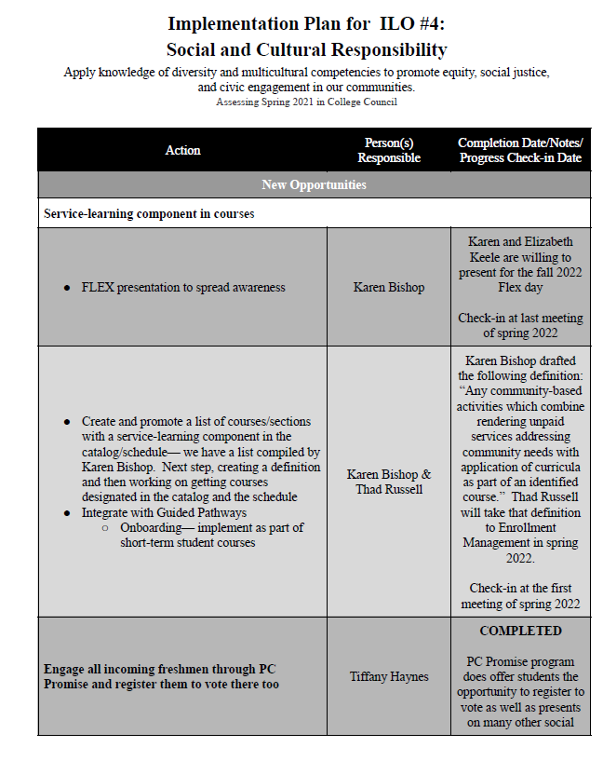

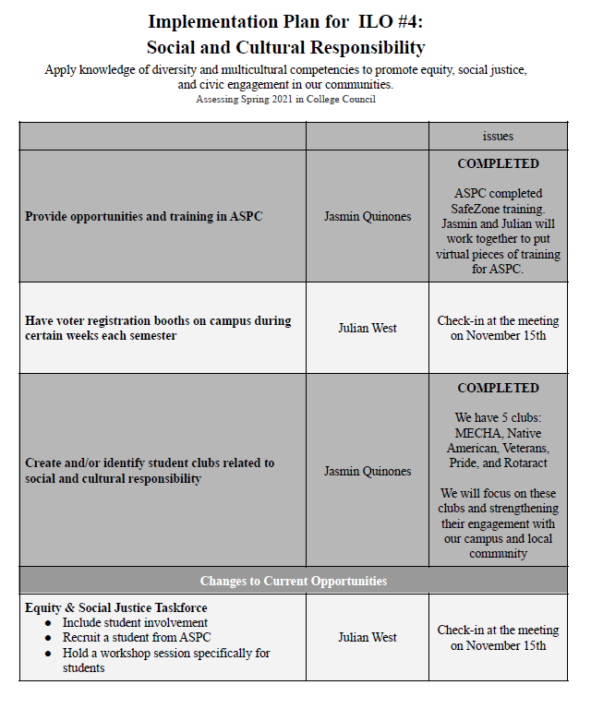

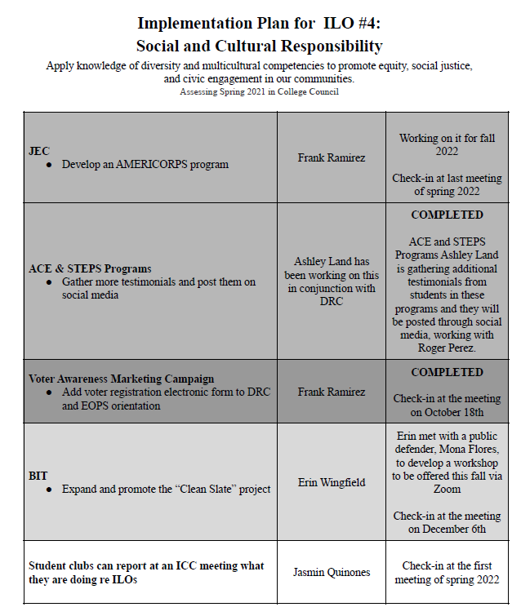

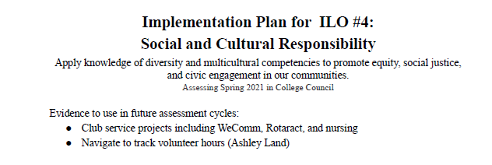

To assess ILO #5, we came up with the following sources of evidence:

* Mental Wellness Annual Report
* CCSSE questions
* Vaccine clinics and Covid testing
* Sports programs
* ASPC beginning a mental awareness campaign with videos every Monday with testimonies about mental health beginning in spring 2022
* Student Services has mental health workshops for cohorts of students
* BIT referrals (Primavera will send a report with how many students are following through)
* Student Mind (?)-- celebration months (i.e. Hispanic Heritage Month) each include a mental health aspect (Jasmin will send a report on the registrations and instructors requiring the students to write reports)

I will compile as much of this information as possible so that we can begin analyzing and discussing in the spring.  In the meantime, if you have other ideas of what we can look at to assess ILO #5, please let me know.

1. **“Defined Service Learning”**

Karen Bishop updated the council on addition of ILO of Service-Learning component in courses. By "service learning" specified as: Any community-based activities which combine rendering unpaid services addressing community needs with application of curricula as part of an identified course.

1. **College Council Charge**

Primavera Arvizu reviewed the College Council Charge purpose statement changes and updates for first read. This will be brought back to the next meeting for second read and approval. Entire College Council Charge document will be brought to future meetings for review.

1. **Social Justice Action Committee Charge**

Document was sent out for council to review. Will be brought back to next College Council for second read and approval.

1. **Meeting Modality for Spring**

Thad Russell asked how we would like to move forward with meeting modality in Spring. Council decided to keep it via Zoom.

1. **Taskforce Membership for CPL Procedure**

Thad Russell gave an update on Credit for Prior Learning (CPL) procedures. Policies and procedures at the district level are already in place but need to be implemented at the college level. Council was asked whom should be placed on this taskforce. Academic Senate is important in approving these procedures yet a taskforce for development of procedures needs to be implemented. Division Chairs were asked to bring back name of representative from their divisions to participate in this taskforce.

1. **Subcommittee Reports**
2. **Other Reports**
3. **President**

Fire academy commencement is coming up. Spring semester will continue the same operations process. Remain at 60/40 scheduling. Students are currently leaning towards online classes. Spring Flex is currently scheduled to be virtual.

1. **Academic Senate**

Next meeting on Friday December 10, 2021. Elections underway and close on Thursday prior to meeting.

1. **Outcomes**

Council was asked to make sure representatives are updated and sent to Melissa to be ready for Spring Outcomes Committee meetings to resume.

1. **CCA**

No Update

1. **CSEA**

Elections begin next week. Minimum wage increase is in negotiations.

1. **ASPC**

Mental health awareness will begin in Spring 2022. New representative will be voted on in April 2022.

1. **Additions**
2. **Future Agenda Items**

None.

There are still budgets that have not been entered. These need to be updated so they can be taken to budget committee on upcoming Friday.

1. **Adjournment**

Meeting adjourned at 4:52 pm.