College Completion Rates Decline More Rapidly
November 17, 2015
Fewer students are earning a college credential within six years of first enrolling in college, according to new data from the National Student Clearinghouse Research Center. The nonprofit clearinghouse is able to track 96 percent of students nationwide. It found an overall national completion rate of 52.9 percent for students who enrolled in the fall of 2009. That rate was down 2.1 percentage points from that of the previous year's cohort of students, according to the clearinghouse, and the rate of decline is accelerating.
The declines were across the board, the report found. Completion rates sagged for students regardless of their age, whether or not they attended college full-time or not, and across the various sectors of higher education. For example, 38.1 percent of students who first enrolled at a two-college earned a credential (either at a two- or four-year college) within six years, a decline of one percentage point.
The recession and its aftermath likely were responsible for some of the decrease in completion. The 2009 group of new students was larger than in previous years, the report said, as more adult students returned to the college while the job market was weak. Yet a smaller percentage of that group completed than in previous years, perhaps due in part to some students returning to the workforce.
"These results should not be taken as an indication that the considerable efforts to drive improvement in student outcomes at the institutional, state and federal levels have been ineffective," the report said. "Indeed, one might easily conclude that without them the declines could have been even worse for particular types of students or institutions, given the demographic and economic forces at play."
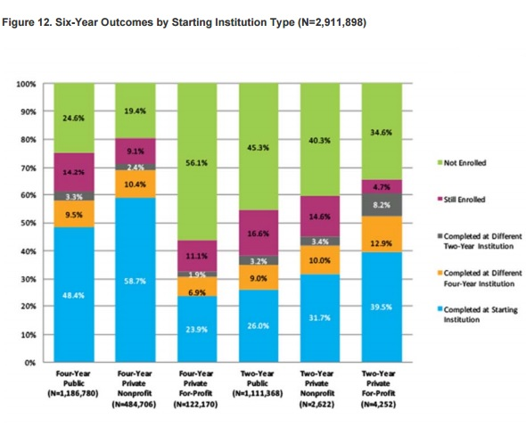
https://www.insidehighered.com/quicktakes/2015/11/17/college-completion-rates-decline-more-rapidly

