Enrollment Management Minutes

3:00pm – 5:00pm  November 9, 2020  Zoom

Our Mission
With students as our focus, Porterville College provides our local and diverse communities quality education that promotes intellectual curiosity, personal growth, and lifelong learning, while preparing students for career and academic success.

Members: Thad Russell, Primavera Arvizu, Arlitha Williams-Harmon, Joe Cascio, James Thompson, Mike Carley, Kim Behrens, Robert Simpkins, Jim Carson, Lupe Guillen, Elizabeth Buchanan, Karen Bishop, Bret Davis, Judy Fallert, Kimanthi Warren, Kendra Haney, Sherie Burgess, Patty Serrato, Frank Ramirez, Sarah Phinney, Miranda Warren. Guest- Stan Carrizosa.

- Call to Order – 3:06 pm
- Approval of Agenda – Motion to approve agenda M/S/C – J. Thompson/K. Haney

- Approval of Minutes – Motion to approve minutes M/S/C – K. Bishop/ J. Thompson

- Full audience - Information Items
- CVHEC Teaching & Learning Resources (Stan Carrizosa) There is $7500 in mini grants available, if anyone is interested Stan is willing to help apply for them.
- Banner 9 Update – no update at this time.
- Student Services Updates – Student Services is in the process of finalizing their schedules for the spring term. There is currently a high rate of students registering and seeing what services are available that they can be connected with. Student Services is in the process of reestablishing our executive cabinet for ASPC, there are several programs being launched for student support. Division Chairs – if you know of any students interested they can reach out to Kimanthi for additional information and a link to an interest form.
- CCCCO Vision for Success – Mike shared his screen with the committee – the Chancellors Office wanted us to set specific targets aligned with the goals in the Vision for Success. These goals are what we believe we can accomplish in five years.
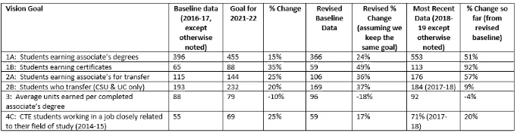
- Navigate – Kimanthi shared her screen on the PC Navigate system at a glance. Navigate is a customer relationship management system that allows communication with students as well as in between departments. There have been 648 students who have used the Navigate app is some capacity since 2018. The app can be accessed through the Porterville College website or they can download and access via their desktop.
- Achieving the Dream Conference – We would like to support at least two faculty members for the (virtual) Achieving the Dream Conference Tuesday February 16-19th. If anyone is interested, reach out to Primavera.

- Full audience - Discussions Items
  - Counseling suggestions & observations – if you have anything to share during the Student Services meeting, they will be meeting November 18th 9:00-11:00 am, let Patty or Erin know and they will add you to the agenda.

- Chairs – Information Items
  - Bookstore Faculty Adoption Platform – Nov 23rd 2:00 pm the colleges will be doing a demo on the new platform.

- Chairs – Discussion Items
  - Spring semester knowns and unknowns – prepare to have more face to face options in the summer and fall.

- Other

- Future Agenda Items

- Adjourn – meeting adjourned at 4:54 pm.

- 2017-2022 Enrollment Management Goals
  - Increase number of declared majors
  - Increase awareness of instructional program offered
  - Increase the number of dual enrollment offerings and track the success of those offerings
  - Increase the percentage of students who take 15 units per semester
  - Increase percentage of students who complete 30 unites by end of 1st year of college
  - Increase awareness of career options within programs/pathways of study
  - Increase the number of students receiving associate degrees and certificates
  - Increase number of students who transfer to university
  - Increase number of students with ready resume, job applications

