Co-Chairs: Thad Russell, Elizabeth Buchanan, Vern Butler

**MINUTES**

**Present:**

Claudia Habib, Thad Russell, Primavera Arvizu, Arlitha Williams-Harmon, Michelle Miller-Galaz, Osvaldo Del Valle, Erin Wingfield, Kim Behrens, Johnathan Miranda, Jasmine Quinones, Frank Ramirez, Joe Cascio, John Ward, Johana Fisher, Michael Carley, Robert Simpkins, Karen Bishop, Vickie Dugan, James Carson, James Thompson, Elizabeth Keele, Patty Serrato, Sherie Burgess, Kendra Haney, Elizabeth Buchanan, Melissa Long, Chris Ebert, Jay Hargis.

**Absent:**

ASPC President, ASPC Vice President, Vern Butler, Tiffany Haynes, Jay Navarrette, Julian West, Errin Sullivan-Arcos, and Shauna Williams.

**Guest:**

None

1. **Call to Order**

Thad Russell called the meeting to order at 3:07 pm.

1. **Adoption of Agenda**

Motion made to approve the November 1, 2021 agenda.

**M/S/C:** Primavera Arvizu/Jay Hargis

1. **Approval of Minutes**

Motion made to approve the October 18, 2021 minutes.

**M/S/C:** Primavera Arvizu/Elizabeth Keele

1. **Old Business-Action Items**
2. **Project Priorities – Dr. Claudia Habib (20 minutes/discussion)**

Dr. Claudia Habib presented the council the status of the creation of the MacKenzie Scott taskforce. Names have been submitted from Academic senate for three faculty. Dr. Habib requested to have representation from all divisions so Robert Simpkins will bring back a name for representation from the CTE division. Currently Sherie Burgess from Mathematics, Melissa Long from Language Arts, and Sarah Rector from Fine and Applied Arts have volunteered. Awaiting names from CSEA for classified representation. Jasmine Quinones will provides specific names after the ASPC President and Vice-President have been finalized. Representation from the foundation will include Richard Christenson. Once all names from all areas are received meetings will begin with status updates brought back to this committee in the future.

1. **New Business-Announcement/Information/Discussion Items**
2. **ILO’s – Melissa Long (15 Minutes/Discussion/Action)**

Melissa Long provided an update on ILO #4.

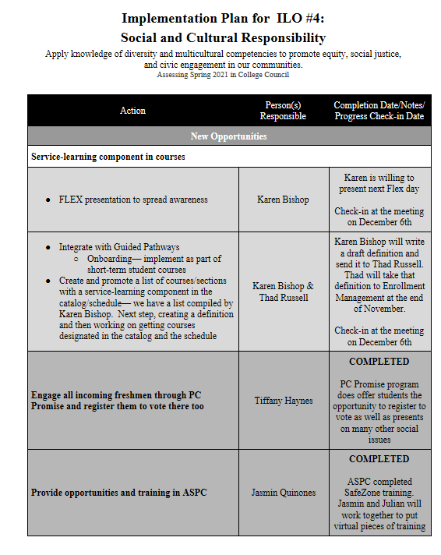

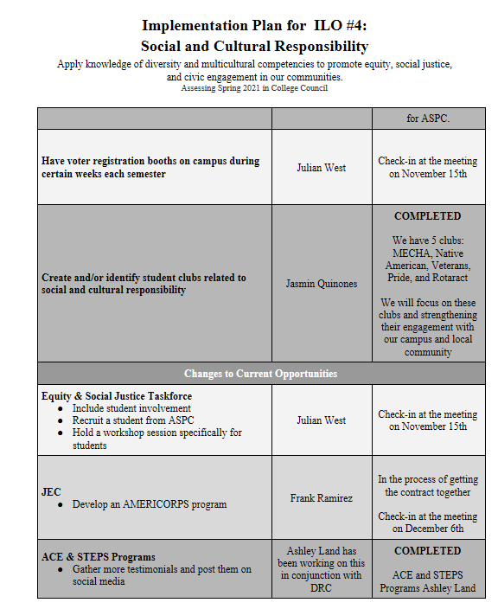

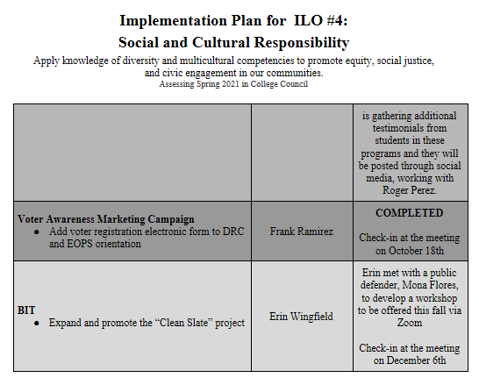

Revisions to the ILO #5 statement were presented to the council for approval:

**Personal Growth**

Demonstrate self-understanding and ethical behavior through practices that promote physical, mental, and emotional well-being.

The following sources of evidence for our assessment of ILO #5:

* CCSSEE (questions 6b, 9d, 9e, & 11)
* Mental Wellness Annual Report (if someone could please send me the most current version, I would appreciate it)
* Mental wellness counselor's workshops and training for students and faculty
* WeComm service learning work (led by Jonathan Hernandez)
* Timely Care
* Student-athletes sign a code of conduct
* Fire and cadet academies have instruction in ethical practices
* Health Careers provides instruction in ethical practices
* We have a list of expectations for students in the catalog

Council was asked to send an email for additions to above sources of evidence.

**Motion, “to accept ILO #5 Statement as presented”**

**M/S/C: Karen Bishop/ James Thompson**

1. **Program Review-Fine & Applied Arts-James Thompson (5 Minutes/Informational)**

James Thompson provided the council with an update on the status of the Fine & Applied Arts Program Review. The division has meet three times and three revisions have been made. Changes include content and date collection. Goal is to have program review completed by end of current fall semester.

1. **Program Review-Natural Science-Kendra Haney (5 Minutes/Informational)**

Kendra Haney provided the council with an update on the status of Natural Science Program Review. Division has competed an outline and in process of collecting data. Currently the division is working collaboratively on a shared document.

1. **Program Review-Mathematics-Sherie Burgess (5 Minutes/Informational)**

Sherie Burgess provided the council with an update on the status of Mathematics Program Review. The entire mathematics division is contributing on this report this time and it is currently 50% complete. Goal is to have Program Review completed by end of current fall semester including AB 705 additions.

1. **Program Review-Non-Instructional-Thad Russell (5 Minutes/Informational)**

Thad Russell provided the council with an update on the status of the Non-Instructional Program Review. Program review committee has not formally met but there has been several ongoing discussions about the content. Meeting with Refugio Rodriguez for Dual and Concurrent Enrollment. Enrollment Management has been developing goals. Discussions with Sarah Finney have been conducted for distance learning and Michelle Miller-Galaz is working with Chris Ebert for Library section. Plan is to have completed by the end of current fall semester.

1. **Program Review-Finance-Arlitha Williams-Harmon (5 Minutes/Informational)**

Arlitha Williams-Harmon provided the council with an update on the Finance Program Review. Currently finance is looking to get some larger things completed district wide to support finance. Finance has new allocation models that are currently going through the district wide process for mobile administrative services. Security has an individual program review that John Word is working on.

1. **Subcommittee Reports**

Thad Russell reminded the council about submitting subcommittee reports via Wufoo email link so that council will have time to review updates and bring any questions or comments to future council meetings.

1. **Other Reports**
2. **President**

Dr. Claudia Habib had three updates for the council. First Fresno State has a campus in Visalia that is ready to start a cohort with the Department of Criminology for students to who want to pursue Criminology and Law Enforcement. Recruiting for the first cohort will soon start for fall 2023. Second Thad Russell and Primavera Arvizu will be attending UC Merced in person to go over the Pathway Mapper that is sponsored by the Community College Foundation to establish a better in-person relationship to increase opportunities for Porterville College students. Porterville College name was announced by ED Source a research paper by Career Ladders as one of the only three colleges that has completed their AB 705 compliance. Lastly, employee compliance for Covid requirements is almost at 100% compliance. Porterville College has taken a friendly approach in reaching both staff and students. The message to portray to students is that we will not drop them we want to assist them in becoming compliant.

1. **Academic Senate**

Robert Simpkins updated the council that the ranking for new positions was finalized and sent to Dr. Habib for review. Finalization of new language for Faculty emeritus process is being discussed to use in the nomination of individuals to be potentially recognized by the Board of Trustees for this year. Winter intercession proposal drafted by Bakersfield College and it has been decided to spend more time reviewing prior to approving.

1. **Outcomes**

No Report.

1. **CCA**

No Report.

1. **CSEA**

Absent.

1. **ASPC**

Jasmine Quinones informed the council by the next College Council she hopes to have the ASPC president in attendance and they are working on finalizing students to assign as representation for committee meetings. Reminder that on November 17th the Native American Club will be out tabling.

1. **Future Agenda Items**

Mike Carley to provide the council with an update on the Mission Statement Task Force. Draft Mission Statement is in process of finalization and will be brought to November 15, 2021 College Council for approval.

Primavera Arvizu asked that College Council Charge is added to the agenda.

1. **Adjournment**

Meeting adjourned at 4:01 pm.