Co-Chairs: Thad Russell, Elizabeth Buchanan, Vern Butler

**MINUTES**

**Present:**

Claudia Habib, Thad Russell, Primavera Arvizu, Michelle Miller-Galaz, Osvaldo Del Valle, Erin Wingfield, Kim Behrens, Jasmine Quinones, Frank Ramirez, Joe Cascio, Jay Navarrette, John Ward, Johana Fisher, Michael Carley, Robert Simpkins, Karen Bishop, James Carson, James Thompson, Elizabeth Keele, Patty Serrato, Sherie Burgess, Tiffany Haynes, Vickie Dugan, Kendra Haney, Elizabeth Buchanan, Melissa Long, Chris Ebert, Vern Butler.

**Absent:**

ASPC President, ASPC Vice President, Arlitha Williams-Harmon, Julian West, Jay Hargis, Terry Crewse, Errin Sullivan-Arcos, and Shauna Williams.

**Guest:**

None

1. **Call to Order**

Thad Russell called the meeting to order at 3:02 pm.

1. **Adoption of Agenda**

Motion made to approve the October 4, 2021 agenda.

**M/S/C:** Elizabeth Keele/Primavera Arvizu

1. **Approval of Minutes**

Motion made to approve the September 20, 2021 minutes.

**M/S/C:** Primavera Arvizu/Kendra Haney

1. **Old Business-Action Items**
2. **HR Staffing Plan – Dr. Claudia Habib (10 minutes/discussion)**

Dr. Habib did not have any new updates for this item. Currently Porterville College is on track. CCA is moving forward with their presentations for faculty position recommendations and management is working on classified and management staff positions. Submissions need to take into considerations programs that the college wants to grow that will help increase enrollments.

1. **Revise Program Review Schedule – Michael Carley (5 Minutes/ 2nd Read/Approval)**

Michael Carley reviewed the updated program review schedule with the Council. He included a minor change from the previous College Council meeting.

**Motion, “to accept update Program Review Schedule as presented”**

**M/S/C: James Thompson/Karen Bishop**

1. **Revise Program Review Forms for Approval – Michael Carley (5 Minutes/ 2nd Read/Approval)**

Michael Carley reviewed the updated Program Review forms. There are separate forms for instructional and non-instructional areas. Reminder for those who are up for review this year: if already started, you can still utilize old forms and move to new form at the next program review.

**Motion, “to accept update Program Review Forms as presented”**

**M/S/C: Primavera Arvizu/Kendra Haney**

1. **Project Priorities – Dr. Claudia Habib (20 Minutes)**

Dr. Habib asked for feedback from council on how to spend MacKensie Scott funds and brainstorm potential projects and ideas of how to contribute towards the growth of current projects to utilize these funds. She asked for ideas of projects that could benefit large groups of people and will be long term projects. A Jamboard activity was shared with the Council, and Dr. Habib asked for suggestions utilizing “stickies” by category. All project ideas will be taken and evaluated to see how they fit with these funds or if they already fit within current projects. This exercise will be taken to other committees and a narrowed list will be brought back to future College Council meetings for further discussion.

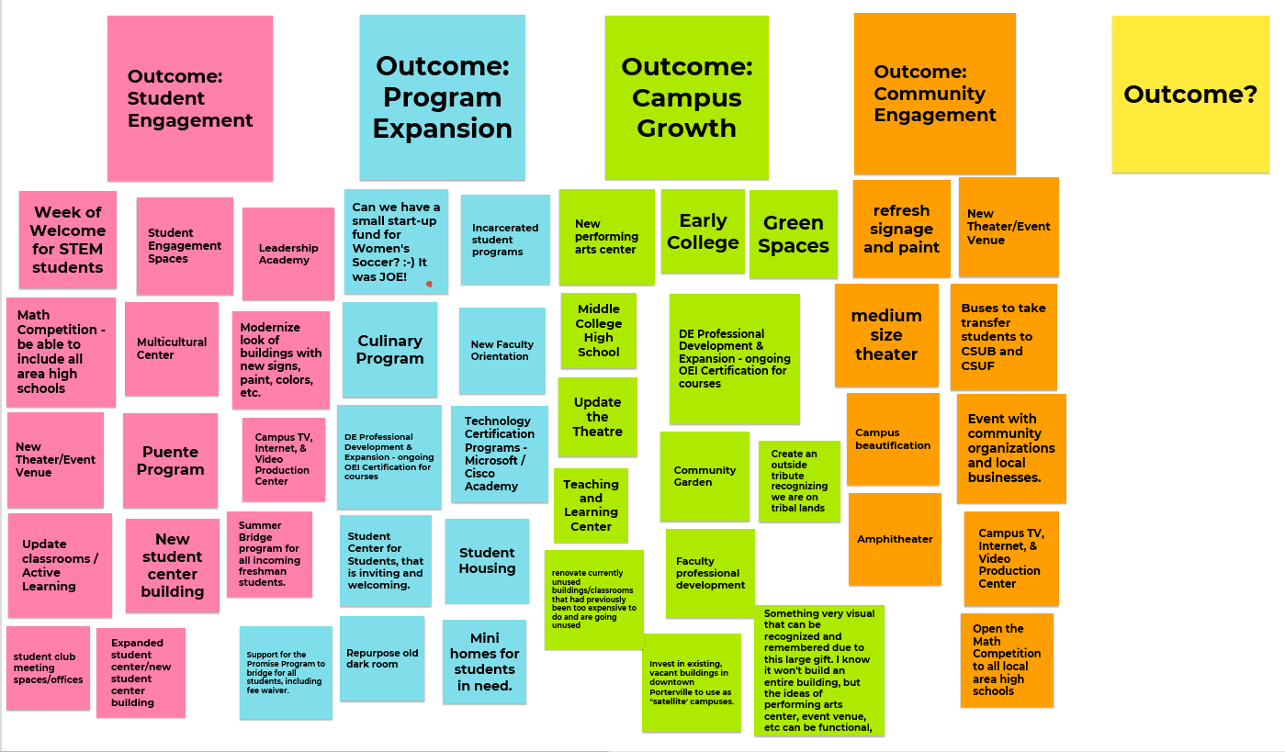

1. **New Business-Announcement/Information/Discussion Items**
2. **ILO’s – Melissa Long (15 Minutes/ 2nd Read/Discussion/Action)**

**Melissa Long ran through the check in for the implementation plan for ILO #4.**

* Student Learning Component-Primavera Arvizu collected information from sociology faculty that was included in the Guided Pathways self-assessment. Once information is compiled it will be sent over for completion.
* Engagement of all incoming freshmen through PC Promise and register them to vote-Tiffany Haynes. When the Promise Program was first implemented there was a collaboration with the Register to Vote Campaign that is currently in process. Students are offered the option to register to vote and provided with information on why it is important. There are a variety of workshops and activities to support social and cultural responsibility, including a social justice speaker during PC Promise Days. The event is hosted on voter registration with a variety of speakers and workshops that cover social justice. High school to college and mental health empowering student and student code of conduct including student handbook workshops are also provided.
* JEC- Move to next meeting.
* ACE and STEPS Programs Ashley Land is gathering additional testimonials from students in these programs and they will be posted through social media, working with Roger Perez.
* Voter Awareness Marketing Campaign- Primavera Arvizu working with Frank Ramirez will bring back at upcoming council meeting.

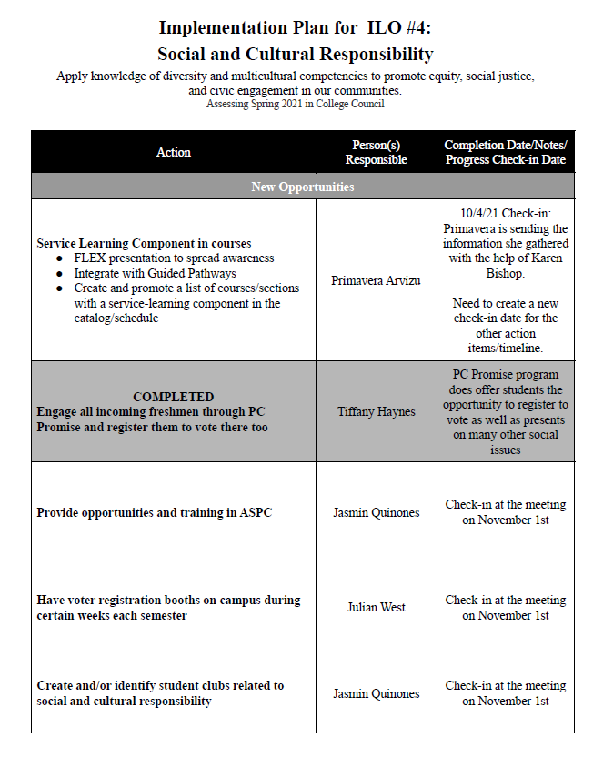

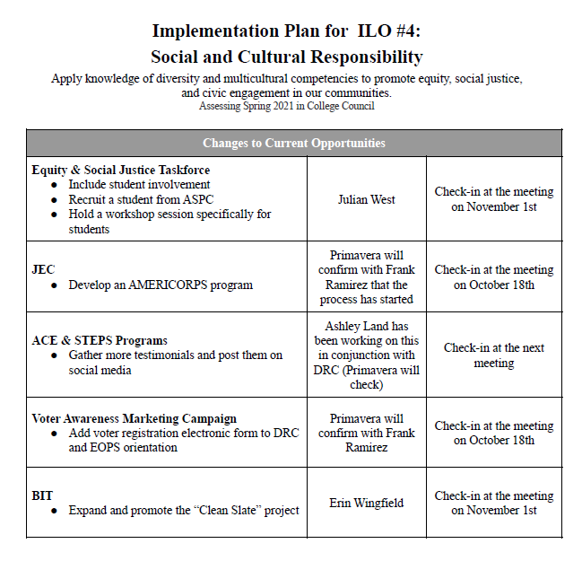

ILO #5 was reviewed with council. Council was asked to take a silent moment to reflect on the meaning of the ILO and provided a reply in the chat box for council review. Council was asked to continue to collect evidence on ILO #5 and bring back to next council meeting.

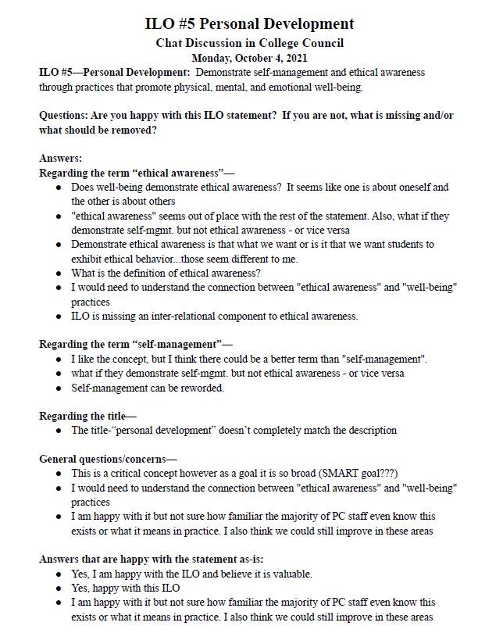

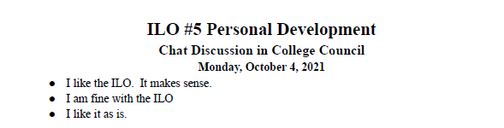

1. **IT Program Review –Jay Navarette (10 Minutes/Approval)**

Jay Navarette walked through the IT Program Review with the council. This already went through Strategic Planning.

* Surface area outcomes using a help desk ticketing system is not always met timely so IT will continue to work on improving in this area.
* New IT survey will be sent out in the spring semester.
* Replacement of computer system cycle from three to five years has been updated.
* Computers should be updated every three years but not sure if that is financially feasible.
* IT is addressing what to do with outdated computers.
* Currently IT is managing about 940 computers and about 180 to 200 printers and servers, including roughly 75 to 100 requests per month.
* Due to COVID, laptops have been checked out to all staff and over 200 students.
* Request for training for IT technicians to send them to trainings to keep current on updated technology.
* Technology is not uniform in classrooms. IT is working on uniformity across the campus.
* Full campus physical inventory needs to be conducted at some point in the future.
* Requested a new System Support Specialist I full time position to keep up with increased workflow.
* **Motion, “to accept IT Program Review as presented”**
* **M/S/C: Karen Bishop/Kendra Haney**

1. **Subcommittee Reports**

Thad Russell reminded the committee to submit subcommittee reports to the online line listed on the agenda prior to the meeting so the council can review prior to council meeting for questions or discussion. Reminders will be sent out on Monday or Tuesday of previous week and reports should be submitted by Wednesday or Thursday with most recent updates. Kendra Haney suggested creating a Microsoft Teams so that council can review documents more often between meetings. Thad Russell will work with IT to develop teams for future submission.

Jay Navarette reminded council about the WiFi/MiFi recall and replacements. For those who have not been returned once the new one is updated, access will be lost.

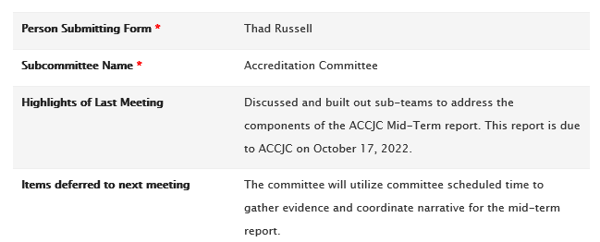

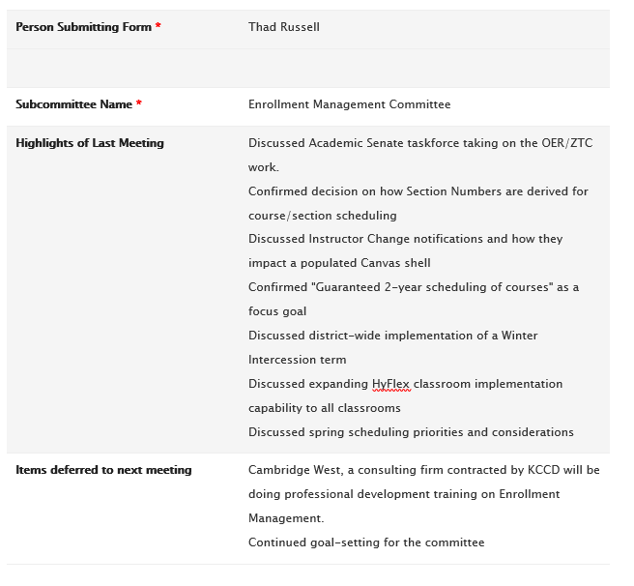

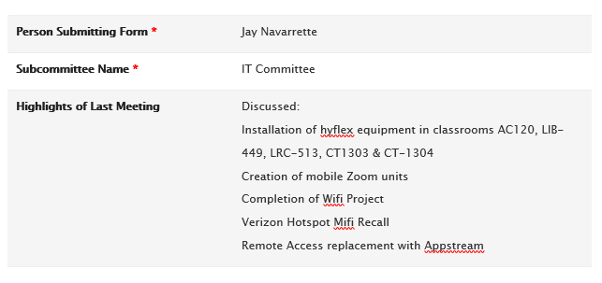

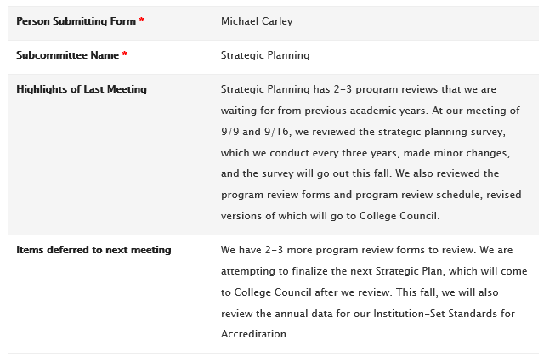

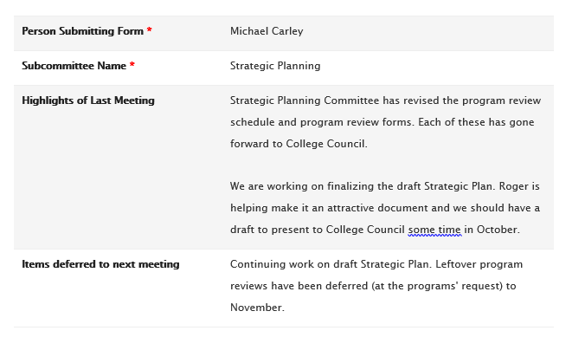

1. **Other Reports**
2. **President**

Porterville College was awarded the Gear-Up Grant providing 1.7 million to fund a project that will take seven years to increase K-12 awareness and readiness on the importance of attending college. This grant will be brought to College Council as an informational item.

An invitation to participate in Equitable Student Success in Mathematics by Education Equity Solutions was received. The study will occur over the next two semesters. It has not been decided if the college will participate.

Air quality has been an issue due to the surrounding fires. Campus was closed on previous Friday due to severe unhealthy air quality conditions. Faculty need to remain flexible until air quality improves. It was suggested that faculty to wear K N95 masks during unhealthy air conditions. Smoke smell in buildings was a concern; however, the updated air filtration system that was installed due to COVID does block smoke particles. John Word is looking into getting an odor neutralizing block to install to help eliminate any future smoke smell.

1. **Academic Senate**

Meeting for new faculty position requests will be held this upcoming Friday, 10/8/21, and rankings will be send to Dr. Habib for approval.

1. **Outcomes**

No updates.

1. **CCA**

Absent.

1. **CSEA**

Five MOUs including mandate for vaccines are going to the Board for ratification. Once they are finalized they will be brought to council.

1. **ASPC**

The student board is in the development, and it is hoped they will join council in the near future. Michael Carley requested a student representative to join the Mission Statement Task Force and an update will be brought to the November College Council meeting.

1. **Future Agenda Items**
2. **Adjournment**

Meeting adjourned at 4:39pm.