Co-Chairs: Thad Russell, Elizabeth Buchanan, Vern Butler

**MINUTES**

**Present:**

Claudia Habib, Thad Russell, Primavera Arvizu, Michelle Miller-Galaz, Osvaldo Del Valle, Erin Wingfield, Kim Behrens, Jasmine Quinones, Frank Ramirez, Joe Cascio, Jay Navarrette, John Ward, Johana Fisher, Michael Carley, Robert Simpkins, Karen Bishop, James Carson, James Thompson, Elizabeth Keele, Patty Serrato, Sherie Burgess, Tiffany Haynes, Kendra Haney, Elizabeth Buchanan, Melissa Long, Chris Ebert, Vern Butler, Jay Hargis,

**Absent:**

ASPC President, ASPC Vice President, Arlitha Williams-Harmon, Osvaldo Del Valle, Johnathan Miranda, Julian West, Vickie Dugan, Errin Sullivan-Arcos, and Shauna Williams.

**Guest:**

None

1. **Call to Order**

Vern Butler called the meeting to order at 3:02 pm.

1. **Adoption of Agenda**

Motion made to approve the October 18, 2021 agenda.

**M/S/C:** Elizabeth Keele/Michael Carley

1. **Approval of Minutes**

Motion made to approve the October 4, 2021 minutes.

**M/S/C:** James Thompson/Robert Simpkins

1. **Old Business-Action Items**
2. **Project Priorities – Dr. Claudia Habib (20 minutes/discussion)**

Dr. Claudia Habib broke down the suggestions for use of the MacKenzie Scott funds after taking ideas from College Council to the President’s Advisory Council via Jamboard. These ideas still need to go through the students for ideas to ensure that these funds are student centered. Dr. Habib asked the council for next step ideas to finalize projects to focus on these funds and ideas that can be used on funds the college already has available. Dr. Habib requested the formation of a small task force to organize all of the ideas and narrow down a few projects to prioritize that can be brought back to this council for finalization. Volunteers from council will bring names to recommend for the taskforce to the November 1, 2021 meeting. Vern Butler and Robert Simpkins were tasked with sending Dr. Habib two names from each contingency prior to the next meeting. The taskforce will include two managers, two faculty, two classified, one representation from the foundation, and two students. Council was reminded that projects need to focus on benefiting a lot of people and have long-berm benefits that can really make a difference.

1. **New Business-Announcement/Information/Discussion Items**
2. **ILO’s – Melissa Long (15 Minutes/ 2nd Read/Discussion/Action)**

Melissa Long ran through the check in for the implementation plan for ILO #4.

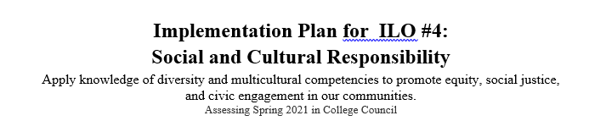

|  |  |  |  |  |
| --- | --- | --- | --- | --- |
| Action | Person(s) Responsible | | Completion Date/Notes/  Progress Check-in Date | |
| **New Opportunities** | | | | |
| **Service-learning component in courses** | | | | |
| * FLEX presentation to spread awareness | Karen Bishop | | Karen is willing to present next Flex day  Check-in at the meeting on December 6th | |
| * Integrate with Guided Pathways   + Onboarding— implement as part of short-term student courses * Create and promote a list of courses/sections with a service-learning component in the catalog/schedule— we have a list compiled by Karen Bishop. Next step, creating a definition and then working on getting courses designated in the catalog and the schedule | Karen Bishop & Thad Russell | | Karen Bishop will write a draft definition and send it to Thad Russell. Thad will take that definition to Enrollment Management at the end of November.  Check-in at the meeting on December 6th | |
| **Engage all incoming freshmen through PC Promise and register them to vote there too** | Tiffany Haynes | | **COMPLETED**  PC Promise program does offer students the opportunity to register to vote as well as presents on many other social issues | |
| **Provide opportunities and training in ASPC** | Jasmin Quinones | | Check-in at the meeting on November 1st | |
| **Have voter registration booths on campus during certain weeks each semester** | | Julian West | | Check-in at the meeting on November 1st |
| **Create and/or identify student clubs related to social and cultural responsibility** | | Jasmin Quinones | | Check-in at the meeting on November 1st |
| **Changes to Current Opportunities** | | | | |
| **Equity & Social Justice Taskforce**   * Include student involvement * Recruit a student from ASPC * Hold a workshop session specifically for students | | Julian West | | Check-in at the meeting on November 1st |
| **JEC**   * Develop an AMERICORPS program | | Frank Ramirez | | In the process of getting the contract together  Check-in at the meeting on October 18th  Check-in at the meeting on December 6th |
| **ACE & STEPS Programs**   * Gather more testimonials and post them on social media | | Ashley Land has been working on this in conjunction with DRC | | **COMPLETED**  ACE and STEPS Programs Ashley Land is gathering additional testimonials from students in these programs and they will be posted through social media, working with Roger Perez. |

|  |  |  |
| --- | --- | --- |
| **ACE & STEPS Programs**   * Gather more testimonials and post them on social media | Ashley Land has been working on this in conjunction with DRC | **COMPLETED**  ACE and STEPS Programs Ashley Land is gathering additional testimonials from students in these programs and they will be posted through social media, working with Roger Perez. |
| **Voter Awareness Marketing Campaign**   * Add voter registration electronic form to DRC and EOPS orientation | Frank Ramirez | **COMPLETED**  Check-in at the meeting on October 18th |
| **BIT**   * Expand and promote the “Clean Slate” project | Erin Wingfield | Check-in at the meeting on November 1st |

Draft for ILO #5 was presented to the council:

**ILO #5—Personal Growth:** Demonstrate self-understanding and ethical behavior through practices that promote physical, mental, and emotional well-being.

Please send me an email with any feedback you have or further revisions you would like to make. Council was asked to be ready to vote on new ILO #5 statement at the November 1, 2021 meeting.

We also made a lot of progress with our implementation plan for ILO #4.  Here is a link to the updated plan: https://docs.google.com/document/d/1X-PH_ko7kHCW6gsHX5j9TVHGR5Ylvk7bB8GYmW_EQr0/edit?usp=sharing.

1. **Gear-Up Grant –Primavera Arvizu (10 Minutes/Informational)**

Primavera Arvizu reviewed details of the Gear-Up grant with the council. Gear-Up grant is a 7-year grant to assist low income and underserved students focusing on grades 6-8 and some high school students to broaden their knowledge about higher learning. To fully manage this grant there will be priorities implemented and will require hiring additional staff that will be paid out of these monies. Two positions have already been approved to move forward with hiring a Program Manager, Program Technician, and Educational Advisor.

1. **Subcommittee Reports**

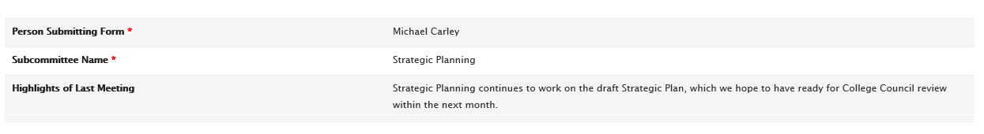

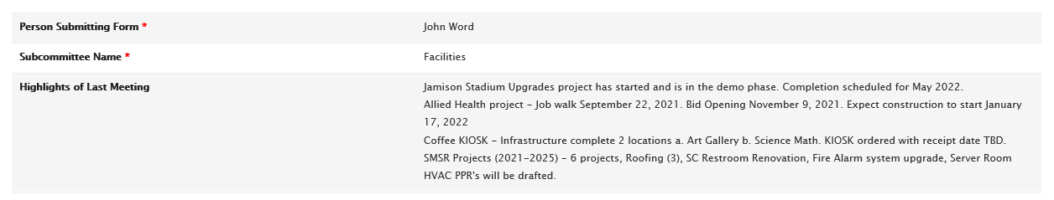

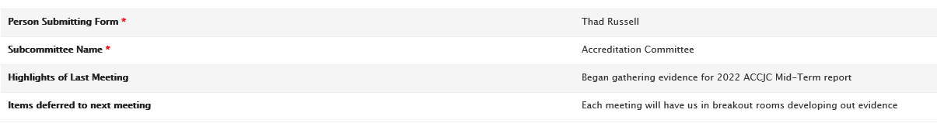

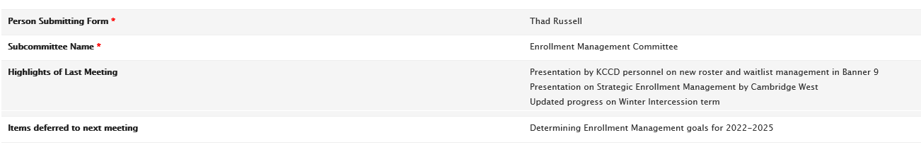

1. **Other Reports**
2. **President**

Dr. Claudia Habib reminded council about the November 1, 2021 Vaccination deadline which is quickly approaching. Council was asked to push our reminders to all staff to submit either proof of vaccination or exemption. One of these options must be completed by the deadline. This is important to know which staff require testing.

1. **Academic Senate**

Academic Senate had their last meeting on October 8, 2021, and position presentations were conducted. This upcoming Friday October 22, 2021 new position rankings will be completed.

1. **Outcomes**

No report.

1. **CCA**

No Report.

1. **CSEA**

Three MOU’s were ratified by the board: Vacation overage, Winter break December 20-31, 2021, and COVID mandate.

1. **ASPC**

Currently there are 13 clubs this semester that are having COVID appropriate events.

1. **Future Agenda Items**

Programs that are due for review need to provide a quick verbal report at the November 1, 2021 meeting.

Dr. Claudia Habib is hoping to have a HR Staffing updates at the November 15, 2021 and December 6, 2021 meetings.

1. **Adjournment**

Meeting adjourned at 4:02 pm.